MULTI-PERIOD SCENARIO GENERATION TO SUPPORT PORTFOLIO OPTIMIZATION

By ERHAN DENIZ

Stochastic Programming (SP) models are widely used for real life problems involving uncertainty. The random nature of problem parameters is modeled via discrete scenarios, which makes the scenario generation process very critical to the success of the overall approach. In this study we consider a portfolio management problem and propose two scenario generation algorithms and a SP model to support investment decisions. The main objective of the scenario generation algorithms is to infer representative probability values to be assigned to the scenario realizations sampled from historical data.

The first algorithm assigns the probabilities by using similarity scores, assigning higher probabilities to the scenarios with data paths that are relatively similar to historical paths, where similarity scores are computed by means of distance measures. We first implement this approach using the weighted Euclidean distance (WED). We also propose a new distance measure to obtain similarity scores as an alternative to WED.

The second scenario generation algorithm is based on the combination of momentmatching technique and the Exponential Generalized Auto-Regressive Conditional Heteroskedasticity (EGARCH) model. Scenario probabilities are assigned such that the first four moments of the sampled returns are fit to target moments through a linear programming model, where the second target moments are set to be conditional on the past scenarios on the scenario tree using the EGARCH model. An additional set of constraints are proposed to increase robustness.

The generated scenarios become input to the SP model to restructure the existing portfolio such that the expected final wealth is maximized and the risk exposure is controlled through constraining Conditional Value-at-Risk at each decision epoch on the scenario tree. We finally propose a generic approach to reduce potential losses and implement it on a logistic regression framework.

# **ACKNOWLEDGEMENT**

I would like to first thank my advisor Prof. James T. Luxhøj for his continuous guidance and valuable feedback throughout my dissertation. He provided me with the right balance of suggestions, criticism, and independence.

I am also grateful to my committee members Prof. Thomas O. Boucher, Assoc. Prof. David W. Coit, and Dr. Yanni Papadakis for their critical review of my dissertation and constructive comments.

I also owe my gratitude to my dear friend Nadide Banu Olcay for giving me invaluable moral support.

# **1. INTRODUCTION and LITERATURE REVIEW**

The objective of this study is to present a stochastic programming (SP) based framework to support financial portfolio management decisions with a focus on the scenario generation phase. The concept of portfolio optimization has attracted many researchers and become a major research area in finance due to the challenging nature of the problem and large demand for solid solutions. Before elaborating on our approach, we briefly discuss some other approaches employed for portfolio optimization. Some of the prominent approaches used for this purpose are:

* Mean-Variance Model and its variations.
* Stochastic Control.
* Monte Carlo Methods.

## 1.1. Mean-Variance Approach

The first significant mathematical treatment of portfolio optimization is the meanvariance (MV) model developed by Markowitz (1952). In this Nobel prized study Markowitz presents a quadratic programming model where, given a fixed level of return, the objective is to minimize the portfolio risk, which is represented by the standard deviation of the portfolio return. The objective might be also given as the difference between the mean return of the portfolio and the variance multiplied with a constant that controls the level of risk aversion. Out of all possible portfolio configurations the MV model yields the ones that are on the *efficient frontier*, which represents the optimum portfolios obtained by setting different levels of risk aversion.

The MV model has the assumption of normally distributed asset returns, which is not always valid due to the fat tailed characteristic of most financial data. Other shortcomings of the original model are the penalization of the positive deviations over the mean portfolio return; single-periodicity; and the exclusion of several restrictions faced in real life (e.g., transaction costs). After Markowitz, portfolio optimization attracted significant attention from researchers with the purpose to improve the MV model and explore new methodologies that would address the problem for different settings.

For example, Markowitz (1959) proposed the *semi-variance* as the risk measure for the portfolio optimization problem instead of the variance, which is defined as*S* =*E*[min(0,*R*−*c*)2], where *R* is the portfolio return and *c* is equal to E[R] or some other constant. Apparently, the semi-variance is a risk measure where only the negative deviations from the mean are penalized.

For instance, Konno and Yamazaki (1991) use a different approach with the mean absolute deviation (MAD) as the risk measure disregarding the quadratic objective function. They show that the MAD model can generate solutions faster than the original MV model. Zenios and Kang (1993) also propose an MAD model to manage the portfolios of mortgage-backed securities.

Benati and Rizzi (2007) present an extension of the Markowitz model where variance is replaced by Value-at-Risk (VaR), which can be simply defined as theα-quantile of the portfolio return distribution. Specifically, VaR is the maximum loss a portfolio can incur that can not be exceeded with the confidence level of 1-α (see Section 2.4.3.4 for more discussion on VaR).

Li and Ng (2000), and references therein, are among the studies extending the MV model to a multi-period setting. Li and Ng (2000) provide an analytical solution for the multiperiod problem where the mean and variance of the final wealth are in the objective function. Moreover, they provide an analytical expression for the resulting efficient frontier.

Ogryczak and Ruszczynski (1999) utilize a relatively different approach of stochastic dominance (Fishburn (1964)) instead of a typical mean-risk approach in order to compare alternative outcomes on random variables. They consider standard semi-deviation and absolute semi-deviation and provide conditions that make the mean-risk approach consistent with second order stochastic dominance. In another study, Ogryczak (2000) develops a linear goal programming model with a multi-criteria setting. Multiple linear functions of portfolio return are considered as a weighted sum in order to find portfolios that are optimum with respect to several different risk-averse preferences.

Instead of using merely mean and variance in the objective function, Parpas and Rustem

(2006) include all first four moments of the portfolio return into the objective function. Considering a minimization problem, skewness of the return would have a negative coefficient in the objective function since positive skewness is desirable due to making high returns possible. Kurtosis is included with a positive coefficient, since it implies a fat tailed distribution, which may lead to high risk exposure.

## 1.2. Stochastic Control

After Markowitz’s single period model, many studies directed attention on the differences between the single period and multi-period model results. A very important research area in portfolio optimization after Markowitz has been developing financial models using stochastic control techniques. These are studies using dynamic stochastic control to obtain closed form solutions for the multi-period/continuous time portfolio management and option pricing. Merton (1969) is the first significant article treating the portfolio optimization as a lifetime consumption and investment problem assuming the asset return rates are generated by a Wiener process and this study can be regarded as the starting point of continuous-time finance literature. Another seminal study, interestingly published in the same year, is Samuelson (1969), where the author achieves a similar analysis in discrete time. Another immediate important study is Hakansson (1970), which provides optimum consumption investment for a class of utility functions.

A review of the stochastic control literature on portfolio optimization reveals that usually controlled stochastic processes are used for modeling the asset returns and wealth of the decision makers are obtained as stochastic differential equations. Dynamic programming and martingale optimality conditions are among the tools used to solve the resulting portfolio optimization problem.

The advantage of these approaches is the simple closed-form solutions obtained under the required assumptions (e.g., no transaction costs). As the assumptions are relaxed and additional constraints are included the problem becomes complicated to solve analytically. Therefore, the practical applicability of the original studies is limited since real life problems contain transaction costs and many other constraints.

In order to obtain more realistic models, researchers extended the original studies. For instance, Davis and Norman (1990) and Taksar et al. (1998) added the transaction cost to continuous time modeling considering two assets. Chellathuraia and Draviamb (2007), and references therein, provide models that consider fixed and proportional transaction costs within a stochastic control framework.

Some of the other noteworthy studies in this area are Cox and Huang (1989), Karatzas (1989), Richardson (1989), Chow (1993), and Kohlmann and Zhou (2000).

## 1.3. Monte Carlo Methods

Different than the alternative approaches, Monte Carlo Methods (MCMs) are highly computational tools. Instead of pure theoretical modeling, MCMs are employed mostly to evaluate/improve an existing model or a decision rule. In this context, the two main subjects where MCMs are used are

* *Evaluating portfolio risk*: The performance of an existing portfolio for future periods could be evaluated by simulating the underlying random variables (e.g., asset prices). This may involve generating a high number of paths for asset prices after which the decision maker can see how his asset allocation would behave in different future scenarios. Specifically, histograms can be built to represent the future distribution of the portfolio return and different risk measures are evaluated to improve the existing asset allocation.
* *Option pricing*: The value of an option is strictly dependent on an underlying asset, mostly a stock. Generating paths for asset price enables the decision maker to observe possible values the option can have at the horizon and therefore value the option at the time of the simulation.

Despite the ease in modeling, Monte Carlo simulation can be computationally demanding due to the high number of scenarios to be generated. Another shortcoming is the possible high variance for the resulting estimates, which is handled via variance reduction techniques (see Glasserman (2003) for more details on MCMs).

## 1.4. Stochastic Programming (SP)

The basic characteristics of the SP approach are:

* Optimization is achieved under uncertainty.
* Probability distributions are known or estimated through discrete scenario sets. Once the scenarios are generated, the decision maker solves the deterministic version of the original stochastic program.
* A typical objective might be the maximization of the expected value of wealth (or utility function) and minimization of some risk measures.
* SP models are generally two-stage or multi-stage models with recourse. This results in two types of variables to be used in the model**:** 
  + *1st stage variables*: These variables are scenario independent and determine the decisions made immediately after the model run. In other words they state the set of actions the decision maker should take considering the set of future scenarios. For example, in a supply chain problem, the first stage variables might be used to select which production plants will be established at the time of network design.
  + *2nd stage (i.e., tth stage* or *time staged) variables*: Different than the first group, these variables are scenario dependent and they determine which action should take place at a particular scenario and a time period given the set of actions taken and outcomes realized in the previous stages. In other words, they take the corrective action after the first stage decisions are made (i.e., *recourse variables*).

The advantage of using SP models is the ability to merge a high number of state variables with various objective functions and complex real life constraints. In comparison to the other approaches, SP comes with more flexibility since • The decision maker can consider more than two assets.

* It is easy to include transaction costs into the model.
* It is possible consider a wide range of objective functions and risk measures.
* There is no restriction on the distribution of asset returns.
* Other real life restrictions can be incorporated into the model easily. These may include:
  + Liability flows. o Taxation rules. o Legal and regulatory issues.
  + Company-driven restrictions.

The main shortcomings of SP might be listed as follow:

* The size of the model can grow exponentially as the number of stages and variables increase, which bring in computational challenges.
* It is difficult for practitioners to develop and implement such complicated models.
* The results of SP models are harder to interpret.

Even though the roots of SP go back to Dantzig (1955), the application to the portfolio optimization domain has not gained acceleration until the recent technological advancements in computing power. The most successful applications of SP are implemented as Asset and Liability Management (ALM) tools. ALM is a generalization of asset allocation problems where various cash flows are also incorporated in the model. Therefore, ALM problems are faced mostly by pension funds and insurance companies. Mulvey (1996a) lists Towers Perrin, State Farm Insurance, Falcon Asset Management, Frank Russell, and Unilever among the companies implementing multistage SP models for their ALM systems.

One of the earliest studies proposing an SP approach to the financial domain is Bradley and Crane (1972). The model presented in this article considers a portfolio of fixed income securities and provide the basic structure that will be used by many following studies in the same area.

The first significant real life application of the SP approach is Kusy and Ziemba (1986). They develop a comprehensive multi-period SP model and implement the model as an ALM framework for Vancouver City Savings Credit Union. Their model is intended to better manage the uncertainty in deposits to and withdrawals from accounts. A shortcoming of their model is that the scenario tree in not updated as the horizon moves into the future.

One of the noteworthy applications on this domain is presented in Carino et al. (1994), which introduces the SP based approach implemented for a Japanese Insurance company. Compared to other models focusing on a specific problem or a set of assets, the difference of this study is that it constitutes the entire dynamic ALM framework of the insurance company. The details of the model are given in Carino et al. (1998) and Carino and Ziemba (1998). They propose and implement a multi-stage linear SP model covering the decisions of the company for the following five years over a scenario tree of 256 scenarios at the horizon. They discuss three different scenario generation approaches to be used for the software. Another important study immediately following Carino et al. (1994) and leading the way to a successful real life application is by Dert (1995), who develops an ALM model to be used by Dutch pension funds.

Mulvey et al. (2000) provide another success story of the SP approach, which presents the SP based ALM system developed for Towers Perrin-Tillinghast for its insurance and pension plan services (see also Mulvey (1996b) and Mulvey and Thorlacius (1998)). The model relates the liabilities and asset returns to structural economic factors. In fact, the generation of scenarios is a multi-layer process, where the top layer is the generation of interest rates and price inflation. Then the other parameters such as fixed income returns, stock returns, and wage inflation are generated through sets of stochastic differential equations at different layers.

Eckstein and Hiller (1993) is also one of the earliest applications of the SP approach with particular focus on the computational side. They apply a relatively simple SP model to a portfolio of fixed income securities. In an accompanying paper, Dantzig and Infanger (1993) present a multi-period stochastic linear programming model for multi-period portfolio optimization and addresses efficient methodologies to solve the resulting SP model. They utilize importance sampling in order to restrict the scenario tree size for computational concerns. Consigli and Dempster (1998) provide a generic SP model to handle the ALM issues for a pension fund.

Golub et al. (1995) present a successful application to money management, where they propose a two stage SP model to manage a portfolio of mortgage backed securities. Interest rate scenarios are generated using the binomial lattice model of Black et al. (1990) and the cash outflows are generated by using the prepayment method described in Kang and Zenios (1992). A similar study is Zenios et al. (1998) where they present a multi-stage dynamic model for the management of fixed income portfolios. The interest rate scenarios in this study are also generated through Monte Carlo simulations based on the binomial lattice model of Black et al. (1990). They implement the model in different settings for two different problems, bond index tracking and money management with mortgage-backed securities.

A relatively recent study is Ziemba and Zhao (2001), which presents an asset allocation problem with multiple risky assets and a risk-free asset. Different than the previous studies, they consider the worst case payoff as the risk measure. Asset return scenarios in this study are generated through auto-regressive models estimated on quarterly index data (i.e., the Salomon Brothers bond index and S&P 500 stock index). Their benchmarking analysis reveals that the SP based model outperforms the mean-variance approach.

Fleten et al. (2002) compare the performance of a multi-stage SP model to that of a static fixed mix within the same problem context where a two asset portfolio is considered. They resort to expert opinion to obtain the statistical features of the asset returns and then achieve moment matching over a discrete set of scenarios so that the recommended statistical features are preserved.

The interested reader is referred to Ziemba and Mulvey (1998) and Censor and Zenios (1997) for more information and references on the topic.

## 1.5. Scenario Generation

Most SP models build decisions by approximating the future uncertainty through a finite set of scenarios having a discrete probability distribution; therefore, the success of SP models directly depends on the effectiveness of the design stage for scenarios. Special effort is required to decide on the number of scenarios (i.e., topology of the scenario tree) and assign individual probabilities for each scenario regarding the random processes in the model.

As stated in Ziemba and Zhao (2001), modeling future asset returns can be categorized into two broad approaches. The first one is the *adaptive expectations* approach where future asset returns are generated by relating them to past observations of the explanatory variables. This approach can be regarded to be a technical analysis. Alternatively, a *rational expectations* approach generates scenarios using forecasts produced by conceptual macroeconomic models where expert expectations are used. The studies in this group are based on fundamental analysis.

We next discuss some of the approaches that can be used for scenario generation.

### 1.5.1. Bootstrapping Historical Data

Bootstrapping historical data is the simplest scenario generation method since it does not require a mathematical effort. This method is basically sampling random periods from the historical data and using the returns realized in those periods as scenarios for the current model. If there are multiple assets in question, all returns from the selected period are recorded into a vector to preserve the correlation among assets. In addition other statistical features of the historical distributions are preserved.

In one of the methods used in Carino and Ziemba (1998), they assume that scenarios are independent across periods and generate scenario by sampling the historical data. Then they employ an algorithm to adjust the variance so that the resulting distribution for each random parameter has the same mean and variance obtained from historical data.

### 1.5.2. Brownian Motion (Wiener Process)

This continuous-time stochastic process was originally defined to describe the movement of particles in fluids. It was also used to characterize some stochastic processes having specific features. In fact, the typical discrete random walk converges to a Wiener process as the time step gets infinitesimal. A stochastic *continuous* process *Wt*is a Wiener process if *W0* =0 and it has independent increments such that *Wt*-*Wτ* is normally distributed with mean 0 and variance *t*-*τ* where 0< *τ < t*.

After Merton (1969), Wiener process was frequently utilized to model the behavior of stock price to be used for portfolio optimization and option pricing. In fact, in these models a Wiener process is used to drive the stochastic portion of the prices process such the resulting logarithms of returns follow a Wiener process (i.e., normally distributed given a time interval). Paths of stock prices can be generated via Monte Carlo simulations to build portfolios or evaluate risk exposure of a given portfolio. For instance, the stochastic differential equations used in Mulvey and Thorlacius (1998) to generate asset return scenarios are driven by correlated Wiener processes. The Wiener process is usually utilized by continuous-time financial models (see Duffie and Richardson (1991) and references therein among many others).

### 1.5.3. Vector-Auto-Regression (VAR)

Auto-regressive (AR) models are univariate econometric models that are used to capture the behavior of time series data and make forecasts. Let *Xt* be the variable in question. Then AR(*p*) (i.e., AR of degree *p*) expresses *Xt* in terms of its lags as *Xt=β0* + *β1Xt-1* + *β2Xt-2* +*…+ βpXt-p* + *εt* where *ε*stands for the error term with zero mean. VAR is the generalization of the AR model, which covers multiple time series and their dependencies on each other. Different than the AR models, VAR models relate each variable to the lags of the other variables in addition to their own lags.

Suppose that **Y*t*** is the vector of all *n* variables in question. Then VAR(*p*) is expressed in matrix form as **Y*t*=C+ D*1*Y*t-1*** + **D*2*Y*t-2* +…+ D*p*Y*t-p* + E*t*** where **C** is an *n*x1 constant vector, **D*1*…D*p*** are *n*x*n* matrices, and **E*t*** is the *n*x1 vector of error terms with zero mean. The selection of the degree of VAR (i.e., length of time lag) and calibrating the parameters are critical for the success of VAR.

Boender (1997), Dert (1995), Kouwenberg (2001) and Ziemba and Zhao (2001) are some of the studies using a VAR model to generate scenarios for asset returns and other random parameters.

### 1.5.4. Moment Matching

This method could be based on an optimization model or some other heuristic where the objective is to obtain a set of scenarios (i.e., realizations of random parameters and probabilities corresponding to each realization) such that the resulting moments, usually the first four, are close or equal to the moments obtained from historical data or some other target set by the decision maker (see Hoyland and Wallace (2001)).

A potential shortcoming is non-convexity since it may prevent finding a perfect match for the moments due to the high probability of obtaining a locally optimum solution. Even though the global optimum can not be found, it can be still acceptable to have statistical features that are sufficiently good approximations to the target moments from a SP point of view. The nonlinearity in this approach can be eliminated by linearizing the objective function such that it is a weighted sum of absolute deviations from the target moments instead of squared deviations.

Ji et al. (2005) reports a comparison between linear and nonlinear versions. Gulpinar et al. (2004), Fleten et al. (2002), and Parpas and Rustem (2006) are some of the studies using moment matching technique in the scenario generation phase.

### 1.5.5. Factor Models

Factor modeling is about relating the evolution of a random variable to some other independent factors. Suppose that we interested in the return of an asset. Then possible factors could be

* return on some other individual asset.
* return on a stock or bond index.
* macro-economic variables such as interest rate, GDP, inflation, currency exchange rates, unemployment, etc.
* some benchmark portfolio or fund.

where the choice of the factors completely depends on the belief of decision maker. A factor model can be simply stated as *X* = *β0* + *β1f1* + *β2f2* +*…+ βmfm* + *ε* where *X* is the variable in question and *f1…fm* are the *m* factors that are assumed to explain the value of *X*.

Carino and Ziemba (1998) report three different scenario generation approaches in their study for the Japanese insurance company and one of the approaches is based on a factor model to build correlation across assets and periods, where the factors are interest rate, overall equity market behavior, and exchange rate. Dantzig and Infanger (1993) provide another study utilizing factor modeling.

### 1.5.6. Binomial Lattice

Being first developed by Black et al. (1990), this method is generally used to generate possible scenarios for short term interest rates considering the current long term interest rates and corresponding volatilities. Therefore, it is mainly used by the studies which focus on portfolios of fixed income securities such as bonds.

Bertocchi et al. (2006) and Bertocchi and Dupacuva (2001) utilize this model over the Italian Bond market whereas Beltratti et al. (1999) consider international bond markets. Golub et al. (1995) and Zenios et al. (1998) are among the other studies using lattice structures to generate scenarios for fixed income portfolios.

### 1.5.7. Expert Judgment

Experts of various domains can have anticipations and beliefs on possible moves on market indicators, indices, or assets, which might be different than those suggested by the historical data. These beliefs may provide a base to construct scenarios either directly by setting values and probabilities or indirectly by modifying the probability distributions suggested by the historical data. In other words, expert judgment may be input directly as a complete scenario or indirectly (or partially) through the specification of some statistical features of the random process.

One of the three methods employed by Carino and Ziemba (1998) is the direct utilization of user input involving expert judgment, which enables the decision makers to build scenario trees with maximum flexibility. Fleten et al. (2002) also utilizes expert judgment to specify target moments for the moment matching phase of their scenario generation.

## 1.6. Research Objectives

Our first objective is to search for new ways of handling the uncertainty for the portfolio optimization problem, which will be achieved through developing new scenario generation methods. Another objective is to build an optimization model to obtain optimum portfolios considering different risk exposures within a multi-period setting and analyze the performance of the proposed approach through different experiments.

We briefly discuss these objectives next. The details of the methodology are given in Chapter 2.

### 1.6.1. Scenario Generation Methodology

Considering the significance of scenario generation, two scenario generation algorithms are proposed with the motivation of exploring a new and acceptable methodology to handle uncertainty.

The first scenario generation algorithm is based on reducing the historical data set into a smaller but more relevant set such that the similarity between the current situation and the historical data set is increased. This reduction is achieved using similarity scores, which are computed via distance measures. A new distance measure is developed and used in conjunction with Euclidean distance to compute the similarity scores. The same distance measures are used to assign probabilities to the scenarios according to the similarity between the scenarios and the past behavior of the data in the reduced historical data set.

The second scenario generation algorithm is based on the moment matching technique discussed in Section 1.5.4., which aims to find a discrete probability distribution for the scenarios such that the first four moments of the generated scenarios are closely matched with the historical data. Originally, Hoyland and Wallace (2001) present this optimization based approach to match general statistical features. They build a nonlinear model where both security prices and corresponding probabilities are decision variables. A shortcoming of that model is the high level of nonlinearity. We consider a linear program and take security returns and interest rates as given parameters (generated before the matching). In addition, we incorporate state dependency of variance via the well-known Exponential - Generalized Auto Regressive Conditional Heteroskedasticity (EGARCH) model, which, to the best of out knowledge, is included into a scenario tree construction for the first time. Instead of node-by-node optimization, we consider solving a single optimization model that optimizes the entire scenario tree at once.

### 1.6.2. Portfolio Optimization Model

Once the scenario tree is constructed, the next step is to input the scenario tree into an SP model in order to obtain the investment decisions. The advantage of SP models is the ability to consider various objective functions and constraints. Therefore, SP based studies focus on different various measures of reward and risk where the measure of reward is usually expected final wealth. Utility functions are used to combine the risk and reward into a single objective. In our SP model, we build the objective function as the maximization of the expected final wealth. We control the risk exposure by limiting the conditional Value-at-Risk (CVaR) within linear constraints. Changing the limiting parameters in these constraints would yield investment strategies for investors having different risk averseness. Different than the studies in literature, we employ risk control dynamically at each node of the scenario tree.

Even though our focus is on the expected shortfall (i.e., CVaR) we provide a generic model that can cover two other measures. The first one is the severity of the worst case scenario, which could be improved by a *maximin* approach (i.e., maximizing the wealth for the worst case scenario). The second one is to decrease the fluctuation of portfolio returns over the time-span of the scenario tree. This corresponds to the minimization of expected deviations among consecutive periods.

In summary, we aim to build a model which will be used to rebalance the current portfolio on hand such that the expected final wealth maximized over the planning horizon subject to the control on risk exposure (NOTE: The term *rebalancing* is usually used in conjunction with the *fixed-mix* rule to refer the trading process for restoring the constant mix. In this report, it refers to executing the buy/sell decisions suggested by the SP model).

The following is a list of the data categories that can be input to the portfolio optimization framework.

* *Asset Prices/Returns:* It is assumed that the current portfolio is a collection of a finite number of financial assets (e.g., stocks, bonds, cash, etc.). It should be noted that the term ‘asset’ may refer to ‘asset class’ since it is common in practice for some investors to invest in asset classes instead of individual assets. The data in this category are of two types:
  + *Historical data*: This set of data includes the historical return data for the universal set of assets and interest rates.
  + *Future scenarios*: This set of data is generated by the two scenario generation algorithms discussed in Chapter 2. This is the most critical data set since it determines how well the model captures the uncertainty associated with the future asset returns.

* *Cash inflows/outflows*: Some assets generate positive cash flows to the investor (e.g., dividend payments of stocks) whereas some investors may have prescheduled or random cash outflows (e.g., liability flows) throughout the planning horizon.

* *External and Internal Parameters*: This group includes parameters those are external (e.g., transaction costs, interest rates) and those set by the investor (e.g., upper and lower bounds on individual asset positions, confidence level and limits for CVaR, objective weights, etc.).

## 1.7. Organization of the Text

We present our methodological approach in Chapter 2, where Section 2.2 presents the scenario generation algorithms and Section 2.3 provides the details of the optimization model. In Chapter 3, we explain about the implementation process and present computational results and sensitivity analysis. Chapter 4 presents a general approach to be used incorporated into any trading strategy and aims to increase the performance from a return/risk point of view. Chapter 5 provides a summary of conclusions, research contributions, and possible extensions of the study.

# **2. METHODOLOGICAL APPROACH**

In this chapter, a multi-period portfolio management framework is presented, which consists of two scenario generation algorithms that provide input parameters and a stochastic programming (SP) model that uses those input parameters and builds a robust portfolio. Sections 2.2 and 2.3 present the scenario generation algorithms and the SP model is given in Section 2.4.

## 2.1. A Brief Introduction to Scenarios

The uncertainty associated with parameters can be modeled through continuous density functions or some discrete probability distributions, the first being not quite practical due to the structure of SP models. As a common practice, a discrete set of possible outcomes (i.e., scenarios) are created with individual realization probabilities as the input to most SP models. Caution is needed when creating this set since the number of scenarios may increase dramatically as the number of parameters and time periods (for multi-period models) increase. The trade-off between the computational power required due to the problem size and the ability of the model to sufficiently capture real-life uncertainty has been a major issue for the SP approach, especially in the past when high levels of computational power were not as available as today. Even though the technological progress keeps loosening the trade-off, developing scenario generation algorithms is still an appealing research area.

What is exactly meant by the term *scenario*? Each scenario corresponds to a realization of a random variable (e.g., asset returns, interest rates, cash flows, etc.) over the planning horizon and has an associated realization probability with it. A multi-period scenario is represented by a set of consecutively ordered single-period scenarios, which can be illustrated by a scenario tree of four different scenarios as in Figure 1, where the first scenario (i.e., s1) is the dashed path highlighted by red lines.

The point where *t=0* usually represents the current time where the decision is made considering the possible four scenarios, *s1, s2, s3,* and *s4*. Each scenario is a realization of random asset returns over the next three periods. After branching in the initial time periods, returns follow a different path into the future. It might be early but worth to note at this point that the decisions for different scenarios can not be different from each other until the period where the corresponding scenarios start differentiating from each other. This rule prevents models that have a scenario tree as the input from exploiting the future information within the tree and is established by the introduction of *non-anticipativity* constraints.

**t=0**

**t=3**

**t=2**

**t=1**

**s**

**1**

**s**

**2**

**s**

**3**

**s**

**4**

**~p**

**1**

**~p**

**2**

**~p**

**3**

**~p**

**4**

Figure 1. Scenario tree for 3-period planning horizon

For instance, the return realizations *s1, s2,* and *s3* are the same in the first period but we observe variations in the following periods. Since the latter periods have not been realized yet at *t=*1, these two scenarios must be equivalent in terms of the decisions made (e.g., buy/sell decisions) in these particular scenarios. Let *zts* denote the security holdings for scenarios *s* at time period *t*. Then, for the scenarios in Figure 1, (1) and (2) are the two non-anticipativity constraints where we force the positions to be equal to each other in the first period for *s1, s2,* and *s3*.

*z1S1 = z1S2* (1) *z1S2 = z1S3* (2)

In this section, we propose two scenario generation algorithms. The first one is based on moment matching whereas the second relies on similarity scores.

In this study the asset returns (i.e., the realization component of the scenarios) are generated by sampling the historical data. However, depending on the type of the algorithm the process of sampling slightly varies, which will be specified in the detailed descriptions of the algorithms.

The generated asset returns are configured on a scenario tree, where we assume that

* It is a *symmetric tree*, where the number of branches emanating from each node is the same for all nodes at the same stage.
* The number of branches emanating from each node decreases for the latter periods.

A sample tree under these assumptions is given in Figure 2. Once such a tree is configured with the generated asset returns, the algorithms, which will be presented in Sections 2.2 and 2.3 assign the probability distributions given the discrete sets of realizations for asset returns at each node except the leaf nodes. Note that, if the decision making process involve multiple assets, then each node (i.e., one period scenario) corresponds to a vector of asset returns and a single probability attached to it.

**0**

**1**

**2**

**3**

Figure 2. A symmetric scenario tree for T=3

## 2.2. Probability Assignment through Similarity Scores

In this section, we propose two scenario generation algorithms that rely on the evaluation of similarity between past and current behavior of the asset returns.

### 2.2.1. Basics of the Approach

Before providing the details, we first present the proposed approach as a combination of two main steps:

*Reduction of the Historical Data Set*: In this step we extract the most relevant part of the historical data set to be used in the next step. Consider the most recent pattern of length *θ* in the time series ending with the last observation in our data set. We seek *similar* patterns observed in the past having the same length. This provides us with the part of the history in which a sequence of realizations occurred that are similar to the most recent pattern in the data set.

*Comparison of Past and Generated Scenario Set*: We now turn our focus to what really had happened one period after those *similar* patterns occurred in the past (obtained at the previous step) and to the scenarios we have just generated for one period ahead. The oneperiod-ahead past realizations are believed to give us insight about how likely the current scenarios are to happen one period later. As a scenario gets more similar to the selected past realizations, it is assigned higher probabilities of occurrence.

In order to better illustrate the approach, consider node J shown in Figure 3, where Nt+1 scenarios (i.e., nodes) were generated. In order to assign the probabilities for the Nt+1 scenarios, the last *n* data points (i.e., the most recent path shown in red with length *n-1*) are considered in order to relate the current state to historical outcomes. The algorithm first searches within the historical data to find out the paths of the same lengththat are similar to the current path ending with node J, which is achieved through the similarity scores of the individual historical paths. Then we turn our focus to the (*n+*1)th data points in those historical paths and obtain the similarity scores of the current Nt+1 scenarios on hand with respect to them. The higher the similarity of a scenario is, the higher the probability of that scenario becomes.

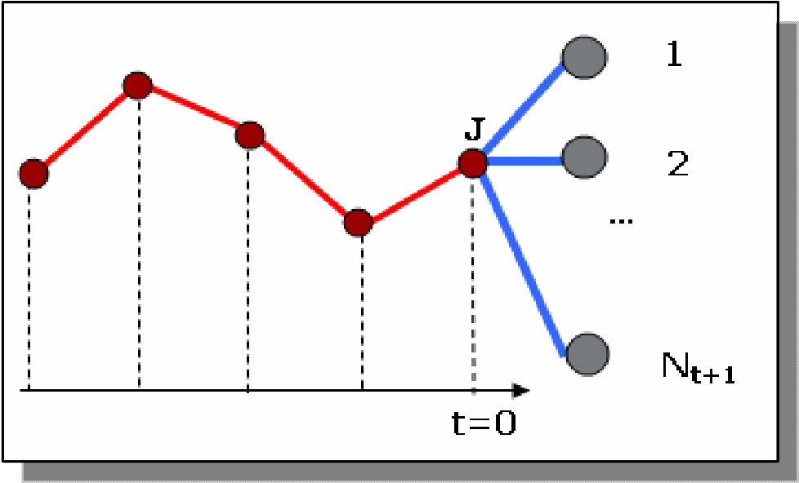

Figure 3. Illustration of one-period scenario generation

The aforementioned similarity scores between any two paths are computed via the overall distance between those two paths in question. In the presented algorithms, the similarity score is inversely proportional to the distance.

The two algorithms presented in Sections 2.2 and 2.3 are similar since they are built upon the same idea briefly provided above. The type of time series and distance measures used in the algorithms form the main differences. The first one utilizes the well-known Euclidean distance measure. We propose and utilize a new distance measure in the second algorithm, the *UD* *Distance*, which evaluates the paths with respect to their sequence of up and down movements.

### 2.2.2. Scenario Generation Based on Weighted Euclidean Distance

In this algorithm we are assumed to have the historical *arithmetic* returns for all *risky* assets given by

*returnt* = *pricepricet*−*t*1 −1 (3).

The weighted Euclidean distance, which can be simply computed as in (4) between two vectors **X** and **Y**, is employed in order to measure both the distance between the most recent and the historical paths. The distance between the one-period-ahead realizations of the most recent path and historical paths is computed as the squared difference as described below in detail.

*DEU* (X,Y) = ∑*n wi* (*X i* −*Yi* )2 (4)

*i*=1

#### 2.2.2.1. Algorithm Description: Alg-1A

Suppose that we have *m* risky assets and the last *TH* (i.e., size of historical data set) historical returns for each of these assets and risk-free asset. Then, we can build the historical data matrix *H* as follows:

 *r*11 *r*12 *r*13 ... ... *r*1*m* 

*r*21 *r*22 ... ... 

=*r*31 ... 

*H*

 ...  (5)

 ... ... 

*rTH*1 ... ... *rTHm*

where *rti* is the return of asset *i* in period *t*.

Another initial step is to decide on a scenario tree topology (i.e., the horizon and the number of scenarios emanating at each period) such as one given in Figure 2 and set the source node of the tree as *current source node* (CSN). Then the algorithm can be formally described as follow:

*Step 1* : For each risky asset, generate the corresponding number of asset returns by sampling from *H* on a random basis.

*Step 2* : Consider last *θ* return vectors for all assets. This implies a *θ*x*m* matrix formed by the last *θ* rows of *H*. Denote this matrix by *A*.

*Step 3* : Let *Kl* be the *θ*x*m* matrix formed by the rows *l, l+*1*, l+*2*…, l+θ-*1 of *H*. For *l* =1 to *TH*-*θ*,compute

*SK l EU* =∑∑*m* θ *w* (*K l* − *A* )2 −1 (6)

 *i* *t* 

w*here SKlEU* is the similarity score given by the multiplicative inverse of the sum of the squared weighted Euclidean distances over all assets. Also note that *Klti* and *Ati* denote the *t*th elements within the *i*th columns of *Kl* and *A* matrices, respectively. The parameters *wti* are the weights assigned to the Euclidean similarity for period *t* within the path.

*Step 4* : Rank the *Kl* matricesaccording to their *SKl* and select the top *C* matrices where *C* is a user-specified scalar (C < *TH-θ*)*.* If *Kl* is selected, then let *Rl* be the (*l+ θ*)*th* row of *H*. Form a *Cxm* matrix with the *C* row vectors (*Rl*) and denote it by *R*.

*Step 5* : For each return scenario *s* emanating from the CSN, compute the similarity score*SSEUs* , where

*SSEUs* 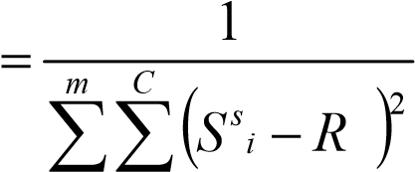 (7)

*i*

It should be noted that a scenario corresponds to a vector of returns for *m* assets and is denoted by*S s* .

*Step 6* : Normalize *SSEUs* to obtain *ps* for the scenarios emanating from CSN.

*Step 7* : If all nodes excluding the leaf nodes have already been assigned as a CSN, STOP. Otherwise, set the node below the CSN as the new CSN. If the CSN is already the bottom, set the node at the top of the next time period’s nodes as the new CSN. Go to Step 8.

*Step 8* : Update the matrix *H* to include the newly generated scenario realizations. Update the matrix *A* such that *A* is the new *θ*x*m* matrix with the most recent θ return vectors including the CSN. Go to Step 1.

### 2.2.3. Scenario Generation Based on the New UD Distance

In this algorithm we introduce new distance measure that is intended to capture the similarities of directional movements of the time series data in a different way.

#### 2.2.3.1. UD Distance Measure

When financial time series data is in question, it may not be sufficient to rely solely on the absolute distances between individual data points to measure the overall similarity between two paths. Consider Figure 4,where three distinct paths, **X,** **Y** and **Z**, are plotted.

It is obvious that **X** and **Y** have a very low Euclidean distance and therefore higher similarity since the individual values are similar. However, the directional movement of the data is quite different between **X** and **Y**. In fact, the illustration implies a strong negative correlation between the processes driving **X** and **Y** (*Note that the paths discussed in this section represent the same asset at different time periods).*

**X**

**Y**

**Z**

Figure 4. Illustration for three arbitrary paths, ***X,*** ***Y*** and ***Z***.

In addition to the difference among data values, the serial movements of the values (consecutive ups and downs) are also worth to be taken into account when comparing two paths. Path **Z** in Figure 4 is apparently much more similar to path **Y** with respect to their patterns; however, the comparison between these two paths may suffer due to high Euclidean distance since the individual observations are far apart.

Developing a distance measure that will decrease the distance as the two paths have more common ups and downs may still result in low distance for some dissimilar paths. The paths **W** and **Z** in Figure 5 have three common ups and downs (highlighted in gray) out of five possible outcomes. The number of common ups and downs would imply a 60% similarity between **W** and **Z** but these patterns obviously have a high dissimilarity. We believe that the distance measure in this case should result in high distance if the common ups and downs occur in separate locations within the path and low distance if they occur without interruption in between.

W

Z

Figure 5. Illustration for two arbitrary paths, **W** and **Z.**

Suppose now that we have two paths, **U** and **V** in Figure 6, having the same number of *consecutive* ups and downs that are common with a benchmark path, **Z**. The objective of developing this distance measure is to extract from the universe of historical data those paths which have low distance, or say more similar, to the most recent path (**Z**) we have at time *t* and relate the one-step-ahead *forecast* of the data process for **Z** to the one-stepahead *realization* of historical path that is similar to **Z**. Therefore, considering a particular historical path, the most recent behavior within that path is more important than the ones at the beginning. This approach will also provide more flexibility when choosing the lag length. Therefore, we conclude that in our problem setting the distance between **V** and **Z** must be lower than the distance between **U** and **Z**. In other words, **V** must be more similar to **Z** than **U**.

U

Z

V

Z

Figure 6. Illustrations for three arbitrary paths, **U**, **V**, and **Z.**

We first focus on comparing the direction of one period moves before defining the distance measure. If the directions of moves are the same then the resulting distance must be low; otherwise it must be higher to reflect the level of opposition. The possible situations for the one-period move directions of two return paths, **X**and **Y**, and corresponding distances can be listed as in Table 1.

Table 1. Comparison of one period directions

*Xi* Î*Xi+1* *Yi* Î*Yi+1* *Distance*

↑ ↑ 0

↓ ↓ 0

→ → 0

↑ → 1

→ ↑ 1

↓ → 1

→ ↓ 1

↑ ↓ 2

↓ ↑ 2

In order to define the distance measure, we define a function that describes the mapping in Table 1. Let *f* :ℜ4 →ℜ and defined as *f* (*x*1,*x*2,*x*3,*x*4) = sgn(*x*2 − *x*1) + sgn(*x*4 − *x*3) − 2

+ 2max{sgn(*x*2 −*x*1) , sgn(*x*4 −*x*3) }- 2 (8)

Considering that *Xi* is the *i*th data point of path **X**, we observe that *f* (*X i* , *X i*+1,*Yi* ,*Yi*+1)=0 if the paths **X** and **Y** move in the same direction after the *i*th position and *f* (*X i* , *X i*+1,*Yi* ,*Yi*+1) =2 if they move in the opposite direction. If at least one of them

remains unchanged, then *f* (*X i* , *X i*+1,*Yi* ,*Yi*+1) =1.

Let two return paths be represented by vectors **X** and **Y** both with *n* elements. Then the

*UD* distance between these two paths is given by

*DUD* (*X*,*Y*) =1max≤*i*≤*n*−1{*ci f* (*X i* , *X i*+1,*Yi* ,*Yi*+1)} (9)

where *ci*’s are positive scalars. In order to give higher importance for more recent periods, we use *ci* values such that *ci*+1 /*ci* > 2 (the maximum value *f* can get is

2) and *c*1 >1.

Under the light of this discussion, *UD* is a new distance measure that evaluates the course of increments and decrements along two separate same-sized data paths. It assigns high values of distance if any of the following is true.

1. The two paths do not have (or have few) common ups and downs.
2. Common ups and downs do not occur at consecutive positions.
3. The two paths have opposite moves at recent steps.

In addition to the comparison between the patterns to reduce the historical data set (i.e., selecting the most similar historical paths), the logic behind *UD* distance measure is also used to compare the generated one-step-ahead scenarios with the one-step-ahead realizations of the selected historical patterns. Just like the similarity scores for the scenarios in Alg-1A are computed using the squared Euclidean distance in *Step 5* as given by (6), the similarity scores for the scenarios in this algorithm will be computed by a simplified version of the *UD* distance measure utilizing function *f*.

#### 2.2.3.2. Algorithm Description: Alg-1B

Now we can describe the second algorithm, Alg-1B, which is quite similar to Alg-1A with following two differences:

1. The distances measure used is *UD* distance instead of the Euclidean.
2. The input data are the historical *prices*, instead of historical *returns*.

Working on price data instead of return data is an issue when it comes to historical sampling since the price data is known to be nonstationary. Therefore, we prefer to *detrend* the historical price. Next we describe the algorithm formally:

Suppose we have the historical data matrix *H* as follows:

 *x*11 *x*12 *x*13 ... ... *x*1*m* 

 *x*21 *x*22 ... ... 

= *x*31 ... 

*H*

 ...  (10)

 ... ... 

*xTH*1 ... ... *xTHm*

where *xti* is the price of asset *i* in period *t*.

*Step 1* : For *i* =1 to *m*;

*Detrend* the price series data (i.e., modify *H* such that *Hti* = *xti* - *ai* - *bi*t where *ai* and *bi* are linear regression constant and coefficient for asset *i*, respectivelywith *t*, the historical time periods, being the independent variable). Generate the *detrended* price scenarios emanating from the CSN by randomly sampling from *H*.

*Step 2* : Consider last *θ* detrended price vectors for all assets. This implies a *θ*x*m* matrix formed by the last *θ* rows of *H*. Denote this matrix by *A*.

*Step 3* : Let *Kl* be the *θ*x*m* matrix formed by the rows *l, l+*1*, l+*2*…, l+θ-*1 of *H*.

For *l* =1 to *TH*-*θ;*

*SK l* =max1,∑*im*=1 *DUD* (*Kil* , *Ai* )−1 (11)

w*here SKl* is the similarity score computed via the *UD* distance measure. Also note that *Kli* and Ai denote the *i*th column vectors of *Kl* and *A* matrices, respectively.

*Step 4* : Rank the *Kl* matricesaccording to their *SKl* and select the top *C* matrices where *C* is a user-specified scalar (C < *TH-θ*)*.* If *Kl* is selected, then let *Rl* be the 2x*m* matrix formed by the (*l+θ*-1)th and (*l+θ*)th rows of *H*. Form a 2*Cxm* matrix with the *C* matrices (i.e., *Rl*) and denote it by *R*.

*Step 5* : For each price scenario *s* emanating from the CSN, compute the similarity score*SSUDs* , where

*SSUDs* = *m C* 1 (12)

∑∑(τ1 *f* (*HTHi* ,*Sis* ,*R*(2*c*−1)*i* ,*R*2*ci* ) +τ2 )

*i*= =1 *c* 1

In (12), *HTHi* is the most recent price data for asset *i* and*Sis* is the detrended price scenario for asset *i*. The constants τ1 and τ2 can be selected such that τ1 *f* (•) +τ2 > 0 in order to prevent a possible division by zero (recall that *f* (•)∈{0,1,2}).

*Step 6* : Normalize *SSUDs* to obtain *ps* for the scenarios emanating from CSN.

*Step 7* : If all nodes excluding the leaf nodes are assigned probabilities, STOP. Add the trend back to the detrended price scenarios to obtain the actual price scenarios and use (3) to obtain the return scenarios to be used in the SP model. Otherwise, set the node below the CSN as the new CSN. If the CSN is already the bottom, set the node at the top of the next time period’s nodes as the new CSN. Go to Step 8.

*Step 8* : Set *H* back to the original historical price data matrix such that now it also includes the most recently generated price scenarios. Update the matrix *A* such

that *A* is the new *θ*x*m* matrix with the most recent *θ* price vectors including the new CSN. Go to Step 1.

The idea behind both Alg-1A and Alg-1B can be illustrated as in Figure 7.

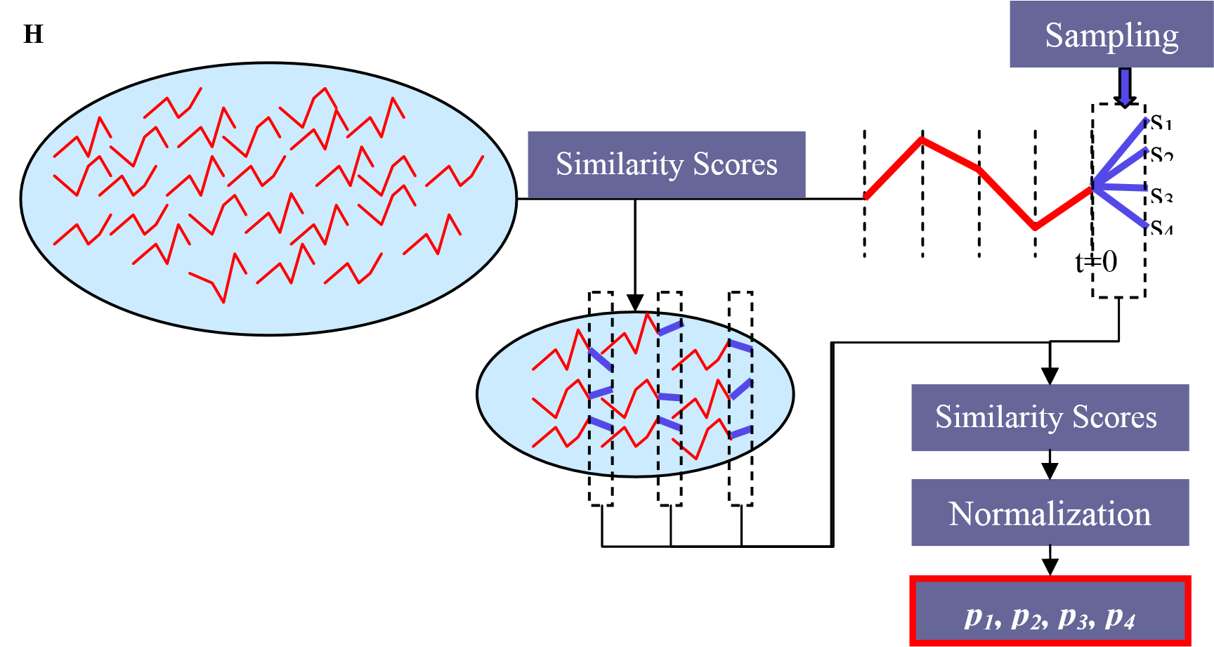

Figure 7. Illustration for Alg-1A and Alg-1B.

**2.3. Probability Assignment through Moment Matching and Heteroskedasticity**

Hoyland and Wallace (2001) use moment matching to assign probabilities to scenarios such that some statistical features of the generated scenarios comply with the statistical features of the historical data. In this study, the nonlinear optimization model given by (13) and (14) is solved taking the asset return scenarios and the corresponding probabilities as decision variables.

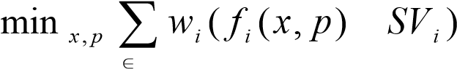− 2 (13)

*i ST*

*s*.*t*. ∑S *ps* =1, *ps* ≥ 0 (14)

s

In this model, *x* is the vector of returns whereas *p* is the vector of scenario probabilities. The set of statistical features is represented by *ST* and *fi(x, p)* and *SVi* represents the *i*th statistical feature obtained from generated data and the historical data, respectively. Moment matching approach is also employed by Gulpinar et al. (2004) where it is applied either sequentially on each node (i.e., scenario) or globally on the whole scenario tree, the first resulting in a number of small nonlinear optimization problems while the second yields one but a large nonlinear optimization problem.

Our approach is based on the same setup; however, we incorporate a *volatility clustering* approach to model the state dependency of variances and covariances via Exponential Generalized Autoregressive Conditional Heteroskedasticity (EGARCH). In addition, we present an additional set of constraints to improve performance of the SP model to be run at the final step. Third, we consider a linear version of the optimization model for moment matching. Another difference is that we generate asset returns first and take only the probability values as decision variables in optimization instead of optimizing both return and probability simultaneously because the latter leads to a nonlinear model.

### 2.3.1. Autoregressive Conditional Heteroskedasticity (ARCH)

The literature on financial time series includes empirical evidence for the fact that most financial time series data have volatility clusters at different time periods. In other words, the variance of data (e.g., stock returns, interest rates, etc.) is not constant over time. In fact, time periods with high (low) variance are followed by time periods with high (low) variance. This persistence of volatility in financial data was formally modeled first by Engle (1982). In his seminal paper, Engle presents his original ARCH (Autoregressive Conditionally Heteroskedastic) model that relates the variance conditionally to the previous periods’ residuals.

Consider the following process on excess returns, *Rt*:

*Rt* =*a*+ε*t* (15)

Then ARCH(*q*) model assumes

ε*t* =σ*t zt* (16) *zt* ~ *i*.*i*.*d*. , *zt* ~ *N*(0,1) (17) σ*t*2 =α0 +α1ε*t*2−1 +...+α*q*ε*t*2−*q* (18)

whereα0 > 0 and α*i* ≥ 0to make sure that conditional variance is positive.

Bollerslev (1986) proposed an extension of this ARCH model, Generalized ARCH (GARCH). In a GARCH setting, variance is conditioned on the previous periods’ variances in addition to their residuals. The conditional variance equation for a GARCH(*p,q*) model is given in (19) where the inequalitiesα0 > 0 ,α*i* ≥ 0, andβ*i* ≥ 0 must hold in order to ensure having positive conditional variances.

σ*t*2 =α0 +α1ε*t*2−1 +...+α*q*ε*t*2−*q* +β1σ*t*2−1 +...+β*p*σ*t*2−*p* (19)

Upon being introduced by Engle (1982) and generalized by Bollerslev (1986), ARCH (GARCH) type models have been a popular approach for modeling stochastic volatility in a discrete time setting. However, a shortcoming of the GARCH models is that only the *magnitudes* of the shocks (innovations) are considered to affect to conditional volatility. Many researchers and practitioners on the other hand believe that stock returns are negatively correlated with stock return volatilities. Black (1976) is a very early study that addresses this issue calling it the *leverage effect*, which can be stated as: A drop in the value of a stock increases the financial leverage, which makes the stock riskier and thus increases the volatility. The original GARCH model was unable to capture the fact that bad news (negative shocks) tend to increase volatility whereas, good news (positive shocks) have a lowering effect.

### 2.3.2. EGARCH

Different extensions of GARCH models were proposed to have a more flexible conditional volatility modeling that captures the aforementioned asymmetric volatility behavior. Among the proposed extensions, the most popular ones are Exponential GARCH (EGARCH) of Nelson (1991), GJR-GARCH of Glosten et al. (1993), Asymmetric GARCH (AGARCH) of Engle and Ng (1993), the threshold GARCH (TGARCH) model of Zakoian (1994), and quadratic GARCH (QGARCH) of Sentana (1995). Bera and Higgins (1993), Bollerslev (1992), and Poon and Granger (2003) are some of the papers providing reviews of those models.

Having the asymmetric volatility as a major weakness of GARCH, another issue for most GARCH models is the non-negativity constraints on *αi* (*i=0...q*) and *βi* (*i=1...p*) for the purpose of obtaining positive σ*t*2 for all *t* in all cases. These constraints make the estimation of GARCH models more difficult and create issues regarding the persistence of volatility over time. In order to overcome these issue Nelson (1991) introduced the exponential GARCH (EGARCH). A frequently used version of EGARCH(*p,q*) is given in (20).

lnσ2 =ω+∑*p* αlnσ2− 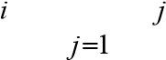+∑*q* βσε*tt*−−*jj* +∑*jq*=1γ*j* σε*tt*−−*jj* −*E*σε*tt*−−*jj*  (20)

Since *zt* ~ *i*.*i*.*d*., *zt* ~ *N*(0,1) ,ε*t* =σ*t zt* , and *E*(*zt* )= 2 π, (10) can be reduced to

lnσ*t*2 =ω+∑*p* α*i* lnσ*t*2−*i* +∑*q* β*j zt*− *j* +∑*q* γ*j* (*zt*− *j* − 2 π) (21)

*i*=1 *j*=1 *j*=1

Review of the relevant literature shows that using first order lags (i.e., *p* = *q* =1) sufficiently captures the heteroskedastic behavior of the most financial time series data. Therefore, we will consider the EGARCH(1,1) model given as

# lnσt2 =ω+αlnσt2−1 +βzt−1 +γ(zt−1 − 2 π) (22)

In contrast with most of the other ARCH models, the restrictions on the parameters (ω, α, β, and γ) are removed since their values have no effect on the sign ofσ*t*2. The utilization of the logarithms ensures always having a positive conditional variance. A careful analysis of (22) reveals thatσ*t*2 is now a function of both the *sign* and the *magnitude* of *zt* , which enables the model to capture asymmetric volatility. Through the last term in the expression, EGARCH captures the magnitude effect of the shocks such that high (low) volatility periods are followed by high (low) volatility periods (i.e., volatility clustering).

The reason to select EGARCH to incorporate in our scenario generation algorithm is its well known capability to capture the heteroskedastic behavior of financial time series data and cope well with asymmetric volatility. Relevant literature agrees on the superiority of the asymmetric GARCH models over regular GARCH models and even though there is not a single and 100% agreed-upon model, EGARCH turns out to be one of the most popular (asymmetric) GARCH models. Some papers include experimental studies testing different GARCH models and supporting EGARCH, such as Awartani and Corradi (2005) and Bali (2007).

## 2.3.3. A New Set of Constraints for Probabilities

We introduce a new set of constraints for the usual moment matching model. The motivation behind this approach is to partially remove a potential shortcoming of the usual moment matching method that can be realized when multi-period models are involved.

Suppose that we generate a symmetric scenario tree for the SP model and let *nnt* denote the number of single-period scenarios (i.e., nodes) emanating from a source node at time *t*-1 where t=1..*T* and *T* is the length of the horizon. For example, considering the symmetric scenario tree in Figure 2, one would have *nn1* =4, *nn2* =3, and *nn3* =2. We consider matching the moments for every single scenario set. For instance, the tree in Figure 1 leads to 17 moment matching processes, which equals the number of nodes in the tree except the *leaf* nodes.

Every moment matching process assigns probabilities to the corresponding set of nodes, some of which can be zero as a result of the optimization. Considering the tree in Figure 1, one would have 24 *three-period* scenarios at the horizon and the final probabilities for these scenarios are computed by multiplying the probabilities of preceding *one-period* scenarios. A low probability assigned in one of the preceding nodes leads to a low probability for the three-period scenario. In fact, if a node is assigned a probability of zero, then the rest of the tree emanating from that node is ignored by the SP model since the following three-period scenarios will assume a zero probability. For example, suppose that one of the four one-period scenarios for the first period of the tree in Figure 2 is assigned a zero probability; then 6 three-period scenarios emanating from that node

will be disregarded by the SP model. In general, ∏*Tj*=*t*+1*nn j* scenarios will be disregarded at the horizon when a one-period scenario assumes a zero probability at time *t*.

Even though zero probability scenarios are statistically acceptable to get close to the specified moments, this would produce an unwanted probability distribution at the horizon, where the expected wealth is computed. We believe that as the number of scenarios with zero (or close to zero) probabilities increase; the SP model will input fewer *T-period* scenarios, which might worsen the robustness of decisions led by the SP model. Therefore, *we propose setting lower-bounds for the probabilities during the moment matching process*. The decision on the levels of bounds is an open question and higher bounds will obviously lead to large deviations from the target moments; however, these parameters can be computationally calibrated by back-testing given a set of data.

To illustrate the issue, we present the probability values we obtained during a test case using a symmetric tree where *T* =2, *nn1* =30, and *nn2* =15. It is observed from Table 2 (See Appendix A) that only 25 of the 450 scenarios have nonzero probability with accuracy to four decimal places.

## 2.3.4. Algorithm Description: Alg-2

We now describe some notation for the simplicity of the presentation. Suppose that *ND* represents the set of all nodes in the symmetric scenario tree excluding the leaf nodes. Suppose also that *NDn* is the set of nodes that emanate from a particular node *n.* Once the scenario realizations are generated and the target moments are set, the problem is to assign probabilities for all the scenarios except the source node of the tree.

At this point there are two possible approaches to match the moments, first being to solve a large scale optimization model that will assign probabilities to all scenarios in a single run. We prefer the alternative approach, which is based on solving one optimization model for each of the nodes in *ND* so that every set of scenarios is individually considered. Recalling the notation described in previous sections, the number of

optimization models to be solved can be simply computed as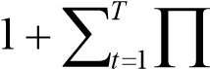*tj*=1*nn j* .

Using the previous notation, *i* is used as the index for risky assets, where we have *m* risky assets. The algorithm can be stated as follow:

*Step 0* : Generate asset return realizations for all nodes in the tree by randomly sampling the historical arithmetic returns (i.e., *H*).

*Step 1* : Estimate the third and fourth central moments, *Mi3* and *Mi4* (*i*=1..*m*), for all risky assets. Estimate the correlation matrix *R* among risky assets.

*Step 2* : Estimate the *univariate* EGARCH(1,1) models for *each* risky asset to obtain parameters*a*,ω,α,β, andγ by maximum log-likelihood method.

*Step 3* :Using the constant-mean model and the scenario realizations, obtain the error termsε for each asset and node*n*∈*ND*.

*Step 4* : Using the estimated EGARCH(1,1) model and the error terms, predict for all risky assets the conditional variances*Min*2for each*n*∈*ND*.

*Step 5* : Using the correlation matrix R and the conditional variances, compute the conditional covariance matrixΣ*n* for each*n*∈*ND* (See the explanation below for the constant correlation model).

*Step 6* : Solve the optimization problem (23)-(30) to find the optimum probabilities *for each n*∈*ND* such that the weighted sum of distances to the target moments are minimized.

***Min***

*m*  4

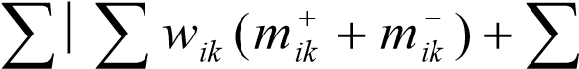*wil*  (23)

*i*=1  *k*=1 *i l*<

***st***

∑*ps* =1 (24)

*s*∈*NDn*

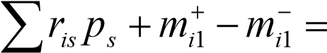*ai* ∀*i* (25)

*s*∈*NDn*

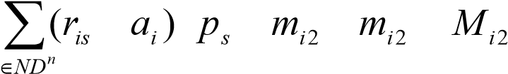 − 2 + + − − = *n* ∀*i* (26)

*s*

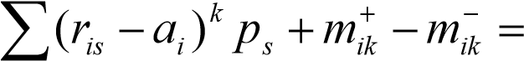*Mik* ∀*i*;*k* = 3,4 (27)

*s*∈*NDn*

*iln* ∀*i*;*i* < *l* (28)

|  |  |  |  |  |  |  |
| --- | --- | --- | --- | --- | --- | --- |
| *s*∈*NDn* |  |  |  |  |  |  |
| *ps* ≥*LBn* |  |  |  | *s*∈*NDn* |  | (29) |

# ps ,m, s∈NDn;∀i,i <l,k =1..4 (30)

In (23)-(30), *wik* and *wil* are the coefficients that capture the relative importance of the moments. The variables denoted by *mik* and *cil* are employed to compute the deviations.

The second moments are time-dependent and are computed conditionally on the previous periods’ realizations (i.e., scenarios) using EGARCH at every node throughout the scenario tree.

The correlation between assets has been addressed by researchers through MultivariateGARCH (MGARCH) models (for a recent and comprehensive review on MGARCH type modeling, see Bauwens et. al. (2006)). Even though these models are successful in capturing the conditional correlation among risky assets, an important shortcoming is the high number of parameters to be estimated, which brings in further computational concerns. Therefore, researchers proposed various versions of MGARCH models that provide less flexibility but come with simplicity. One of these studies is the Constant Conditional Correlation GARCH (CCC-GARCH) proposed by Bollerslev (1990). This approach decreases the number of parameters to be estimated significantly by assuming that the correlations among assets are constant over time. In CCC-GARCH, the conditional variances are computed via some univariate GARCH model (e.g., EGARCH) and then the covariance matrix is constructed using the initial correlations and conditional variances.

Let *Dn* be the *m*x*m* diagonal matrix formed by *Min*2 values where *i*=1..*m*. According to the CCC-GARCH model, the conditional covariance matrix for node *n*, is computed asΣ*n* =*DnRDn* . We use the elements of this covariance matrix in (28) in order to match covariance.

Constraint (29) puts a lower bound on the probability values for each node as discussed in Section 2.3.3. The value of the parameter*LBn* is subject empirical tests and can be computationally calibrated over a series of back-testing procedures. Even though we can not claim a specific value, it is immediately realized that *LB n* <1/ *ND n* for all *n*.

Therefore *LBn* can be written as *LB n* = *lb n* ×1/ *ND n* so that *lbn* can be calibrated by experimenting with values of *lbn* ∈(0,1).

## 2.4. Stochastic Programming Model

This section presents the mathematical notation and the details of the optimization model, which is a multi-stage SP model. The outcomes that are of interest are the *first stage variables* representing the rebalancing decisions (i.e., how much to buy/sell each asset at the time of running the model). Assuming that the investor continues investing over the discrete time periods, the process of managing the portfolio is based on updating the data sets and the initial portfolio and re-running the model at the beginning of each period (See Figure 8).

### 2.4.1. Parameters

The main parameters used in the SP model can be grouped as:

* *Asset return scenarios and scenario probabilities*: These one period rates and probabilities are obtained via the scenario generation algorithms presented in Sections 2.2 and 2.3. They are the most critical parameter set since the model captures the real life uncertainty through these parameters.
* *Economic parameters*: Parameters such as transaction costs, interest rates and initial security prices can be considered in this group depending on the implemented investment scheme.

**Generate scenarios**

**Run the model**

**Rebalancetheportfolio**

**t =0**

**t**

**=**

**1**

**t**

**=**

**2**

**t =3**

**t =0**

**t**

**=**

**1**

**t**

**=**

**2**

**Update data sets**

**Generate Scenarios**

**Run the model**

**Rebalancetheportfolio**

**t =0**

**t**

**=**

**1**

**Update data sets**

**Generate Scenarios**

**Run the model**

**Rebalancetheportfolio**

**…**

Figure 8. Portfolio management process

* *User-defined parameters*: Some parameters are set by the investor according to preferences or restrictions. Experimenting with these parameters may give valuable insight about how the model will behave in different environments (e.g., parameters controlling the risk averseness and exposure, statistical confidence levels, weights for different objectives, upper/lower bounds on asset positions, etc.).
* *Cash flows*: This group may contain dividend payments and possible liability obligations depending on the investment scheme.

In this chapter we provide a general *deterministic* version of the SP model built for this study.

NOTE: For simplicity of the presentation, the variables that apply to all risky assets are given as vectors shown in bold. Index *i* to will be appended later to represent the individual elements of the vector.

*Sets:*

*s* : Scenarios *t* : Time periods

*I* : Set of monetary assets available (|*I* |=*m*)

*NT* : Set of scenarios for *t =T* (T is the horizon length)

*Parameters:*

|  |  |
| --- | --- |
| *y* | : Risk-free asset (cash) available at *t* = 0 (in monetary units) |
| **w** | : Vector for the amount of assets in the current portfolio (in monetary units) |
| **Pts** | : Vector of security prices |
| *rbts* | : One period risk-free investment rate |
| **rts** | : Vector of one period returns for securities |
| *Lts* | : Liabilities or cash outflows |
| **cts** | : Vector of cash flows generated by securities (per unit share) |
| *ps* | : Probabilities of a scenario at *t = T* |
| *ε* | : Unit transaction cost |

**ub, lb** : Vectors of upper and lower bounds for securities (weights in the portfolio) *δ* : Spread between borrowing and lending rates *βk* : Weight of the *k*th objective in the objective function *α* : Confidence level for CVaR.

*LCVaR* : Limit for CVaR

### 2.4.2. Variables

The variables in this model are of two types:

* *Variables for decisions*: In this set are the variables regarding the portfolio rebalancing and cash flow decisions. In other words, the decisions of how much to sell/buy each of the securities; how much to invest in risk-free asset; and how much to borrow/lend are made through these variables.
* *Other variables*: These variables are implied by the investment decisions such as expected wealth, auxiliary variables, etc.

Since the optimization will be achieved within an SP model, we group the variables as first stage and *t*th stage variables.

#### 2.4.2.1. First stage variables

These are the variables that will be actually practiced by the decision maker. They are time and scenario independent variables giving information on the optimum rebalancing decisions at *t* = 0 after the optimization model is run. The multi-period portfolio management framework proposed in this study is built on the successive running of the model at the beginning of each period and practicing the first stage variables immediately (See Figure 8). These first stage variables can be regarded to have a time index as *t* = 0.

The variables used in our model are:

**xb0** : Vector of amounts of securities bought (in monetary units) **xs0** : Vector of amounts of securities sold (in monetary units) **z0** : Vector of amounts of securities held after purchase and selling (in monetary

units)

*y0* : Amount of cash invested in risk-free asset *b0* : Amount of cash borrowed

#### 2.4.2.2. Variables for stage *t*

Different than the first stage variables, variables for stage *t* are recourse variables which determine the corrective actions as future information is realized over the scenario tree after the first stage decisions are made. They are not actually practiced by the decision maker. The *t*thstage variables used in our model are:

**xbts**: Vector of amounts of securities bought (in monetary units) **xsts** : Vector of amounts of securities sold (in monetary units) **zts** : Vector of amounts of securities held after rebalancing (in monetary units) *yts* : Amount of cash invested in risk-free asset *bts* : Amount of cash borrowed

#### 2.4.2.3. Other Variables

These variables are used to get aggregate information on the outcomes of all investment decisions. This information might be used to achieve different types of performance analysis (see Sections 2.4.3.5-2.4.3.8 for further information on these variables and their indices).

*Ws* : Wealth at the end of the horizon

*Wt* : Wealth at intermediate periods

*Devt+* : Expected positive deviation

*Devt-* : Expected negative deviation

*EW* : Expected final wealth

*MWn* : The variable used to limit the worst case scenario wealth.

*INS* : The variable used to measure the instability. *unj* ,ζ*n* : Auxiliary variables used for CVaR constraints

### 2.4.3. Deterministic Version of the Stochastic Programming Model

The model presented in this section is the deterministic version of the stochastic programming model built for the optimization step of the multi-period portfolio management framework.

#### 2.4.3.1. Initialization and Restrictions

As mentioned in Section 2.4.2.1, first stage variables are time and scenario independent. These first stage parameters must be linked to time dependent variables at *t = 0*. In other words, the time dependent variables are initialized to their first stage counterparts. Variables for sales/purchases and security holdings are initialized in (31)-(33). The cashrelated initializations are done through (34) and (35).

|  |  |  |  |  |  |  |  |  |  |
| --- | --- | --- | --- | --- | --- | --- | --- | --- | --- |
| **xb0s** = **xb0** |  |  |  |  |  | ∀*s* |  |  | (31) |
| **xs0s** = **xs0** |  |  |  |  |  | ∀*s* |  |  | (32) |
| **z0s** = **z0** |  |  |  |  |  | ∀*s* |  |  | (33) |
| y0s = y0 |  |  |  |  |  | ∀*s* |  |  | (34) |
| b0s = b0 |  |  |  |  |  | ∀*s* |  |  | (35) |

A very typical set of restrictions that might be posed by investors are the lower and upper bounds for the weights of particular assets in their portfolios. These might be personal, institutional or legal restrictions. Constraints (36) and (37) assure that the weights are within the allowed limits.

*m*

*ztsi* ≤ *ubi* ∑*ztsi*  ∀*s*,*i*,*t* (36)

*i*=1

*m*

*ztsi* ≥ *lbi* ∑*ztsi*  ∀*s*,*i*,*t* (37)

*i*=1

Another reasonable restriction that must be included in order to have a practically feasible solution is to prevent last time borrowing. In addition, no trading must take place at the very end of the planning horizon. Considering the planning horizon of *T*, any transaction will have to be closed at the end in order to evaluate the true performance of the portfolio. These restrictions can be imposed by the constraints in (38).

*bTs* = 0; **xbTs = 0**; **xsTs** = **0** ∀*s* (38)

Short-selling (i.e., the trading strategy where the seller does not have the stock when he sells it with the expectation of a price fall during the delivery of the asset) prevention and other sign restrictions are satisfied by (39).

**xbts**, **xsts**, **zts,** *yts* ,*bts* ≥ 0 ∀*s*,*t* (39)

#### 2.4.3.2. Asset/Cash Balance

Variables in consecutive periods are connected through asset balance equations. Eq. (40) captures the relation between the current portfolio and the rebalanced portfolio using the first stage variables related to sell/purchase decisions. Eq. (41) captures the same relation between other time periods and scenarios.

**w- xs0 + xb0 = z0** (40)*z(t-*1*)si* (1+ *rtsi* )− *xstsi* + *xbtsi* = *ztsi*  ∀*s*,*i*,*t* =1..*T* (41)

Cash balance equations are given by (42) and (43). Eq. (42) builds the cash flow balance at *t =* 0, whereas (43) stands for the latter periods. In (43), the first term on the left is the investment in the risk-free asset (cash) and the second is the proceeds from dividend payments. The cash obtained from security sales are in the third term with applied transaction cost. The last term on the left is the borrowed cash, if any. The summation of these four terms is equal to the sum of outflows for cash investment, security purchase, liability obligation, and the pay-back for the previous periods borrowing, respectively. In the last equation (44) in this group, we compute the final wealth for each scenario for use in portfolio performance analysis.

# y+b0 +(1−ε)∑m xs0i −(1+ε)∑m xb0i = y0 (42)

*i*=1 *i*=1

*y*(*t*−1)*s* (1+ *rbts* ) +∑*m* (*ctsi ztsi* / *Ptsi* ) + (1−ε)∑*m xstsi* +*bts*

*i*=1 *i*=1

= *yts* + (1+ε)∑*m xbtsi* + *Lts* + *b*(*t*−1)*s* (1+ *rbts* +δ) ∀*s*,*t* =1..*T* (43)

*i*=1

*m*

*Ws* = *yTs* +∑*zTsi* −*b*(*T*−1)*s* (1+ *rbTs* +δ) ∀*s* (44)

*i*=1

## 2.4.3.3. Non-Anticipativity

Non-anticipativity constraints are given in (45)-(49). These constraints make sure that the scenarios with common history up to time *t* (*s* and *s*' in (45)-(49)) will have the same values for all decision variables up to time *t*. In other words, exploitation of the future information (see Section 2.1. for the illustration) is prevented. Construction of these constraints strictly depends on the scenario tree topology and needs specific attention.

|  |  |  |  |  |  |  |  |  |  |
| --- | --- | --- | --- | --- | --- | --- | --- | --- | --- |
| **xbts** = **xbts’** |  |  |  |  |  | ∀*t* |  |  | (45) |
| **xsts** = **xsts’** |  |  |  |  |  | ∀*t* |  |  | (46) |
| **zts** = **zts’** |  |  |  |  |  | ∀*t* |  |  | (47) |
| yts = yts’ |  |  |  |  |  | ∀*t* |  |  | (48) |
| bts = bts’ |  |  |  |  |  | ∀*t* |  |  | (49) |

## 2.4.3.4. CVaR

Any investment management scheme must consider the risk exposure led by the investment decisions. Risk management is a broad subject that has applications in numerous domains, financial risk being one of the most commonly researched ones.

Financial risk, depending on the context and type of the investment, may take different names such as capital risk, credit risk, interest rate risk, liquidity risk, default risk, market risk, etc. Even though they have different names and definitions, all refer in some way to monetary loss. The financial industry created plenty of instruments in order to hedge financial risk (e.g., derivatives) and there is a very broad literature addressing financial risk in different contexts, which would be beyond the scope of this study to summarize here. We can briefly state our approach as the measurement and minimization of the downside risk of the portfolio.

A very common risk measure used for portfolio management is Value-at-Risk (VaR), which can be defined as the maximum loss of a portfolio that can not be exceeded given a confidence level. VaR is defined over a fixed time interval, which is the time between the initial investment and the final valuation of the portfolio. Figure 9 illustrates VaR over a histogram of portfolio loss, given a confidence level of *β*.

Despite its high popularity, VaR has received many critics. First, VaR does not provide any information regarding the severity of loss. Second, it is not a coherent risk measure according to the criteria proposed by Artzner et al. (1999). For instance VaR of two instruments can be greater than the sum of individual VaRs. Non-convexity is another issue raised by VaR critics (Uryasev (2000)).

Conditional Value-at-Risk (CVaR) is a risk measure that addresses the aforementioned issues and provides some other implementation-related advantages. Minimizing CVaR leads to solutions with low VaR and in fact they both result in the same decisions when the return-loss distribution is normal (Uryasev (2000)). Verbally, it is the expected loss, given that the loss exceeds VaR. In other words, it is the weighted average of VaR and losses exceeding VaR. Therefore, *CVaR* ≥*VaR*.strictly holds (See Figure 9).

We incorporate into our model a discrete version of CVaR as a constraint set. Here is a brief definition of CVaR:

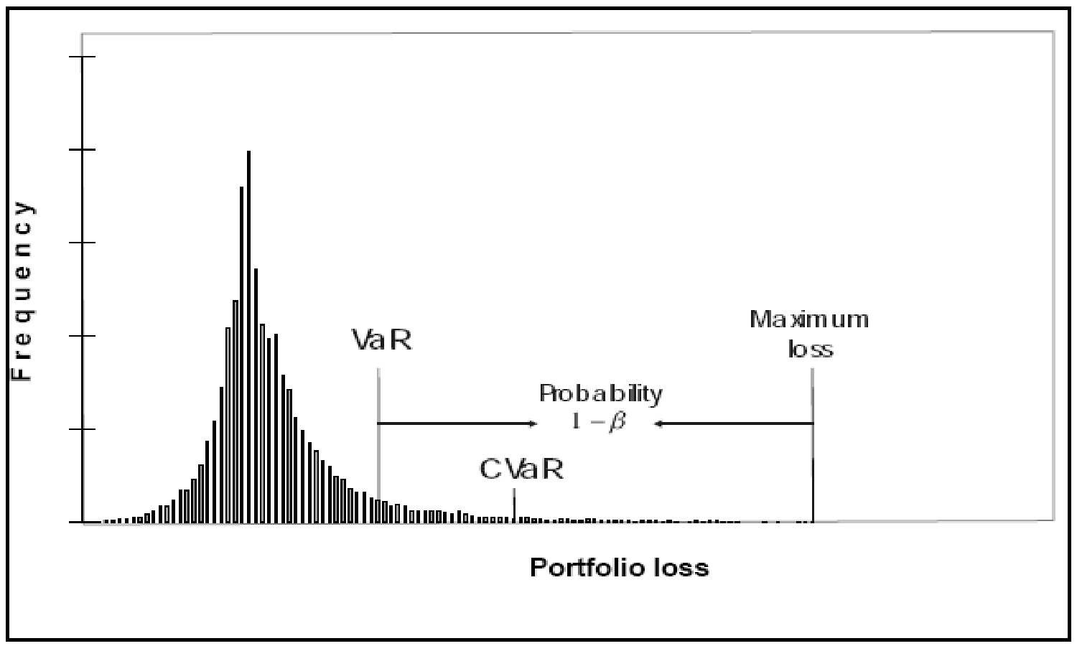

Figure 9. Illustration of VaR and CVaR (Uryasev (2000)).

Apart from the notation presented previously in this text, let *f(x,y)* be the loss function associated with decision vector *x* and random vector *y*. Supposing that *y* has a density, the cumulative function of this loss function is

## ψ(*x*,ζ) = ∫ *p*(*y*)*dy* (50)

*f* (*x*,*y*)≤ξ

Given the confidence level α,

*VaR*α=ξα(*x*) = min{ξ∈ℜ:ψ(*x*,ζ) ≥α} (51)

# CVaRα=φα(x) = (1−α)−1 ∫ f (x, y)p(y)dy (52)

*f* (*x*,*y*)≥ζα(*x*)

Define

*F*α(*x*,ζ) =ζ+ (1−α)−1 ∫[ *f* (*x*, *y*) −ζ]+ *p*(*y*)*dy* (53)

Then *CVaR*αis obtained as

## φα(*x*) = minζ∈ℜ *F*α(*x*,ζ) (54)

If *y* has discrete scenarios with probabilitiesπ*j* instead of a continuous distribution, then

(53) can be approximated as

## *F*~ α(*x*,ζ) =ζ+ (1−α)−1∑*J* π*j*[ *f* (*x*, *y*) −ζ]+ (55)

*j*=1

Then, using auxiliary variables *uj*, CVaR is restricted above by *w* through the constraints

(56) and (57).

ζ+ (1−α)−1∑*J* π*ju j* ≤ *w* (56)

*j*=1

## *u j* ≥ *f* (*x*, *y j* ) −ζ, *u j* ≥ 0, ∀*j* (57)

Suppose that an investor defines his loss function as the difference between the initial portfolio value and the final wealth, which is obtained through discrete scenarios and denoted by *Ws*. Therefore, given the confidence level of α and upper limit *LCVaR*, constraints (58)-(60) impose control CVaR.

# ζ+ (1−α)−1 ∑ psus ≤ LCVaR (58)

*s*∈*NT*

*us* ≥∑*m wi* + *y*−*Ws* −ζ ∀*s* (59)

*i*=1

*us* ≥ 0 ∀*s* (60)

It should be noted that the actually realized CVaR may not be strictly controlled by *LCVaR* since, constraints (58)-(60), as all other constraints in the model, assume that the inputted scenario tree reflects the true future uncertainty (i.e., the true scenario tree). Since the generated scenario tree is an approximation, constraints (58)-(60) provide an approximate risk control.

## 2.4.3.5. Worst Case Scenario

Investors benefit from robustness especially when out-of-sample scenarios come true. It should be noted that not all out-of-sample scenarios are critical in terms of robustness since some of them may be captured to some extent by the in-sample scenarios. Plus, robustness can not remedy all problems caused by an out-of-sample scenario but can decrease the realized *severity* according to the structure of the scenario.

SP models can not include all possible scenarios due to complexity issues but approximate the actual universal set of scenarios in order to achieve optimization under uncertainty. Therefore, depending on the scenario generation process, there might be a tradeoff between the robustness and computational complexity. Given a fixed number of scenarios, an SP model based approach may increase the robustness by including some worst-case scenarios and optimizing the objective function for those unexpected scenarios. The worst case scenario results in the minimum objective value (for a maximization problem); therefore, maximizing the minimum possible outcome may improve the robustness of the decisions.

## 2.4.3.6. Dynamic Risk Control

It is expected that an investor would be interested in the performance of his investment strategy solely at the end of the planning horizon, therefore tolerate losses in the intermediate periods. However, when multi-period models are involved in decision making, measuring and controlling the risk of an investing strategy *merely* at the end of the horizon may lead to unwanted results. If is risk control is achieved only to the end of the horizon and a multi-period model with a scenario tree is utilized, the model would result in decisions that may lead to deviations from the targeted risk exposure in the former periods as long as performance constraints at the end of the horizon are not violated.

The issue can be understood better by considering the investment process in Figure 8. Even though the investor has a multi-period model, he will re-run the model at the beginning of each period and exercise the first stage decisions provided by the model. Therefore, the performance of the resulting trading will be highly dependent on the first stage decisions. If risk is not controlled within the first period, then the first stage variables will assume values such that the objective at the end will be optimized, which may lead to high risk exposure for the first period. Repetition of the investment process eventually creates high risk exposure in the long run even if it is controlled in the last period of the model.

In order to decrease the deviation from the desired risk level, the proposed model constrains CVaR for each node of the scenario tree, other than the leafnodes. In other words, risk is controlled by limiting CVaR at each decision epoch considering the one period ahead risk exposure and, in turn, spreading risk control over the whole scenario tree.

The can be illustrated via a simple case. Suppose that *ωn* is a decision vector that corresponds to node *n* and *ρ* is a risk measure such that *ρ*(*ωn*) is the risk exposure caused by decision vector *ωn*. Let *RLn* be the risk limit to be imposed on the decisions for node *n*. Consider the simple scenario tree in Figure 10 which is used to solve a two-period problem. Then the constraints given by (61) provide a more powerful risk control over the scenario tree than the case where risk control is accomplished merely at the horizon over the leaf nodes represented by smaller circles.

## ρ(*wn* ) ≤ *RLn* ;*n* =1..11 (61)

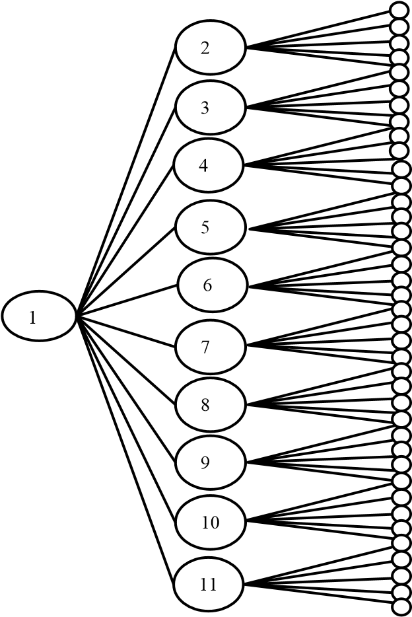

Figure 10. A simple scenario tree with two periods

Recalling *ND* represents the set of all nodes in the scenario tree for the proposed SP model excluding the leafnodes and that *NDn* is the set of nodes that emanate from node *n*, the idea of dynamic risk control can be combined with the linear CVaR constraints as in (62)-(64) to be incorporated into the SP model. Note that we will use index *n* instead of *s* for simplicity.

ζ*n* +(1−α)−1 ∑ *pnjunj* ≤ *LCVaR* ∀*n*∈ *ND* (62)

*j*∈*NDn*

*unj* ≥∑*m ztni* +*ytn* −∑*m ztni*(1+*rt*+1*ji*)−*ytn*(1+*rbt*+1*j*)−ζ*n* ∀*n*∈ *ND*,∀*j* ∈ *NDn* (63)

*i*=1 *i*=1

*unj* ≥ 0 ∀*n*∈ *ND*,∀*j* ∈ *NDn* (64)

In (62)-(64), *t* represents the time period that node *n* implies in the tree and *pnj* is the probability of the scenario represented by node *j*, which emanates from node *n* such that

∑ *pnj* =1 for∀*n*∈ *ND* . *LCVAR* is the same for all nodes; however, different values can

*j*∈*NDn*

be used to obtain different risk limits for different periods and/or different nodes, which might bring in further flexibilities in risk control. We build the loss function for CVaR to be the one-period-ahead loss given by ∑*m ztni* + *ytn* − ∑*m ztni* (1+ *rt*+1*ji* ) − *ytn* (1+*rbt*+1*j* ).

*i*=1 *i*=1

The same setting can be used for other risk measures such as maximizing the wealth for the worst possible scenario after each node. For each node *n*, denote by *MWn* the minimum wealth resulting from the decision vector of node *n*, which can be placed in the objective for maximization and constrained above by the wealth for each scenario emanating from node *n* as in (65).

∑*m ztni*(1+*rt*+1*ji*)+*ytn*(1+*rbt*+1*j* )≥*MWn* ∀*n*∈*ND*,∀*j*∈*NDn* (65)

*i*=1

### 2.4.3.7. Stability over the Horizon

Another performance measure that might be of interested is the fluctuation of the portfolio value over time. Given a fixed horizon, less fluctuating portfolio returns over oscillating portfolio returns if the final wealth levels do not differ significantly might be preferable. It should be noted that this measure obviously has overlapping characteristics with other risk measures such as *variance* or *volatility*. However, direct minimization of these measures implies nonlinearity. The stability can be improved by minimizing the expected deviations between the portfolio returns of consecutive periods within a linear approach as in (66)-(69) where *INS* denotes an average measure for instability.

*Wt* = ∑ ∑*ps*  *m ztsi* +*yts*  *t* =1...*T* (66) *s*∈*NT*  *i*=1 

*Wt* *Devt*− *t* =1...*T* (67)

*INS* 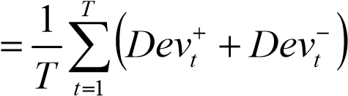 (68)

*W*0 =∑*m wi* + *y* ; *Devt*+,*Devt*− ≥ 0 *t* =1...*T* (69)

*i*=1

### 2.4.3.8. Objective

Like many other portfolio management models, maximizing the expected return of the portfolio at the end of the horizon is the major objective. In order to be able to consider the expected return in the objective function, (70) is included in the constraint set.

*EW* = ∑ *psWs* (70)

*s*∈*NT*

Following the discussions in Sections 2.4.3.5 and 2.4.3.7, a *general* objective function can be written as:

β1*EW* +β2 ∑*MWn* −β3*INS* (71)

*n*∈*ND*

where *β1*, *β2*, and *β3* are the weights preferred by the investor that measure the relative importance of expected final wealth, worst case scenario improvement, and stability, respectively. Therefore, a comprehensive SP model can be given by

**Max**  (70)

**Subject to** (31)-(49) and (62)-(70).

### 3. COMPUTATIONAL RESULTS and SENSITIVITY ANALYSIS

In this chapter we present the results of the implementation of the proposed approach, which includes three scenario generation algorithms (Alg-1A, Alg-1B, and Alg-2) and a Stochastic Programming (SP) model. Section 3.1 presents the computational results obtained via Alg-1A and Alg-1B (i.e., the algorithms based on similarity scores) and Section 3.2 presents the results led by Alg-2 (i.e., the algorithm based on moment matching and heteroskedasticity).

#### 3.1. Algorithm-1A and Algorithm-1B

Even though Algorithm-1A (Alg-1A) and Algorithm-1A (Alg-1B) can be implemented for problems with multiple riskyassets, in this section we assume that the decision maker has two investment options in total, one risky and one risk-free asset. Results are obtained through both single-period and multi-period investing strategies and analyzed in terms of their risk-return profiles.

##### 3.1.1. Setup for Computations

In this section, some details regarding the implementation process such as the input data and selection of some parameters are provided.

###### 3.1.1.1 Data

The risky asset is represented by the index S&P 500, which is a commonly used indicator of the stock market. The time unit for the decisions is assumed to be one week. Different than some SP approaches, the time period remain constant over the different stages in the planning horizon. In other words, stages of the SP model correspond to consecutive oneweek periods.

The historical data for S&P 500 covers 301 index values for each week between 10/15/2001 and 7/16/2007, which is illustrated in Figure 11. Applying (3), we obtain 300 weekly arithmetic return values for the index. The *average weekly return* over this time frame turns out to be 0.1368%.

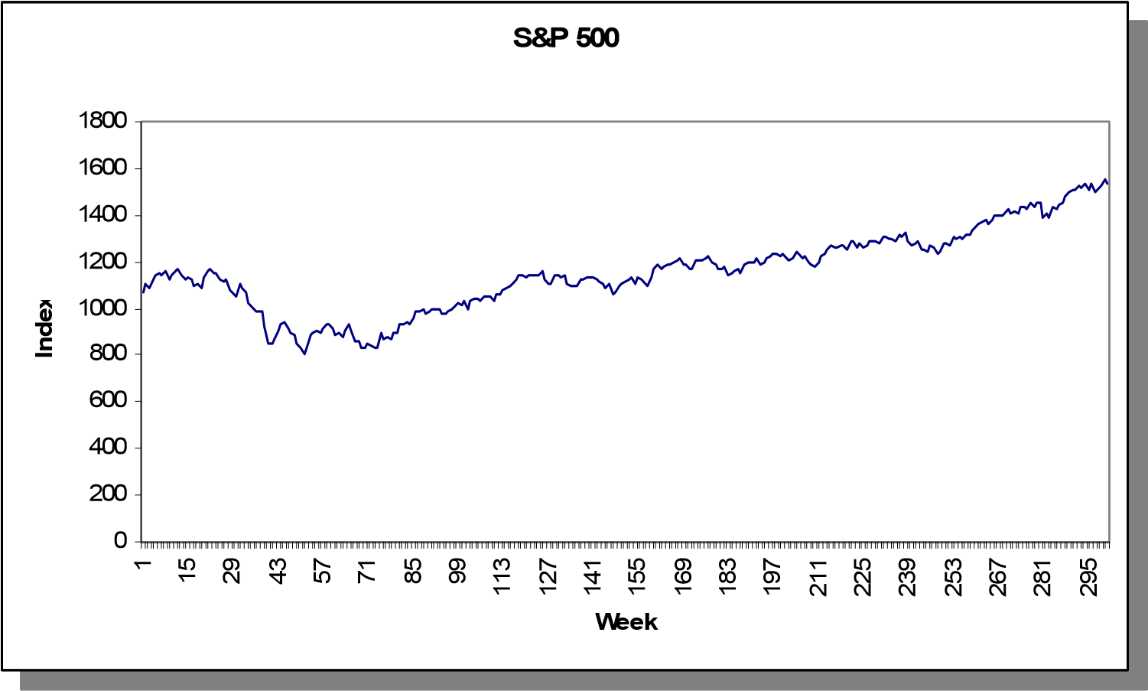

Figure 11. S&P 500 index on a weekly basis.

We assume that the short term interest rate is fixed and represents the risk-free asset. In addition, the length of planning horizon will be short enough (few weeks) to support this assumption. The *weekly* risk-free rate is assumed to be 0.04%.

###### 3.1.1.2. Parameters

Both the scenario generation algorithms and the general SP model presented earlier include many different parameters. However, we implemented a simplified version of the approach presented in Chapter 2. In what follows is the discussion about the important parameters in the model:

*SP MODEL:*

* *LCVAR*: This parameter is used in the SP model in order to control CVaR by imposing an upper limit. Trying different values for *LCVAR* would give reliable information on the behavior of the model with respect to changing risk limits. Considering the loss function embedded in (63) with an initial wealth of $1,000, we used various *LCVAR* values starting from 10 in different experiments.
* *α*: Confidence level for CVaR is 0.90.
* *βk*: For the computations in this report, only the expected final wealth is considered. Therefore, *β1=*1, *β2=*0, *β3=*0.
* *ε*: Unit transaction cost is taken to be $0.001 unless specified as different values.
* *ub, lb*: No limitation is imposed on security weights in the portfolio.
* *δ*: Borrowing is not allowed for the implementation.
* *Lts*: It is assumed that there are no liabilities.
* *cts*: We assume that there are no dividend payments from the risky asset (i.e., S&P 500). Therefore *cts* and *Pts* are not considered for the model presented in this chapter.

*SCENARIO GENERATION:*

* *T*:The planning horizon is 4 weeks in this study.
* θ: The length of return paths is selected to be three weeks, which is specified with four consecutive data points.
* *Scenario Tree Topology*: Different numbers of branches per node are used in this study. For all computations the number of scenarios in the first period is 40. In the remaining periods, this number is 4, 2, and 2, respectively. Therefore we create a total of 40x4x2x2=640 scenarios at the horizon. Having more branches per node at the initial periods is a common practice in a tree structure used for SP models. This is partly because the uncertainty in the first period plays a more crucial role than the following periods. Another reason is that, since the scenarios are built upon the previous scenarios, such a structure guarantees to have high number of scenarios at each period. The resulting scenario tree that is used in the computations is partly illustrated in Figure 12.

###### 3.1.1.3. Implementation

The scenario generation algorithms are implemented in MATLAB version 7.1. The input for MATLAB is the set of index values for 301 consecutive weeks. Then the algorithms are run and the outputs are written on different MS-EXCEL sheets. The outputs are return scenarios together with their corresponding probabilities. In addition, the sets for nonanticipativity constraints and some other sets and parameters are also printed in specific locations in the workbook.

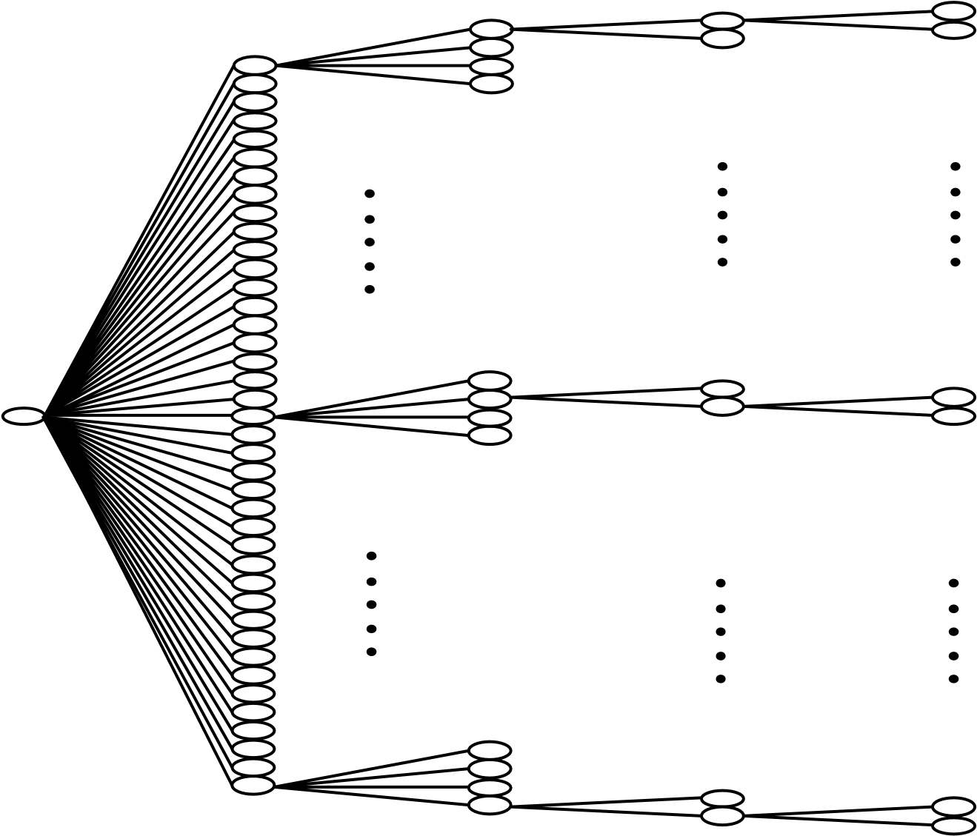

Figure 12. Scenario tree used in the implemented model.

The SP model is implemented in GAMS. After the scenario generation process is complete the GAMS model is run to read the inputs created by MATLAB and the resulting SP model is solved by CPLEX solver. The computational time for scenario generation is relatively higher being around 1 minute, most of which is caused by the communication between MATLAB and MS-EXCEL, whereas a single run of optimization takes around 6 seconds (Figure 13 provides a rough sketch of the overall process for one time period).

Index Data Parameters/Sets



Results

Scenario Generation

Figure 13. Rough sketch of the computation process

##### 3.1.2. Single Period Analysis

The presented portfolio management framework is evaluated through both single-period and multi-period investment points of view. In a single-period investment setting, the investor makes the asset allocation decision at a specific time and realizes the results of his decisions after one period where the only concern is the one-period performance of the portfolio decisions and reinvesting the resulting portfolio is not considered.

NOTE: The focus of the implementation effort for the whole methodological approach presented in Chapter 2 is investment in a *multi-period* sense. Therefore, for the singleperiod analysis, we implement and present the results obtained via *only Alg-1A*.

###### 3.1.2.1. In-Sample Testing & Methodology

In this section we present the results of the model obtained by computing the future values of investment decisions through in-sample return scenarios.

3.1.2.1.1. Obtaining Investment Decisions

The process of obtaining investment decisions (i.e., asset allocation) can be summarized as follow:

*Step 0*: Let *TH* be 200 and the initial wealth be $1,000.

*Step 1*: Take the first *TH* historicalreturns and generate the scenario tree with *T* = 4 starting at *t* = *TH.*

*Step 2*: Solve the SP model for the generated scenarios keeping the resulting investment decisions.

*Step3*: Initialize wealth back to $1,000 cash. If *TH*<299 then set *TH*=*TH*+1 and go to *Step 1*; otherwise, stop.

Considering the historical data set contains 300 weekly returns, this methodology requires the repetition of the process in Figure 13 for 100 times. Since we have two alternative assets, the output of this process is a 100x2 matrix where the *i*th row is the allocation of funds among two assets at the beginning of (*i*+199)th period. It should be noted that these correspond to the first stage variables of the stochastic program (i.e., *z0* and *y0*).

The next step is to compute the value of this portfolio one period after the asset allocation decision is made using the *in-sample* return scenarios. To do this, we randomly select 100 return values from the historical dataset of the first 200 returns and match them with the 100 different allocations obtained at the previous step. Suppose that *z0* and *y0* are the amounts of money invested on the risky and risk-free asset at some time t and *rt+*1 (a randomly selected in-sample scenario for the risky asset) and *rbt+*1(i.e., risk-free rate of 0.04%) are the corresponding rate of returns for the next period. Then the portfolio value after one period is computed as

*Wt*+1 = *z*0 (1+*rt*+1) + *y*0 (1+*rbt*+1) (72)

After these computations, we can add a third column to the asset allocation matrix which will contain the realized portfolio value after one period, which we can hereafter call *decisions-table for* convenience.

3.1.2.1.2. Experimentation with Various Parameters

The presented framework is composed of numerous parameters, which makes it tedious to carry over the computations using several values for all parameters. For the purposes of this section we focused on computations with different values of only *LCVAR* from the SP model. The different LCVAR values would allow the user to obtain a return/risk curve for the whole strategy.

We carried over the computation process mentioned in Section 3.1.2.1.1 for *LCVAR*∈{10,15,20}; therefore we obtained 3 different decisions-tables (See Tables 3-

5 in Appendix B). An immediate observation from these tables is that the average amount allocated to the risky asset as *LCVAR* obtains higher values (See Figure 14). This is an expected result since increasing the risk limit leads to higher risk exposure through higher allocation on the risky asset.

0

50

100

150

200

250

300

350

10

15

20

**LCVA**

**R**

**Avg. Inv. in S&P 500 ($)**

**……**

**…**

0

50

100

150

200

250

300

350

10

15

20

**LCVA**

**R**

**Avg. Inv. in S&P 500 ($)**

**……**

**…**

Figure 14. Average amount allocated to the risky asset (Alg-1A).

3.1.2.1.3. Performance Analysis and Benchmarking

As mentioned at the beginning of this chapter, we will analyze the proposed portfolio management framework in terms of the resulting return vs. risk profile. In order to decrease the potential bias from one outcome, we will aggregate the results over all 100 in-sample scenarios.

We use two measures of observed risk, *variance* and *average shortfall*. Even though the proposed SP model does not constrain variance, it is conjectured that control over shortfall through *LCVAR* will have a minimizing effect on variance.

Suppose that we have a decisions-table part of which is given in Table 6. Then the average return, variance, and average shortfall are computed as in (73)-(75).

*R* = 1 ∑=*n Rt* = 1*n*∑*t*=*n*1 (*Wt* −1,000)/1,000 (73)

*n t* 1

*V* =*Var*(*R*) (74)

*S* = 1*n* ∑*t*=*n*1 max(1,000 −*Wt* ,0) (75)

Table 6. *W* column of a *sample* decisions-table *.*

|  |  |
| --- | --- |
| **t** | **W** |
| 1 | 1023 |
| 2 | 1022 |
| 3 | 989 |
| 4 | 1045 |
| 5 | 1019 |
| 6 | 1003 |
| 7 | 990 |
| 8 | 995 |
| …  n | …  1013 |

The measures specified in (73)-(75) are applied to Tables 3-5 so we obtain three measures (i.e., average return, variance, and average shortfall) for each. In order to decrease the bias, we repeat the same process for three additional in-sample sets each including 100 randomly selected historical return scenarios. The resulting return/risk profiles are provided in Tables 7 and 8.

Table 7. Return-Variance profiles obtained from different samples (Alg-1A)

|  |  |  |  |  |
| --- | --- | --- | --- | --- |
|  | **Sample 1** | **Sample 2** | **Sample 3** | **Sample 4** |
| LCVAR | Avg. Ret. VAR | Avg. Ret. VAR | Avg. Ret. VAR | Avg. Ret. VAR |
| 10 | 1.66 39.89 | 1.13 22.41 | 1.04 23.15 | 1.33 26.13 |
| 15 | 2.05 87.64 | 1.25 49.20 | 1.11 50.77 | 1.51 57.66 |
| 20 | 2.42 153.78 | 1.37 86.33 | 1.17 89.11 | 1.71 101.15 |

Table 8. Return-Shortfall profiles obtained from different samples (Alg-1A)

|  |  |  |  |  |
| --- | --- | --- | --- | --- |
|  | **Sample 1** | **Sample 2** | **Sample 3** | **Sample 4** |
| LCVAR | Avg. Avg. Ret. Short. | Avg. Avg. Ret. Short. | Avg. Avg. Ret. Short. | Avg. Avg. Ret. Short. |
| 10 | 1.66 0.91 | 1.13 0.89 | 1.04 0.96 | 1.33 0.86 |
| 15 | 2.05 1.39 | 1.25 1.39 | 1.11 1.51 | 1.51 1.38 |
| 20 | 2.42 1.88 | 1.37 1.90 | 1.17 2.06 | 1.71 1.88 |

Table 9. Return-Variance profiles obtained from different samples (RS)

|  |  |  |  |  |
| --- | --- | --- | --- | --- |
|  | **Sample 1** | **Sample 2** | **Sample 3** | **Sample 4** |
| SP/Cash | Avg. Ret. VAR | Avg. Ret. VAR | Avg. Ret. VAR | Avg. Ret. VAR |
| 0.2 | 1.04 20.82 | 0.40 12.52 | 0.57 16.10 | 1.01 12.37 |
| 0.4 | 1.68 83.26 | 0.41 50.08 | 0.74 64.40 | 1.62 49.46 |
| 0.6 | 2.32 187.34 | 0.41 112.68 | 0.91 144.89 | 2.24 111.29 |
| 0.8 | 2.96 333.06 | 0.42 200.32 | 1.08 257.58 | 2.85 197.85 |

Table 10. Return-Variance profiles obtained from different samples (RS)

|  |  |  |  |  |
| --- | --- | --- | --- | --- |
|  | **Sample 1** | **Sample 2** | **Sample 3** | **Sample 4** |
| SP/Cash | Avg. Avg. Ret. Short. | Avg. Avg. Ret. Short. | Avg. Avg. Ret. Short. | Avg. Avg. Ret. Short. |
| 0.2 | 1.04 1.23 | 0.40 1.18 | 0.57 1.23 | 1.01 0.90 |
| 0.4 | 1.68 2.58 | 0.41 2.53 | 0.74 2.62 | 1.62 1.95 |
| 0.6 | 2.32 3.94 | 0.41 3.88 | 0.91 4.02 | 2.24 3.00 |
| 0.8 | 2.96 5.30 | 0.42 5.24 | 1.08 5.41 | 2.85 4.05 |

For benchmarking purposes, now we include a third strategy into our performance analysis in order to see any possible gains over the simplest single-period strategy. Since single-period investing is in question, a typical portfolio strategy is nothing but deciding on the ratio of wealth to be invested on the risky asset (risk-free asset). Let us denote with *RS* the strategy of deciding on a ratio and allocating the funds according to the ratio. In order to obtain a risk/return profile for *RS*, we consider different ratios for the risk-free asset in the portfolio; being 0.2, 0.4, 0.6, and 0.8.

Since the investment decisions are already known for this strategy, it only remains to create a decisions-table to compute the *W* column using the same in-sample return scenarios for all 100 time periods across four different scenario sets. The return/risk profiles obtained by this strategy are given in Tables 9 and 10. As an expected result, we observe that increasing the amount allocated to the risky asset leads to higher risk exposure through higher variances and average shortfalls.

In order to compare Alg-1A with the RS strategy, we plot for each sample the average return versus variance and the average return versus average shortfall. Therefore, we obtain 8 graphs where the approaches are compared with each other. Figures 15 and 16 provide the plots obtained from Sample 1. Alg-1A clearly dominates RS since it provides higher returns for the same level of risk exposure regardless the type of the risk is measure. The results obtained from Samples 2-4 are given in Figures 17-22 in Appendix B. The dominance of Alg-1A is strongly supported by the results obtained from all of these samples (i.e., Samples 2, 3, and 4) when average shortfall is considered as the risk measure. Alg-1A is dominated by RS only in Sample 4 when variance is considered to be the risk measure.

###### 3.1.2.2. Out-of-Sample Testing

Out-of-sample scenarios are the actually observed rate of returns for S&P 500 for the periods 201 through 300. In other words the results in this section reflect the true singleperiod performance of the proposed portfolio management if it had been applied in periods 201 through 300.

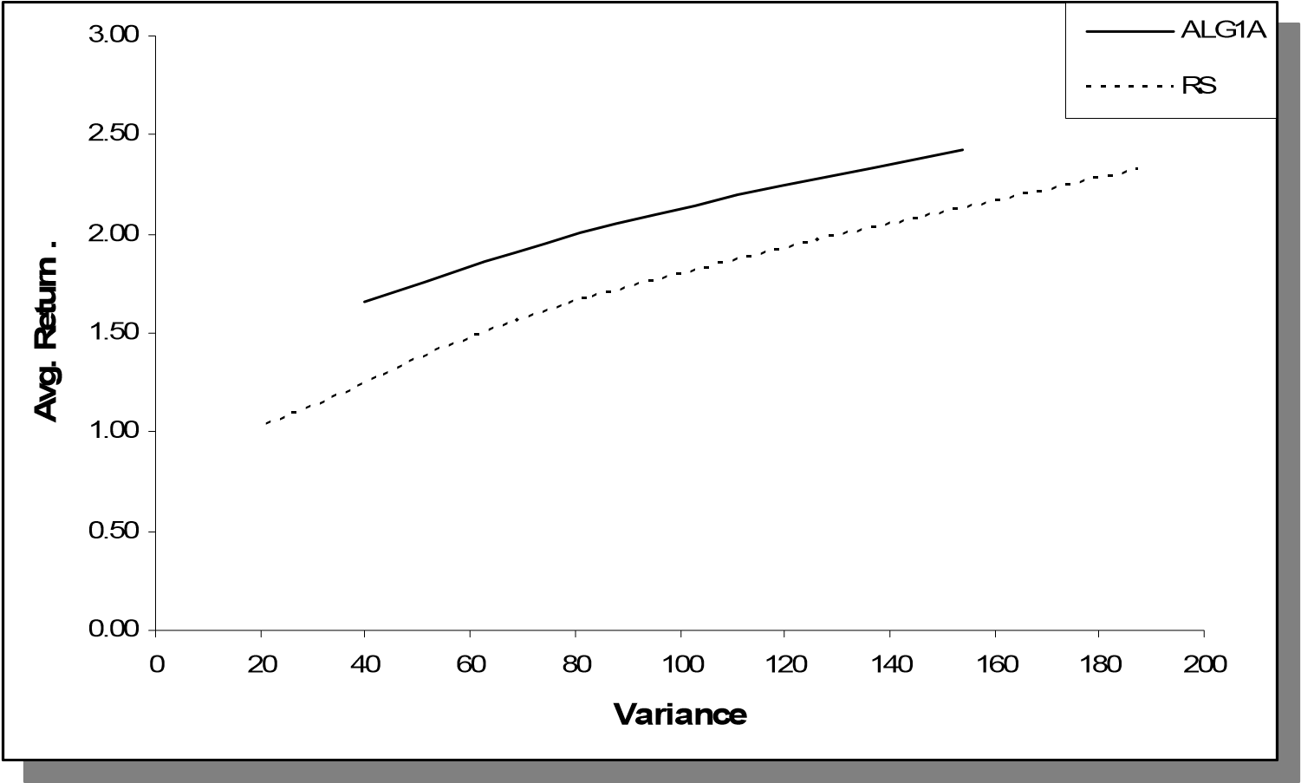

Figure 15. Comparison of Alg-1A and RS over Sample-1 (Variance)

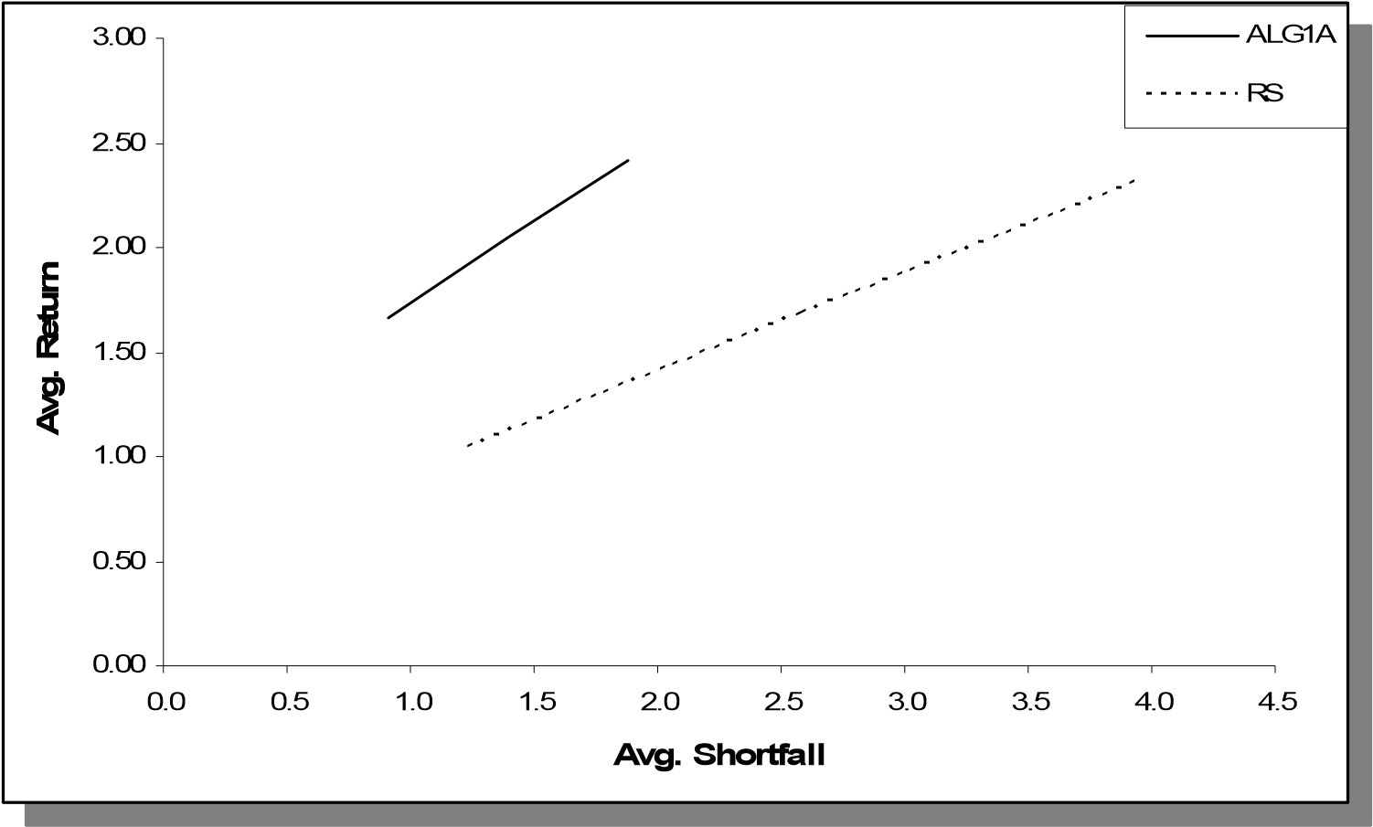

Figure 16. Comparison of Alg-1A and RS over Sample-1 (Avg. Shortfall)

In order to provide a compact presentation, we will not explain about the methodology used to obtain the aggregate results since it is the same as explained in Sections

3.1.2.1.1.-3.1.2.1.3. The only difference here is the set of return scenarios used to obtain the statistics about the model performance. Instead of four different in-sample scenario sets, now we have only one set of return scenarios which consists of *actual* returns of S&P 500 in periods 201 through 300.

Considering one out of sample scenario set and different investment decisions for

*LCVAR*∈{10,15,20}we again obtain three different decisions-tables (see Tables 11-13 in

Appendix B).

As in in-sample testing, we obtained average returns and corresponding variances using the *Wt*valuesin Tables 11-13. The same process is also repeated for the RS strategy with the amounts invested in risky asset being $200, $400, $600, and $800. The results are given in Tables 14 and 15 and plotted in Figures 23 and 24.

Table 14. Return/risk profiles of Alg-1A (Single Period, Out-of-Sample)

|  |  |  |  |  |
| --- | --- | --- | --- | --- |
| LCVAR | Avg. Ret. |  | VAR | Avg. Shortfall |
| 10 | 0.63 |  | 10.76 | 0.57 |
| 15 | 0.75 |  | 23.59 | 0.91 |
| 20 | 0.86 |  | 41.41 | 1.25 |

Table 15. Return/risk profiles of RS (Single Period, Out-of-Sample)

|  |  |  |  |
| --- | --- | --- | --- |
| SP/Cash | Avg. Ret. | VAR | Avg. Shortfall |
| 0.2 | 0.60 | 8.01 | 0.86 |
| 0.4 | 0.80 | 32.05 | 1.89 |
| 0.6 | 1.00 | 72.11 | 2.93 |
| 0.8 | 1.19 | 128.19 | 3.97 |

We observe that Alg-1A still enables the investor to experience more efficient portfolios in terms of a mean/variance perspective; however, the level of domination is not significant. From our experiments using both in-sample and out-of-sample scenarios and weekly S&P index data covering periods 10/15/2001 and 7/16/2007, it can be concluded that Alg-1A produces a trading strategy that provides *slightly* more efficient portfolios (i.e., higher average return (lower variance) given a fixed level of variance (average return)) when compared with the RS strategy given a single-period investment approach.

Considering the average shortfall as the risk measure, Figure 24 reveals that Alg-1A dominates the *RS* strategy with a more significant difference when compared to the variance-based benchmarking. Variance is a commonly used measure for risk; however, it penalizes the negative deviations as well as positive deviations. For this reason, we use another measure to control risk, CVAR, which controls only negative deviations. The reason for poor performance of Alg-1A in a mean/variance setting (Figure 23) is that no constraint is imposed in the SP model to control variance. Instead, CVAR is constrained, which leads lower shortfalls on the average and superior performance in terms of Average Return/Average Shortfall trade-off. Therefore, from our experiments using both in-sample and out-of-sample scenarios and weekly S&P index data covering periods 10/15/2001 and 7/16/2007, it can be concluded that Alg-1A produces a trading strategy that provides more efficient portfolios (i.e., higher average return (lower average shortfall) given a fixed level of average shortfall (average return)) when compared with the RS strategy.

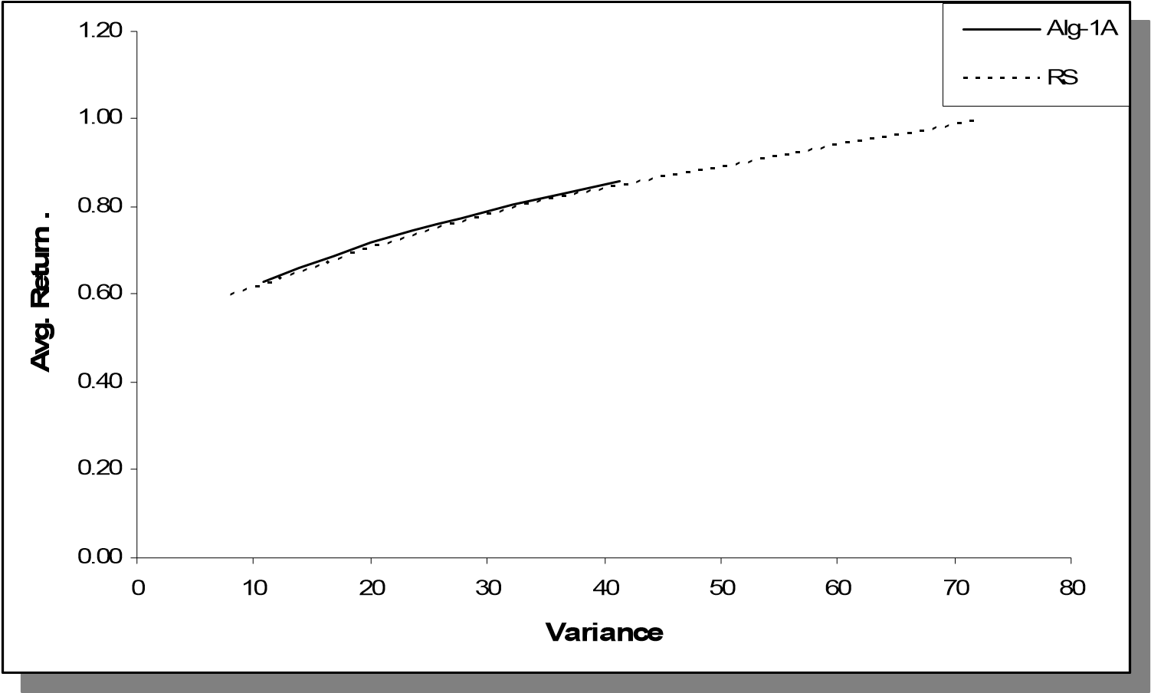

Figure 23. Comparison of Alg-1A and RS (Out-of-Sample, Variance)

0.00

0.20

0.40

0.60

0.80

1.00

1.20

1.0

0.5

0.0

3.5

3.0

2.5

2.0

1.5

**Avg. Shortfall**

**Avg. Return**

**…**

A

Alg-1

RS

0.00

0.20

0.40

0.60

0.80

1.00

1.20

0.0

0.5

1.0

1.5

2.0

2.5

3.5

3.0

**Avg. Shortfall**

**Avg. Return**

**…**

Alg-1A

RS

Figure 24. Comparison of Alg-1A and RS (Out-of-Sample, Avg. Shortfall)

##### 3.1.3. Multi-Period Analysis

In this section the proposed similarity-scores-based approach is implemented through a multi-period investment perspective. Different than the single period setting, the investment decisions made at consecutive periods are not totally independent from each other. The decision made in period *t* may have effects on decisions in periods *τ*>*t.* The resulting portfolio after the decisions made in period *t* becomes the initial portfolio for period *t+1* after the actual returns are realized. In other words, the total wealth of the investor is assumed to be repetitively reinvested upon realizing the returns at consecutive periods.

In this section, in addition to Alg-1A we present the results also for Alg-1B, the algorithm based on the UD distance measure.

###### 3.1.3.1 Implementation

The methodology applied for multi-period analysis is mostly the same with that of single period analysis. The major difference in implementation is that once the returns are realized at a specific period, the resulting portfolio is reinvested by running the whole approach (scenario generation and solving the SP model) for the next period such that the initial portfolio is set to the portfolio obtained from the previous period after the actual returns are realized and applied to the portfolio.

In order to convert the computation process into a multi-period setting, a few modifications are made. Figure 25 illustrates this modification in the computation process.

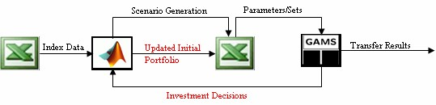

Figure 25. The sketch of the modified computation process

The process of obtaining investment decisions can be formally summarized as follows (Note that the methodology is the same as the single-period case except *Step 3*):

*Step 0*: Let *TH* be 200 and the initial wealth is $1,000.

*Step 1*: Take the first *TH* historicalreturns and generate the scenario tree of length

*T =* 4 starting at *t*=*TH.*

*Step 2*: Solve the SP model for the generated scenarios keeping the investment decision.

*Step3*: Update the portfolio using the investment decisions and applying the actual returns for *t*=*TH*+1. If *TH* < 299then go to *Step 1*; otherwise stop.

The performance measures are obtained via (76)-(78) where *W0*=1,000.

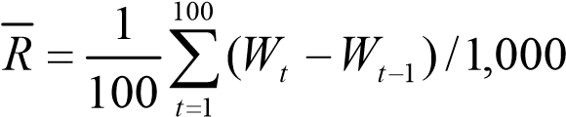 (76)

*V* =*Var*( )*R* (77)

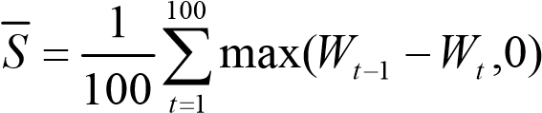 (78)

###### 3.1.3.2. Performance Analysis

In multi-period analysis, we expand the interval for risk exposure by setting *LCVAR* ∈

{5,15,25,35} instead of *LCVAR*∈{10,15,20}as in single-period analysis. (See Tables 16 and 17 in Appendix B for the decisions obtained from both algorithms corresponding *LCVAR* = 35). The return/risk profiles of the both algorithms are given in Table 18, where variance is taken as the risk measure and in Table 19, where average shortfall is the risk measure. As seen from these tables, the increase in *LCVAR* leads to increase in all three performance measures.

###### 3.1.3.3. Benchmarking

We consider the benchmarking process within two different approaches. In the first one, we compare the proposed approach (i.e., Alg-1A or Alg-1B and the SP model) with another portfolio management technique. In the other approach, we compare the performance of the proposed scenario generation algorithms with two other scenario generation algorithms.

Table 18. Avg. Return/Variance profiles of Alg-1A and Alg-1B (Multi-Period)

|  |  |  |  |  |
| --- | --- | --- | --- | --- |
|  | Alg-1A |  | Alg-1B |  |
| LCVAR | Avg. Ret. | VAR | Avg. Ret. | VAR |
| 5 | 0.77 | 5.24 | 0.93 | 44.15 |
| 15 | 1.63 | 48.60 | 1.51 | 60.11 |
| 25 | 2.31 | 129.73 | 1.92 | 84.62 |
| 35 | 2.43 | 172.00 | 2.20 | 111.91 |

Table 19. Avg. Return/Avg. Shortfall profiles of Alg-1A and Alg-1B (Multi-Period)

|  |  |  |
| --- | --- | --- |
|  | Alg-1A | Alg-1B |
| LCVAR | Avg. Ret. Avg. Shortfall | Avg. Ret. Avg. Shortfall |
| 5 | 0.77 0.46 | 0.93 0.97 |
| 15 | 1.63 1.62 | 1.51 1.48 |
| 25 | 2.31 2.79 | 1.92 1.99 |
| 35 | 2.43 3.30 | 2.20 2.42 |

3.1.3.3.1 Benchmarking with the Buy & Hold Strategy

In this section, we compare the proposed approach with the *Buy and Hold* (B&H). B&H is a commonly used investing strategy and can be regarded as a good approximation to the well known *fixed-mix* rule in our case because the time unit is one week, which leads to lower returns, and in turn, lower deviations from a fixed-mix of asset allocation. Note that the deviations may increase as the time span of the test period gets larger as in our case (i.e., 100 weeks).

In order to obtain the average return/variance profile of the B&H strategy, decisionstables are created by starting a certain amount of cash allocated in risky asset and the rest being invested in the risk-free asset. As the rule of the strategy, no trade takes place in the following periods. An obvious advantage of this strategy is that no transaction costs are incurred in the periods except the initial one.

Similar to the single period case, we initialize the allocation on the risky asset as $200, $400, $600, and $800. The resulting performance measures are shown in Table 20.

Table 20. Return/Risk profile of B&H Strategy (Multi-Period)

|  |  |  |  |
| --- | --- | --- | --- |
| SP/Cash | Avg. Ret. | VAR | Avg. Shortfall |
| 0.2 | 0.78 | 8.35 | 0.80 |
| 0.4 | 1.15 | 33.39 | 1.75 |
| 0.6 | 1.53 | 75.13 | 2.71 |
| 0.8 | 1.91 | 133.57 | 3.67 |

The performance measures tabulated in Tables 18-20 are plotted in Figures 26 and 27. Figure 26 compares the alternative strategies by considering variance as the risk measure, where we observe that the proposed strategy, when Alg-1A is used during the scenario generation phase, provides more efficient portfolios in terms of a mean/variance perspective. Moreover, the level of domination is significant over the whole interval of risk exposure. Alg-1B also provides more efficient portfolios when compared to B&H strategy, especially in the high risk region. Alg-1B performs relatively worse in the low risk region; however, *it should be noted that the proposed approach controls the shortfall as the risk measure instead of variance*. A more compact comparison in terms of Avg. Return/Variance relation is given in Figure 28, which provides plots of the Sharpe Ratios obtained from alternative strategies as computed in (79), where *rf* is the risk free rate.

= *R* − *rf* (79)

*SharpeRatio*

*V*

Figure 27 provides the comparison where we consider the average shortfall as the risk measure, *which is the actual measure targeted within the proposed approach*. We observe in Figure 27 that the proposed approach dominates the B&H strategy regardless of the algorithms used in the scenario generation phase. In other words, the repetitive usage of the proposed approach with continuous reinvesting yields higher returns (lower average shortfall) than the B&H strategy given a fixed level of average shortfall (average return).

Therefore, from our experiments using weekly S&P index data covering periods 10/15/2001 and 7/16/2007, it can be concluded that the *proposed approach* produces a trading strategy that provides more efficient portfolios (i.e., higher average return (lower risk) given a fixed level of risk (average return)) when compared with the B&H strategy within a multi-period investment approach. Both algorithms lead to superior results when average shortfall is assumed to be the risk measure whereas a slight underperformance is observed only in the low risk measure for Alg-1B when variance is considered to be the risk measure.

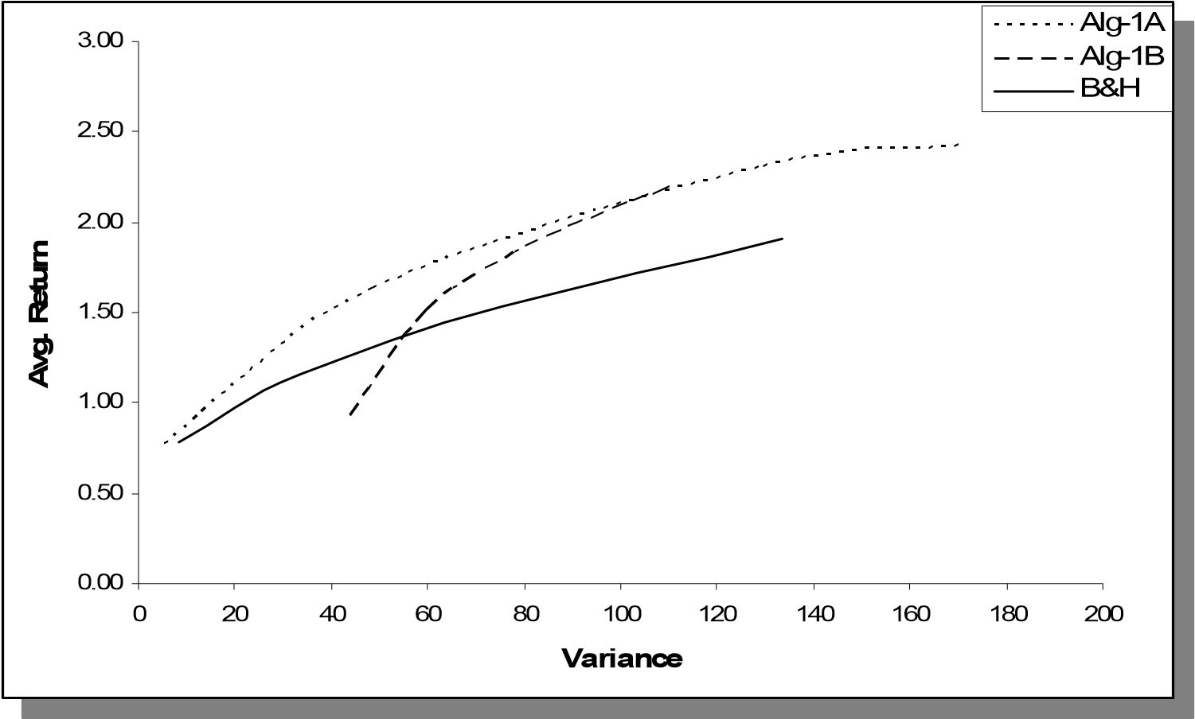

Figure 26. Comparison of Alg-1A, Alg-1B and B&H (Multi-Period, Variance)

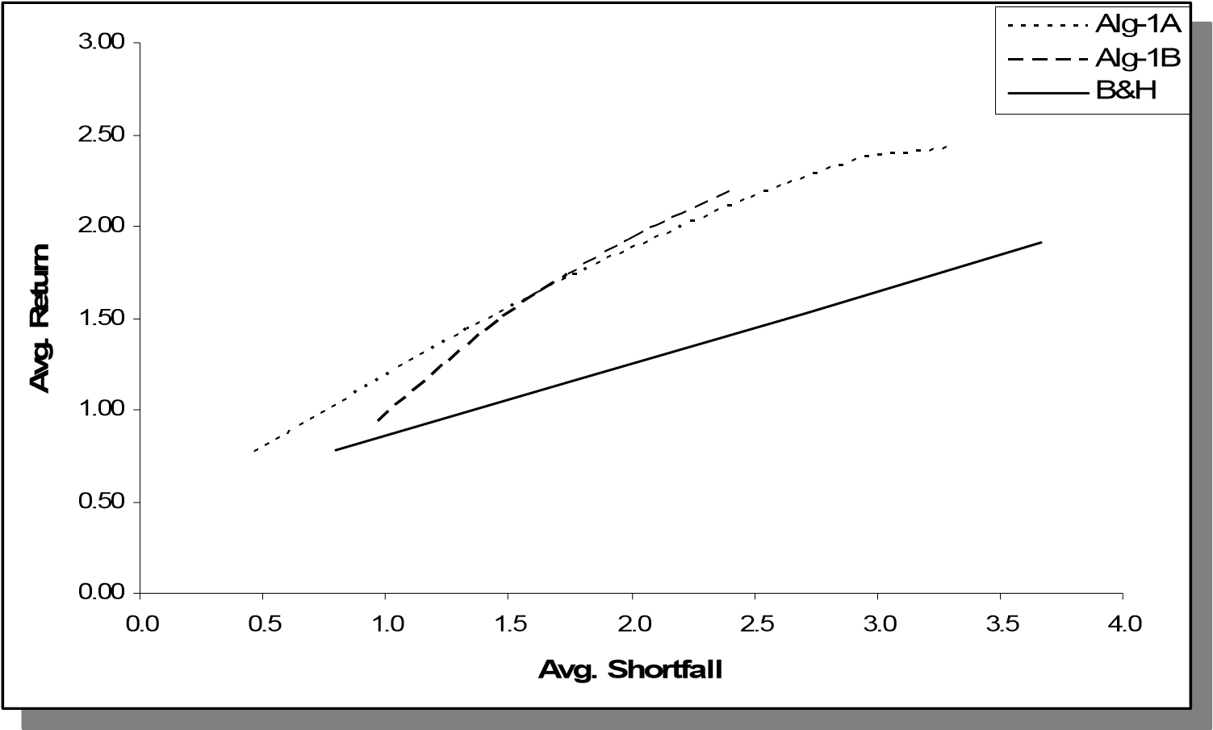

Figure 27. Comparison of Alg-1A, Alg-1B and B&H (Multi-Period, Avg. Shortfall)

0

0.02

0.04

0.06

0.08

0.1

0.12

0.14

0.16

0.18

0.2

Alg-1B

B&H

Alg-1A

**Sharpe Ratio**

0

0.02

0.04

0.06

0.08

0.1

0.12

0.14

0.16

0.18

0.2

B&H

Alg-1A

Alg-1B

**Sharpe Ratio**

Figure 28. Sharpe Ratios obtained via Alg-1A, Alg-1B and B&H.

3.1.3.3.2 Benchmarking with other Scenario Generation Methods

In this section, our focus is on comparing the performance of the proposed scenario generation algorithms with other scenario generation algorithms. The objective is to assess the performance led merely by the scenario generation algorithms by considering the SP model as separate piece. In other words we try to differentiate between the benefits contributed by the algorithms and those coming from the usage of the SP model.

In order to achieve this objective, we run additional experiments where we replace Alg1A and Alg-1B with alternative scenario generation algorithms but utilize the same proposed SP model used in previous computations. The two tools we will consider are:

* Geometric Brownian Motion (GBM)
* Auto-Regressive Model (AR)

In order to generate scenarios using GBM, we assume that the price of the risky asset, say *xt*, follows the process given by the stochastic differential equation in (80)

# dxt =µxt dt +σxt dWt (80)

whereµis the drift,σis the volatility of the stochastic process and *Wt* is the Wiener process. The solution for equation (80) is

*xt* = *x*0 expµ−σ2 *t* +σ*Wt*  (81)

 2  

Therefore,

 *xt* =µ−σ22 *t* +σ*Wt* (82)

ln *x*0  

which implies that ln(*xt* / *x*0 ) ~ *N*((µ−σ2 / 2)*t*,σ2*t*) . The Wiener process has independent increments; therefore, for the consecutive price values we have ln(*xt* / *xt*−1) ~ *N*((µ−σ2 / 2),σ2 ). Considering the dataset containing the logarithms of consecutive price ratios, we can estimate drift and volatility parameters corresponding to the GBM given in (80).

Once we estimated the drift and volatility parameters, we consider a scenario tree having the same topology used by Alg-1A and Alg-1B. Then, for each node except the leaf nodes (i.e., CSN), we draw randomly from *N*((µ−σ2 / 2),σ2 ) to obtain a discrete set of price values with the cardinality being equal to the number of nodes emanating from the CSN. Due to the randomness in sampling, the resulting scenario probabilities are all equal to each other for a given CSN and they add up to 1 for each CSN.

The parameters for GBM are estimated repetitively at the beginning of each period and the SP model is run at each period after the scenario tree is constructed. The initial portfolios are continuously updated to obtain the multi-period results for the SP approach fed by GBM.

In addition to GBM, we considered an AR model of degree two for benchmarking purposes. Let *rt* denote the return of the risky asset (e.g., index value) for period *t*. Then we estimate the AR(2) process in (83).

*rt* =β0 +β1*rt*−1 +β2*rt*−2 +ε (83)

Similar to the methodology we used in GBM; once the estimation is accomplished we consider a scenario tree having the same topology used by Alg-1A and Alg-1B. We compute the residuals for all possible historical periods using the estimated equation and obtain a set of residuals to sample from.

Then, for each node except the leaf nodes (i.e., CSN), we draw randomly from the historical residuals and add them to the AR(2) equation implied for that period to obtain a discrete set of return scenarios with the cardinality being equal to the number of nodes emanating from the CSN. Due to the randomness in sampling, the resulting scenario probabilities are all equal to each other for a given CSN and they add up to 1 for each CSN.

Considering the 100 consecutive test periods, we estimate the parameters of GBM and AR(2) at the beginning of each period so that we always use the most up-to-date models in the scenario generation process. We next provide the estimations only for the first test period (i.e., *t* = 200) since it would not be reasonable to provide the estimations for all periods.

Regarding the GBM at *t* = 200, µis estimated to be 0.000903 whereas σis 0.020865 considering the weekly S&P 500 data. Therefore for this time period, we use *xt*+1 =*xt* exp(0.000686+ 0.020865*W*1) for the generation of price scenarios (and then

return scenarios) where *W1* is drawn from *N*(0,1).

For the same period, the AR(2) equation estimated through ordinary least squares (OLS) method is given in (84).

## *rt* = 0.000798+ 0.092857*rt*−1 + 0.022419*rt*−2 +ε (84)

Using the AR(2) and GBM in the scenario generation phase in place of Alg-1A and Alg1B, we obtain the performance measures given in Tables 21 and 22 (See Tables 23 and 24 in Appendix B for a sample decisions-table obtained via each of these alternative methods).

Table 21. Return/Risk profile obtained via AR(2) (Multi-Period)

|  |  |  |  |  |
| --- | --- | --- | --- | --- |
| LCVAR | Avg. Ret. |  | VAR | Avg. Shortfall |
| 10 | 0.75 |  | 6.81 | 0.56 |
| 20 | 1.11 |  | 27.46 | 1.25 |
| 30 | 1.44 |  | 61.04 | 1.96 |
| 40 | 1.66 |  | 85.29 | 2.35 |
| 60 | 1.71 |  | 97.39 | 2.55 |

Table 22. Return/Risk profile obtained via GBM (Multi-Period)

|  |  |  |  |
| --- | --- | --- | --- |
| LCVAR | Avg. Ret. | VAR | Avg. Shortfall |
| 10 | 0.74 | 13.42 | 0.89 |
| 20 | 1.07 | 54.98 | 1.95 |
| 30 | 1.43 | 115.30 | 2.87 |
| 40 | 1.50 | 160.74 | 3.47 |
| 60 | 1.56 | 169.21 | 3.57 |

Figures 29 and 30 provide the comparison between the proposed algorithms and AR(2). The results are quite similar to ones obtained from the benchmarking process against the B&H strategy. We observe that the proposed strategy, when Alg-1A is used during the scenario generation phase, provides more efficient portfolios in terms of a mean/variance perspective than the strategy where we use AR(2) during the scenario generation phase instead of Alg-1A. Alg-1B also provides more efficient portfolios when compared to AR(2) strategy, especially in the high risk region. Alg-1B performs relatively worse in the low risk region. Figure 33 provides the corresponding Sharpe Ratios where we observe that AR(2) is mostly outperformed by the proposed algorithms.

We observe in Figure 30 that the strategy of using *any* of the proposed algorithms during the scenario generation phase dominate the strategy led by using AR(2) for scenario generation when we consider the average shortfall as the risk measure, *which is the actual measure targeted within the proposed approach*.

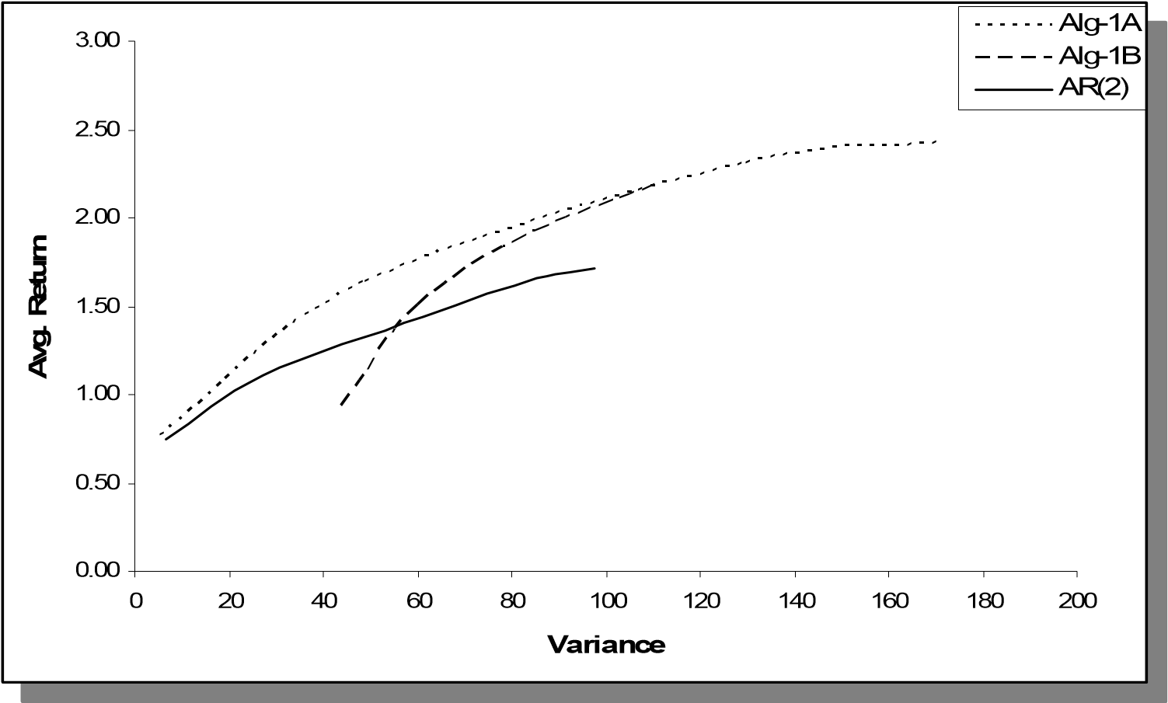

Figure 29. Comparison of Alg-1A, Alg-1B and AR(2) (Multi-Period, Variance)

Figures 31 and 32 provide the comparison between the proposed algorithms and GBM. We observe that the proposed strategy, *regardless of either Alg-1A or Alg-1B* *is used during the scenario generation phase*, provides more efficient portfolios in terms of a mean/variance perspective than the strategy where we use GBM during the scenario generation phase instead of the proposed algorithms. The Sharpe Ratios given in Figure 33 are clearly in favor of the proposed algorithms.

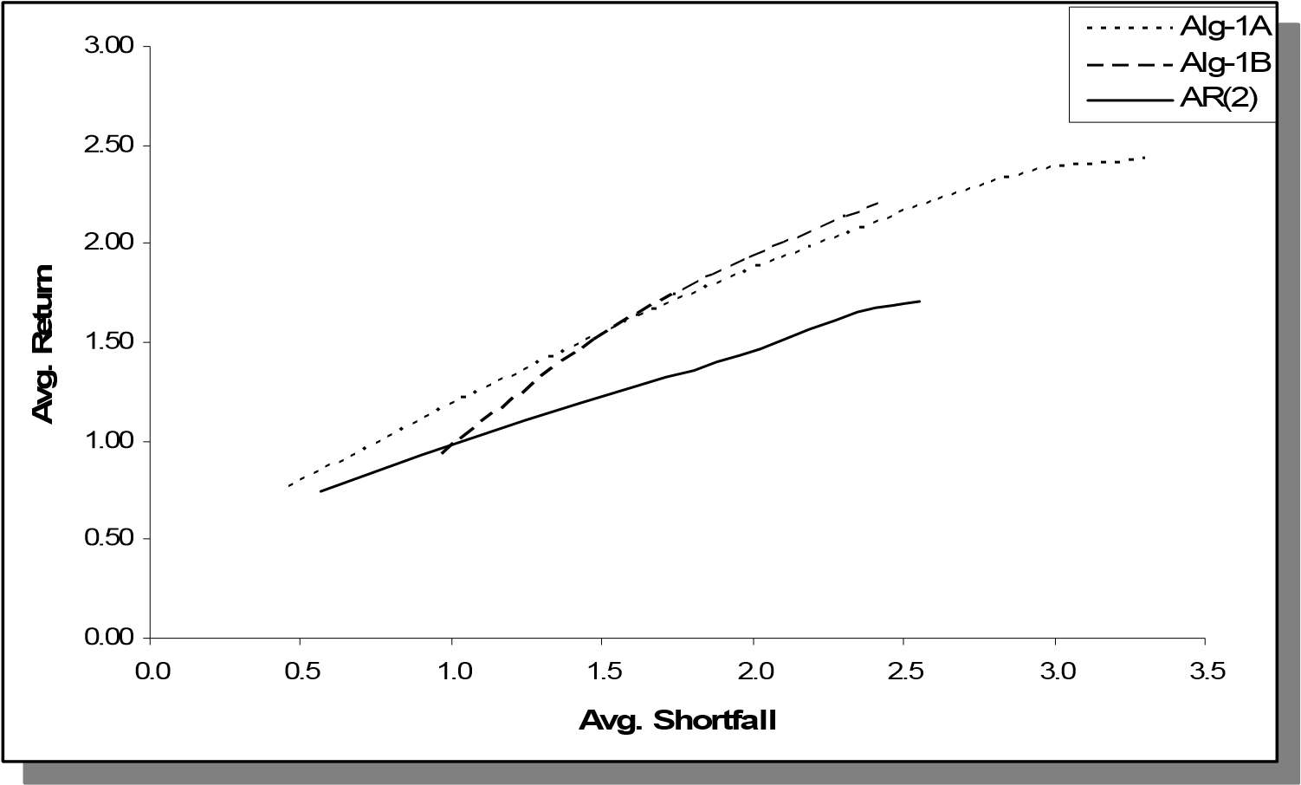

Figure 30. Comparison of Alg-1A, Alg-1B and AR(2) (Multi-Period, Avg. Shortfall)

We come to the same conclusion when we consider the average shortfall as the risk measure. Figure 32 illustrates the results showing that the strategy of using *any* of the proposed algorithms during the scenario generation phase dominate the strategy led by using GBM for scenario generation.

The distinction between the performances can be attributed merely to the proposed scenario generation algorithms since *the same* SP model is used to generate trading strategies for Alg-1A, Alg-1B,AR(2), and GBM. Therefore, from our experiments using weekly S&P index data covering periods 10/15/2001 and 7/16/2007, it can be concluded that within a multi-period investment scheme, the *proposed scenario generation algorithms* produce trading strategies that provide more efficient portfolios (i.e., higher average return (lower risk) given a fixed level of risk (average return)) when compared with the strategies led by using GBM or AR(2) during the scenario generation phase.

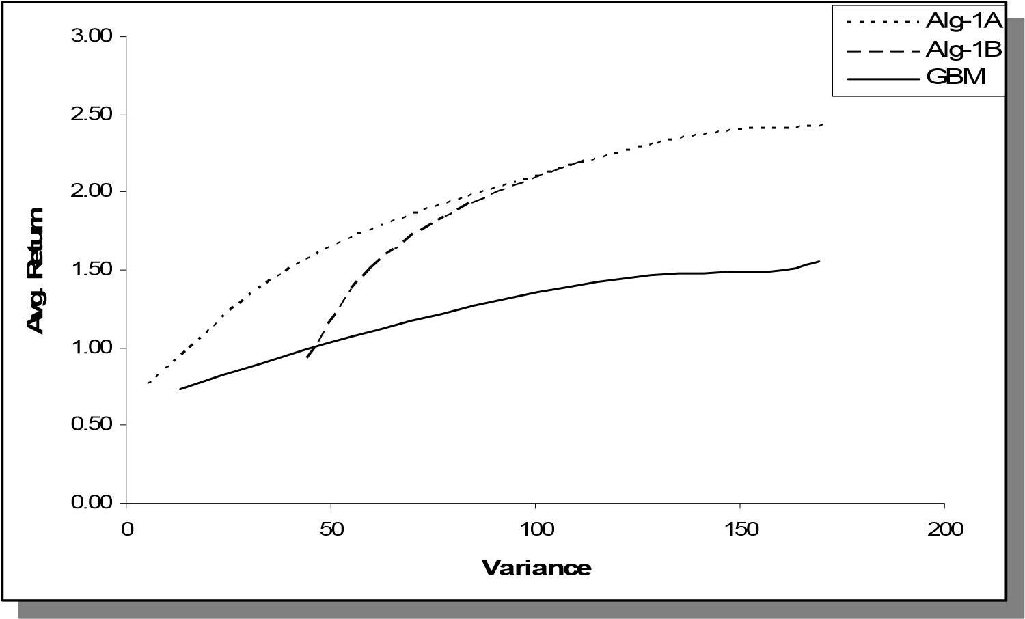

Figure 31. Comparison of Alg-1A, Alg-1B and GBM (Multi-Period, Variance)

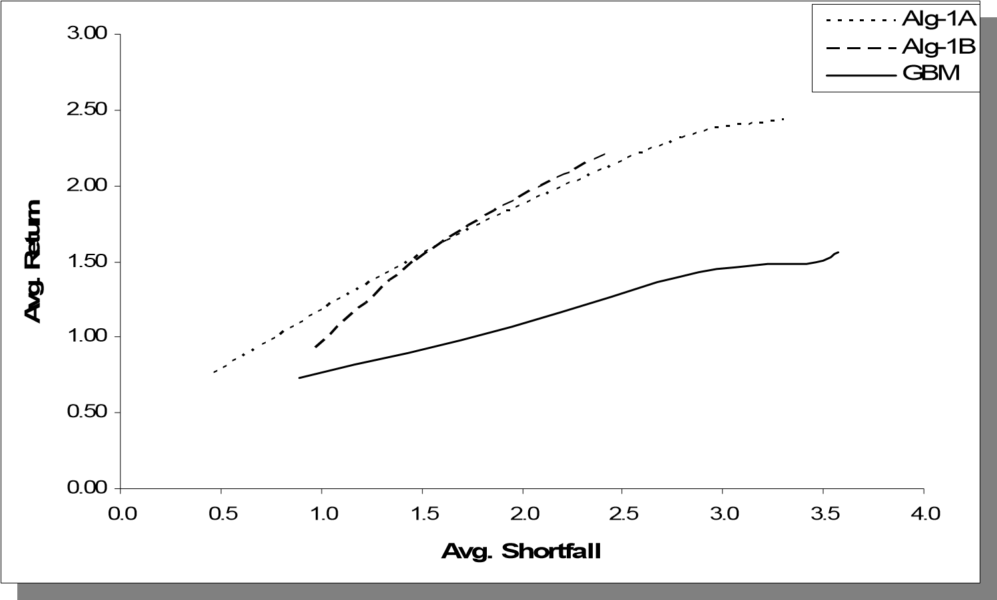

Figure 32. Comparison of Alg-1A, Alg-1B and GBM (Multi-Period, Avg. Shortfall)

0

0.02

0.04

0.06

0.08

0.1

0.12

0.14

0.16

0.18

0.2

Alg-1B

AR(2)

GBM

Alg-1A

Sharpe Ratio

0

0.02

0.04

0.06

0.08

0.1

0.12

0.14

0.16

0.18

0.2

AR(2)

GBM

Alg-1A

Alg-1B

Sharpe Ratio

Figure 33. Sharpe Ratios obtained via Alg-1A, Alg-1B, AR(2) and GBM.

### 3.1.4. Sensitivity Analysis

In this section, we present the outcomes obtained by implementing the proposed approach with different parameters and input data. Our objective is to observe how the proposed strategy responds to slight changes in the model and evaluate its performance over the alternative approaches within different settings.

#### 3.1.4.1. Sensitivity to Weights used in Euclidean Distance

Recall from the definition of Alg-1A that the parameters *wti* are the weights assigned to the Euclidean similarity for period *t* within the selected path of asset *i*. For the computations presented so far, the same weights were used for all assets. In addition, the latter periods were assumed to have more weight. Therefore, we used the same **w** = [0.1

0.1 0.2 0.2] vector for all computations.

In order to see the effect of using different weights and justify our assumption to have higher weights for more recent periods, we re-implemented Alg-1A with three other different **w** vectors. The first two assign higher weights to initial periods, whereas the last one sets weights to the recent periods that are even higher than initial experiments:

* **w1** = [0.6 0.4 0.2 0.1]
* **w2** = [0.2 0.2 0.1 0.1]
* **w3** = [0.1 0.2 0.4 0.6]

The performance measures obtained using **w1**, **w2**, and **w3** instead of **w** are given in Tables 25-27 (due to space concerns, we provide only the decisions-table for **w2**, Table 28 in Appendix B, obtained by setting *LCVAR*=35). The corresponding return/risk profiles are given in Figures 34 and 35 to provide a comparison with the base case, **w**.

Table 25. Return/Risk profile obtained via **w1**.

|  |  |  |  |
| --- | --- | --- | --- |
| LCVAR | Avg. Ret. | VAR | Avg. Shortfall |
| 5 | 0.66 | 7.47 | 0.70 |
| 15 | 1.17 | 71.99 | 2.48 |
| 25 | 1.74 | 170.97 | 3.84 |
| 35 | 1.92 | 188.39 | 4.08 |

Table 26. Return/Risk profile obtained via **w2**.

|  |  |  |  |  |
| --- | --- | --- | --- | --- |
| LCVAR | Avg. Ret. |  | VAR | Avg. Shortfall |
| 5 | 0.72 |  | 6.28 | 0.59 |
| 15 | 1.36 |  | 61.41 | 2.12 |
| 25 | 1.87 |  | 152.77 | 3.45 |
| 35 | 2.00 |  | 178.02 | 3.80 |

Table 27. Return/Risk profile obtained via **w3**.

|  |  |  |  |
| --- | --- | --- | --- |
| LCVAR | Avg. Ret. | VAR | Avg. Shortfall |
| 5 | 0.87 | 5.07 | 0.42 |
| 15 | 1.81 | 49.21 | 1.58 |
| 25 | 2.78 | 121.73 | 2.51 |
| 35 | 3.00 | 160.50 | 2.97 |

Given the weekly S&P index data covering periods 10/15/2001 and 7/16/2007, the first observation from Figures 34 and 35 is that the performance of the proposed approach, when Alg-1A is used for scenario generation, is significantly sensitive to the weights used for computing the Euclidean distances. This is an expected result since the changes in weights have a direct impact on the similarity scores and in turn the scenario probabilities, which will eventually change the investment decisions implied by the SP model.

The second observation is that the change in the performance supports our initial approach of assigning higher weights to more recent periods. In fact, there is a consistent improvement in the performance as more weight is shifted towards the latter periods.

This can be observed clearly from the Sharpe Ratios depicted in Figure 36.

The two observations above remain valid regardless of the risk measure we consider, variance or average shortfall. A critical side note is that the performance of the proposed approach reported in Section 3.1.3 for Alg-1A could be significantly higher by setting **w** = **w3**.

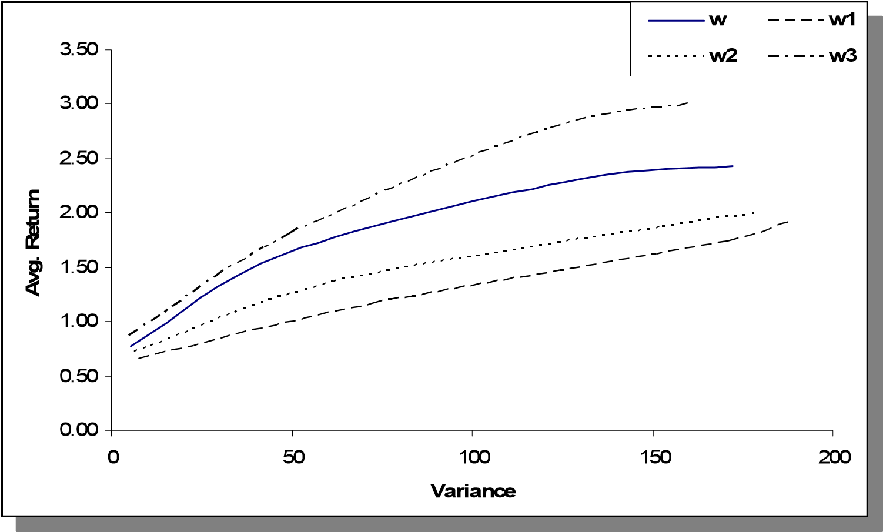

Figure 34. Sensitivity to Euclidean weights (Variance)

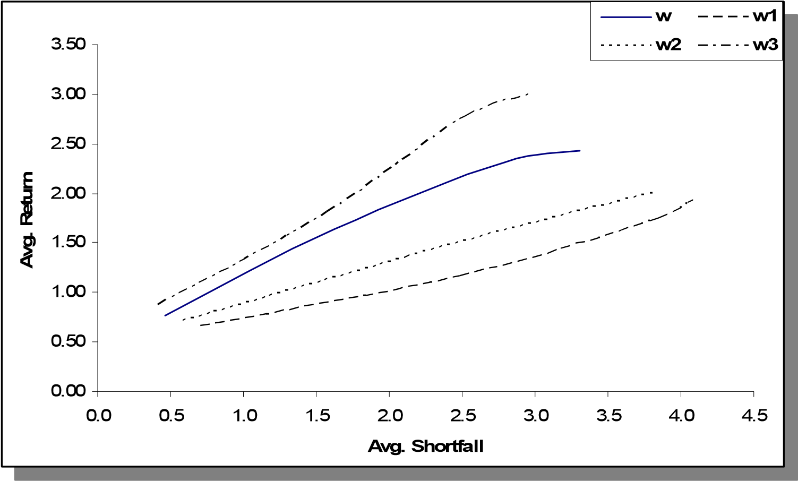

Figure 35. Sensitivity to Euclidean weights (Avg. Shortfall)

#### 3.1.4.2. Sensitivity to Time Unit

In our previous experiments, the investor is assumed to make investment decisions at the beginning of each week and has no interest in the intra-week fluctuation in asset values.

However, high-frequency trading is also common in the financial industry shifting the focus from weeks, months, and quarters to a finer time grid where day-to-day and intraday course of financial data is critical to make frequent investment decisions.

0.00

0.05

0.10

0.15

0.20

0.25

**w3**

**w1**

**w2**

**w**

**Sharpe Ratio**

0.00

0.05

0.10

0.15

0.20

0.25

**w1**

**w2**

**w**

**w3**

**Sharpe Ratio**

Figure 36. Sharpe Rations led by different Euclidean weights.

In this section we assume that the investor makes investment decisions on a daily basis. For our first experiment, similar to the computations presented earlier, we consider a time frame of 401 index values such that the historical data is composed of 400 arithmetic daily returns. Using the same methodology of Sections 3.1.2 and 3.1.3, we initially take the first 300 of the 400 data points to train the algorithms and increase the training set cardinality by one after decisions made for the corresponding test period. In other words, the first 300 return values are used to train the algorithms when *t* = 301, whereas the first 399 return values are used for training when *t* = 400. The initial data set is the daily S&P 500 index values starting from 04/14/2003 - 11/12/2004.

Switching from weekly data to daily data implies a change in the financial time series data fed into the model; therefore the following experiments are expected to yield valuable information on *the sensitivity of the proposed approach to the input data* and its performance with respect to several alternative approaches.

For the computations presented in this section, all parameters are kept the same as in the previous sections except the risk-free rate since the time unit is shortened. We now assume that the investor can invest at a risk-free rate of 0.005%. Similar to Section 3.1.3, alternative scenario generation methods (i.e., AR(2) and GBM) and an alternative investment approach (i.e., B& H) are estimated for benchmarking purposes using the aforementioned daily data set.

Tables 29 and 30 provide the performance measures obtained by using the proposed approach with Alg-1A and Alg-1B, whereas Tables 31 and 32 provide the results led by alternative scenario generation methods, AR(2) and GBM, respectively. Figures 37 and 38 plot the return/risk profiles given in Tables 29-32.

Table 29. Return/Risk profile obtained via Alg-1A

|  |  |  |  |
| --- | --- | --- | --- |
| LCVAR | Avg. Ret. | VAR | Avg. Shortfall |
| 2 | 0.121 | 1.250 | 0.337 |
| 6 | 0.274 | 11.015 | 1.037 |
| 10 | 0.362 | 28.403 | 1.703 |
| 14 | 0.498 | 35.055 | 1.852 |

Table 30. Return/Risk profile obtained via Alg-1B

|  |  |  |  |
| --- | --- | --- | --- |
| LCVAR | Avg. Ret. | VAR | Avg. Shortfall 0.505 |
| 2 | 0.157 | 10.335 |
| 10 | 0.319 | 20.600 | 1.215 |
| 18 | 0.368 | 29.758 | 1.667 |
| 30 | 0.342 | 39.006 | 2.060 |

Table 31. Return/Risk profile obtained via AR(2)

|  |  |  |  |
| --- | --- | --- | --- |
| LCVAR | Avg. Ret. | VAR | Avg. Shortfall |
| 2 | -0.016 | 1.042 | 0.391 |
| 6 | -0.138 | 9.526 | 1.227 |
| 10 | -0.208 | 24.745 | 1.978 |
| 14 | -0.127 | 37.486 | 2.368 |

Table 32. Return/Risk profile obtained via GBM

|  |  |  |  |
| --- | --- | --- | --- |
| LCVAR | Avg. Ret. | VAR | Avg. Shortfall |
| 2 | 0.051 | 1.118 | 0.366 |
| 6 | 0.061 | 10.268 | 1.150 |
| 10 | 0.073 | 27.714 | 1.903 |
| 14 | 0.089 | 38.955 | 2.266 |

The results depicted in Figures 37 and 38 are in favor of the proposed approach. The return risk profiles generated by both Alg-1A and Alg-1B are superior to the alternative approaches used for this experiment regardless the risk measure considered. Among the alternative tools used for scenario generation, GBM leads to more efficient portfolio when compared to AR(2).

Similar to Section 3.1.3, we now compare the proposed approach with the alternative investment approach, B&H. Table 33 provides the return/risk profile obtained by this strategy (i.e., allocating different amounts of the initial wealth to S&P 500 and not trading for the next 100 periods). Figures 39 and 40 compare B&H to the proposed algorithms, where we observe that B&H is outperformed by both Alg-1A and Alg-1B.

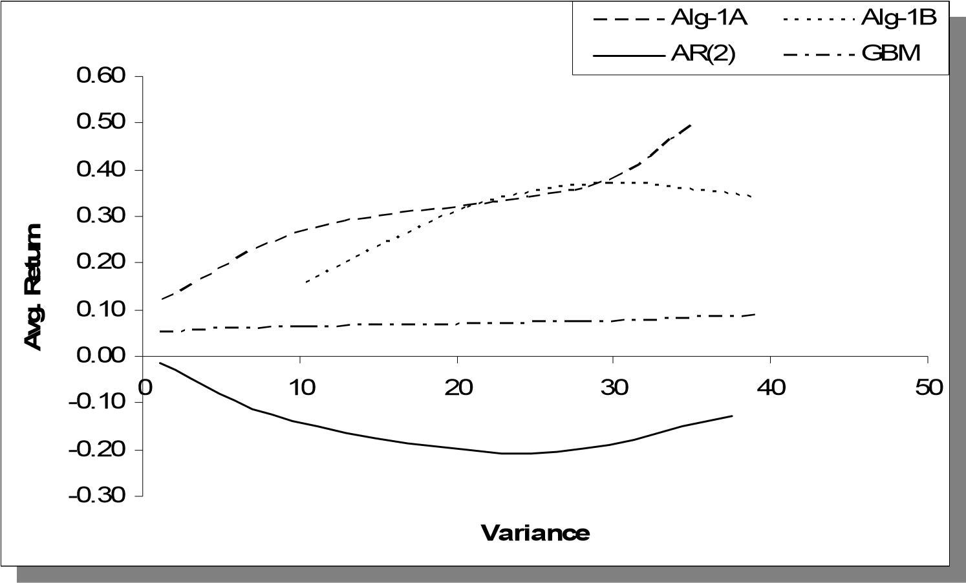

Figure 37. Comparison of Alg-1A, Alg-1B, AR(2) and GBM (Daily, Variance)

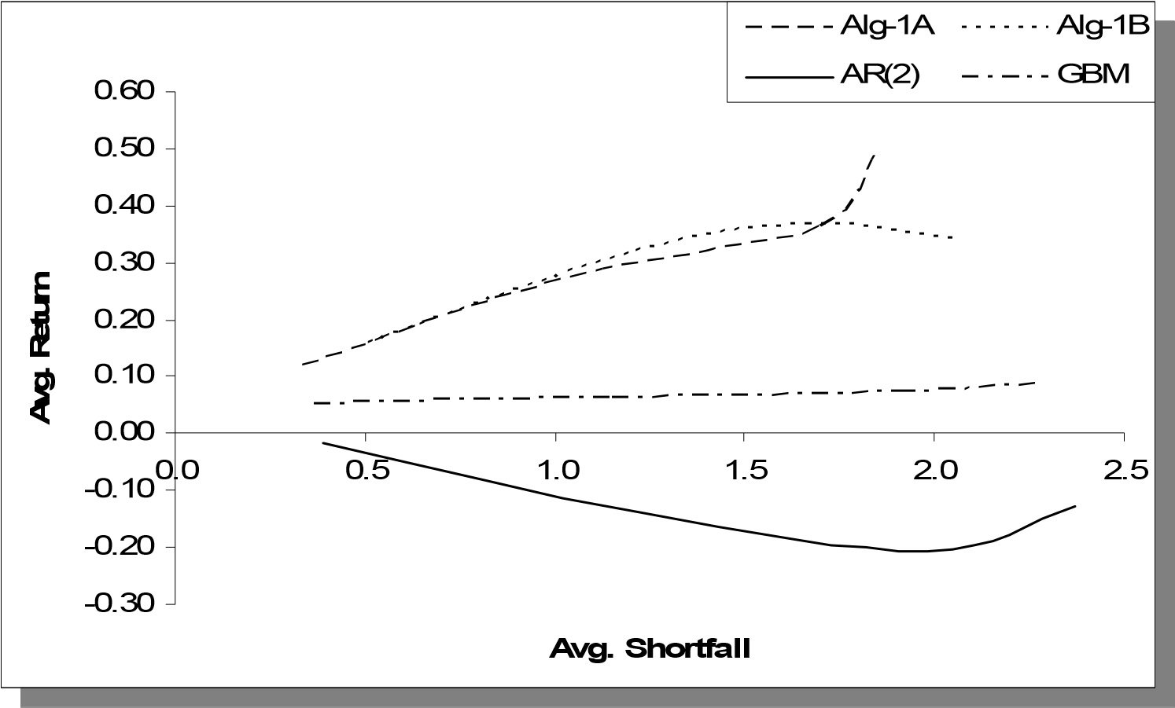

Figure 38. Comparison of Alg-1A, Alg-1B, AR(2) and GBM (Daily, Avg. Shortfall) Table 33. Return/Risk profile obtained via B&H

|  |  |  |
| --- | --- | --- |
| SP/Cash | Avg. Ret. | VAR Avg. Shortfall |
| 0.20 | 0.107 | 1.829 0.475 |
| 0.35 | 0.150 | 5.602 0.847 |
| 0.50 | 0.192 | 11.433 1.219 |
| 0.65 | 0.235 | 19.322 1.591 |
| 0.80 | 0.277 | 29.269 1.963 |

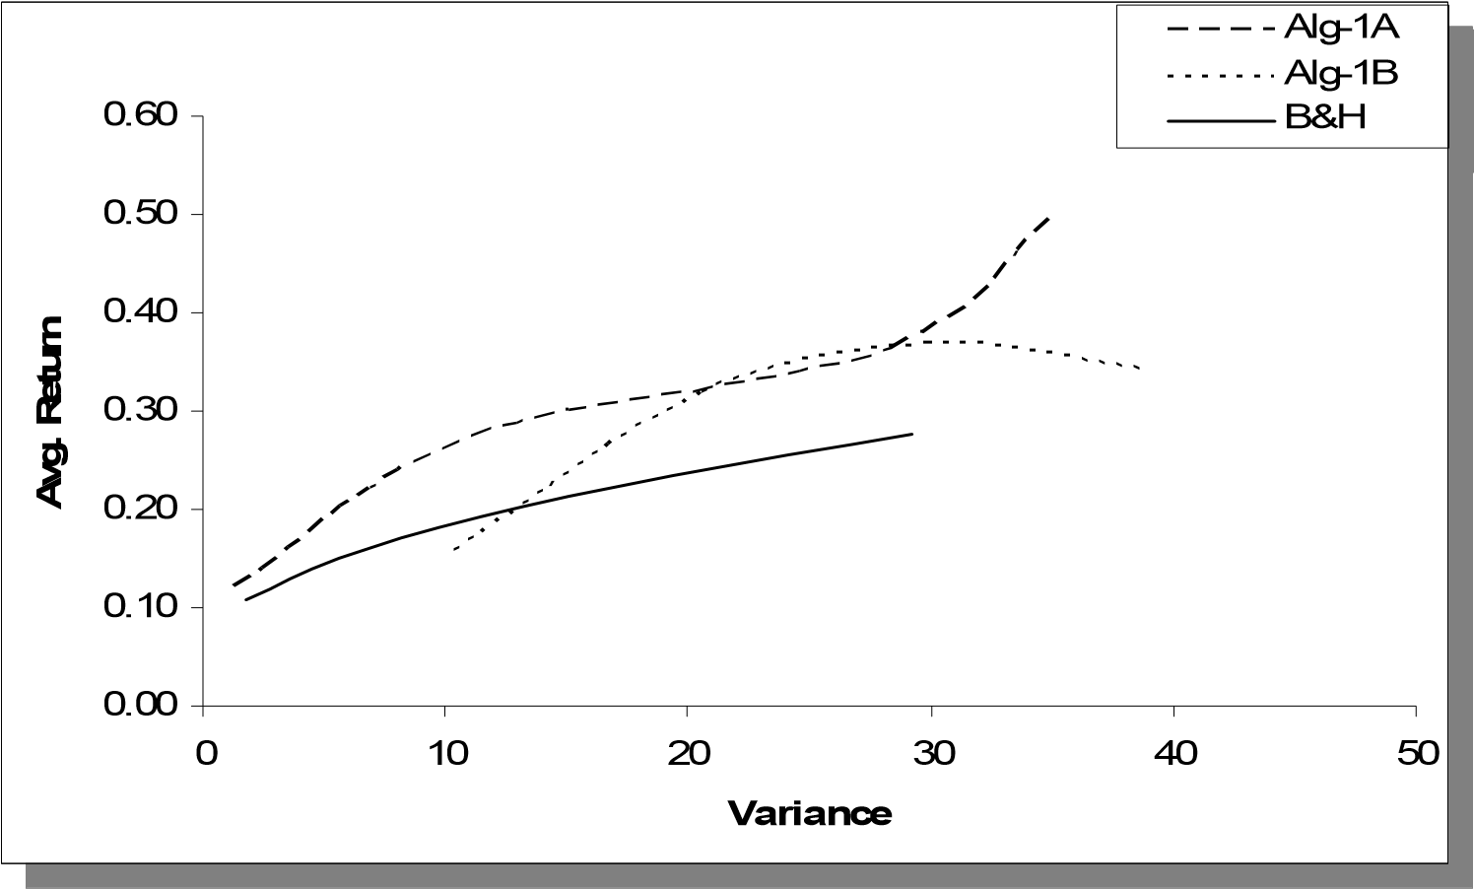

Figure 39. Comparison of Alg-1A, Alg-1B, and B&H (Daily, Variance)

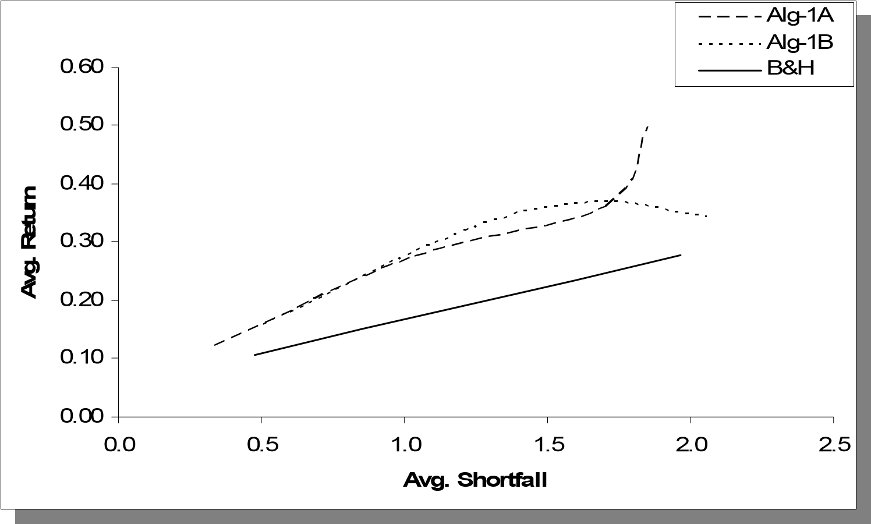

Figure 40. Comparison of Alg-1A, Alg-1B, and B&H (Daily, Avg. Shortfall)

#### 3.1.4.3. Sensitivity to Time Window

As observed from Section 3.1.4.2, the performance of the proposed approach and the alternative ones are sensitive to time unit and in turn the input data, even though the conclusion from the benchmarking process did not change significantly favoring the proposed algorithms.

The sensitivity to input data requires further experiments to be able to provide a better judgment over the alternative approaches. Therefore, we now consider multiple time windows each including an exclusive test set of 100 days but overlapping training sets of various lengths. Each time window is created by adding the following 100 days’ data to the previous time window starting from the initial 400 data points studied in the previous section (i.e., Section 3.1.4.2). Recalling that the original time window covers the data between 4/14/2003 to 11/12/2004 and denoting it by TW1, the next four time windows can be defined as the daily S&P 500 index values between the following dates (see Figure 41 for an illustration):

1. TW1: 04/14/2003 - 11/12/2004
2. TW2: 04/14/2003 - 04/08/2005
3. TW3: 04/14/2003 - 08/30/2005
4. TW4: 04/14/2003 - 01/24/2006
5. TW5: 04/14/2003 - 06/16/2006

Note that each time window starts at the same day spanning 100 days further into the future than the previous time window. For all time windows, the last 100 days are used for testing the trading strategies.

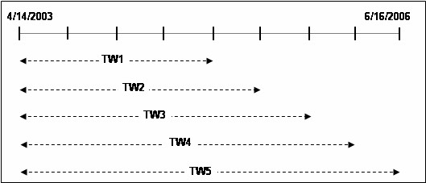

Figure 41. Time windows used for sensitivity analysis. Each bar represents 100 days.

All five approaches (i.e., Alg-1A, Alg-1B, AR(2), GBM, and B&H) are implemented over the four new time windows. Keeping the previous format of presenting the results, we obtained 20 tables, each corresponding to one of the five strategies over one of the four new time windows (See Tables 34-37 in Appendix B).

Similar to the results presented in the former sections, the conclusions for different time windows led by measuring risk by average shortfall are mostly in accordance with the conclusions led by measuring risk by variance. Therefore, instead of focusing on each time window separately, we prefer to report the only Sharpe Ratios, which provide a brief summary of the benchmarking process. Similar to Section 3.1.3, we provide a compact the comparison of the alternative approaches by plotting the Sharpe Ratios obtained from the points that build the Avg. Return vs. Variance curves (e.g., Figure 37, Figure 39, etc.). In other words we obtain a single Sharpe Ratio by setting a specific value for the parameter controlling risk (i.e., LCVAR for scenario generation algorithms and S&P500/Cash ratio for the B&H strategy) and implementing the corresponding method for the 100 consecutive test periods.

Five different levels of risk exposures are set for each of the approaches for each of the five time windows, TW1-TW5, leading to 125 Sharpe Ratios as given in Table 38 (see Appendix B) and plotted in Figure 42.

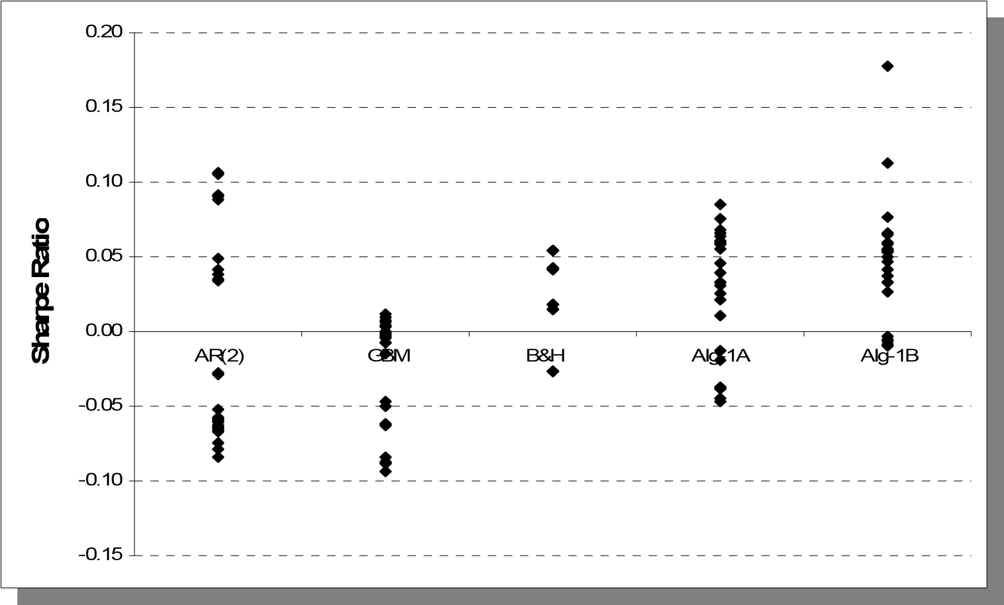

Figure 42. Sharpe Ratios led by alternative approaches over all time windows.

The performance of the alternative approaches exhibit high variation over different time windows, leading to large intervals for the Sharpe Ratios. However, Figure 42 reveals that Alg-1A and Alg-1B have relatively higher Sharpe Ratios compared to the alternative approaches. In fact, this relation is observed very clearly in Figure 43 where the average Sharpe Ratios are plotted for each of the methods in question.

The points in Figure 43 reveal that AR(2) and GBM are both outperformed by B&H, Alg-1A, and Alg-1B. Among these three, both Alg-1A and Alg-1B outperform B&H where Alg-1B has a higher score than Alg-1A considering merely the proposed algorithms. Therefore, considering the five different time windows (i.e., TW1-TW5) over the daily S&P 500 index values between 04/14/2003 - 06/16/2006 and the results presented in Tables 34-37 and Figures 42-43, it can be concluded that within a multiperiod investment scheme, the proposed approachproduces trading strategies that provide more efficient portfolios when compared with the strategies led by AR(2), GBM, and B&H.

-0.04

-0.03

-0.02

-0.01

0

0.01

0.02

0.03

0.04

0.05

0.06

R(2

A

)

B

G

M

B

&H

A

l

g

-1

A

Alg-1B

**Sharpe Ratio**

-0.04

-0.03

-0.02

-0.01

0

0.01

0.02

0.03

0.04

0.05

0.06

AR(2

)

GB

M

B

&H

A

l

g

-1

A

Alg-1B

**Sharpe Ratio**

Figure 43. Average Sharpe Ratios led by alternative approaches.

### 3.2. Algorithm-2

After the analysis of Alg-1A and Alg-1B, we turn our focus to the computational analysis of Algorithm-2 (Alg-2). Different than Section 3.1, we now assume that the decision maker has three investment options in total, two risky assets and one risk-free asset. Another difference over Section 3.1 is that for all computations we consider only the multi-period investing scheme. In other words, we analyze the risk-return profiles assuming that the investor reinvests at each period his/her portfolio resulting from the previous period.

#### 3.2.1. Setup for Computations

In this section, some details regarding the implementation process such as the input data and selection of some parameters are provided. Note that most of the implementation process is similar to Section 3.1.

##### 3.2.1.1 Data

In addition to the S&P 500, we consider the Russell 2000 stock index to represent the second risky asset. The Russell 2000 is an index covering the stocks of small-cap companies in US equity market. The time unit for the decisions is again assumed to be one week for the initial experiments.

The historical data covers 801 index values for S&P 500 and the Russell 2000 from each week between 1/2/1990 and 5/9/2005, which is illustrated in Figure 44. Applying (3), we obtain 800 weekly arithmetic return values to be used in training and testing Alg-2 and alternative approaches. Basic statistics for these indices over the aforementioned period are given in Table 39. Similar to Section 3.1, the weeklyrisk-free rate is assumed to be fixed at 0.04%.

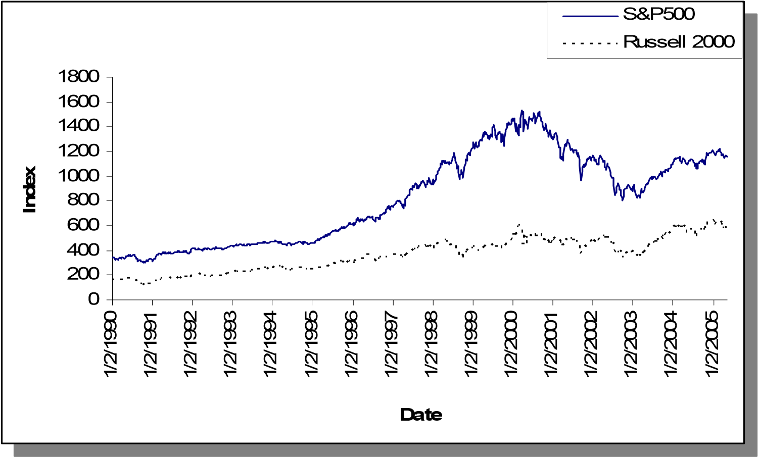

Figure 44. Weekly S&P 500 and Russell 2000 indices.

Table 39. Basic statistics of returns for S&P 500 and Russell 2000

|  |  |  |
| --- | --- | --- |
| *Stat.* | S&P500 | Russell 2000 |
| Mean Return | 0.001712 | 0.001854 |
| Variance | 0.000453 | 0.000616 |
| Skewness | -0.261194 | -0.778697 |
| Kurtosis | 2.380273 | 5.162751 |

##### 3.2.1.2. Parameters

Most parameters are assigned the same values as the ones used for Alg-1A and Alg-1B, especially those used within the SP model. As for the scenario generation, there are differences on two parameters:

* *T*:The planning horizon is assumed to be 2 weeks for the implementation purposes of Alg-2.
* *Scenario Tree Topology*: Unless mentioned differently, the number of scenarios in the first period is 30 where 15 scenarios are built after each scenario in the first period. Therefore a total of 30x15=450 scenarios are created at the horizon.

##### 3.2.1.3. Implementation

We consider only a multi-period setting for the implementation of Alg-2. The same process used for the multi-period analysis of Alg-1A and Alg-1B is employed to obtain the results presented in the following sections (see Figure 25 for the illustration of the implementation process). The last 100 periods out of the 800 are used for testing whereas the initial 700 periods are used merely to train the alternative approaches. Similar to Section 3.1, as the alternative strategies are implemented for any period *t*1 ∈{701..800}, all the data corresponding to the periods *t* < *t*1 are used for training.

##### 3.2.1.4. Initial Analysis

The proposed methodology is based on the assumption that the data contains heteroskedasticity. In order to support this assumption, we compute the sample autocorrelation functions (ACF) on *squared returns* for lags 1, 2, and 3 of both indices. The results given in Figures 45 and 46 show that the auto-correlation is significant for both indices for lag 1.

The presence of heteroskedasticity can be justified also by the Ljung-Box test (Ljung and Box (1978)), where the null hypothesis is that the time series has no autocorrelation. The *squared residuals* obtained from the constant mean model are used as the input time series to test this null hypothesis. The resulting *Q-statistic* given in Table 40 is chi-square distributed with confidence level 0.95 and degrees of freedom being equal to the number of lags, which is equal to 1 since the proposed methodology is based on EGARCH(1,1). We observe from Table 40 that *p-*values are almost zero and *Q-statistics* are much larger than theχ02.95,1 =3.8415; therefore, we reject the null hypothesis.

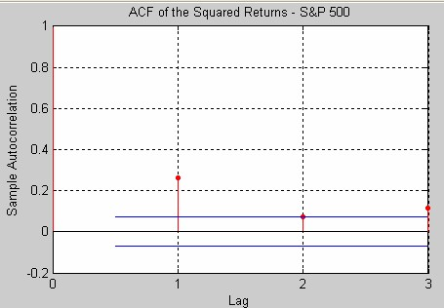

Figure 45. Sample ACF for S&P 500

Table 40. L-B Test for S&P 500 and Russell 2000 for lag 1.

|  |  |  |
| --- | --- | --- |
| Index | p-value | Q-Stat Critical Value |
| S&P 500 | 0.84e-13 | 55.7091 3.8415 |
| Russell 2000 | 0.17e-06 | 27.4013 3.8415 |

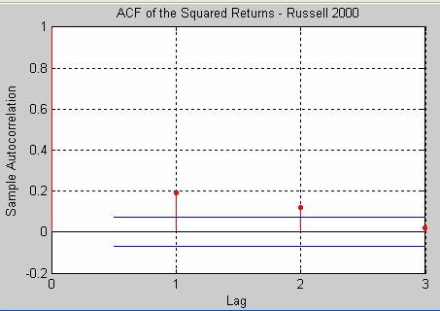

Figure 46. Sample ACF for Russell 2000

#### 3.2.2. Effects of Constraints on Scenario Probabilities

The results obtained by setting no constraints on scenario probabilities (see Section 2.3.3) are provided in Table 41 whereas Tables 42 and 43 provide those obtained by setting relatively lower values for the parameter*lbn* . These return/risk profiles are plotted in Figures 47 and 48, which support the argument on setting lower-bounds for probability values in moment matching process. When *lbn* =0.1,∀*n* , we observe a decrease in risk given a fixed level of return. Moreover, the case *lbn* =0.2 yields a trading strategy that is improved further over the entire curve.

Table 41. Return/Risk profile obtained via Alg-2 (*lbn* = 0)

|  |  |  |  |
| --- | --- | --- | --- |
| LCVAR | Avg. Ret. | VAR | Avg. Shortfall |
| 10 | 0.898 | 38.882 | 1.975 |
| 20 | 1.391 | 157.606 | 4.173 |
| 30 | 1.829 | 359.853 | 6.418 |
| 40 | 2.369 | 542.350 | 7.900 |
| 50 | 2.835 | 676.307 | 8.748 |
| 70 | 2.971 | 857.193 | 10.028 |

Table 42. Return/Risk profile obtained via Alg-2 (*lbn* = 0.1)

|  |  |  |  |  |
| --- | --- | --- | --- | --- |
| LCVAR | Avg. Ret. |  | VAR | Avg. Shortfall |
| 10 | 0.903 |  | 37.947 | 1.950 |
| 20 | 1.383 |  | 155.225 | 4.145 |
| 30 | 1.858 |  | 346.997 | 6.296 |
| 40 | 2.397 |  | 542.002 | 7.899 |
| 50 | 2.836 |  | 675.048 | 8.765 |
| 70 | 2.970 |  | 853.100 | 10.012 |

Table 43. Return/Risk profile obtained via Alg-2 (*lbn* = 0.2)

|  |  |  |  |
| --- | --- | --- | --- |
| LCVAR | Avg. Ret. | VAR | Avg. Shortfall |
| 10 | 0.922 | 35.039 | 1.866 |
| 20 | 1.422 | 142.764 | 3.961 |
| 30 | 1.897 | 323.150 | 6.070 |
| 40 | 2.501 | 517.796 | 7.707 |
| 50 | 2.850 | 670.966 | 8.769 |
| 70 | 2.980 | 855.991 | 10.054 |

|  |  |  |
| --- | --- | --- |
| 0.00  0.50  1.00  1.50  2.00  2.50  3.00  3.50  400  200  0  **Variance**  **Avg. Retur**  **n**    0.00  0.50  1.00  1.50  2.00  2.50  3.00  3.50  0  200  400  600  **Variance**  **Avg. Retur**  **n** | ALG-2  ALG-2 BOUNDED(0.1)ALG-2 ALG-2 BOUNDED(0.2)ALG-2 BOUNDED(0.  ALG-2 BOUNDED(0. | 1)  2)  0 |
| 800 1000  600 800 100 |
|  | |

Figure 47. Results for Alg-2 where *lbn* ∈{0,0.1,0.2} (Weekly, Variance)

|  |  |  |
| --- | --- | --- |
| 0.00  0.50  1.00  1.50  2.00  2.50  3.00  3.50  0.0  2.0  4.0  6.0  **Avg. Shortfall**  **Avg. Retur**  **n**    0.00  0.50  1.00  1.50  2.00  2.50  3.00  3.50  0.0  4.0  6.0  2.0  **Avg. Shortfall**  **Avg. Retur**  **n** | ALG-2  ALG-2 BOUNDED(0.1ALG-2 ) ALG-2 BOUNDED(0.2ALG-2 BOUNDED(0.)  ALG-2 BOUNDED(0. | 1  2 |
| 8.0 10.0 12.0  8.0 10.0 12.0 |
|  | |

)

)

Figure 48. Results for Alg-2 where *lbn* ∈{0,0.1,0.2} (Weekly, Avg. Shortfall)

However, setting relative higher values for *lbn* does not lead to comprehensively improved strategies of the unbounded case. As seen Tables 44 and 45 and plotted in Figures 49 and 50, the cases where *lbn* =0.4 and *lbn* =0.6 may worsen the performance in various intervals. This is not unexpected since setting higher bounds lead to higher deviations from the target moments in the moment matching process. Conditioned on the current data and parameter sets, we conclude that the proposed methodology performs better when *lbn* =0.2. Note that for another investment problem with different types of investment options and the time unit for decisions, further experiments should be carried over to obtain a value of *lbn* calibrated for the specific investment problem.

Table 44. Return/Risk profile obtained via Alg-2 (*lbn* = 0.4)

|  |  |  |  |
| --- | --- | --- | --- |
| LCVAR | Avg. Ret. | VAR | Avg. Shortfall |
| 10 | 0.924 | 35.444 | 1.857 |
| 20 | 1.413 | 145.110 | 3.960 |
| 30 | 1.923 | 326.008 | 6.019 |
| 40 | 2.322 | 503.592 | 7.536 |
| 50 | 2.611 | 680.961 | 8.855 |
| 70 | 2.892 | 846.331 | 10.012 |

Table 45. Return/Risk profile obtained via Alg-2 (*lbn* = 0.6)

|  |  |  |  |
| --- | --- | --- | --- |
| LCVAR | Avg. Ret. | VAR | Avg. Shortfall |
| 10 | 0.911 | 31.472 | 1.722 |
| 20 | 1.353 | 124.623 | 3.620 |
| 30 | 1.833 | 284.270 | 5.570 |
| 40 | 2.015 | 456.990 | 7.162 |
| 50 | 2.310 | 654.007 | 8.729 |
| 70 | 2.757 | 865.807 | 10.145 |

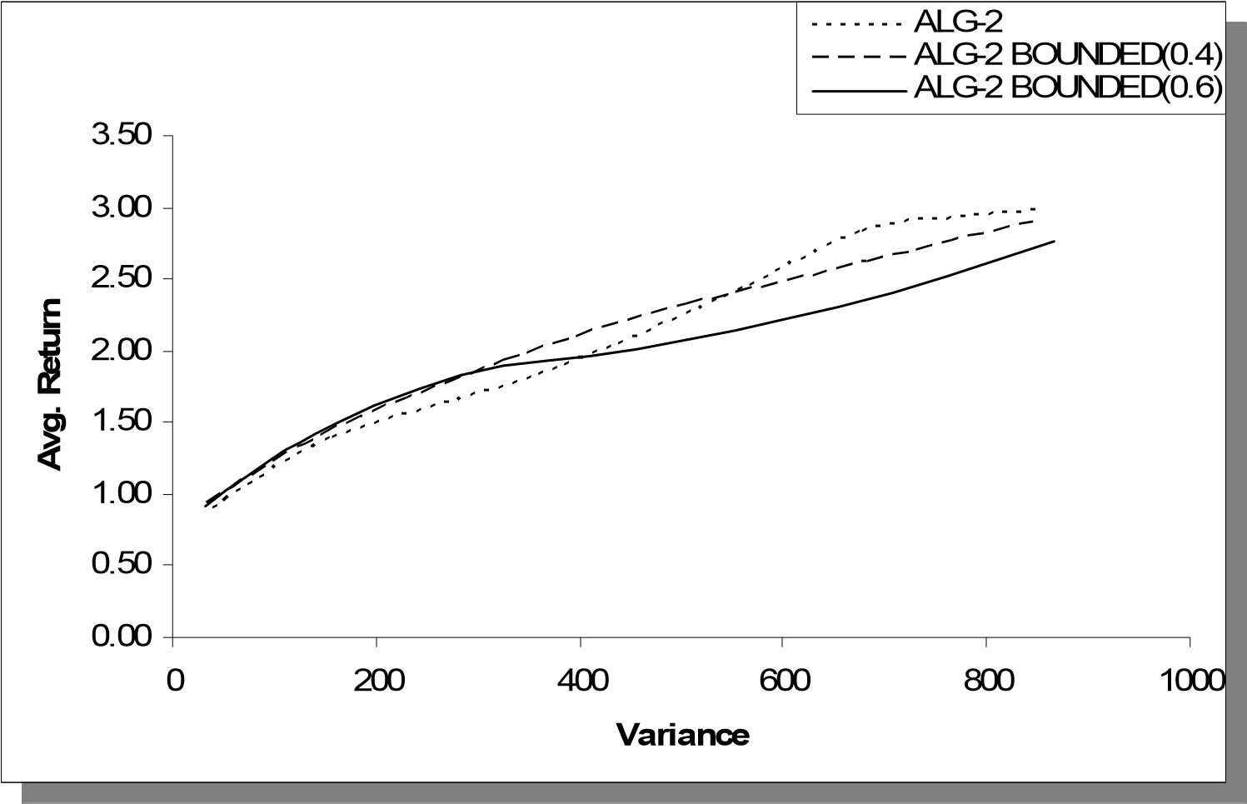

Figure 49. Results for Alg-2 where *lbn* ∈{0,0.4,0.6} (Weekly, Variance)

|  |  |  |
| --- | --- | --- |
| 0.00  0.50  1.00  1.50  2.00  2.50  3.00  3.50  0.0  2.0  4.0  6.0  **Avg. Shortfall**  **Avg. Retur**  **n**    0.00  0.50  1.00  1.50  2.00  2.50  3.00  3.50  0.0  4.0  6.0  2.0  **Avg. Shortfall**  **Avg. Retur**  **n** | ALG-2  ALG-2 BOUNDED(0.4)ALG-2 ALG-2 BOUNDED(0.6)ALG-2 BOUNDED(0.  ALG-2 BOUNDED(0. | 4)  6) |
| 8.0 10.0 12.0  8.0 10.0 12.0 |
|  | |

Figure 50. Results for Alg-2 where *lbn* ∈{0,0.4,0.6} (Weekly, Avg. Shortfall)

#### 3.2.3. Effects of E-GARCH

We now turn our focus on the effects of considering heteroskedasticity in scenario generation. We consider the case with no probability constraints and the concept of conditional variance is omitted for this comparative analysis; therefore, the historical variance and covariance are set as the targets in the moment matching process. In other words, all computations related to EGARCH and CCC-GARCH are ignored and variances and covariance matrix are assumed to be state-independent. Table 46 provides the resulting return/risk profile, which is plotted in Figures 51 and 52. The outcome strongly supports the proposed approach of including heteroskedastic models into the scenario generation process.

Table 46. Return/Risk profile obtained via Alg-2 (Fixed Variance)

|  |  |  |  |
| --- | --- | --- | --- |
| LCVAR | Avg. Ret. | VAR | Avg. Shortfall |
| 10 | 0.518 | 20.521 | 1.345 |
| 20 | 0.622 | 84.722 | 2.890 |
| 30 | 0.726 | 192.641 | 4.435 |
| 40 | 0.878 | 310.137 | 5.706 |
| 50 | 0.968 | 421.162 | 6.731 |

|  |  |  |
| --- | --- | --- |
| 0.00  0.50  1.00  1.50  2.00  2.50  300  200  100  0  **Variance**  **Avg. Retur**  **n**    0.00  0.50  1.00  1.50  2.00  2.50  0  200  300  400  100  **Variance**  **Avg. Retur**  **n** | ALG-2  ALG-2  ALG-2 Fixed Var.  ALG-2 Fixed V | ar. |
| 500 600 400 500 600 |
|  | |

Figure 51. Results for Alg-2 where variance is state independent (Weekly, Variance)

|  |  |  |
| --- | --- | --- |
| 0.00  0.50  1.00  1.50  2.00  2.50  5.0  3.0  2.0  1.0  0.0  4.0  **Avg. Shortfall**  **Avg. Retur**  **n**    0.00  0.50  1.00  1.50  2.00  2.50  0.0  1.0  2.0  3.0  4.0  6.0  5.0  **Avg. Shortfall**  **Avg. Retur**  **n** | ALG-2  ALG-2  ALG-2 Fixed Var.  ALG-2 Fixed V | ar.  0 |
| 7.0 8.0 9.0 6.0 7.0 8.0 9. |
|  | |

Figure 52. Results for Alg-2 where variance is state independent (Weekly, Avg.Shortfall)

#### 3.2.4. Benchmarking with B&H and Markowitz’s Model

We now consider two other investment strategies in order to evaluate the performance of the proposed approach against the alternatives. The first alternative is the simple B&H strategy mentioned in Section 3.1, where different percentages of the initial wealth are allocated to the risky assets and no trade occurs thereafter. The percentages are set as in Table 47 to represent different levels of risk averseness.

Table 47. Portfolio weights for B&H strategy

|  |  |  |
| --- | --- | --- |
| Cash | SP 500 | RUS 2000 |
| 0.70 | 0.20 | 0.10 |
| 0.35 | 0.35 | 0.30 |
| 0.10 | 0.30 | 0.60 |
| 0.05  0.00 | 0.25  0.05 | 0.70  0.95 |

The second alternative is the popular mean-variance (MV) model developed by Markowitz (1952), which is a quadratic programming model where, given a fixed level of return, the objective is to minimize the portfolio risk, which is represented by the variance of the portfolio return. The objective might be also given as the difference between the mean return of the portfolio and the variance multiplied with a constant (i.e., risk aversion). We implemented the version given in (85)-(87),

min 1 *xT*Σ*x* (85)

2

s.t. *xT*µ=µ*level* (86)

*xT* **1** = 1 (87)

where *x* is the column vector containing nonnegative portfolio weights for each asset; µis the column vector of expected returns for each asset;Σ is the covariance matrix for asset returns; and **1** represents the vector of ones. Setting different values for expected portfolio return,µ*level* , we obtain portfolio allocations for four different risk exposure levels. Note that the covariance matrixΣ and the expected return vectorµare computed for each test period using all past returns before that period. The resulting portfolio weights are then used to compute the performance measures.

The performance measures of the alternative approaches are given in Tables 48-49 and plotted in Figures 53-54 together with the measures obtained via Alg-2. These return/risk profiles in these figures reveal that the approach with Alg-2 provides more efficient portfolios than the B&H and MV strategies. In fact the difference gets more significant as the risk averseness is decreased (i.e., risk exposure is increased). This conclusion stays the same regardless the type of the risk measure, variance or average shortfall, we consider.

Table 48. Return/Risk profile obtained via B&H

|  |  |  |  |  |
| --- | --- | --- | --- | --- |
| Cash % | Avg. Ret. |  | VAR | Avg. Shortfall |
| 70% | 0.904 |  | 37.998 | 2.003 |
| 35% | 1.587 |  | 212.181 | 4.982 |
| 10% | 2.274 |  | 528.358 | 7.960 |
| 5% | 2.462 |  | 640.678 | 8.776 |
| 0% | 2.840 |  | 904.396 | 10.433 |

Table 49. Return/Risk profile obtained via MV

|  |  |  |  |  |
| --- | --- | --- | --- | --- |
| Risk Level | Avg. Ret. |  | VAR | Avg. Shortfall |
| 1 | 0.774 |  | 25.543 | 1.631 |
| 2 | 1.128 |  | 108.437 | 3.557 |
| 3 | 1.469 |  | 258.565 | 5.608 |
| 4 | 2.692 |  | 926.533 | 10.691 |

|  |  |  |
| --- | --- | --- |
|  | ALG-2  B&HALG-2  MVB&H  MV | 0 |
| 800 1000  800 100 |
|  |  |

Figure 53. Comparison of Alg-2, B&H, and MV (Weekly, Variance)

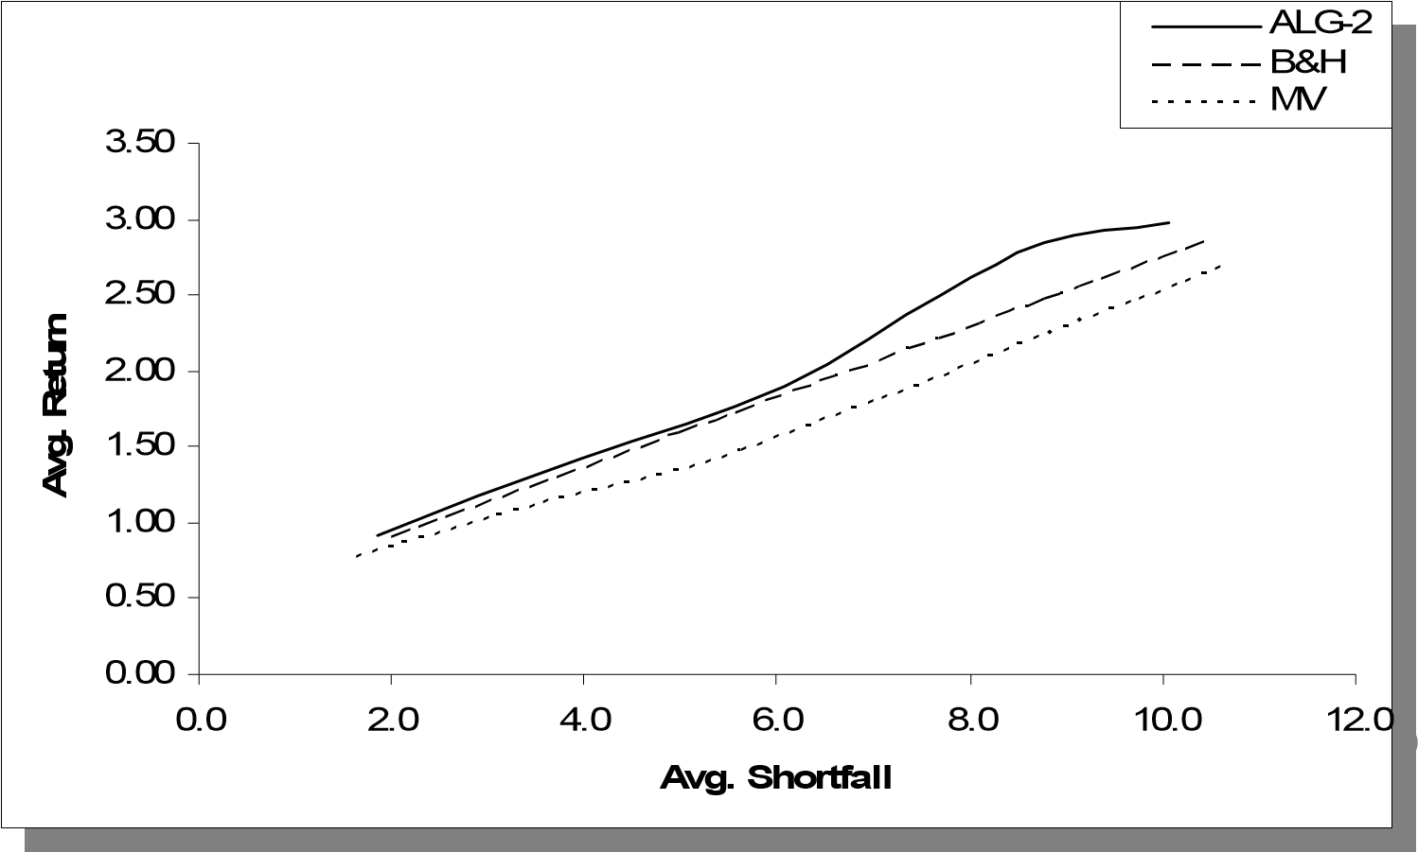

Figure 54. Comparison of Alg-2, B&H, and MV (Weekly, Avg. Shortfall)

#### 3.2.5. Benchmarking with Vector Auto Regressive Model

The comparative assessment is now achieved by considering an alternative scenario generation method, Vector Auto Regression of degree 2 (VAR(2)). For this analysis, the proposed framework implemented in the aforementioned way; however, the proposed scenario generation algorithm is now replaced by VAR(2) estimated on index returns leaving the optimization stage unchanged with the same SP model.

Let *X* and *Y* denote the return series for S&P 500 and Russell 2000, respectively. Then, for each time period, the VAR(2) model given by in (88)-(89) is estimated using ordinary least squares method. Similar to the benchmarking presented in Section 3.1 and in Ziemba and Zhao (2001), we create a set,∈, of residualsε1and ε2after the estimation, which represents the joint distribution for the error terms. Then we populate the scenario tree using equations (88) and (89) where the residuals are randomly sampled from∈. Scenario probabilities are equal given a source node. As mentioned in Section 3.2.1.3, this process is repeated consecutively for the last 100 time periods of the data set given a fixed *LCVAR*. Results for different *LCVAR* values are obtained to represent the return/risk profile of the approach with VAR(2), which are given Table 50.

*Xt* =*c*1 +*a*1*X t*−1 +*a*2*X t*−2 +*a*3*Yt*−1 +*a*4*Yt*−2 +ε*t*1 (88)

*Yt* =*c*2 +*b*1*Yt*−1 +*b*2*Yt*−2 +*b*3*X t*−1 +*b*4*X t*−2 +ε*t*2 (89)

Figures 55 and 56 plot the return/risk profile obtained by using VAR(2) in the scenario generation process comparing it against Alg-2. The proposed scenario generation scheme produces higher returns than VAR(2) given a fixed level of variance. The same conclusion is valid for the higher risk region when average shortfall is considered. Another observation from the decisions-table obtain via VAR(2) is that the SP model results in a trading strategy where portfolio turnover is very high across periods, which might make it more sensitive to transaction cost. In Figures 57 and 58, risk/return curves obtained by setting transaction to 0.4% instead of 0.1% are shown (See Table 51). As expected, the VAR(2) curve shifted downwards whereas the proposed methodology is observed to be more robust with respect to an increase in the transaction cost.

Table 50. Return/Risk profile obtained via VAR(2)

|  |  |  |  |  |
| --- | --- | --- | --- | --- |
| LCVAR | Avg. Ret. |  | VAR | Avg. Shortfall |
| 10 | 0.891 |  | 39.233 | 1.815 |
| 20 | 1.411 |  | 155.537 | 3.670 |
| 40 | 1.672 |  | 344.397 | 5.768 |
| 90 | 1.727 |  | 406.291 | 6.389 |

0.00

0.50

1.00

1.50

2.00

2.50

3.00

600

500

400

300

200

100

0

**Variance**

**Avg. Retur**

**n**

2

ALG-

VAR

0.00

0.50

1.00

1.50

2.00

2.50

3.00

100

0

200

300

400

500

60

0

**Variance**

**Avg. Retur**

**n**

ALG-2

VAR

Figure 55. Comparison of Alg-2 and VAR(2) (Weekly, Variance)

0.00

0.50

1.00

1.50

2.00

2.50

3.00

8.0

6.0

4.0

2.0

0.0

10.0

**Avg. Shortfall**

**Avg. Retur**

**n**

2

ALG-

VAR

0.00

0.50

1.00

1.50

2.00

2.50

3.00

0.0

2.0

4.0

6.0

8.0

10.

0

**Avg. Shortfall**

**Avg. Retur**

**n**

ALG-2

VAR

Figure 56. Comparison of Alg-2 and VAR(2) (Weekly, Avg. Shortfall)

Table 51. Return/Risk profile obtained via VAR(2) (Tran.=0.4%)

|  |  |  |  |  |
| --- | --- | --- | --- | --- |
| LCVAR | Avg. Ret. |  | VAR | Avg. Shortfall |
| 10 | 0.836 |  | 36.353 | 1.769 |
| 20 | 1.163 |  | 150.882 | 3.821 |
| 40 | 1.363 |  | 340.909 | 5.922 |
| 80 | 1.396 |  | 424.663 | 6.703 |

|  |  |  |
| --- | --- | --- |
| 0.00  0.50  1.00  1.50  2.00  2.50  300  250  200  150  100  50  0  **Variance**  **Avg. Retur**  **n**    0.00  0.50  1.00  1.50  2.00  2.50  0  50  100  150  200  250  350  300  **Variance**  **Avg. Retur**  **n** | ALG-2  ALG-2  VAR  VAR |  |
| 400 450  350 400 450 |
|  | |

Figure 57. Comparison of Alg-2 and VAR(2) (Weekly, Variance, Tran=0.4%)

0.00

0.50

1.00

1.50

2.00

2.50

3.00

3.50

8.0

6.0

4.0

2.0

0.0

10.0

**Avg. Shortfall**

**Avg. Retur**

**n**

2

ALG-

VAR

0.00

0.50

1.00

1.50

2.00

2.50

3.00

3.50

0.0

2.0

4.0

6.0

8.0

10.

0

**Avg. Shortfall**

**Avg. Retur**

**n**

ALG-2

VAR

Figure 58. Comparison of Alg-2 and VAR(2) (Weekly, Avg. Shortfall, Tran=0.4%)

#### 3.2.6. Sensitivity Analysis

Similar to Section 3.1.4, we now present the outcomes obtained by implementing the proposed approach with different parameters and input data. Our objective is to observe how the proposed strategy responds to slight changes in the model and evaluate its performance over the alternative approaches within different settings.

##### 3.2.6.1. Sensitivity to Weights used in Moment Matching

Recalling the definition of Alg-2, we use different weights (i.e., *wil* and *wik*) for deviations from different target moments in the objective function (23). For the computations presented in this section, we use the same weight vector for all assets. Let **we** denote the 1x5 row vector of these weights where the first four elements represent the weights used for the first four moments, whereas the fifth element is the weight used for the second comoment (i.e., target covariance). The base case we used to obtain the aforementioned results gives priority to the first moment, followed by the second moment, fourth moment and the third moment.

Specifically **we** is set to [0.31 0.23 0.08 0.15 0.23], which is denoted by **we0**. For sensitivity analysis purposes we now consider the following four weight vectors each putting extra weight in one of the four moments (Notice that the maximums are underlined):

|  |  |  |  |  |
| --- | --- | --- | --- | --- |
| • **we1** = [0.56 | 0.17 | 0.06 | 0.06 | 0.17] |
| • **we2** = [0.12 | 0.40 | 0.04 | 0.04 | 0.40] |
| • **we3** = [0.07 | 0.07 | 0.71 | 0.07 | 0.07] |
| • **we4** = [0.07 | 0.07 | 0.07 | 0.71 | 0.07] |

The performance measures obtained via using **we1 – we4** are provided in Table 52 (see Appendix C) and plotted in Figures 59 and 60. The return/risk profile does not seem to be quite sensitive with respect to the weights used for the deviations from different target moments. This is not unexpected since the scenario tree used in this computation has 30 branches in the first period and 15 branches after each first-period scenario (See Section 3.2.1.2), which yields a high number of decision variables (i.e., scenario probabilities) to fit a given set of target moments. This scenario tree topology will be denoted by a row vector form, [30 15].

An alternative approach would be doing the same experiment with a different scenario tree having a lower number of branches and therefore providing few decision variables to fit the target moments. We expect to obtain higher sensitivity within such a setting. In order to illustrate this argument, we obtain the return/risk profiles obtained by using a scenario tree topology of [8 4] resulting in 32 scenarios at the horizon (See Table 53 in Appendix C).

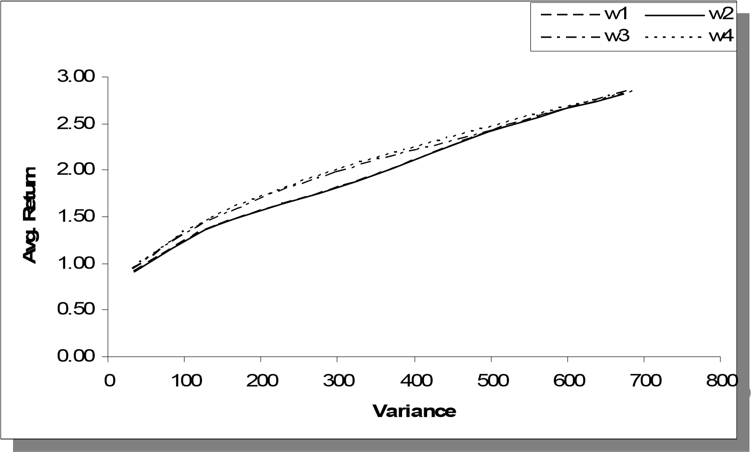

Figure 59. Comparison of weight vectors **we1, we2, we3, we4** (Variance)

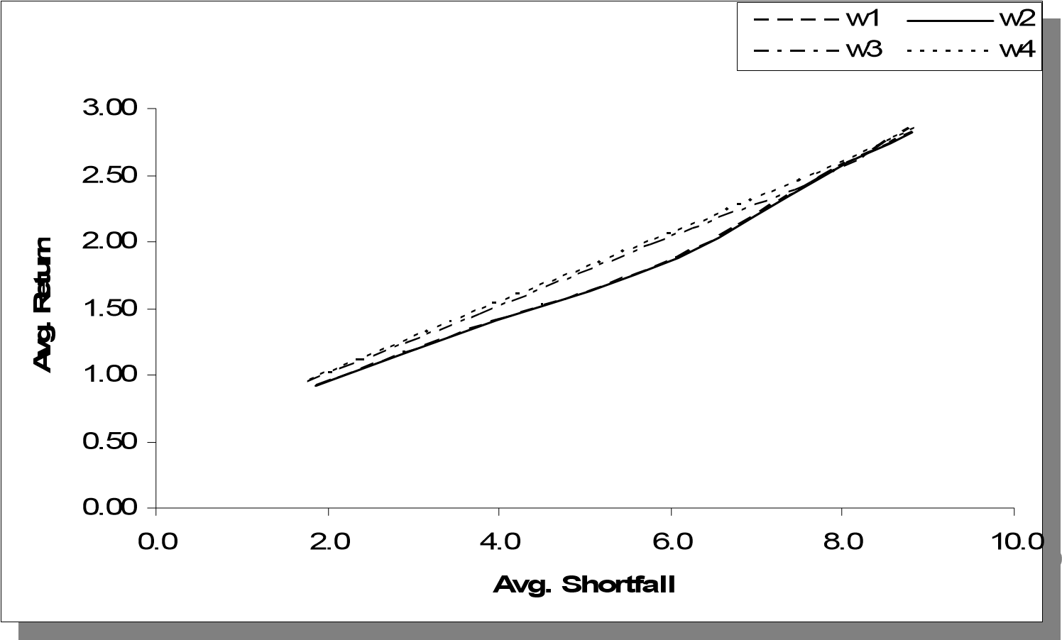

Figure 60. Comparison of weight vectors **we1, we2, we3, we4** (Avg. Shortfall)

The results obtained by using a [8 4] scenario tree are plotted in Figures 61-62. The outcome supports our expectation of a higher sensitivity when fewer scenarios are used at each period during the moment matching process. The return/risk curves are clearly apart from each other when compared to the curves in Figure 59-60, which implies the performance of the proposed approach becomes more sensitive to the weights assigned to deviation from target moments as the number of scenarios is decreased. We also present the Sharpe Ratios obtained from these two experiments (see Table 54 in Appendix C). The values for [8 4] topology have more variation than the values led by [30 15] topology, which can be better observed from the sample variances plotted in Figure 63.

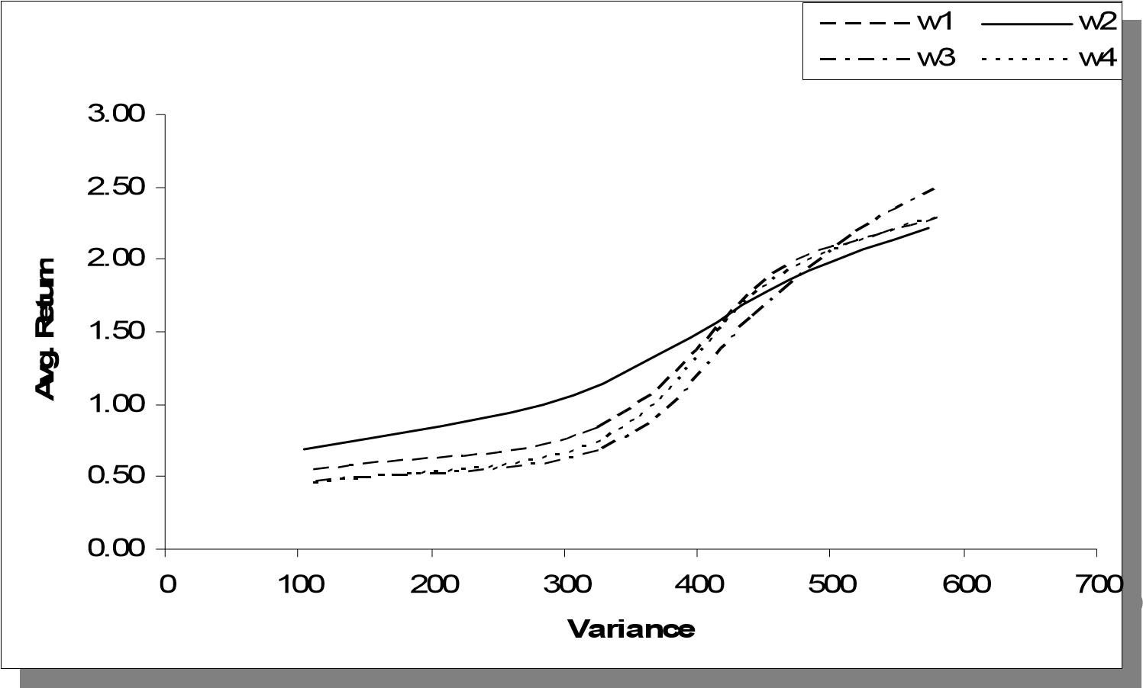

Figure 61. Comparison of weight vectors **we1, we2, we3, we4** ([8 4], Variance)

|  |  |  |
| --- | --- | --- |
| 0.00  0.50  1.00  1.50  2.00  2.50  3.00  4.0  6.0  0.0  2.0  **Avg. Shortfall**  **Avg. Retur**  **n**    0.00  0.50  1.00  1.50  2.00  2.50  3.00  0.0  2.0  4.0  6.0  **Avg. Shortfall**  **Avg. Retur**  **n** | w1 w2  w3w1 w4w2 w3 w4 |  |
| 8.0 10.0  8.0 10.0 |
|  | |

Figure 62. Comparison of weight vectors **we1, we2, we3, we4** ([8 4], Avg. Shortfall)

0.0E+00

1.0E-04

2.0E-04

3.0E-04

4.0E-04

5.0E-04

6.0E-04

7.0E-04

8.0E-04

9.0E-04

1.0E-03

**[8**

**4]**

**[30 15]**

0.0E+00

1.0E-04

2.0E-04

3.0E-04

4.0E-04

5.0E-04

6.0E-04

7.0E-04

8.0E-04

9.0E-04

1.0E-03

**[8**

**4]**

**[30 15]**

Figure 63. Sample variance for values in Table 54.

##### 3.2.6.2. Sensitivity to the Number of Scenarios

As mentioned in Chapters 1 and 2, a major concern with SP models is the increase in problem size as the number of scenarios is increased, which may lead to significant increases in computation times. This constitutes a trade-off since a comprehensive scenario tree including a high number of scenarios would have more capability to capture a wide range of different discrete probability distributions for random variables involved in the model.

As mentioned in Section 3.2.6.1, we obtained results for two different scenario tree topologies, [8 4] and [30 15], having 32 and 450 scenarios at the horizon, which provides us with the opportunity to compare the performance of the proposed approach when low and high number of scenarios are used.

Noting that the conclusions are the same for both risk measures, we turn our focus to the Sharpe Ratios provided in Table 54 (see Appendix C), where the results of the experiments carried over with different weight vectors (i.e., **we0-we4**) are tabulated for two different scenario topologies. These values are plotted in Figure 64 and averages are compared in Figure 65. The immediate observation is that the performance is highly sensitive to the scenario tree topology. In addition, note that the topology [30 15] leads to significantly higher Sharpe Ratios when compared to [8 4]. This result confirms the validity of the trade-off between the problem size and the resulting power of modeling uncertainty, which in turn affects the performance of the SP-based approach.

##### 3.2.6.3. Sensitivity to Time Unit and Time Windows

Similar to Section 3.1.4.2, we now change the dataset we use for our experiments such that the investment decisions are assumed to be made on a daily basis. In addition to evaluating the *sensitivity of the proposed approach with Alg-2 to the input data* and its performance with respect to several alternative approaches, we also aim to test the validity of some of the aforementioned conclusions when a daily-investment scheme is in question.

0.00

0.02

0.04

0.06

0.08

0.10

0.12

[8

4]

[30 15]

0.00

0.02

0.04

0.06

0.08

0.10

0.12

[8

4]

[30 15]

Figure 64. Sharpe Ratios obtained via different scenario tree topologies.

0.00

0.01

0.02

0.03

0.04

0.05

0.06

0.07

0.08

0.09

0.10

[30 15]

[8

4]

0.00

0.01

0.02

0.03

0.04

0.05

0.06

0.07

0.08

0.09

0.10

[8

4]

[30 15]

Figure 65. Average Sharpe Ratios obtained via different scenario tree topologies.

###### 3.2.6.3.1. Effects of Constraints on Scenario Probabilities

The analysis presented in Section 3.2.2 is now carried over the daily data set, which covers the daily S&P 500 and Russell 2000 index values starting in the range 04/14/2003

- 11/12/2004. Note that this corresponds to the time window denoted by TW1 in Figure

41.

The objective is to see the effect of posing constraints on scenario probabilities during the moment matching process and calibrating the lower bound, *lbn* , according to a daily setting. Keeping other parameters constant, four different experiments were done over TW1 such that *lbn* is consecutively set to 0, 0.05, 0.10, and 0.20∀*n* . Tables 55-58 provide the resulting return / risk profiles which are plotted in Figures 66-67.

Table 55. Return / risk profile obtained when *lbn* =0

|  |  |  |  |  |
| --- | --- | --- | --- | --- |
| LCVAR | Avg. Ret. |  | VAR | Avg. Shortfall |
| 2 | 0.1034 |  | 2.1962 | 0.5452 |
| 6 | 0.2228 |  | 19.8575 | 1.6823 |
| 10 | 0.3396 |  | 53.2657 | 2.7706 |
| 14 | 0.4551 |  | 84.9398 | 3.5074 |
| 24 | 0.7101 |  | 115.5461 | 4.0620 |
| 32 | 0.7103 |  | 115.5502 | 4.0620 |

Table 56. Return / risk profile obtained when *lbn* =0.05

|  |  |  |  |  |
| --- | --- | --- | --- | --- |
| LCVAR | Avg. Ret. |  | VAR | Avg. Shortfall |
| 2 | 0.1072 |  | 2.0265 | 0.5162 |
| 6 | 0.2286 |  | 18.5740 | 1.6088 |
| 10 | 0.3924 |  | 49.2092 | 2.6141 |
| 14 | 0.5307 |  | 85.1486 | 3.4721 |
| 24 | 0.7103 |  | 115.5502 | 4.0620 |
| 32 | 0.7103 |  | 115.5502 | 4.0620 |

Table 57. Return / risk profile obtained when *lbn* =0.10

|  |  |  |  |
| --- | --- | --- | --- |
| LCVAR | Avg. Ret. | VAR | Avg. Shortfall |
| 2 | 0.0940 | 2.3001 | 0.5585 |
| 6 | 0.1973 | 20.6736 | 1.7170 |
| 10 | 0.3535 | 54.1148 | 2.7757 |
| 14 | 0.5214 | 88.1326 | 3.5369 |
| 24 | 0.7103 | 115.5502 | 4.0620 |
| 32 | 0.7103 | 115.5502 | 4.0620 |

Table 58. Return / risk profile obtained when *lbn* =0.20

|  |  |  |  |
| --- | --- | --- | --- |
| LCVAR | Avg. Ret. | VAR | Avg. Shortfall |
| 2 | 0.1116 | 2.5382 | 0.5694 |
| 6 | 0.2468 | 22.9670 | 1.7566 |
| 10 | 0.3798 | 56.9178 | 2.8140 |
| 14 | 0.5055 | 87.7278 | 3.5351 |
| 24 | 0.7097 | 115.5365 | 4.0620 |
| 32 | 0.7103 | 115.5502 | 4.0620 |

As expected, the performance of Alg-2 increases when a scenario probabilities bounded below; however, the gain in performance is undermined when larger values are employed for bounding. This observation is similar to the one observed in Section 3.2.2; however, we now observe that the maximum performance is obtained when probabilities is bounded below by 0.05(number of scenarios)-1 instead of 0.20(number of scenarios)-1.

In order to illustrate the effect of constraints on probabilities, we now repeat the same analysis for four new time windows TW2, TW3, TW4, and TW5. These are the same time windows used in Section 3.1.4.3and illustrated in Figure 41.

The performance measures obtained from these 16 experiments (i.e., four different bounding parameters over four different time windows) are given in Tables 59-62 in Appendix C. We present here the 120 (i.e., six different risk levels for each of the five time windows and for each of the four different values of *lbn* ) Sharpe Ratios obtained from all five time windows, TW1-TW5 (see Table 63 in Appendix C).

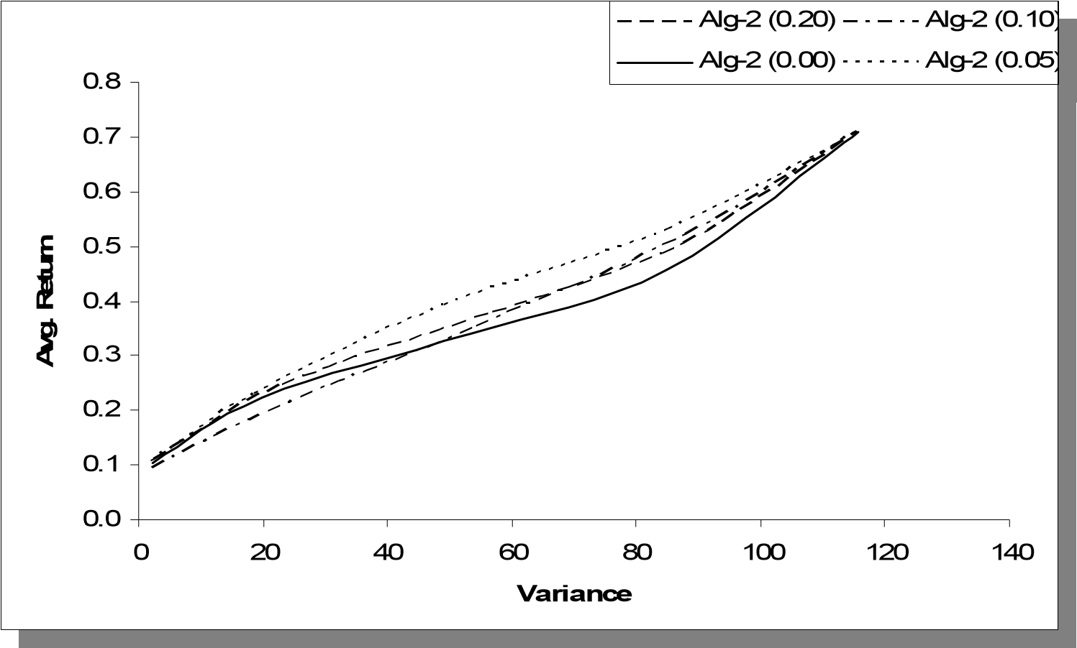

Figure 66. Results for Alg-2 where *lbn* ∈{0,0.05,0.10,0.20} (TW1, Variance)

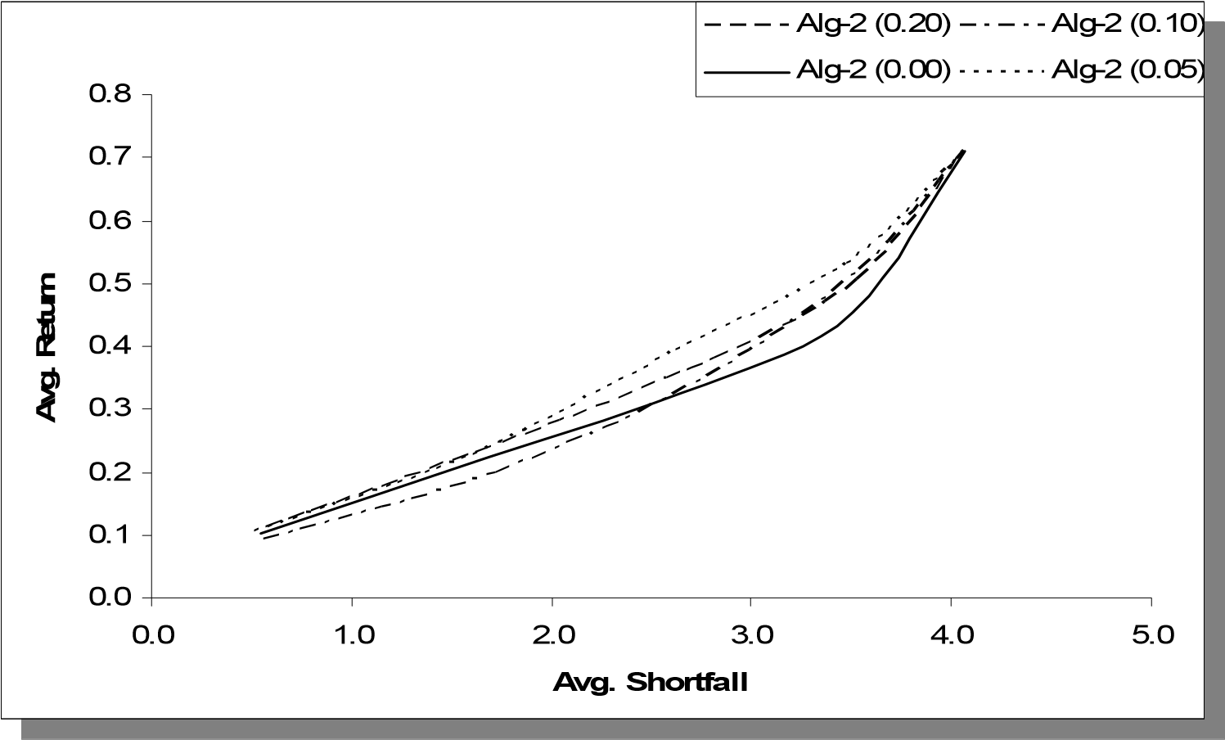

Figure 67. Results for Alg-2 where *lbn* ∈{0,0.05,0.10,0.20} (TW1, Avg. Shortfall)

The average Sharpe Ratios are plotted in Figure 68. Even though they are close to each other, we observe that the performance of Alg-2 is maximized when *lbn* =0.05, given the possible values of 0, 0.05, 0.10, and 0.20.

Different than the results led by weekly data where the performance is maximized when *lbn* =0.20, we now observe that a smaller lower bound parameter, *lbn* =0.05, leads to a better performance. Recalling that higher bounds would lead to higher deviations from target moments, the results on daily data imply that the deviations from target moments are penalized quicker than the weekly data. This can be attributed to the typical characteristics of the high-frequency financial data such as skewness and fat tails.

0

0.02

0.02

2

4

0.02

6

0.02

8

0.02

0

0.03

0.03

2

Alg-2 (0.20)

Alg-2 (0.00)

Alg-2 (0.05)

Alg-2 (0.10)

0.020

0.022

0.024

0.026

0.028

0.030

0.032

Alg-2 (0.00)

Alg-2 (0.05)

Alg-2 (0.10)

Alg-2 (0.20)

Figure 68. Comparison of average Sharpe Ratios led by different *lbn* values

###### 3.2.6.3.2. Effects of E-GARCH

In Section 3.2.3, we presented results obtained by removing E-GARCH modeling from the algorithm and using the historical unconditional variance and covariance values for moment matching. In addition, *the lower bounds on scenario probabilities had been removed* in order to better observe the effect contributed merely by using heteroskedastic modeling. The return/risk profiles obtained in Section 3.2.3 supported the idea of using

E-GARCH.

Our objective is now to extend that the same analysis into the daily data framework. The five different time windows introduced in Section 3.1.4.3 and used in Section 3.2.6.3.1 (i.e., TW1-TW5) are considered for this analysis. Table 64 in Appendix C provides the performance measures obtained by using state independent variances and covariance matrix. Note that *lbn* =0 for both cases.

Table 65 (see Appendix C) provides the Sharpe Ratios obtained by fixing the second moments and those obtained by Alg-2. The average values are plotted in Figure 69 where we observe that the usage of E-GARCH model within the scenario generation yields a higher Sharpe Ratios on the average. This comparison supports the conclusion in Section

3.2.3.

0.020

0.021

0.022

0.023

0.024

0.025

0.026

0.027

0.028

0.029

Alg-2

Alg-2 Fixed VAR

0.020

0.021

0.022

0.023

0.024

0.025

0.026

0.027

0.028

0.029

Alg-2 Fixed VAR

Alg-2

Figure 69. Comparison of average Sharpe Ratios

###### 3.2.6.3.3. Sensitivity to Weights used in Moment Matching

We now analyze the sensitivity of the performance of Alg-2 with respect to the weights used in the objective function of moment matching model given the daily investment scheme.

In addition to the base vector **we0**, four different weight vectors introduced in Section 3.2.6.1 (i.e., **we1** - **we4**) are considered in this analysis. The scenario tree topology is set to [30 15] leading to 450 scenarios at the horizon. Time windows TW1-TW5 are used to train and test the approach, which yielded the performance measures provided in Tables 66-71 (see Appendix C) and Sharpe Ratios plotted in Figure 70. The scatter diagram in Figure 70 does not reveal a significant sensitivity of the performance with respect to weight vectors. The average values depicted in Figure 71 illustrates the low level of sensitivity, where observe that the performance does not significantly change over weight vectors. Even though the differences are low, **we4**yields a slightly higher average Sharpe Ratio among the vectors considered. This can be attributed the fat-tail characteristic of the high-frequency data since **we4** puts more weight on the fourth moment.

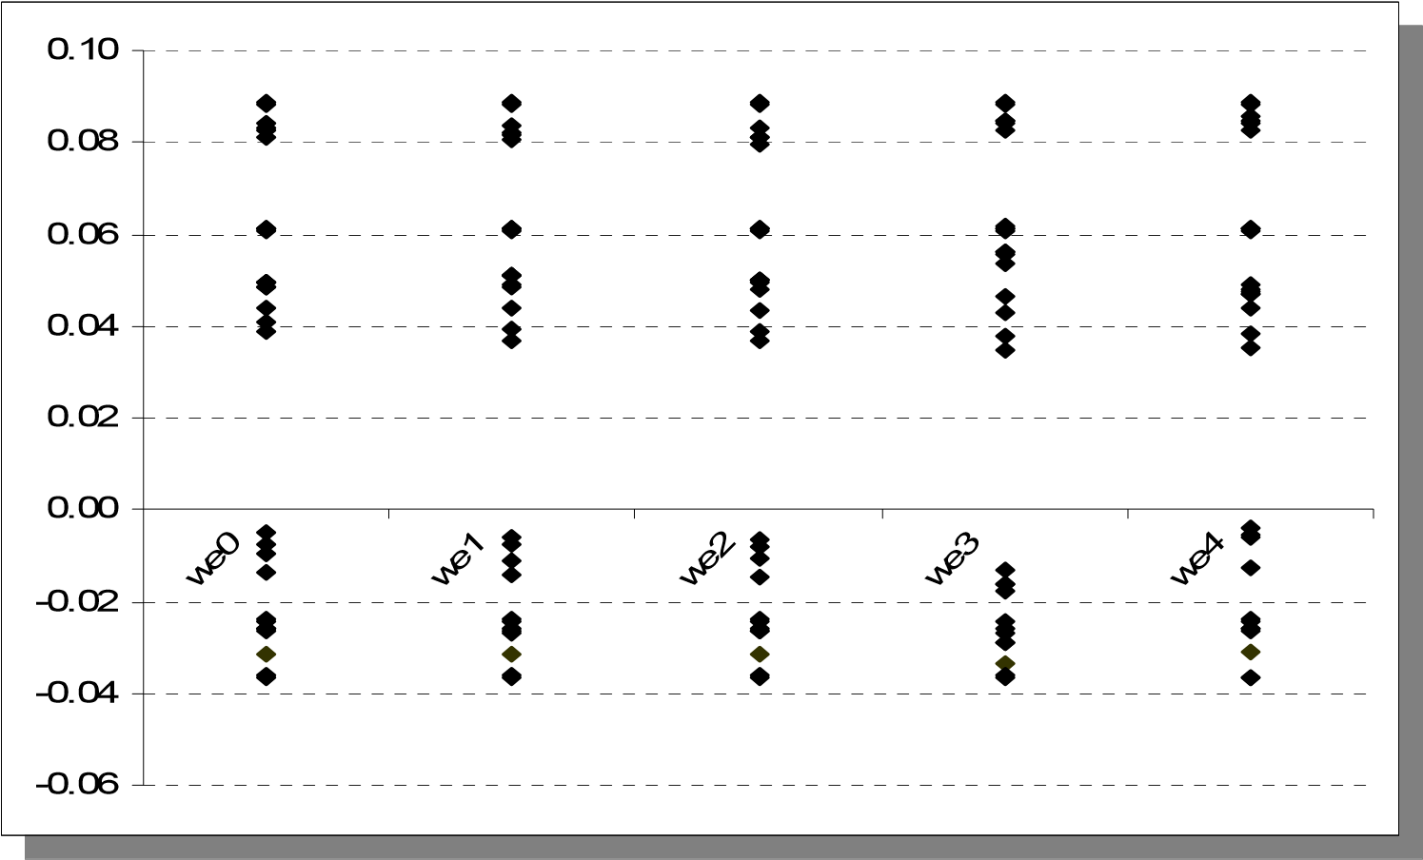

Figure 70. Sharpe Ratios obtained via different weight vectors.

0.020

0.021

0.022

0.023

0.024

0.025

0.026

0.027

0.028

0.029

we4

we0

we1

we2

we3

0.020

0.021

0.022

0.023

0.024

0.025

0.026

0.027

0.028

0.029

we0

we1

we2

we3

we4

Figure 71. Comparison of average Sharpe Ratios led by different weight vectors.

###### 3.2.6.3.4. Sensitivity to the Number of Scenarios

As mentioned Section 3.2.6.2, the topology of the scenario tree is critical to the success of SP based approaches. Recalling the experiments carried over considering the weekly data the increase in the number of scenarios has been shown to increase the performance of the proposed approach.

In this section we also consider the [80 40] topology in addition to [8 4] and [30 15] in order to see the affect of further increasing the number of scenarios. Therefore the analysis will cover the models with 32, 450, and 3200 scenarios at the horizon. Similar to the previous sections the analysis in this section also covers the time windows TW1TW5.

The results obtained by using the [8 4] and [80 40] topologies are provided in Tables 7273 (see Appendix C). We present in Table 74 (see Appendix C) all the Sharpe Ratios obtained from the experiments with all topologies and in Figure 72 the resulting average Sharpe Ratios. As expected, we obtain an increase in the average Sharpe Ratio as we use larger scenario trees with more scenarios at all periods. This observation supports the conclusion in Section 3.2.6.2 and is in accordance with the common trade-off regarding the problem sizes in SP models.

###### 3.2.6.3.5. Benchmarking with B&H and Markowitz’s Model

In this section we repeat the analysis presented in Section 3.2.4 considering the daily index data over time windows TW1-TW5. Regarding the B&H strategy, the asset allocations corresponding to different risk levels are as given in Table 63 (see Appendix C). The Markowitz’s MV model given by (85)-(87) is implemented with four different target expected returns implying four different risk exposure levels.

0.014

0.016

0.018

0.020

0.022

0.024

0.026

0.028

0.030

0.032

[30 15]

4]

[8

[80 40]

0.014

0.016

0.018

0.020

0.022

0.024

0.026

0.028

0.030

0.032

[8

4]

[30 15]

[80 40]

Figure 72. Comparison of average Sharpe Ratios led by different tree topologies.

The performance measures led by B&H and MV strategies over time windows TW1TW5 are given in Tables 75-76 (See Appendix C). For benchmarking purposes we consider two versions of the proposed approach. The first is the base case with the scenario tree topology [30 15] whereas the second version has the scenario tree topology of [80 40].

Noting that the conclusions are the same regardless whether average shortfall or variance is considered as the risk measure, we present here the compact comparative analysis using the Sharpe Ratios obtained from alternative approaches. Figure 73 provides the scatter diagram and Figure 74 provides the average values. We observe from Figure 74 that the sample average of the Sharpe Ratios obtained from different experiments over TW1-TW5 gets its highest value when the proposed approach is implemented with the scenario tree topology [80 40]. When we decrease the number of scenarios (i.e., use [30 15] topology), the proposed approach is slightly outperformed by the strategy led by MV approach. Among all, the B&H strategy is outperformed by all of the approaches.

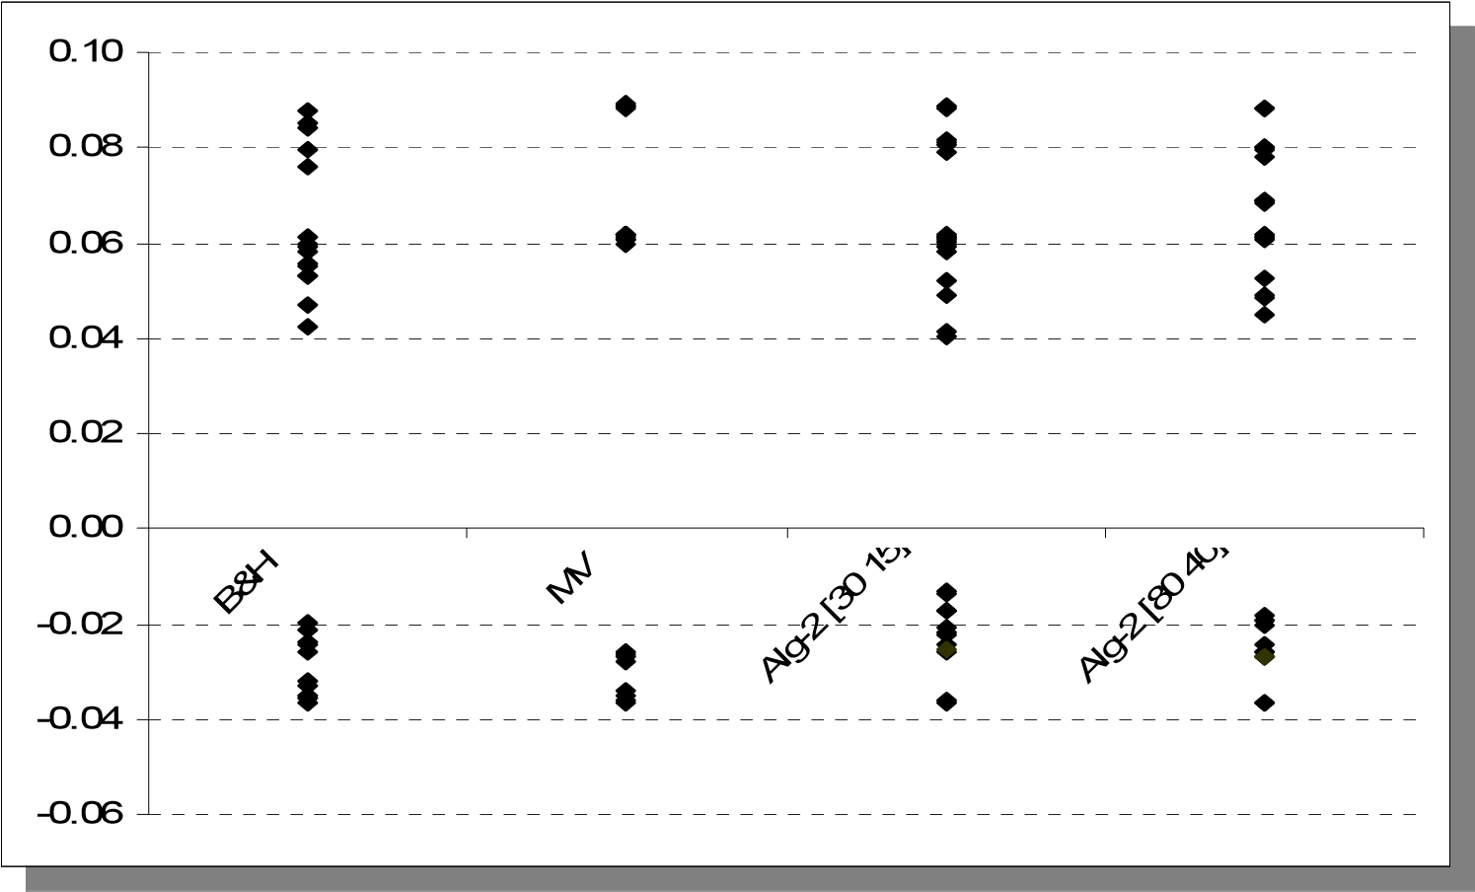

Figure 73. Sharpe Ratios obtained via alternative approaches.

###### 3.2.6.3.6. Benchmarking with Vector Auto Regressive Model

We now repeat the analysis presented in Section 3.2.5by estimating (88)-(89) over the daily index data over time windows TW1-TW5 and using the resulting model for scenario generation. The performance measures led by VAR(2) are given in Table 77 (See Appendix C). Similar to Section 3.2.6.3.5, we consider two versions of the proposed approach with two different the scenario tree topologies, [30 15] and [80 40].

0.020

0.022

0.024

0.026

0.028

0.030

0.032

MV

B&H

Alg-2 [30 15]

Alg-2 [80 40]

0.020

0.022

0.024

0.026

0.028

0.030

0.032

B&H

MV

Alg-2 [30 15]

Alg-2 [80 40]

Figure 74. Average Sharpe Ratio values obtained via alternative approaches.

Figure 75 provides the scatter diagram and Figure 76 provides the average values. We observe from Figure 76 that Alg-2 significantly outperforms VAR(2) when the sample averages of the Sharpe Ratios obtained from different experiments over TW1-TW5 are considered. The conclusion is not sensitive to the scenario tree topology considered for implementation.

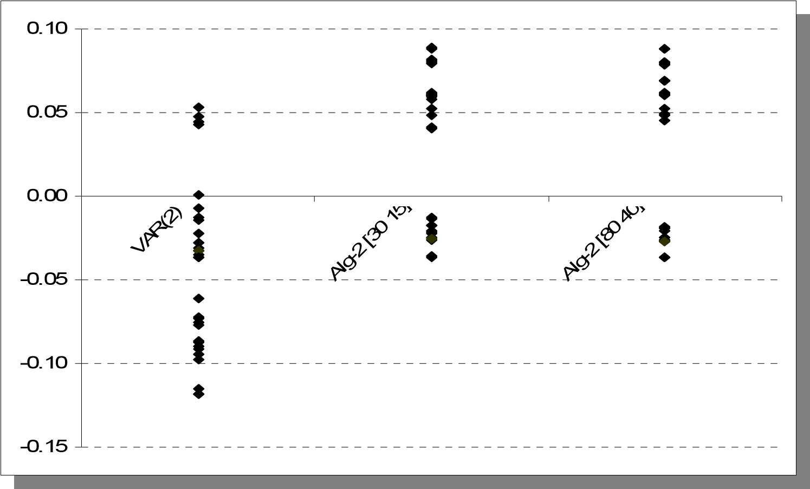

Figure 75. Sharpe Ratios obtained via alternative scenario generation methods.

0

-0.100

0

-0.080

0

-0.060

-0.040

0

-0.020

0

0

0.000

0.020

0

0.040

0

Alg-2 [80 40]

Alg-2 [30 15]

VAR(2)

-0.1000

-0.0800

-0.0600

-0.0400

-0.0200

0.0000

0.0200

0.0400

VAR(2)

Alg-2 [30 15]

Alg-2 [80 40]

Figure 76. Average Sharpe Ratios obtained via alternative scenario generation methods.

### 4. A GENERAL APPROACH for LOSS REDUCTION

In this chapter, we address the process of modifying investment decisions led by a given trading strategy in accordance with the state of the market. In particular, we consider the state of the market in terms of volatility of the observed time series. Our objective is to examine an approach to identify potential ways to take corrective actions on a trading strategy such that the original return/risk profile is enhanced.

#### 4.1. Market State

The state of the market can be related to various indicators such as GDP, unemployment, stock indices, etc. The usual classification distinguishes time intervals as periods where the economy is either in recession or not. Clustering time intervals in this manner may involve analyzing measures, such as returns and volatilities of stock market indices, interest rates, etc.

Markov switching models are broadly used in order to analyze the breaking points in the economy and make forecasts on market states given some observed variables. For instance, in his influential paper Hamilton (1989) proposes a methodology to obtain probabilistic inference about the unobservable regime changes in an observed time series data. In this study, it is assumed that the transition between the states is governed by a Markov process where the states indicate whether there is a negative (recessionary) or positive (non-recessionary) growth rate. State transition probabilities are estimated through an iterative procedure, which are utilized to draw inference regarding the turning points in the business cycle. There are many studies based on the methodology of Hamilton (1989), such as Chu et. al. (1996), Yilmazkuday and Akay (2008), Chen (2008), Angelidis and Tessaromatis (2009), and references therein.

Li (2007) adopts the Markov switching ARCH model of Hamilton and Susmel (1994) in order to determine the states of the economy in terms of volatility. Fukuda (2009) analyzes the financial time series considering switching between probability distributions. Alternative approaches are evaluated where the observed data set is split into segments and different distributions (i.e., distribution of the innovations for the autoregressive model) are fit to each segment.

#### 4.2. An Approach Based on Logistic Regression

The approach presented here does not aim to classify the past time intervals to be recessionary or not. In addition, we do not try to infer probabilities for the state of the market for the future periods. Our analysis focuses on the behavior of the trading strategy with respect to the volatility of the asset returns. The goal is to infer the probability of incurring a significant loss due to the decisions suggested by the trading strategy.

In order to achieve this goal we utilize logistic regression, which is a type of regression used to predict the occurrence of an event given a set of independent explanatory variables. Logistic regression fits data on a logistic curve expressed as in (90) and illustrated as in Figure 77.

*L*(*Y*) = 1+1*e*−*Y* (90)

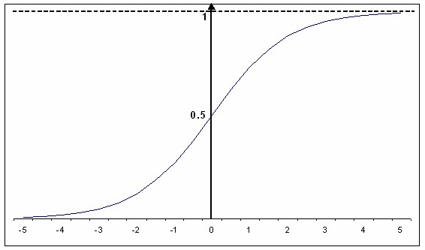

Figure 77. Logistic Curve for interval [-5, 5]

Logistic function takes values between 0 and 1 regardless the value of the independent variable. This property makes it a useful tool to predict the probability of an event given the explanatory variable(s). The variable *Y* in (90) is called *logit* and it is expressed as the linear combination of independent variables as in (91), where we assume that there are *k* independent variables denoted by *X1…Xk*.

*Y* =β0 +β1*X*1 +β2 *X* 2 +...+β*k X k* (91)

In this approach we consider a *binary* *dependent* event, which can be described as the occurrence of the following two events *at the same time*

* The trading strategy suggests investment on a specific asset that exceeds some constant threshold, *TSD*. The parameter *TSD* can be considered as the weight of the asset in portfolio or an amount measured in terms of some monetary value.
* The return on that specific asset for the *following* period becomes negative.

The occurrence of these two events implies a significant loss that is led by the original trading strategy. The approach is based on estimating the probability of incurring such significant losses and updating the investment decision with the intention to decrease possibly high shortfalls.

This approach focuses on the evolution of time series data in conjunction with the actions led by the trading strategy. If the constant threshold *TSD* is set to 0, the resulting method would not be different than estimating the probability of having a negative return on a specific asset. However, setting a non-zero *TSD* value could enable the decision maker to track the decisions suggested by the trading strategy that produce a harmful effect for the portfolio. If the strategy does not invest in a specific asset, which will have a negative return in the following period, then no loss will be incurred. Therefore, the focus is not on whether the returns will be negative but on whether there will be a significant loss.

We are interested in relating the performance of a given trading strategy to the market volatility. Volatility is one of the most important characteristics defining the behavior of financial time series data. It is critical for the models used in option pricing, portfolio optimization, and many other models involving risk management.

Volatility is known to be a random variable rather than being constant over time. This concept is addressed by numerous stochastic volatility models (including ARCH-type models in discrete time) and a complete review of this subject is beyond the scope of our study. As for the general approach presented in this section, we are interested in using a *proxy* for volatility rather than predicting its value for the following periods.

Since volatility is derived from variance of the returns, we shift our focus to variance of returns. Different measures are used to obtain a proxy of return variance. We can list some common measures used to serve as a proxy of instantaneous return variance and volatility as follow:

* Squared return :*rt*2
* Absolute return : *r*

*t*

∑

=

*n*

*i*

*i*

*t*

*r*

1

2

,

* Realized volatility : where*rt*2,*i* denotes the returns obtained at *n* equal

time intervals obtained within period *t* (e.g. intraday data).

* Implied volatility : This measure is obtained using market prices of options and an option pricing formula such as Black-Scholes. It gives insight about the expectations of the market.

For instance, Li (2007) uses squared return whereas Gavrishchaka and Ganguli (2002) consider the absolute returns. Some of the studies using realized return are Jacquier and Marcus (2001), Micciche et al. (2002), and Chu et al. (1996).

We consider two different measures, denoted by *M1* and *M2*, as proxies to the market volatility, which will serve as explanatory variables in two different logistic regressions where the constants will be 0. These are:

*M1*: *Absolute value of the product of consecutive returns*.

*M2*: *Sum of squared returns*.

Specifically, returns for the first three lags are considered. Therefore, the logistic regression models can be stated as

*Pi*,*t* =1+*e*1−*Yi*,*t*−1 (92)

*Yi*,*t*−1 =β*i ri*,*t*−1*ri*,*t*−2*ri*,*t*−3 (*M1*) (93)

*Yi*,*t*−1 =β*i* (*ri*2,*t*−1 +*ri*2,*t*−2 +*ri*2,*t*−3) (*M2*) (94)

where *Pi*,*t* denotes the probability of incurring a loss in period *t* due to investment in risky

asset *i* that exceeds *TSD* given the past three return values (i.e., *ri*,*t*−1 ,*ri*,*t*−2 ,*ri*,*t*−3 ) and proxy type (i.e., *M1* *or* *M2*). The resulting*Pi*,*t* value is used to update the investment decision suggested by the original trading strategy for period *t*. The approach is based on decreasing the amount of investment in asset *i* depending on the value of*Pi*,*t* and transferring the corresponding funds to the risk-free asset. In fact, the amount of transfer becomes higher as*Pi*,*t* gets larger values.

We estimate the regression model by (92) and (93) or (92) and (94) by dividing the set of *training periods* originally used by the trading strategy into two. The first set of periods, denoted by *TR1*, is utilized for the usual training of the trading strategy. In other words, this set of data is used to estimate any parameters that belong to the trading strategy. For instance, consider Alg-2 presented in Chapter 2. This set of data is used to estimate merely the parameters of the EGARCH. The second set of data, denoted by *TR2*, is used to estimate the regression parameters in (92)-(94) given the investment decisions and corresponding losses, if any, led by the trading strategy. The following periods are used for testing purposes, denoted by *Test*). See Section 4.3 for more details on the implementation process.

Suppose that *zi*,*t* and *yt* denote the amount of investment on risky asset *i* and risk-free asset, respectively, suggested by the trading strategy at the beginning of period *t* (i.e., *before realizing* the return for period *t*). Also denote by *zi*\*,*t* the updated investment on risky asset *i*. Given the preferred proxy for volatility as *M1* (note that consideration of *M2* will only change the equation labels in the description below) and the time window as being the combination of *TR1*, *TR2* and *Test*, the proposed approach can be outlined by the following steps *for each risky asset* *i*:

*Step 0* : Estimate the parameters that belong to the trading strategy using the data

in *TR1*.

*Step 1* : For each *t* in *TR2*;

Execute the trading strategy and obtain *zi*,*t* . Then assign *Pi*,*t* as:

*Pi*,*t* =01 if *z* *i*,*t* > *TSD* andotherwise *ri,t* < 0 (95)

Let *REG* denote the set of observations obtained.

*Step 2* : Estimate the logistic regression model (92)-(93) using the data set *REG*. Compute *Pi*,*t* via (92)-(93).

*Step 3* : For period *t* in *Test*, execute the trading strategy and obtain *zi*,*t* . Add this investment decision into *REG* using(95) (Note that this step is included

here for description purposes. The corresponding observation is utilized in period *t*+1, after the return for period *t* is realized).

*Step 4* :Update the allocation on risky asset *i* as

*zi*\*,*t* = (1- *Pi*,*t* ) *zi*,*t* (96)

*Step 5* : Update the allocation on risk-free asset as given in (97). This essentially involves adding the funds obtained by the update (i.e., reduction) on risky asset positions given in (96); adding any transaction costs led originally by the trading strategy; and subtracting the transaction costs implied by (96).

*yt*\* = *yt* +*Pi*,*t zi*,*t* +ε*zi*\*,*t*−1(1+*ri*,*t*−1) −*zi*,*t*

−ε*zi*\*,*t*−1(1+ *ri*,*t*−1)− *zi*\*,*t* (97)

*Step 6* : Repeat Steps 2-5 for all *t* ∈*Test* .

#### 4.3. Computational Results

The approach presented in Section 4.2 is based on a general idea and can be implemented in conjunction with any methodology mentioned in this study. For implementation purposes of this section, we consider only Alg-2. The input data contains the daily time windows, TW1-TW5, which are the same time windows used to obtain results in Chapter

3.

Each time window contains a set of time periods for training and another set for testing the trading strategy, which includes 100 consecutive time periods as mentioned in Chapter 3. In order to implement the decision rule we split the training data set into two as described in Section 4.2. Specifically we take the last 100 periods of the training set to obtain the observations, *TR2*, to be used for estimating (92)-(94) (see Figure 78 for the illustration involving TW1 as an example, which is composed of 400 consecutive days).

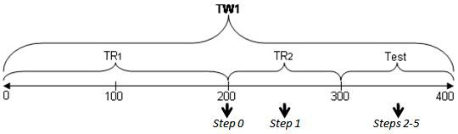

Figure 78. Illustration for the segmentation of time windows.

The critical parameter of the proposed approach is *TSD*, which is used to determine the value of the binary dependent variable in the regression. It specifies the threshold for the investment on an individual asset such that only the investments exceeding *TSD* are eligible to be considered as significant losses. Therefore, low *TSD* values are expected to modify the original trading strategy (i.e., Alg-2 combined with the multi-stage SP model) in a more conservative way than high values of *TSD*.

We consider four different values for *TSD* (i.e., $200, $400, $600, $800 noting that the initial portfolio value is $1000), two different measures (i.e., *M1*, *M2*), five time windows (i.e., TW1-TW5), and six different risk tolerances (i.e., various *LCVAR* values). Similar to the implementation process presented in Chapter 3, the approach presented in this chapter required extensive computation. Considering the aforementioned setting, the combination of Alg-2 and the SP model needed to be run for 4x2x5x2x100x6=48,000 times and the logistic regression model needed to be estimated for 4x2x5x100x6=24,000 times.

The results are aggregated over time windows and risk tolerances leading to eight different trading strategies (i.e., four *TSD* values and two volatility measures). Similar to the previous analysis in Chapter 3, benchmarking is achieved by considering the Sharpe Ratios led by alternative strategies. Figures 79 and 80 provide the scatter plot of the individual Sharpe Ratios obtained from each time window and risk tolerance by implementing the proposed approach considering *M1* and *M2*, respectively whereas Figure 81 provides a comparison of the average Sharpe Ratios (see Tables 78-85 in Appendix D for the performance measures for each of the eight problem setups).

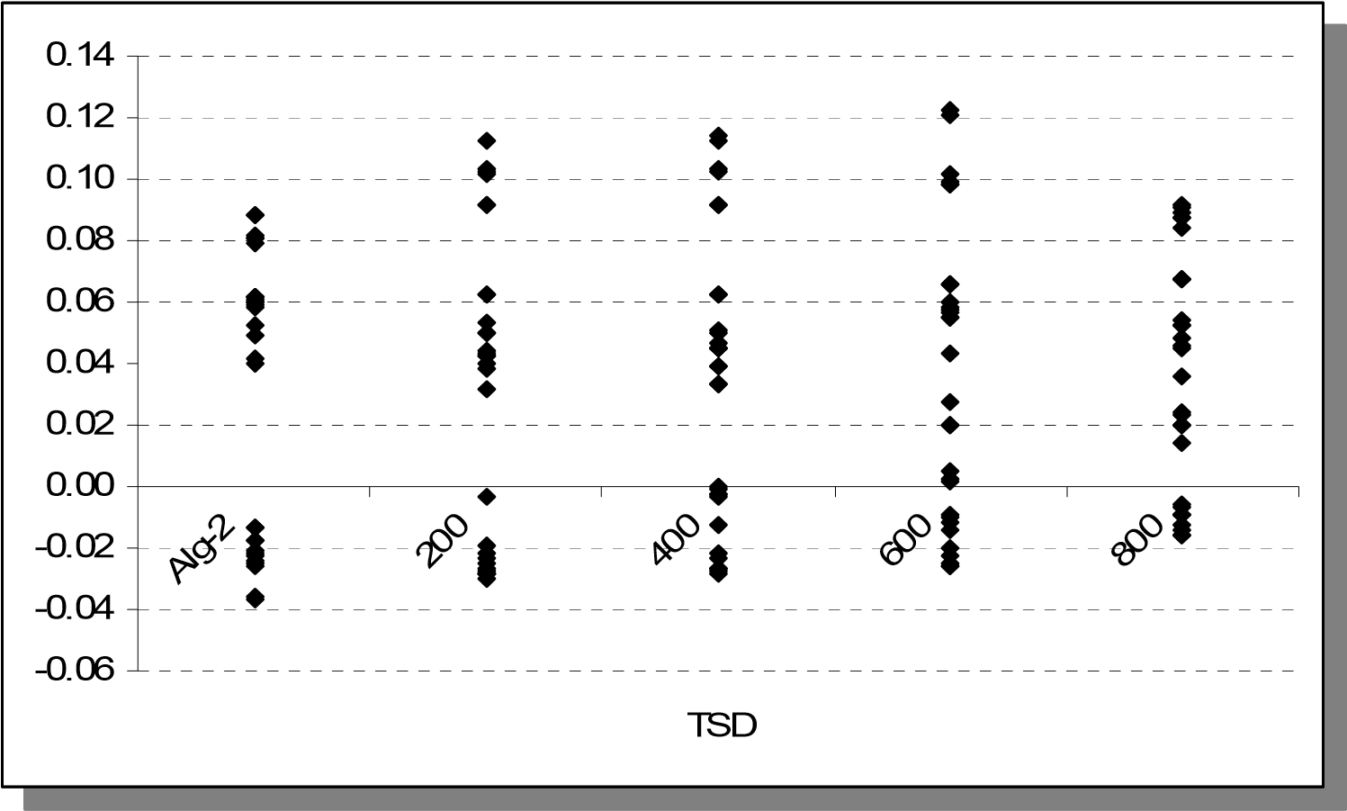

Figure 79. Sharpe Ratios obtained via different *TSD* values with *M1*.

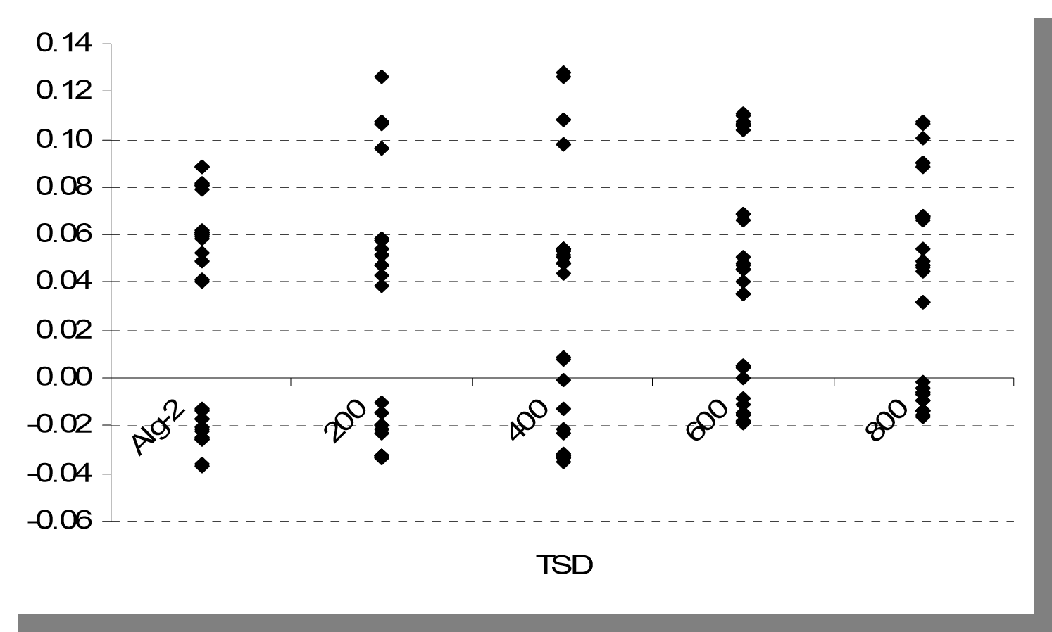

Figure 80. Sharpe Ratios obtained via different *TSD* values with *M2*.

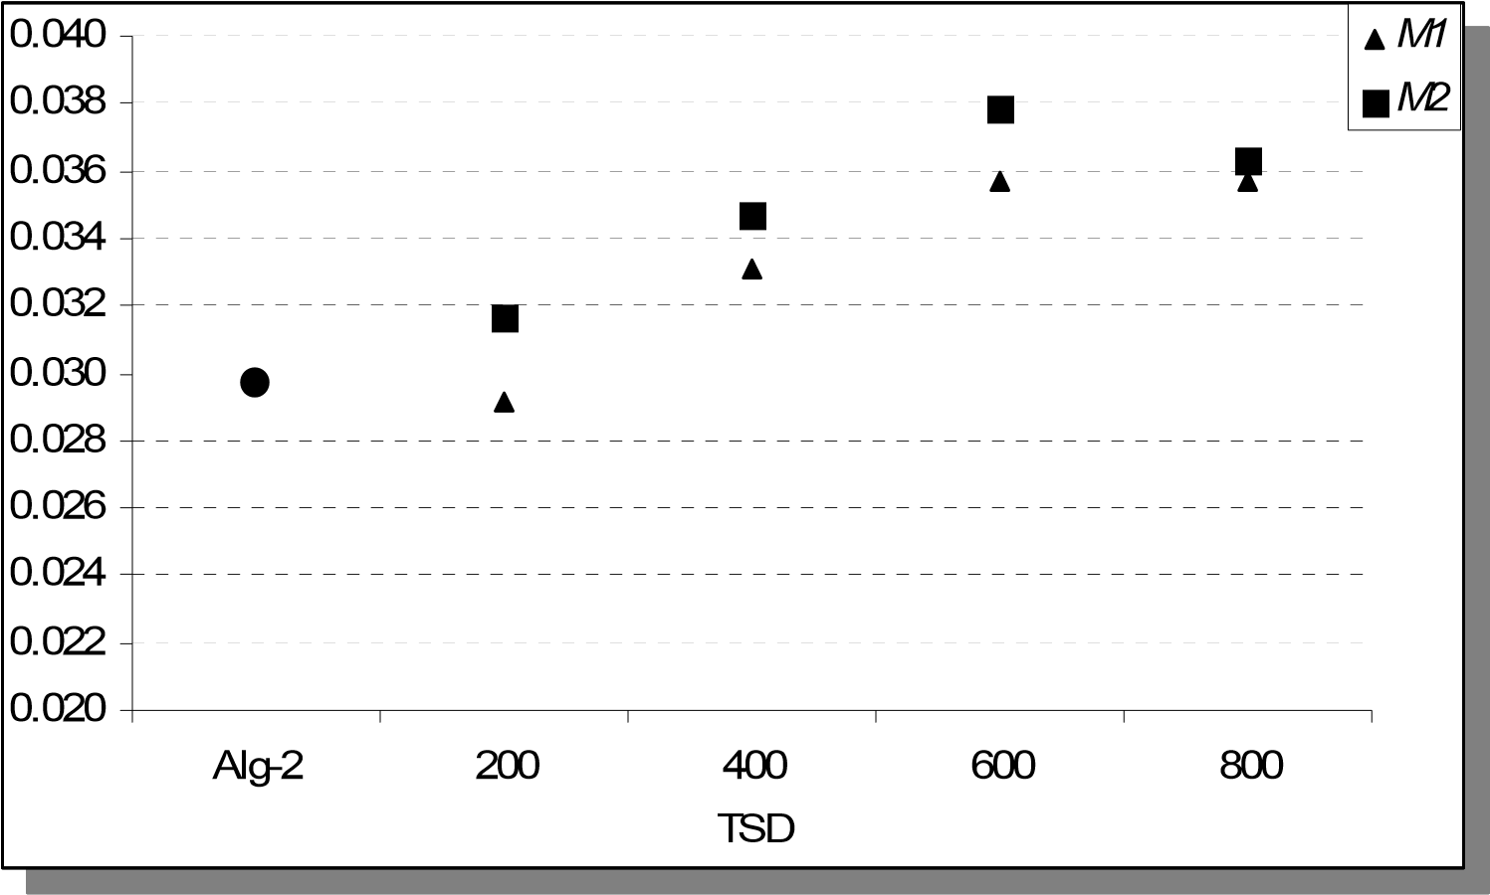

Figure 81. Average Sharpe Ratios obtained with both *M1* and *M2*.

The distributions of the Sharpe Ratios in both Figures 79 and 80 imply an improvement led by the implementation of the proposed approach when compared to the base strategy, Alg-2, where the positive effect is clearly identified through the average values in Figure

81. One can make three observations from these aggregate results:

1. Almost all problem settings with the new approach (except *M1* with *TSD*=200) outperforms the base strategy of the original Alg-2. This can be attributed to the potential benefit of employing the proposed regression-based approach itself.

1. Usage of *M2* leads to superior results when compared to M1 regardless the value

of *TSD*. This can be attributed to (*ri*2,*t*−1 +*ri*2,*t*−2 +*ri*2,*t*−3)being a better proxy for

instantaneous volatility than*ri*,*t*−1*ri*,*t*−2*ri*,*t*−3  . This is not unexpected considering the wide usage of squared returns as a proxy for volatility. The difference between two measures become more apparent when at least one of the return values is

close to zero, in which case *ri*,*t*−1*ri*,*t*−2*ri*,*t*−3  attains small values regardless the magnitude of the other returns.

The maximum performance is achieved when *TSD* = 600 regardless *M1* or *M2* is used as the proxy for volatility. This outcome can be attributed to the significance of regression coefficients, which are usually measured via *p*-values. As commonly interpreted, lower *p*-values support the rejection of the null-hypothesis that independent variables do not provide information about the dependent variable. Due to the high number of estimations carried over (i.e., 24,000), we provide here only the average *p*-values for each time window in Table 86. The last row in Table 86 shows that *p*-values get the lowest magnitude when *TSD* is

set to 600, which could be a valid explanation for the performance being maximized in this setting. In fact, the ranking of the other average *p*-values is in accordance with the average Sharpe Ratios as given in Table 87. In other words, the order of average *p*-values is the reverse of the order of average Sharpe Ratios for both *M1* and *M2*.

Table 86. Average *p*-values for each time window.

|  |  |  |  |  |
| --- | --- | --- | --- | --- |
|  |  | TSD | |  |
| Time Window | 200 | 400 | 600 | 800 |
| TW1 | 0.216966 | 0.065138 | 0.000096 | 0.000148 |
| TW2 | 0.334505 | 0.468634 | 0.000068 | 0.000012 |
| TW3 | 0.277518 | 0.154268 | 0.021265 | 0.022551 |
| TW4 | 0.238465 | 0.334029 | 0.005683 | 0.012273 |
| TW5 | 0.215589 | 0.142874 | 0.004237 **0.006270** | 0.000112  **0.007019** |
| **Overall Average** | **0.256609** | **0.232988** |

Table 87. Average *p*-values vs. average Sharpe Ratios.

|  |  |  |  |  |
| --- | --- | --- | --- | --- |
|  |  | TSD |  |  |
| Statistics | 200 | 400 | 600 | 800 |
| Avg. *p*-value | 0.256609 | 0.232988 | 0.006270 | 0.007019 |
| Avg. Sharpe Ratio (*M1*) | 0.029172 | 0.033090 | 0.035714 | 0.035709 |
| Avg. Sharpe Ratio (*M2*) | 0.031684 | 0.034698 | 0.037837 | 0.036320 |

In this chapter we proposed a general approach that is based on updating the investment decisions led by a given trading strategy. We implemented this approach considering Alg-2 as the underlying strategy and logistic regression as the learning model. We calibrated the main parameter *TSD* to 600, which provides the best return/risk profile among the tested values.

We should note that the magnitude of improvement on the performance measures and the corresponding parameter values can vary when different trading strategies, assets, and learning models are considered. However, the experimentation carried over in this section provides significant empirical support for the proposed approach.

### 5. CONCLUSION

In this study we presented a multi-period financial portfolio optimization framework based on stochastic programming (SP). We proposed two new scenario generation algorithms each capturing the uncertainty in random variables through creating discrete probability distributions on a scenario tree. We also presented a general multi-stage SP model to obtain the investment decisions to maximize the expected wealth given the generated scenario tree and limits on risk exposure at each decision node.

We implemented the proposed methodology considering different parameter and data sets in order to evaluate the performance in different settings and to obtain insight about the sensitivity of the results. We next summarize our methodological approach and computational results.

*NOTE 1*: In the following section we use the term *dominate* in order to compare two different strategies. We use the phrase “Strategy A dominates Strategy B” to mean than Strategy A yields a more efficient strategy such that it provides the investor with higher average return (less risk) than Strategy B given a fixed level of risk exposure (average return).

#### 5.1. Multi-Stage Linear SP model

We presented a multi-stage linear SP model with the objective of maximizing expected final wealth where the risk exposure is controlled by linear constraints on CVaR. For the implementation of the proposed scenario generation algorithms, we considered an asset allocation problem, where the investor has an initial amount of wealth and wants to allocate this amount among a risk-free asset and risky assets. Note that the multi-stage linear SP model presented in Chapter 2 is a comprehensive ALM model since it is also capable of handling cash inflows and outflows. In addition, risk measures different than the CVaR are included in the general model.

One aspect that is unique to our model to the best of our knowledge is the state dependent risk control. Instead of measuring risk merely at the horizon, we include linear constraints that limit the realized CVaR for each node of the scenario tree except the leaf nodes. In our computational analysis, we set all CVaR limits to the same value in each experiment. However, our general SP model is capable of setting different parameters for risk control at different decision epochs. Given a complete scenario tree, the decision maker is able to set a specific limit on CVaR depending on the state at a particular node or a particular time period.

The size of the deterministic version of the SP model presented and implemented in this study is determined mainly by the topology of the scenario tree. The experiments run for Alg-2 suggest the usage of larger scenario trees for improved performance; however, the problems become significantly larger as the number of scenarios is increased (see Table 88).

Table 88. Problem size for different tree topologies

|  |  |  |  |
| --- | --- | --- | --- |
| **Tree Topology** | **[8 4]** | **[30 15]** | **[80 40]** |
| Number of Scenarios | 32 | 450 | 3200 |
| Number of Constraints | 1,604 | 41,952 | 617,852 |
| Number of Variables | 876 | 11,810 | 83,460 |

#### 5.2. Alg-1A and Alg-1B

We present our first approach in the form of two separate, but very similar, scenario generation algorithms, Alg-1A and Alg-1B, to create scenario trees with the objective of capturing the true uncertainty associated with the random variables in question. Both scenario generation algorithms are based on the same idea of reducing the historical data set into a smaller but more relevant set such that the similarity between the current situation and the historical data set is increased. This reduction is achieved using similarity scores, which are computed via distance measures. There are two differences between Alg-1A and Alg-1B. First one is the type of the distance measure used to assign similarity scores. Alg-1A is based on *weighted* Euclidean distance whereas Alg-1B is built on the new *UD* distance measure proposed in Chapter 2. Another difference is that Alg-1B is implemented on price series rather than return series. The proposed approach can be implemented also via other distance measures such as *Mahalanobis* distance, which is equal to (*X*−*Y*)*T*Σ−1(*X*−*Y*) for random vectors *X* and *Y*. Note that this particular distance measure assumes a covariance structure given byΣ and has the Euclidean distance as a special case.

We implemented the resulting framework (i.e., first scenario generation approach and the proposed SP model) assuming that the investor has two alternatives for investing, one risky asset and one risk-free asset. As a proxy for the risky asset, we considered the weekly S&P 500 index.

Our main interest has been on a multi-period investment problem where the investor continues investing the portfolio resulting from the previous periods. However, we also carried over several experiments to see the performance of Alg-1A in a single period investing scheme. We considered both in-sample and out-of-sample testing and compared the proposed approach with the static strategy. The results show that Alg-1A dominates the static strategy. The level of dominance is much higher when average shortfall is assumed to be the risk measure.

The remaining computations presented in this study are implemented assuming a multiperiod investment setting. For the analysis in a multi-period investing scheme, we ran the scenario generation and optimization phases repetitively for consecutive periods such that the portfolio is revalued after realizing returns and reinvested using the results of the next run. We implemented both Alg-1A and Alg-1B using this methodology. For benchmarking purposes, we compared the results first with the B&H strategy as the alternative portfolio management strategy. Next we obtained the results for AR(2) and GBM as the alternative scenario generation methods using the same proposed SP model. We observe from the results that the proposed approach, regardless whether we employ Alg-1A or Alg-1B, outperforms the strategies led by B&H, AR(2), and GBM. The dominance is stronger especially when risk averseness is low (i.e., in the high risk region).

We performed further computations to observe the sensitivity against variation in input parameters and data. For instance, changing the weights used in weighted Euclidean distance revealed outcomes that suggest putting more weight to lower lags (i.e., more recent periods), which is in accordance with our original consideration and initial vector of weights. The sensitivity with respect to time unit has been also investigated by implementing the proposed approach over the *daily* S&P 500 index data (i.e., the time window denoted by TW1) instead of *weekly* data. We also implemented the aforementioned alternative strategies (i.e., B&H as the alternative portfolio management strategy and AR(2) and GBM as the alternative scenario generation tools) using the same set of data. The results suggest that the proposed approach dominates B&H, AR(2), and GBM regardless of the risk measure taken and regardless whether Alg-1A or Alg-1B is used for scenario generation.

Following the experiments considering a different time unit, we investigated the sensitivity with respect to time window. We considered four additional time windows, TW2-TW5, each having exclusive *test periods* of 100 days, which resulted in a high number of outcomes representing return/risk profiles. We presented the individual and average Sharpe Ratios obtained from each experiment in order to have a concise benchmarking process. The results we obtained from these additional experiments confirmed the conclusions suggested by the previous experiments. Considering the aggregate results from all time windows, the results suggest that the proposed approach dominates B&H, AR(2), and GBM. Among the proposed algorithms, Alg-1B outperformed the Alg-1A given the five time windows of daily S&P 500 index data. This is quite promising for the new *UD* distance measure proposed in this study.

#### 5.3. Alg-2

Separate than the first approach, we proposed another approach, Alg-2, which aims to find a discrete probability distribution for the scenarios such that the first four moments of the generated scenarios are closely matched with target moments through a linear program. This approach incorporates state dependency of variance via the well-known EGARCH model. The first two target moments are set dynamically by EGARCH and CCC-GARCH over the scenario tree (i.e., the innovations on each node are used to estimate the second moments in the following node) whereas the third and fourth moments are set by historical estimation. Once the target moments are set, a linear programming model is run for the entire scenario tree to obtain the scenario probabilities.

During the design stage of this algorithm, we also investigated an issue led by using moment matching technique for a multi period model. During the moment matching process for a particular source node, a number of nodes (i.e., scenarios) following the source node could be assigned probabilities that are either equal or close to zero. Considering the multi-period structure of the scenario tree, we discussed the likely event of having zero probabilities for many scenarios at the horizon since the final probabilities are computed by multiplying all probabilities on the underlying path. We presented a test case to illustrate this issue and argued that it might decrease the performance of a multiperiod SP model. Therefore, we proposed setting lower-bounds on probabilities, which would be calibrated in accordance with the data used.

For our computations regarding Alg-2, we assumed that the investor appropriates a multiperiod investing scheme and has three alternatives for investing, two risky assets and one risk-free asset. As proxies for the risky assets, we considered the weekly S&P 500 (largecap) and Russell 2000 (small-cap) stock indices.

We first investigated the effects of setting lower bounds on scenario probabilities during the moment matching. The results supported our initial discussion since setting a lower bound led to an improved return/risk profile. The lower bound was calibrated through multiple experiments which show that exposing high lower-bounds worsen the performance. This was expected since setting high lower-bounds would lead to large deviations from target moments.

The next set of experiments was carried over in order to reveal the effect of incorporating EGARCH into the scenario generation methodology. For this purpose, we implemented the same framework without EGARCH (i.e., state-independent variance) and lowerbounds on probabilities. The results strongly favored Alg-2 since removing EGARCH resulted in lowered performance.

For benchmarking purposes, we compared the results with B&H strategy and Markowitz’s MV model as the alternative portfolio management strategies over the same set of data. Regardless of the risk measure used, the results suggested that Alg-2 dominates both B&H and MV strategies. The dominance was found to be more significant especially in the high risk region. Next we obtained the results for VAR(2) as the alternative scenario generation method using the same proposed SP model. We observed that the trading strategy with Alg-2 dominates the one with VAR(2) for all risk regions when variance is taken as the risk measure whereas the dominance is clearly observed only in the high risk region when average shortfall is taken as the risk measure. We also observed that VAR(2) led to a trading strategy with high turnover, which leads to higher transaction costs. In a new set of computations, we implemented both strategies with a higher unit transaction cost and Alg-2 outperformed VAR(2) in this experiment regardless of the risk region and risk measure taken.

For sensitivity analysis, we first considered the weights used in the objective function of the moment matching model. Considering the base tree topology of [30 15], the results were not too sensitive to different weight vectors; however, we observed an increase in sensitivity when we made experiments with a different tree topology, [8 4]. This was expected since the decrease in the number of scenarios leads to fewer variables (i.e., probabilities) to fit the all four moments. From this same set of experiments, we had the opportunity to evaluate the sensitivity with respect to the tree topology, or sensitivity against the number of scenarios. The change from a topology of [8 4] to [30 15] provides a significant and positive change in the output. The comparison of Sharpe Ratios reveals that allowing more scenarios in the tree pays off by an increase in performance, which is in accordance with the well known trade-off for SP models.

Following the same procedure mentioned in Section 5.2, the next set of observations are pulled out from experiments involving *daily* S&P 500 and Russell 2000 data in order to analyze the sensitivity with respect to both time unit and time windows. For instance similar to the experiments on weekly data we carried of several experiments on the first daily time window TW1, which was used for Alg-1A and Alg-1B, to calibrate the lower bound parameter for the daily investment setting. The resulting parameter was found to be smaller than the one corresponding to the weekly data. Setting the calibrated lower bound parameter, we considered the four time windows TW2-TW5, which were used for Alg-1A and Alg-1B, for the rest of the computations.

Another set of computations were achieved to investigate the pure contribution of EGARCH modeling in scenario generation as described for the weekly experiments. The results obtained from five time windows TW1-TW5 indicate that usage of EGARCH improves the return/risk profile of the trading strategy. This observation is in agreement with the one obtained from the weekly data.

Sensitivity with respect to weights used in the objective function of the moment matching model has been reinvestigated considering the daily data. Even though there were no significant discrepancies among the different weight vectors, the Sharpe Ratios imply that the performance over daily data is improved when maximum weight is used for the fourth moment. This can be *partially* explained by the fat-tail characteristic of the high frequency financial data.

Using the weekly data we had obtained results in alignment with the tradeoff between the problem size and the performance of the SP based approaches since the strategy based on a [30 15] scenario tree dominated the one based on the [8 4] tree. We extended this sensitivity analysis over the daily time windows TW1-TW5. Plus, we implemented the proposed approach with [80 40] scenario tree topology in addition to [30 15] and [8 4]. The switch from [30 15] to [80 40] changed the performance; however, the sensitivity was much higher when compared to the transition from [8 4] to [30 15]. Nevertheless, the results suggest that increase in problem size is compensated by an increase in performance. Therefore, computations regarding the scenario tree suggest that the performance is sensitive to the scenario tree topology; however, the possible gains from an increased number of scenarios might be diminishing depending on the starting tree topology.

The final set of computations aimed at benchmarking the proposed approach with the alternative strategies considering a daily investment environment. Similar to the weekly setting, we implemented B&H and Markowitz’s MV strategy as the alternative portfolio management strategies over the time windows TW1-TW5. The aggregate results presented by the Sharpe Ratios show that the proposed strategy outperforms both B&H and MV strategies when implemented by a scenario tree topology of [80 40]. When the [30 15] scenario tree is implemented, it is only slightly outperformed by MV whereas it still outperforms the B&H strategy. Next we obtained the results for VAR(2) as the alternative scenario generation method using the same proposed SP model over the daily time windows TW1-TW5. The combination of Alg-2 and the proposed SP model generated a higher performance than VAR(2) combined with the same SP model regardless we consider a scenario tree with the topology of [30 15] or [80 40].

#### 5.4. A General Approach for Loss Reduction

In Chapter 4, we presented a general approach aiming to modify investment decisions led by a given trading strategy in accordance with the state of the market in terms of volatility. The proposed methodology is based on utilizing all information realized up to time tick *t*-1 within a learning model to infer probability of a significant loss at time tick *t*. In particular, we considered logistic regression to make predictions and take corrective actions on the original investment decisions with the intention of preventing significant losses and enhancing the return/risk profile.

We considered two simple proxies for volatility at a given time to be used as the independent variables in logistic regression, which are functions of the past three return values. We implemented the combined approach over time windows TW1-TW5 having Alg-2 and the SP model presented in Chapter 2 as the underlying trading strategy. The implementation process involves setting a threshold value, which identifies a trading decision as a significant loss in the following period.

We tested four different threshold values with two different proxies adding up to eight different trading strategies, all of which improved performance except one. The second proxy (i.e., sum of squared returns) outperformed the first measure (i.e., absolute value of the product of returns) at all threshold values, whereas the maximum performance is observed when the threshold is set to 600 for both proxies. This observation is in alignment with the average *p*-values obtained from regression estimations.

*NOTE 2:* It can be argued how sensitive the results presented in Chapters 3 and 4 are with respect to the composition of S&P 500 company list as this index is considered as one of the two representative risky assets in this study, the other one being Russell 2000 index.

We conjecture that the sensitivity will be extremely low because of two reasons:

1. The turnover in the company list is low when we consider the additions/deletions provided in Table 89. Moreover, the weekly and daily time windows considered in this study (i.e., 2001-2007 and 2003-2006) have average number of additions/deletions to be 21.5 and 26.6, which are lower than the average number of additions/deletions over 2000-2008, which is 32.2.

1. Standard & Poor’s requires certain criteria for the companies to be eligible for S&P 500 index such as market capitalization, liquidity, financial viability, etc. Therefore, the removal of the companies that fail the criteria and inclusion of those that meet the criteria is expected to keep the index to be based on similar underlying components and less sensitive to additions/deletions over time.

Table 89. Changes in S&P 500 company listing

|  |  |
| --- | --- |
| Year | Number of Additions/Deletions |
| 2009* | 17 |
| 2008 | 44 |
| 2007 | 43 |
| 2006 | 34 |
| 2005 | 21 |
| 2004 | 22 |
| 2003 | 9 |
| 2002 | 25 |
| 2001 | 32 |
| 2000 | 60 |

*As of 8/18/09

*NOTE 3*: The portfolio management strategies considered in this study have different levels of *portfolio turnover*. The lowest turnover is observed for the static B&H strategy, in which case there is no trade after the initial asset allocation. Another strategy implemented in this study with a low portfolio turnover is the MV approach, which is based on solving a quadratic optimization problem with the inputs of covariance matrix and expected return vector. These input parameters were estimated for each test period; however, they are not expected to change significantly from one period to the next period considering the entire historical data set. Therefore, we obtained very low turnover for MV approach. The highest portfolio turnover was observed when scenarios are generated via VAR(2). This issue is further discussed in Section 3.2.5 based on the experiments carried over with different transaction costs. Different than the alternative approaches, the proposed approaches led to moderate levels of portfolio turnover at various experiments.

*NOTE 4*: Throughout the implementation process presented in this study, we paid special attention on the experimental setup for alternative strategies. Experiments with different input parameters and data provided a significant number of performance measures and therefore enabled us to achieve an extensive sensitivity analysis. We increased the precision of the estimates for the performance measures led by alternative strategies by keeping the number of experiments specifically high. For instance, *average return* is the major driver of the performance measures considered in this study and the standard error of this measure is inversely proportional to the square root of the number of observations. Considering the high number of runs at different experiments (e.g., 2,500-3,000), we can conclude that the estimates for the performance measures are satisfactorily precise from the statistical significance point of view.

#### 5.5. Research Contributions

We identify the contributions of this study briefly as follow:

* We developed a new scenario generation approach based on reducing historical data and assigning probabilities via distance measures. The algorithm does not require estimation or optimization procedures.
  + We proposed a new distance measure to capture the similarities between data patterns. It is used as an alternative to the weighted Euclidean distance to implement the proposed scenario generation approach.
* We developed another new scenario generation approach that combines the moment matching technique with the ARCH-type modeling approach and provides input for an SP model.
  + In particular, we incorporated state dependent second moments into the scenario generation phase via EGARCH and CCC-GARCH.
  + We addressed the issue of having extremely low scenario probabilities and proposed imposing lower-bounds that are calibrated to navigate the tradeoff between fitting the moments and the overall performance of the SP model.
* We proposed a comprehensive multi-stage linear SP formulation that is capable of addressing a diverse set of parameters, constraints, and objectives.
  + We presented constraints that enable the decision maker to control risk with different risk tolerances at each decision epoch. Each node in the scenario tree except the leaf nodes has its own set of constraints to control the realized CVaR.
* We proposed a general methodology that can be appended to any trading strategy to increase the original performance from a return/risk point of view.
  + The implementation, which is presented in Chapter 4, yielded empirical results that strongly support the proposed approach when used in conjunction with Alg-2 and the SP model presented Chapter 2.

#### 5.6. Directions for Future Research

Stochastic programming is a broad area of operations research providing flexible models that are able to solve complex real life problems faced in various domains. The success of a SP based approach depends strictly on its capability to capture the underlying uncertainty associated with the random parameters in question. This makes the scenario generation phase especially critical. Therefore, developing new methodologies to generate representative scenario trees is still an open research area. We conjecture that domain-specific algorithms would perform better than generic algorithms.

The scenario generation algorithms proposed in this study can be combined with actuarial methodologies to generate representative liability scenarios so that a complete ALM system is obtained. The combined framework would be applicable to additional problems where positive and negative cash flows are involved.

An extension of this study that could be quite rewarding is the further development of the general decision rule presented in Chapter 4 through further computations and modeling effort. A learning model that is able to capture possible states of the market and relate this to the performance of a trading strategy can produce significant improvement as shown in this study. In fact the general approach described in Section 4.2 can also be implemented using a model other than logistic regression and combined with a scenario generation algorithm or a SP model in order to obtain a portfolio management framework that can adapt to changing market conditions and provide enhanced investment decisions.

We conjecture that external factors such as interest rates (i.e., risk-free return) could affect the relative and absolute performances of portfolio optimization models. In our analyses we assumed that the risk-free rates are fixed throughout the horizon, which is a sound assumption since the planning horizon is short (i.e., several days/weeks). Another possible way of addressing the portfolio management problem is to consider longer planning horizons (i.e., several months/years), which could benefit from incorporating a stochastic interest rate model (e.g., Hull and White (1994a-b) into the scenario generation process.

### APPENDIX A

Table 2. Probability values for a test case of 450 scenarios

|  |  |  |  |  |
| --- | --- | --- | --- | --- |
| 0.0000 0.0000 0.0000 0.0000 0.0000 0.0000 0.0000 0.0000 0.0000 0.0000 | | | | |
| 0.0000 0.0000 0.0000 0.0000 | 0.0000 | 0.0000 | 0.0000 | 0.0000 0.0000 0.0000 |
| 0.0000 0.0000 0.0000 0.0000 | 0.0000 | 0.0000 | 0.0000 | 0.0000 0.0000 0.0000 |
| 0.0000 0.0000 0.0000 0.0000 | 0.0000 | 0.0000 | 0.0000 | 0.0000 0.0000 0.0000 |
| 0.0000 0.0000 0.0000 0.0000 | 0.0000 | 0.0000 | 0.0000 | 0.0000 0.0000 0.0000 |
| 0.0000 0.0000 0.0000 0.0000 | 0.0000 | 0.0000 | 0.0000 | 0.0000 0.0000 0.0000 |
| 0.0000 0.0000 0.0000 0.0000 | 0.0000 | 0.0000 | 0.0000 | 0.0000 0.0000 0.0000 |
| 0.0000 0.0000 0.0000 0.0000 | 0.0000 | 0.0000 | 0.0000 | 0.0000 0.0000 0.0000 |
| 0.0000 0.0000 0.0000 0.0000 | 0.0000 | 0.0000 | 0.0000 | 0.0000 0.0000 0.0000 |
| 0.0000 0.0000 0.0000 0.0000 | 0.0000 | 0.0000 | 0.0000 | 0.0000 0.0000 0.0000 |
| 0.0000 0.0000 0.0000 0.0000 | 0.0000 | 0.0000 | 0.0000 | 0.0000 0.0000 0.0000 |
| 0.0000 0.0000 0.0000 0.0000 | 0.0000 | 0.0000 | 0.0000 | 0.0000 0.0000 0.0000 |
| 0.0000 0.0000 0.0000 0.0000 | 0.0000 | 0.0000 | 0.0000 | 0.0000 0.0000 0.0000 |
| 0.0000 0.0000 0.0000 0.0000 | 0.0000 | 0.0000 | 0.0000 | 0.0000 0.0000 0.0000 |
| 0.0000 0.0000 0.0000 0.0000 | 0.0000 | 0.0000 | 0.0000 | 0.0000 0.0000 0.0000 |
| 0.0000 0.0574 0.0000 0.0000 | 0.0000 | 0.0000 | 0.0000 | 0.0000 0.0000 0.0000 |
| 0.0032 0.1967 0.0000 0.0000 | 0.0000 | 0.0000 | 0.0000 | 0.0000 0.0000 0.0319 |
| 0.0017 0.0000 0.0000 0.0000 | 0.0000 | 0.0000 | 0.0000 | 0.0000 0.0000 0.0000 |
| 0.0000 0.0000 0.0000 0.0000 | 0.0000 | 0.0000 | 0.0000 | 0.0000 0.0000 0.0198 |
| 0.0156 0.0000 0.0000 0.0000 | 0.0000 | 0.0732 | 0.0000 | 0.0000 0.0000 0.0000 |
| 0.0053 0.0819 0.0000 0.0000 | 0.0000 | 0.0000 | 0.0000 | 0.0000 0.0000 0.0000 |
| 0.0000 0.0000 0.0000 0.0000 | 0.0000 | 0.0000 | 0.0000 | 0.0000 0.0000 0.0000 |
| 0.0272 0.0178 0.0000 0.0000 | 0.0000 | 0.0478 | 0.0000 | 0.0000 0.0000 0.0000 |
| 0.0418 0.0000 0.0000 0.0000 | 0.0000 | 0.0000 | 0.0000 | 0.0000 0.0000 0.0000 |
| 0.0117 0.0000 0.0000 0.0000 | 0.0000 | 0.0000 | 0.0000 | 0.0000 0.0000 0.0000 |
| 0.0000 0.0169 0.0000 0.0000 | 0.0000 | 0.0000 | 0.0000 | 0.0000 0.0000 0.0159 |
| 0.0000 0.0000 0.0000 0.0000 | 0.0000 | 0.0421 | 0.0000 | 0.0000 0.0000 0.0000 |
| 0.0000 0.0000 0.0000 0.0000 | 0.0000 | 0.0000 | 0.0000 | 0.0000 0.0000 0.0033 |
| 0.0266 0.0000 0.0000 0.0000 | 0.0000 | 0.0000 | 0.0000 | 0.0000 0.0000 0.0000 |
| 0.0000 0.0000 0.0000 0.0000 | 0.0000 | 0.0290 | 0.0000 | 0.0000 0.0000 0.0000 |
| 0.0000 0.0000 0.0000 0.0000 | 0.0000 | 0.0000 | 0.0000 | 0.0000 0.0000 0.0000 |
| 0.0000 0.0000 0.0000 0.0000 | 0.0000 | 0.0000 | 0.0000 | 0.0000 0.0000 0.0000 |
| 0.0000 0.0000 0.0000 0.0000 | 0.0000 | 0.0000 | 0.0000 | 0.0000 0.0000 0.0000 |
| 0.0000 0.0000 0.0000 0.0000 | 0.0000 | 0.0000 | 0.0000 | 0.0000 0.0000 0.0000 |
| 0.0000 0.0279 0.0000 0.0000 | 0.0000 | 0.0000 | 0.0000 | 0.0000 0.0000 0.0000 |
| 0.0000 0.0864 0.0000 0.0000 | 0.0000 | 0.0000 | 0.0000 | 0.0000 0.0000 0.0000 |
| 0.0000 0.0287 0.0000 0.0000 | 0.0000 | 0.0000 | 0.0000 | 0.0000 0.0000 0.0000 |
| 0.0000 0.0000 0.0000 0.0000 | 0.0000 | 0.0000 | 0.0000 | 0.0000 0.0000 0.0000 |
| 0.0000 0.0000 0.0000 0.0000 | 0.0000 | 0.0000 | 0.0000 | 0.0000 0.0000 0.0000 |
| 0.0000 0.0000 0.0000 0.0000 | 0.0000 | 0.0000 | 0.0000 | 0.0000 0.0000 0.0000 |
| 0.0000 0.0000 0.0000 0.0000 | 0.0000 | 0.0000 | 0.0000 | 0.0000 0.0000 0.0000 |
| 0.0000 0.0000 0.0000 0.0000 | 0.0000 | 0.0000 | 0.0000 | 0.0000 0.0000 0.0000 |
| 0.0000 0.0903 0.0000 0.0000 | 0.0000 | 0.0000 | 0.0000 | 0.0000 0.0000 0.0000 |
| 0.0000 0.0000 0.0000 0.0000 | 0.0000 | 0.0000 | 0.0000 | 0.0000 0.0000 0.0000 |
| 0.0000 0.0000 0.0000 0.0000 | 0.0000 | 0.0000 | 0.0000 | 0.0000 0.0000 0.0000 |

### APPENDIX B (Alg-1)

Table 3. Decisions table for Alg-1A, LCVAR=10 (Single Period)

|  |  |  |  |  |  |  |  |
| --- | --- | --- | --- | --- | --- | --- | --- |
| **t** | **CASH** | **SP500** | **W** | **t** | **CASH** | **SP500** | **W** |
| 201 | 631.73 | 367.91 | 1004.81 | 251 | 635.43 | 364.21 | 996.09 |
| 202 | 1000.00 | 0.00 | 1000.40 | 252 | 729.70 | 270.03 | 995.01 |
| 203 | 781.08 | 218.70 | 1000.62 | 253 | 1000.00 | 0.00 | 1000.40 |
| 204 | 1000.00 | 0.00 | 1000.40 | 254 | 1000.00 | 0.00 | 1000.40 |
| 205 | 1000.00 | 0.00 | 1000.40 | 255 | 1000.00 | 0.00 | 1000.40 |
| 206 | 640.12 | 359.52 | 994.39 | 256 | 639.63 | 360.01 | 1001.02 |
| 207 | 1000.00 | 0.00 | 1000.40 | 257 | 1000.00 | 0.00 | 1000.40 |
| 208 | 677.10 | 322.58 | 1000.17 | 258 | 1000.00 | 0.00 | 1000.40 |
| 209 | 652.93 | 346.72 | 1025.93 | 259 | 1000.00 | 0.00 | 1000.40 |
| 210 | 683.47 | 316.22 | 1007.90 | 260 | 514.98 | 484.54 | 1003.22 |
| 211 | 1000.00 | 0.00 | 1000.40 | 261 | 599.98 | 399.62 | 996.37 |
| 212 | 1000.00 | 0.00 | 1000.40 | 262 | 649.23 | 350.42 | 990.17 |
| 213 | 1000.00 | 0.00 | 1000.40 | 263 | 1000.00 | 0.00 | 1000.40 |
| 214 | 1000.00 | 0.00 | 1000.40 | 264 | 603.17 | 396.44 | 968.17 |
| 215 | 1000.00 | 0.00 | 1000.40 | 265 | 1000.00 | 0.00 | 1000.40 |
| 216 | 633.58 | 366.05 | 1000.15 | 266 | 1000.00 | 0.00 | 1000.40 |
| 217 | 728.91 | 270.82 | 1004.36 | 267 | 1000.00 | 0.00 | 1000.40 |
| 218 | 1000.00 | 0.00 | 1000.40 | 268 | 1000.00 | 0.00 | 1000.40 |
| 219 | 1000.00 | 0.00 | 1000.40 | 269 | 690.79 | 308.90 | 995.10 |
| 220 | 1000.00 | 0.00 | 1000.40 | 270 | 1000.00 | 0.00 | 1000.40 |
| 221 | 1000.00 | 0.00 | 1000.40 | 271 | 674.94 | 324.74 | 991.85 |
| 222 | 1000.00 | 0.00 | 1000.40 | 272 | 1000.00 | 0.00 | 1000.40 |
| 223 | 1000.00 | 0.00 | 1000.40 | 273 | 518.93 | 480.59 | 1003.99 |
| 224 | 1000.00 | 0.00 | 1000.40 | 274 | 668.21 | 331.46 | 997.65 |
| 225 | 515.30 | 484.22 | 1006.79 | 275 | 1000.00 | 0.00 | 1000.40 |
| 226 | 1000.00 | 0.00 | 1000.40 | 276 | 608.37 | 391.24 | 1006.33 |
| 227 | 1000.00 | 0.00 | 1000.40 | 277 | 1000.00 | 0.00 | 1000.40 |
| 228 | 1000.00 | 0.00 | 1000.40 | 278 | 1000.00 | 0.00 | 1000.40 |
| 229 | 672.60 | 327.08 | 1001.12 | 279 | 1000.00 | 0.00 | 1000.40 |
| 230 | 1000.00 | 0.00 | 1000.40 | 280 | 621.09 | 378.53 | 1010.75 |
| 231 | 1000.00 | 0.00 | 1000.40 | 281 | 1000.00 | 0.00 | 1000.40 |
| 232 | 626.88 | 372.75 | 1002.22 | 282 | 691.46 | 308.23 | 1001.60 |
| 233 | 572.07 | 427.51 | 1004.90 | 283 | 1000.00 | 0.00 | 1000.40 |
| 234 | 659.61 | 340.05 | 1003.83 | 284 | 571.20 | 428.38 | 1000.84 |
| 235 | 1000.00 | 0.00 | 1000.40 | 285 | 609.25 | 390.36 | 1005.43 |
| 236 | 1000.00 | 0.00 | 1000.40 | 286 | 1000.00 | 0.00 | 1000.40 |
| 237 | 624.58 | 375.04 | 1000.02 | 287 | 616.63 | 382.99 | 986.74 |
| 238 | 606.00 | 393.60 | 1004.59 | 288 | 1000.00 | 0.00 | 1000.40 |
| 239 | 719.32 | 280.40 | 1003.96 | 289 | 708.53 | 291.18 | 1000.11 |
| 240 | 623.10 | 376.53 | 1011.35 | 290 | 643.85 | 355.79 | 1015.34 |
| 241 | 1000.00 | 0.00 | 1000.40 | 291 | 537.46 | 462.08 | 1000.85 |
| 242 | 1000.00 | 0.00 | 1000.40 | 292 | 1000.00 | 0.00 | 1000.40 |
| 243 | 610.67 | 388.94 | 1029.04 | 293 | 1000.00 | 0.00 | 1000.40 |
| 244 | 707.87 | 291.84 | 1003.06 | 294 | 1000.00 | 0.00 | 1000.40 |
| 245 | 1000.00 | 0.00 | 1000.40 | 295 | 1000.00 | 0.00 | 1000.40 |
| 246 | 662.01 | 337.65 | 1004.99 | 296 | 1000.00 | 0.00 | 1000.40 |
| 247 | 1000.00 | 0.00 | 1000.40 | 297 | 674.92 | 324.75 | 992.09 |
| 248 | 582.58 | 417.00 | 1009.31 | 298 | 603.25 | 396.35 | 1002.30 |
| 249 | 1000.00 | 0.00 | 1000.40 | 299 | 556.55 | 443.01 | 1009.59 |
| 250 1000.00 0.00 1000.40 | | | | 300 1000.00 0.00 1000.40 | | | |

Table 4. Decisions table for Alg-1A, LCVAR=15 (Single Period)

|  |  |  |  |  |  |  |  |
| --- | --- | --- | --- | --- | --- | --- | --- |
| **t** | **CASH** | **SP500** | **W** | **t** | **CASH** | **SP500** | **W** |
| 201 | 454.67 | 544.79 | 1006.92 | 251 | 460.16 | 539.30 | 994.01 |
| 202 | 1000.00 | 0.00 | 1000.40 | 252 | 599.60 | 400.00 | 992.42 |
| 203 | 683.29 | 316.39 | 1000.72 | 253 | 1000.00 | 0.00 | 1000.40 |
| 204 | 1000.00 | 0.00 | 1000.40 | 254 | 1000.00 | 0.00 | 1000.40 |
| 205 | 1000.00 | 0.00 | 1000.40 | 255 | 1000.00 | 0.00 | 1000.40 |
| 206 | 467.10 | 532.37 | 991.50 | 256 | 466.37 | 533.09 | 1001.31 |
| 207 | 1000.00 | 0.00 | 1000.40 | 257 | 1000.00 | 0.00 | 1000.40 |
| 208 | 521.85 | 477.67 | 1000.06 | 258 | 1000.00 | 0.00 | 1000.40 |
| 209 | 486.07 | 513.41 | 1038.20 | 259 | 1000.00 | 0.00 | 1000.40 |
| 210 | 531.29 | 468.25 | 1011.50 | 260 | 281.80 | 717.49 | 1004.57 |
| 211 | 1000.00 | 0.00 | 1000.40 | 261 | 407.66 | 591.74 | 994.42 |
| 212 | 1000.00 | 0.00 | 1000.40 | 262 | 480.59 | 518.89 | 985.25 |
| 213 | 1000.00 | 0.00 | 1000.40 | 263 | 1000.00 | 0.00 | 1000.40 |
| 214 | 1000.00 | 0.00 | 1000.40 | 264 | 412.38 | 587.03 | 952.66 |
| 215 | 1000.00 | 0.00 | 1000.40 | 265 | 1000.00 | 0.00 | 1000.40 |
| 216 | 457.42 | 542.04 | 1000.04 | 266 | 1000.00 | 0.00 | 1000.40 |
| 217 | 501.33 | 498.17 | 1007.68 | 267 | 1000.00 | 0.00 | 1000.40 |
| 218 | 1000.00 | 0.00 | 1000.40 | 268 | 1000.00 | 0.00 | 1000.40 |
| 219 | 1000.00 | 0.00 | 1000.40 | 269 | 542.13 | 457.41 | 992.55 |
| 220 | 1000.00 | 0.00 | 1000.40 | 270 | 1000.00 | 0.00 | 1000.40 |
| 221 | 1000.00 | 0.00 | 1000.40 | 271 | 518.66 | 480.86 | 987.74 |
| 222 | 1000.00 | 0.00 | 1000.40 | 272 | 1000.00 | 0.00 | 1000.40 |
| 223 | 1000.00 | 0.00 | 1000.40 | 273 | 287.64 | 711.65 | 1005.72 |
| 224 | 1000.00 | 0.00 | 1000.40 | 274 | 508.69 | 490.82 | 996.33 |
| 225 | 282.27 | 717.01 | 1009.85 | 275 | 1000.00 | 0.00 | 1000.40 |
| 226 | 1000.00 | 0.00 | 1000.40 | 276 | 420.09 | 579.34 | 1009.19 |
| 227 | 1000.00 | 0.00 | 1000.40 | 277 | 1000.00 | 0.00 | 1000.40 |
| 228 | 1000.00 | 0.00 | 1000.40 | 278 | 1000.00 | 0.00 | 1000.40 |
| 229 | 515.19 | 484.33 | 1001.46 | 279 | 1000.00 | 0.00 | 1000.40 |
| 230 | 1000.00 | 0.00 | 1000.40 | 280 | 438.72 | 560.72 | 1015.73 |
| 231 | 1000.00 | 0.00 | 1000.40 | 281 | 1000.00 | 0.00 | 1000.40 |
| 232 | 447.50 | 551.95 | 1003.09 | 282 | 543.13 | 456.42 | 1002.18 |
| 233 | 366.33 | 633.04 | 1007.06 | 283 | 1000.00 | 0.00 | 1000.40 |
| 234 | 495.96 | 503.53 | 1005.47 | 284 | 365.04 | 634.33 | 1001.05 |
| 235 | 1000.00 | 0.00 | 1000.40 | 285 | 421.39 | 578.03 | 1007.85 |
| 236 | 1000.00 | 0.00 | 1000.40 | 286 | 1000.00 | 0.00 | 1000.40 |
| 237 | 444.09 | 555.35 | 999.84 | 287 | 432.32 | 567.12 | 980.18 |
| 238 | 416.58 | 582.84 | 1006.62 | 288 | 1000.00 | 0.00 | 1000.40 |
| 239 | 584.38 | 415.21 | 1005.67 | 289 | 568.39 | 431.18 | 999.97 |
| 240 | 441.89 | 557.55 | 1016.60 | 290 | 472.62 | 526.85 | 1022.52 |
| 241 | 1000.00 | 0.00 | 1000.40 | 291 | 315.08 | 684.23 | 1001.06 |
| 242 | 1000.00 | 0.00 | 1000.40 | 292 | 1000.00 | 0.00 | 1000.40 |
| 243 | 423.49 | 575.94 | 1042.81 | 293 | 1000.00 | 0.00 | 1000.40 |
| 244 | 567.42 | 432.15 | 1004.34 | 294 | 1000.00 | 0.00 | 1000.40 |
| 245 | 1000.00 | 0.00 | 1000.40 | 295 | 1000.00 | 0.00 | 1000.40 |
| 246 | 499.51 | 499.99 | 1007.20 | 296 | 1000.00 | 0.00 | 1000.40 |
| 247 | 1000.00 | 0.00 | 1000.40 | 297 | 518.63 | 480.89 | 988.10 |
| 248 | 381.90 | 617.49 | 1013.61 | 298 | 412.51 | 586.90 | 1003.21 |
| 249 | 1000.00 | 0.00 | 1000.40 | 299 | 343.35 | 655.99 | 1014.00 |
| 250 | 1000.00 | 0.00 | 1000.40 | 300 | 1000.00 | 0.00 | 1000.40 |

Table 5. Decisions table for Alg-1A, LCVAR=20 (Single Period)

|  |  |  |  |  |  |  |  |
| --- | --- | --- | --- | --- | --- | --- | --- |
| **t** | **CASH** | **SP500** | **W** | **t** | **CASH** | **SP500** | **W** |
| 201 | 277.61 | 721.66 | 1009.03 | 251 | 284.88 | 714.40 | 991.94 |
| 202 | 1000.00 | 0.00 | 1000.40 | 252 | 469.50 | 529.97 | 989.82 |
| 203 | 580.39 | 419.19 | 1000.82 | 253 | 1000.00 | 0.00 | 1000.40 |
| 204 | 1000.00 | 0.00 | 1000.40 | 254 | 1000.00 | 0.00 | 1000.40 |
| 205 | 1000.00 | 0.00 | 1000.40 | 255 | 1000.00 | 0.00 | 1000.40 |
| 206 | 294.08 | 705.21 | 988.60 | 256 | 293.12 | 706.17 | 1001.61 |
| 207 | 1000.00 | 0.00 | 1000.40 | 257 | 1000.00 | 0.00 | 1000.40 |
| 208 | 366.61 | 632.76 | 999.95 | 258 | 1000.00 | 0.00 | 1000.40 |
| 209 | 319.21 | 680.11 | 1050.48 | 259 | 1000.00 | 0.00 | 1000.40 |
| 210 | 379.11 | 620.27 | 1015.09 | 260 | 48.61 | 950.43 | 1005.91 |
| 211 | 1000.00 | 0.00 | 1000.40 | 261 | 215.35 | 783.87 | 992.49 |
| 212 | 1000.00 | 0.00 | 1000.40 | 262 | 311.96 | 687.36 | 980.33 |
| 213 | 1000.00 | 0.00 | 1000.40 | 263 | 1000.00 | 0.00 | 1000.40 |
| 214 | 1000.00 | 0.00 | 1000.40 | 264 | 221.59 | 777.63 | 937.16 |
| 215 | 1000.00 | 0.00 | 1000.40 | 265 | 1000.00 | 0.00 | 1000.40 |
| 216 | 281.26 | 718.02 | 999.91 | 266 | 1000.00 | 0.00 | 1000.40 |
| 217 | 339.30 | 660.04 | 1010.05 | 267 | 1000.00 | 0.00 | 1000.40 |
| 218 | 1000.00 | 0.00 | 1000.40 | 268 | 1000.00 | 0.00 | 1000.40 |
| 219 | 1000.00 | 0.00 | 1000.40 | 269 | 393.47 | 605.92 | 990.00 |
| 220 | 1000.00 | 0.00 | 1000.40 | 270 | 1000.00 | 0.00 | 1000.40 |
| 221 | 1000.00 | 0.00 | 1000.40 | 271 | 362.38 | 636.99 | 983.63 |
| 222 | 1000.00 | 0.00 | 1000.40 | 272 | 1000.00 | 0.00 | 1000.40 |
| 223 | 1000.00 | 0.00 | 1000.40 | 273 | 56.36 | 942.70 | 1007.45 |
| 224 | 1000.00 | 0.00 | 1000.40 | 274 | 349.17 | 650.18 | 995.00 |
| 225 | 49.24 | 949.81 | 1012.92 | 275 | 1000.00 | 0.00 | 1000.40 |
| 226 | 1000.00 | 0.00 | 1000.40 | 276 | 231.80 | 767.43 | 1012.03 |
| 227 | 1000.00 | 0.00 | 1000.40 | 277 | 1000.00 | 0.00 | 1000.40 |
| 228 | 1000.00 | 0.00 | 1000.40 | 278 | 1000.00 | 0.00 | 1000.40 |
| 229 | 357.78 | 641.57 | 1001.79 | 279 | 1000.00 | 0.00 | 1000.40 |
| 230 | 1000.00 | 0.00 | 1000.40 | 280 | 256.34 | 742.91 | 1020.71 |
| 231 | 1000.00 | 0.00 | 1000.40 | 281 | 1000.00 | 0.00 | 1000.40 |
| 232 | 268.11 | 731.16 | 1003.96 | 282 | 394.79 | 604.60 | 1002.75 |
| 233 | 160.59 | 838.57 | 1009.21 | 283 | 1000.00 | 0.00 | 1000.40 |
| 234 | 332.32 | 667.02 | 1007.14 | 284 | 158.88 | 840.28 | 1001.25 |
| 235 | 1000.00 | 0.00 | 1000.40 | 285 | 233.53 | 765.70 | 1010.26 |
| 236 | 1000.00 | 0.00 | 1000.40 | 286 | 1000.00 | 0.00 | 1000.40 |
| 237 | 263.60 | 735.66 | 999.66 | 287 | 248.00 | 751.24 | 973.60 |
| 238 | 227.16 | 772.07 | 1008.64 | 288 | 1000.00 | 0.00 | 1000.40 |
| 239 | 449.44 | 550.01 | 1007.38 | 289 | 428.26 | 571.17 | 999.83 |
| 240 | 260.69 | 738.57 | 1021.86 | 290 | 301.40 | 697.90 | 1029.71 |
| 241 | 1000.00 | 0.00 | 1000.40 | 291 | 92.71 | 906.38 | 1001.28 |
| 242 | 1000.00 | 0.00 | 1000.40 | 292 | 1000.00 | 0.00 | 1000.40 |
| 243 | 236.31 | 762.93 | 1056.58 | 293 | 1000.00 | 0.00 | 1000.40 |
| 244 | 426.97 | 572.46 | 1005.62 | 294 | 1000.00 | 0.00 | 1000.40 |
| 245 | 1000.00 | 0.00 | 1000.40 | 295 | 1000.00 | 0.00 | 1000.40 |
| 246 | 337.02 | 662.32 | 1009.41 | 296 | 1000.00 | 0.00 | 1000.40 |
| 247 | 1000.00 | 0.00 | 1000.40 | 297 | 362.34 | 637.02 | 984.10 |
| 248 | 181.21 | 817.97 | 1017.88 | 298 | 221.77 | 777.46 | 1004.13 |
| 249 | 1000.00 | 0.00 | 1000.40 | 299 | 130.16 | 868.98 | 1018.43 |
| 250 1000.00 0.00 1000.40 | | | | 300 1000.00 0.00 1000.40 | | | |

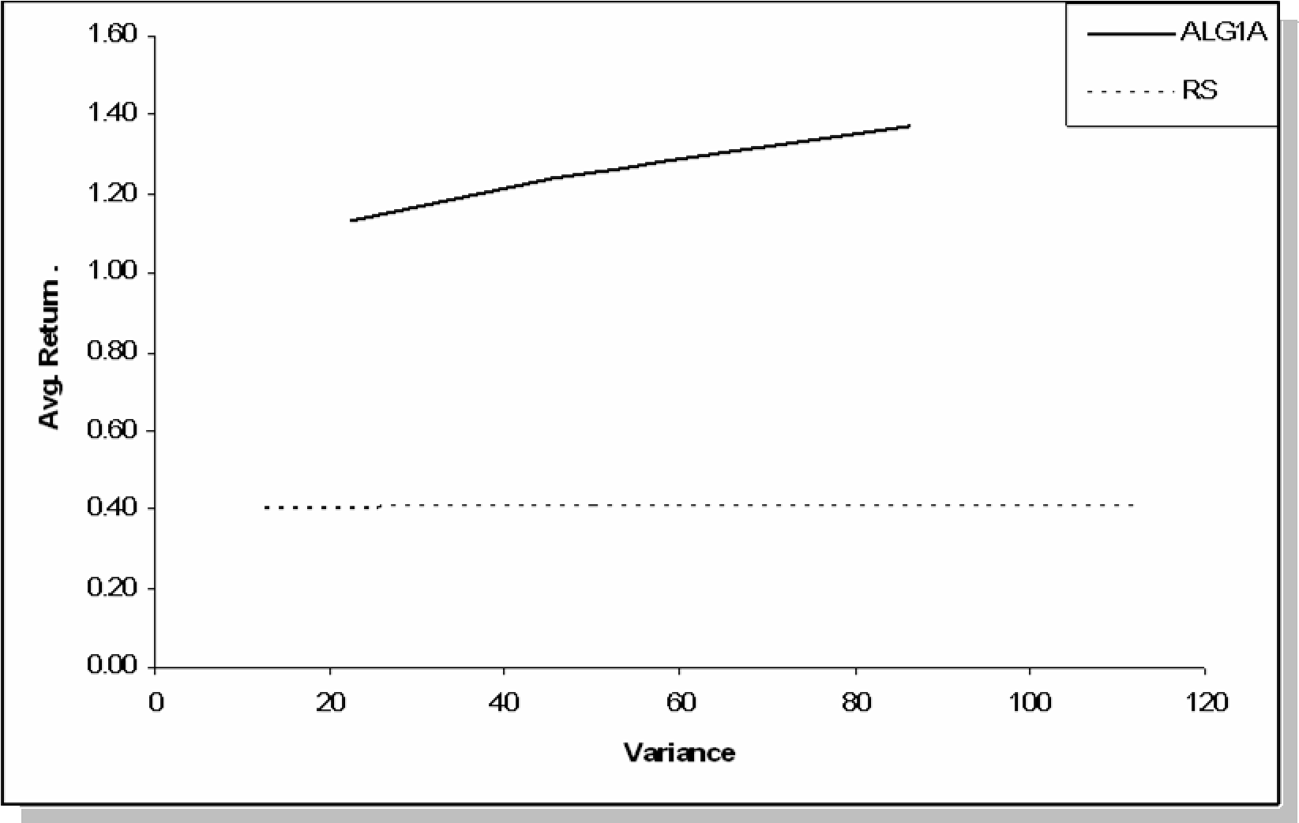

Figure 17. Comparison of Alg-1A and RS over Sample-2 (Variance)

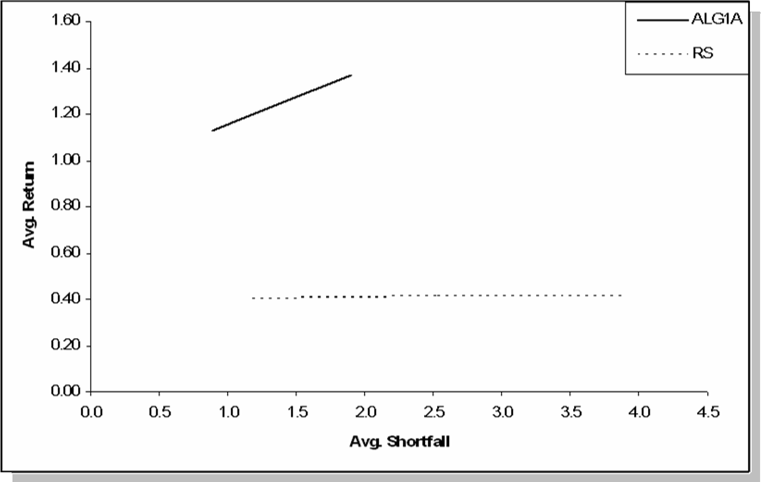

Figure 18. Comparison of Alg-1A and RS over Sample-2 (Avg. Shortfall)

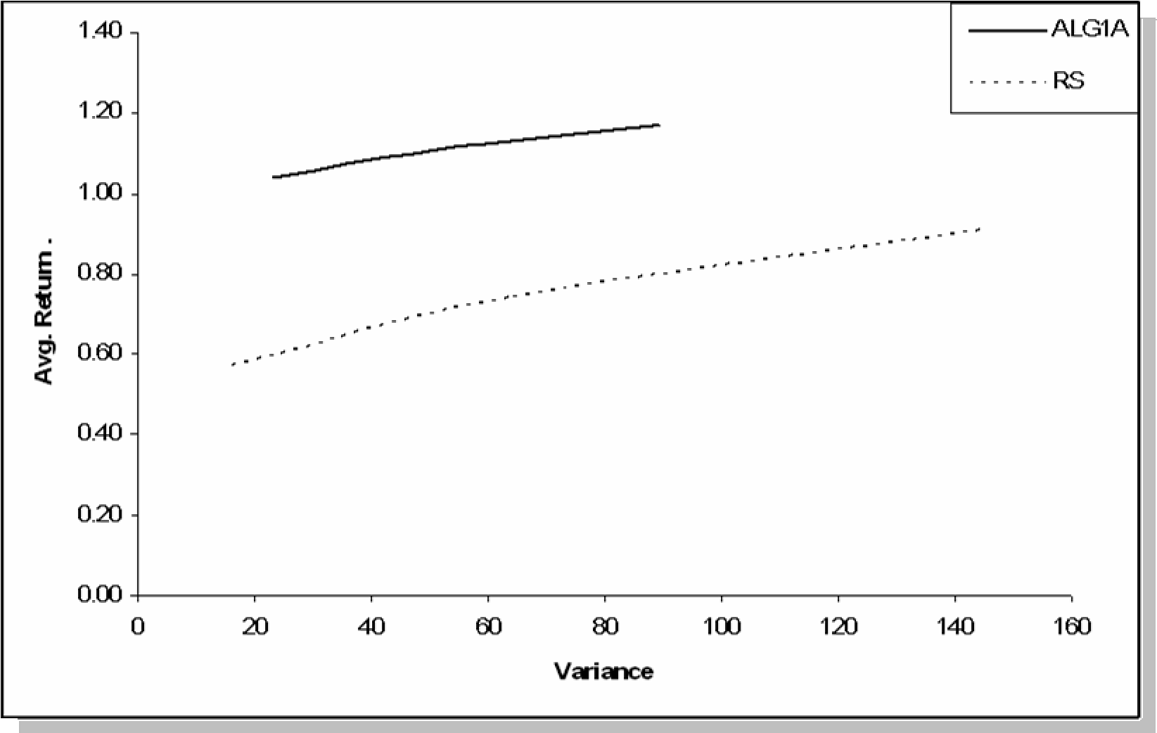

Figure 19. Comparison of Alg-1A and RS over Sample-3 (Variance)

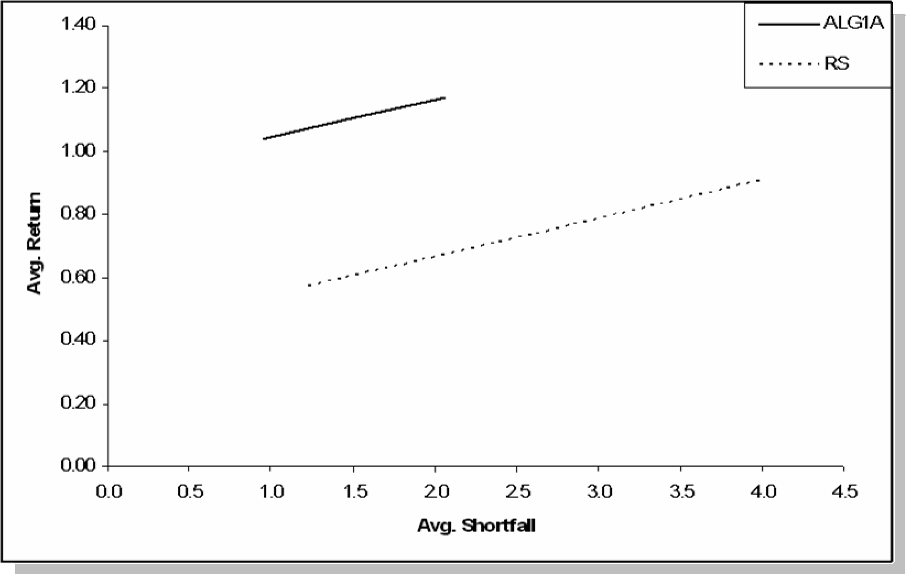

Figure 20. Comparison of Alg-1A and RS over Sample-3 (Avg. Shortfall)

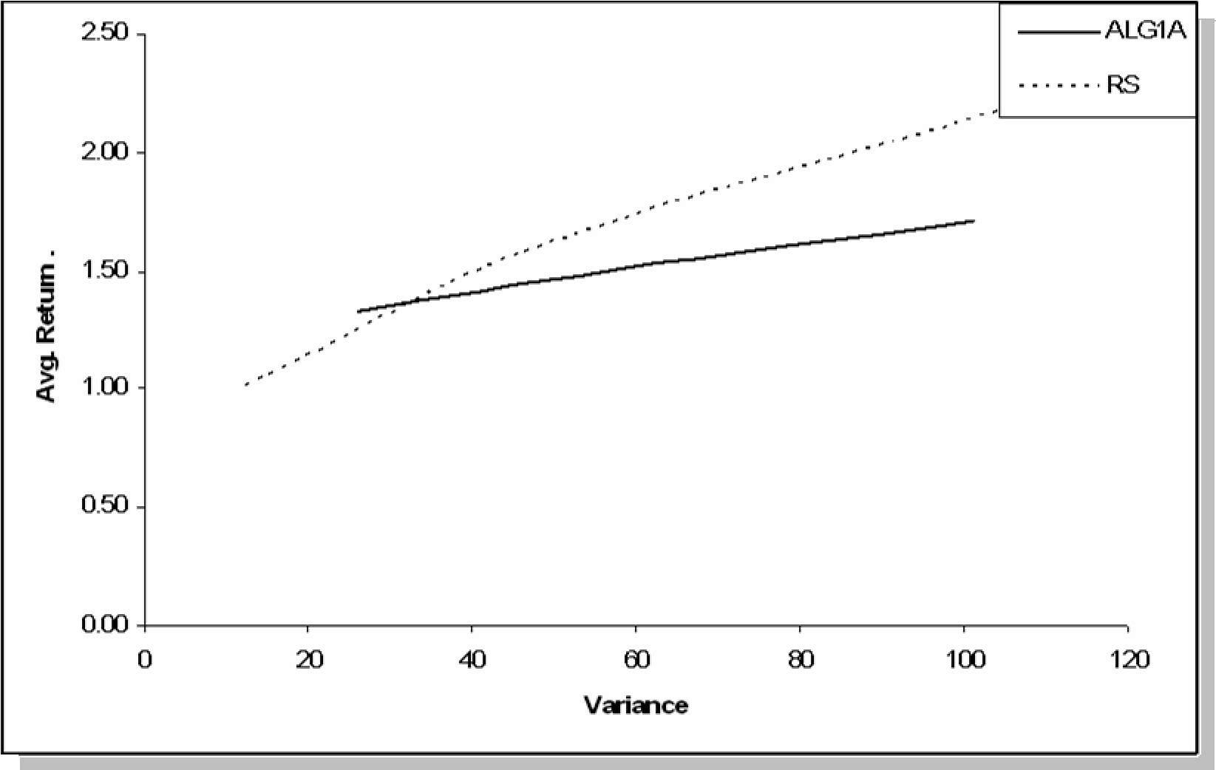

Figure 21. Comparison of Alg-1A and RS over Sample-4 (Variance)

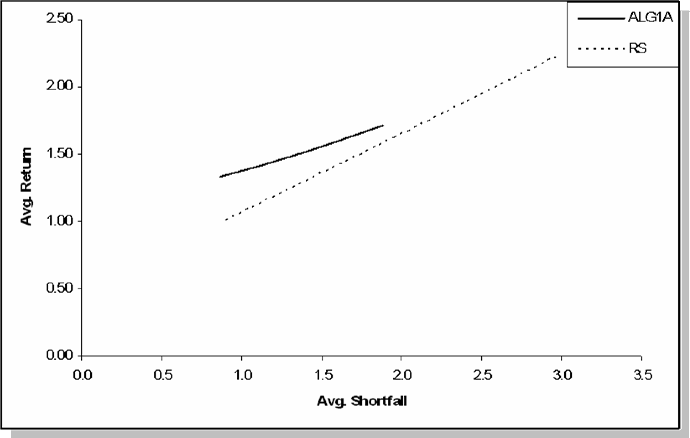

Figure 22. Comparison of Alg-1A and RS over Sample-4 (Avg. Shortfall) Table 11. Decisions table for Alg-1A, LCVAR=10 (Single Period - Out of Sample)

|  |  |  |  |  |  |  |  |
| --- | --- | --- | --- | --- | --- | --- | --- |
| **t** | **CASH** | **SP500** | **W** | **t** | **CASH** | **SP500** | **W** |
| 201 | 631.98 | 363.50 | 995.49 | 251 | 635.68 | 360.62 | 996.30 |
| 202 | 1000.40 | 0.00 | 1000.40 | 252 | 729.99 | 277.61 | 1007.60 |
| 203 | 781.39 | 222.91 | 1004.31 | 253 | 1000.40 | 0.00 | 1000.40 |
| 204 | 1000.40 | 0.00 | 1000.40 | 254 | 1000.40 | 0.00 | 1000.40 |
| 205 | 1000.40 | 0.00 | 1000.40 | 255 | 1000.40 | 0.00 | 1000.40 |
| 206 | 640.38 | 363.52 | 1003.90 | 256 | 639.89 | 365.76 | 1005.64 |
| 207 | 1000.40 | 0.00 | 1000.40 | 257 | 1000.40 | 0.00 | 1000.40 |
| 208 | 677.37 | 320.06 | 997.43 | 258 | 1000.40 | 0.00 | 1000.40 |
| 209 | 653.19 | 344.68 | 997.87 | 259 | 1000.40 | 0.00 | 1000.40 |
| 210 | 683.74 | 321.27 | 1005.01 | 260 | 515.19 | 490.30 | 1005.48 |
| 211 | 1000.40 | 0.00 | 1000.40 | 261 | 600.22 | 400.49 | 1000.71 |
| 212 | 1000.40 | 0.00 | 1000.40 | 262 | 649.49 | 352.66 | 1002.15 |
| 213 | 1000.40 | 0.00 | 1000.40 | 263 | 1000.40 | 0.00 | 1000.40 |
| 214 | 1000.40 | 0.00 | 1000.40 | 264 | 603.41 | 401.26 | 1004.68 |
| 215 | 1000.40 | 0.00 | 1000.40 | 265 | 1000.40 | 0.00 | 1000.40 |
| 216 | 633.83 | 364.40 | 998.23 | 266 | 1000.40 | 0.00 | 1000.40 |
| 217 | 729.20 | 272.53 | 1001.73 | 267 | 1000.40 | 0.00 | 1000.40 |
| 218 | 1000.40 | 0.00 | 1000.40 | 268 | 1000.40 | 0.00 | 1000.40 |
| 219 | 1000.40 | 0.00 | 1000.40 | 269 | 691.07 | 312.68 | 1003.75 |
| 220 | 1000.40 | 0.00 | 1000.40 | 270 | 1000.40 | 0.00 | 1000.40 |
| 221 | 1000.40 | 0.00 | 1000.40 | 271 | 675.21 | 326.48 | 1001.69 |
| 222 | 1000.40 | 0.00 | 1000.40 | 272 | 1000.40 | 0.00 | 1000.40 |
| 223 | 1000.40 | 0.00 | 1000.40 | 273 | 519.14 | 487.76 | 1006.89 |
| 224 | 1000.40 | 0.00 | 1000.40 | 274 | 668.48 | 331.41 | 999.88 |
| 225 | 515.51 | 485.35 | 1000.86 | 275 | 1000.40 | 0.00 | 1000.40 |
| 226 | 1000.40 | 0.00 | 1000.40 | 276 | 608.61 | 398.45 | 1007.06 |
| 227 | 1000.40 | 0.00 | 1000.40 | 277 | 1000.40 | 0.00 | 1000.40 |
| 228 | 1000.40 | 0.00 | 1000.40 | 278 | 1000.40 | 0.00 | 1000.40 |
| 229 | 672.87 | 325.60 | 998.47 | 279 | 1000.40 | 0.00 | 1000.40 |
| 230 | 1000.40 | 0.00 | 1000.40 | 280 | 621.34 | 361.83 | 983.17 |
| 231 | 1000.40 | 0.00 | 1000.40 | 281 | 1000.40 | 0.00 | 1000.40 |
| 232 | 627.13 | 370.44 | 997.57 | 282 | 691.74 | 304.74 | 996.48 |
| 233 | 572.30 | 427.72 | 1000.02 | 283 | 1000.40 | 0.00 | 1000.40 |
| 234 | 659.87 | 338.38 | 998.25 | 284 | 571.43 | 423.83 | 995.26 |
| 235 | 1000.40 | 0.00 | 1000.40 | 285 | 609.49 | 396.65 | 1006.15 |
| 236 | 1000.40 | 0.00 | 1000.40 | 286 | 1000.40 | 0.00 | 1000.40 |
| 237 | 624.83 | 379.38 | 1004.21 | 287 | 616.88 | 391.29 | 1008.17 |
| 238 | 606.24 | 383.35 | 989.59 | 288 | 1000.40 | 0.00 | 1000.40 |
| 239 | 719.61 | 275.14 | 994.75 | 289 | 708.81 | 293.43 | 1002.24 |
| 240 | 623.35 | 380.43 | 1003.78 | 290 | 644.11 | 355.84 | 999.95 |
| 241 | 1000.40 | 0.00 | 1000.40 | 291 | 537.68 | 467.27 | 1004.94 |
| 242 | 1000.40 | 0.00 | 1000.40 | 292 | 1000.40 | 0.00 | 1000.40 |
| 243 | 610.91 | 388.70 | 999.62 | 293 | 1000.40 | 0.00 | 1000.40 |
| 244 | 708.15 | 290.20 | 998.35 | 294 | 1000.40 | 0.00 | 1000.40 |
| 245 | 1000.40 | 0.00 | 1000.40 | 295 | 1000.40 | 0.00 | 1000.40 |
| 246 | 662.28 | 336.40 | 998.67 | 296 | 1000.40 | 0.00 | 1000.40 |
| 247 | 1000.40 | 0.00 | 1000.40 | 297 | 675.19 | 324.92 | 1000.11 |
| 248 | 582.81 | 418.38 | 1001.19 | 298 | 603.49 | 403.49 | 1006.98 |
| 249 | 1000.40 | 0.00 | 1000.40 | 299 | 556.77 | 449.40 | 1006.17 |
| 250 1000.40 0.00 1000.40 | | | | 300 1000.40 0.00 1000.40 | | | |

Table 12. Decisions table for Alg-1A, LCVAR=15 (Single Period - Out of Sample)

|  |  |  |  |  |  |  |  |
| --- | --- | --- | --- | --- | --- | --- | --- |
| **t** | **CASH** | **SP500** | **W** | **t** | **CASH** | **SP500** | **W** |
| 201 | 454.85 | 538.26 | 993.12 | 251 | 460.34 | 533.98 | 994.32 |
| 202 | 1000.40 | 0.00 | 1000.40 | 252 | 599.84 | 411.23 | 1011.07 |
| 203 | 683.56 | 322.48 | 1006.05 | 253 | 1000.40 | 0.00 | 1000.40 |
| 204 | 1000.40 | 0.00 | 1000.40 | 254 | 1000.40 | 0.00 | 1000.40 |
| 205 | 1000.40 | 0.00 | 1000.40 | 255 | 1000.40 | 0.00 | 1000.40 |
| 206 | 467.29 | 538.29 | 1005.58 | 256 | 466.56 | 541.60 | 1008.16 |
| 207 | 1000.40 | 0.00 | 1000.40 | 257 | 1000.40 | 0.00 | 1000.40 |
| 208 | 522.06 | 473.94 | 996.00 | 258 | 1000.40 | 0.00 | 1000.40 |
| 209 | 486.26 | 510.39 | 996.65 | 259 | 1000.40 | 0.00 | 1000.40 |
| 210 | 531.50 | 475.72 | 1007.22 | 260 | 281.91 | 726.01 | 1007.93 |
| 211 | 1000.40 | 0.00 | 1000.40 | 261 | 407.82 | 593.03 | 1000.85 |
| 212 | 1000.40 | 0.00 | 1000.40 | 262 | 480.78 | 522.20 | 1002.99 |
| 213 | 1000.40 | 0.00 | 1000.40 | 263 | 1000.40 | 0.00 | 1000.40 |
| 214 | 1000.40 | 0.00 | 1000.40 | 264 | 412.55 | 594.17 | 1006.72 |
| 215 | 1000.40 | 0.00 | 1000.40 | 265 | 1000.40 | 0.00 | 1000.40 |
| 216 | 457.60 | 539.59 | 997.20 | 266 | 1000.40 | 0.00 | 1000.40 |
| 217 | 501.53 | 501.32 | 1002.85 | 267 | 1000.40 | 0.00 | 1000.40 |
| 218 | 1000.40 | 0.00 | 1000.40 | 268 | 1000.40 | 0.00 | 1000.40 |
| 219 | 1000.40 | 0.00 | 1000.40 | 269 | 542.35 | 463.01 | 1005.35 |
| 220 | 1000.40 | 0.00 | 1000.40 | 270 | 1000.40 | 0.00 | 1000.40 |
| 221 | 1000.40 | 0.00 | 1000.40 | 271 | 518.87 | 483.43 | 1002.30 |
| 222 | 1000.40 | 0.00 | 1000.40 | 272 | 1000.40 | 0.00 | 1000.40 |
| 223 | 1000.40 | 0.00 | 1000.40 | 273 | 287.76 | 722.26 | 1010.02 |
| 224 | 1000.40 | 0.00 | 1000.40 | 274 | 508.89 | 490.74 | 999.64 |
| 225 | 282.38 | 718.69 | 1001.07 | 275 | 1000.40 | 0.00 | 1000.40 |
| 226 | 1000.40 | 0.00 | 1000.40 | 276 | 420.26 | 590.02 | 1010.28 |
| 227 | 1000.40 | 0.00 | 1000.40 | 277 | 1000.40 | 0.00 | 1000.40 |
| 228 | 1000.40 | 0.00 | 1000.40 | 278 | 1000.40 | 0.00 | 1000.40 |
| 229 | 515.40 | 482.14 | 997.54 | 279 | 1000.40 | 0.00 | 1000.40 |
| 230 | 1000.40 | 0.00 | 1000.40 | 280 | 438.90 | 535.98 | 974.88 |
| 231 | 1000.40 | 0.00 | 1000.40 | 281 | 1000.40 | 0.00 | 1000.40 |
| 232 | 447.68 | 548.53 | 996.21 | 282 | 543.35 | 451.25 | 994.60 |
| 233 | 366.48 | 633.35 | 999.83 | 283 | 1000.40 | 0.00 | 1000.40 |
| 234 | 496.16 | 501.05 | 997.21 | 284 | 365.19 | 627.59 | 992.78 |
| 235 | 1000.40 | 0.00 | 1000.40 | 285 | 421.56 | 587.35 | 1008.91 |
| 236 | 1000.40 | 0.00 | 1000.40 | 286 | 1000.40 | 0.00 | 1000.40 |
| 237 | 444.27 | 561.77 | 1006.04 | 287 | 432.49 | 579.42 | 1011.91 |
| 238 | 416.75 | 567.66 | 984.41 | 288 | 1000.40 | 0.00 | 1000.40 |
| 239 | 584.61 | 407.43 | 992.04 | 289 | 568.62 | 434.51 | 1003.13 |
| 240 | 442.07 | 563.33 | 1005.40 | 290 | 472.81 | 526.93 | 999.74 |
| 241 | 1000.40 | 0.00 | 1000.40 | 291 | 315.21 | 691.91 | 1007.12 |
| 242 | 1000.40 | 0.00 | 1000.40 | 292 | 1000.40 | 0.00 | 1000.40 |
| 243 | 423.66 | 575.59 | 999.25 | 293 | 1000.40 | 0.00 | 1000.40 |
| 244 | 567.65 | 429.72 | 997.37 | 294 | 1000.40 | 0.00 | 1000.40 |
| 245 | 1000.40 | 0.00 | 1000.40 | 295 | 1000.40 | 0.00 | 1000.40 |
| 246 | 499.71 | 498.13 | 997.84 | 296 | 1000.40 | 0.00 | 1000.40 |
| 247 | 1000.40 | 0.00 | 1000.40 | 297 | 518.84 | 481.14 | 999.98 |
| 248 | 382.05 | 619.53 | 1001.59 | 298 | 412.68 | 597.48 | 1010.15 |
| 249 | 1000.40 | 0.00 | 1000.40 | 299 | 343.49 | 665.45 | 1008.93 |
| 250 1000.40 0.00 1000.40 | | | | 300 1000.40 0.00 1000.40 | | | |

Table 13. Decisions table for Alg-1A, LCVAR=20 (Single Period - Out of Sample)

|  |  |  |  |  |  |  |  |
| --- | --- | --- | --- | --- | --- | --- | --- |
| **t** | **CASH** | **SP500** | **W** | **t** | **CASH** | **SP500** | **W** |
| 201 | 277.72 | 713.02 | 990.74 | 251 | 284.99 | 707.35 | 992.35 |
| 202 | 1000.40 | 0.00 | 1000.40 | 252 | 469.69 | 544.85 | 1014.54 |
| 203 | 580.62 | 427.26 | 1007.89 | 253 | 1000.40 | 0.00 | 1000.40 |
| 204 | 1000.40 | 0.00 | 1000.40 | 254 | 1000.40 | 0.00 | 1000.40 |
| 205 | 1000.40 | 0.00 | 1000.40 | 255 | 1000.40 | 0.00 | 1000.40 |
| 206 | 294.20 | 713.06 | 1007.25 | 256 | 293.24 | 717.45 | 1010.68 |
| 207 | 1000.40 | 0.00 | 1000.40 | 257 | 1000.40 | 0.00 | 1000.40 |
| 208 | 366.76 | 627.82 | 994.58 | 258 | 1000.40 | 0.00 | 1000.40 |
| 209 | 319.34 | 676.11 | 995.45 | 259 | 1000.40 | 0.00 | 1000.40 |
| 210 | 379.26 | 630.17 | 1009.43 | 260 | 48.63 | 961.72 | 1010.35 |
| 211 | 1000.40 | 0.00 | 1000.40 | 261 | 215.44 | 785.58 | 1001.02 |
| 212 | 1000.40 | 0.00 | 1000.40 | 262 | 312.09 | 691.75 | 1003.83 |
| 213 | 1000.40 | 0.00 | 1000.40 | 263 | 1000.40 | 0.00 | 1000.40 |
| 214 | 1000.40 | 0.00 | 1000.40 | 264 | 221.68 | 787.09 | 1008.77 |
| 215 | 1000.40 | 0.00 | 1000.40 | 265 | 1000.40 | 0.00 | 1000.40 |
| 216 | 281.37 | 714.78 | 996.15 | 266 | 1000.40 | 0.00 | 1000.40 |
| 217 | 339.44 | 664.21 | 1003.64 | 267 | 1000.40 | 0.00 | 1000.40 |
| 218 | 1000.40 | 0.00 | 1000.40 | 268 | 1000.40 | 0.00 | 1000.40 |
| 219 | 1000.40 | 0.00 | 1000.40 | 269 | 393.63 | 613.33 | 1006.96 |
| 220 | 1000.40 | 0.00 | 1000.40 | 270 | 1000.40 | 0.00 | 1000.40 |
| 221 | 1000.40 | 0.00 | 1000.40 | 271 | 362.53 | 640.39 | 1002.92 |
| 222 | 1000.40 | 0.00 | 1000.40 | 272 | 1000.40 | 0.00 | 1000.40 |
| 223 | 1000.40 | 0.00 | 1000.40 | 273 | 56.38 | 956.76 | 1013.14 |
| 224 | 1000.40 | 0.00 | 1000.40 | 274 | 349.31 | 650.08 | 999.39 |
| 225 | 49.26 | 952.03 | 1001.29 | 275 | 1000.40 | 0.00 | 1000.40 |
| 226 | 1000.40 | 0.00 | 1000.40 | 276 | 231.89 | 781.57 | 1013.47 |
| 227 | 1000.40 | 0.00 | 1000.40 | 277 | 1000.40 | 0.00 | 1000.40 |
| 228 | 1000.40 | 0.00 | 1000.40 | 278 | 1000.40 | 0.00 | 1000.40 |
| 229 | 357.92 | 638.67 | 996.60 | 279 | 1000.40 | 0.00 | 1000.40 |
| 230 | 1000.40 | 0.00 | 1000.40 | 280 | 256.44 | 710.14 | 966.58 |
| 231 | 1000.40 | 0.00 | 1000.40 | 281 | 1000.40 | 0.00 | 1000.40 |
| 232 | 268.22 | 726.63 | 994.84 | 282 | 394.95 | 597.75 | 992.70 |
| 233 | 160.65 | 838.98 | 999.63 | 283 | 1000.40 | 0.00 | 1000.40 |
| 234 | 332.45 | 663.74 | 996.19 | 284 | 158.94 | 831.36 | 990.30 |
| 235 | 1000.40 | 0.00 | 1000.40 | 285 | 233.62 | 778.04 | 1011.66 |
| 236 | 1000.40 | 0.00 | 1000.40 | 286 | 1000.40 | 0.00 | 1000.40 |
| 237 | 263.71 | 744.16 | 1007.87 | 287 | 248.10 | 767.53 | 1015.63 |
| 238 | 227.25 | 751.97 | 979.22 | 288 | 1000.40 | 0.00 | 1000.40 |
| 239 | 449.62 | 539.70 | 989.32 | 289 | 428.43 | 575.59 | 1004.02 |
| 240 | 260.79 | 746.22 | 1007.02 | 290 | 301.52 | 698.01 | 999.53 |
| 241 | 1000.40 | 0.00 | 1000.40 | 291 | 92.75 | 916.55 | 1009.30 |
| 242 | 1000.40 | 0.00 | 1000.40 | 292 | 1000.40 | 0.00 | 1000.40 |
| 243 | 236.41 | 762.47 | 998.87 | 293 | 1000.40 | 0.00 | 1000.40 |
| 244 | 427.14 | 569.24 | 996.38 | 294 | 1000.40 | 0.00 | 1000.40 |
| 245 | 1000.40 | 0.00 | 1000.40 | 295 | 1000.40 | 0.00 | 1000.40 |
| 246 | 337.16 | 659.86 | 997.01 | 296 | 1000.40 | 0.00 | 1000.40 |
| 247 | 1000.40 | 0.00 | 1000.40 | 297 | 362.49 | 637.36 | 999.84 |
| 248 | 181.28 | 820.68 | 1001.96 | 298 | 221.86 | 791.47 | 1013.33 |
| 249 | 1000.40 | 0.00 | 1000.40 | 299 | 130.21 | 881.51 | 1011.72 |
| 250 1000.40 0.00 1000.40 | | | | 300 1000.40 0.00 1000.40 | | | |

Table 16. Decisions table for Alg-1A, LCVAR=35 (Multi-Period)

|  |  |  |  |  |  |  |  |
| --- | --- | --- | --- | --- | --- | --- | --- |
| **t** | **Cash** | **SP500** | **W** | **t** | **Cash** | **SP500** | **W** |
| 201 | 0.00 | 999.00 | 999.00 | 251 | 1065.36 | 0.00 | 1065.36 |
| 202 | 0.00 | 987.03 | 987.03 | 252 | 0.00 | 1064.72 | 1064.72 |
| 203 | 0.00 | 997.62 | 997.62 | 253 | 0.00 | 1094.61 | 1094.61 |
| 204 | 1015.81 | 0.00 | 1015.81 | 254 | 1087.46 | 0.00 | 1087.46 |
| 205 | 241.03 | 774.41 | 1015.45 | 255 | 1087.90 | 0.00 | 1087.90 |
| 206 | 0.00 | 1001.15 | 1001.15 | 256 | 0.00 | 1087.25 | 1087.25 |
| 207 | 0.00 | 1012.29 | 1012.29 | 257 | 0.00 | 1104.61 | 1104.61 |
| 208 | 0.00 | 985.18 | 985.18 | 258 | 0.00 | 1100.52 | 1100.52 |
| 209 | 0.00 | 977.49 | 977.49 | 259 | 1117.04 | 0.00 | 1117.04 |
| 210 | 0.00 | 971.74 | 971.74 | 260 | 1117.49 | 0.00 | 1117.49 |
| 211 | 312.38 | 674.56 | 986.93 | 261 | 0.00 | 1116.82 | 1116.82 |
| 212 | 312.50 | 686.79 | 999.29 | 262 | 0.00 | 1119.25 | 1119.25 |
| 213 | 50.78 | 956.58 | 1007.36 | 263 | 1125.28 | 0.00 | 1125.28 |
| 214 | 50.80 | 967.08 | 1017.88 | 264 | 0.00 | 1124.60 | 1124.60 |
| 215 | 0.00 | 1033.33 | 1033.33 | 265 | 1137.15 | 0.00 | 1137.15 |
| 216 | 0.00 | 1030.74 | 1030.74 | 266 | 1137.60 | 0.00 | 1137.60 |
| 217 | 0.00 | 1026.09 | 1026.09 | 267 | 1138.06 | 0.00 | 1138.06 |
| 218 | 0.00 | 1032.57 | 1032.57 | 268 | 0.00 | 1137.37 | 1137.37 |
| 219 | 80.58 | 953.00 | 1033.58 | 269 | 0.00 | 1148.07 | 1148.07 |
| 220 | 1017.37 | 0.00 | 1017.37 | 270 | 0.00 | 1162.11 | 1162.11 |
| 221 | 1017.78 | 0.00 | 1017.78 | 271 | 0.00 | 1148.82 | 1148.82 |
| 222 | 1018.19 | 0.00 | 1018.19 | 272 | 1153.80 | 0.00 | 1153.80 |
| 223 | 0.00 | 1017.58 | 1017.58 | 273 | 0.00 | 1153.11 | 1153.11 |
| 224 | 0.00 | 1035.51 | 1035.51 | 274 | 0.00 | 1170.30 | 1170.30 |
| 225 | 0.00 | 1019.63 | 1019.63 | 275 | 0.00 | 1170.11 | 1170.11 |
| 226 | 0.00 | 1022.01 | 1022.01 | 276 | 0.00 | 1163.31 | 1163.31 |
| 227 | 0.00 | 1038.35 | 1038.35 | 277 | 1183.56 | 0.00 | 1183.56 |
| 228 | 1039.07 | 0.00 | 1039.07 | 278 | 1184.04 | 0.00 | 1184.04 |
| 229 | 0.00 | 1038.45 | 1038.45 | 279 | 1184.51 | 0.00 | 1184.51 |
| 230 | 0.00 | 1033.76 | 1033.76 | 280 | 0.00 | 1183.80 | 1183.80 |
| 231 | 1053.55 | 0.00 | 1053.55 | 281 | 0.00 | 1131.58 | 1131.58 |
| 232 | 1053.97 | 0.00 | 1053.97 | 282 | 0.00 | 1144.36 | 1144.36 |
| 233 | 0.00 | 1053.34 | 1053.34 | 283 | 0.00 | 1131.40 | 1131.40 |
| 234 | 0.00 | 1053.85 | 1053.85 | 284 | 0.00 | 1171.50 | 1171.50 |
| 235 | 1047.61 | 0.00 | 1047.61 | 285 | 0.00 | 1159.06 | 1159.06 |
| 236 | 1048.03 | 0.00 | 1048.03 | 286 | 1176.56 | 0.00 | 1176.56 |
| 237 | 1048.45 | 0.00 | 1048.45 | 287 | 0.00 | 1175.86 | 1175.86 |
| 238 | 1048.87 | 0.00 | 1048.87 | 288 | 244.86 | 956.25 | 1201.11 |
| 239 | 0.00 | 1048.24 | 1048.24 | 289 | 244.95 | 962.51 | 1207.47 |
| 240 | 0.00 | 1028.59 | 1028.59 | 290 | 245.05 | 969.95 | 1215.00 |
| 241 | 0.00 | 1039.25 | 1039.25 | 291 | 0.00 | 1215.01 | 1215.01 |
| 242 | 1044.74 | 0.00 | 1044.74 | 292 | 0.00 | 1228.64 | 1228.64 |
| 243 | 0.00 | 1044.12 | 1044.12 | 293 | 1221.75 | 0.00 | 1221.75 |
| 244 | 0.00 | 1043.48 | 1043.48 | 294 | 1222.24 | 0.00 | 1222.24 |
| 245 | 0.00 | 1037.61 | 1037.61 | 295 | 0.00 | 1221.51 | 1221.51 |
| 246 | 0.00 | 1059.04 | 1059.04 | 296 | 89.20 | 1152.67 | 1241.87 |
| 247 | 0.00 | 1055.11 | 1055.11 | 297 | 0.00 | 1219.00 | 1219.00 |
| 248 | 0.00 | 1030.69 | 1030.69 | 298 | 0.00 | 1219.64 | 1219.64 |
| 249 | 0.00 | 1034.10 | 1034.10 | 299 | 566.07 | 674.98 | 1241.05 |
| 250 1064.94 0.00 1064.94 | | | | 300 566.29 684.71 1251.00 | | | |

Table 17. Decisions table for Alg-1B, LCVAR=35 (Multi-Period)

|  |  |  |  |  |  |  |  |
| --- | --- | --- | --- | --- | --- | --- | --- |
| **t** | **Cash** | **SP500** | **W** | **t** | **Cash** | **SP500** | **W** |
| 200 | 270.78 | 728.50 | 999.27 | 250 | 0.00 | 1085.94 | 1085.94 |
| 201 | 0.00 | 992.79 | 992.79 | 251 | 0.00 | 1086.62 | 1086.62 |
| 202 | 113.68 | 867.10 | 980.78 | 252 | 0.00 | 1075.91 | 1075.91 |
| 203 | 58.48 | 931.59 | 990.07 | 253 | 135.14 | 970.83 | 1105.97 |
| 204 | 332.31 | 675.45 | 1007.76 | 254 | 0.00 | 1100.52 | 1100.52 |
| 205 | 350.41 | 655.52 | 1005.93 | 255 | 0.00 | 1114.05 | 1114.05 |
| 206 | 0.00 | 993.74 | 993.74 | 256 | 0.00 | 1103.77 | 1103.77 |
| 207 | 0.00 | 1004.80 | 1004.80 | 257 | 314.85 | 806.23 | 1121.08 |
| 208 | 0.00 | 977.89 | 977.89 | 258 | 119.85 | 998.18 | 1118.03 |
| 209 | 0.00 | 970.26 | 970.26 | 259 | 347.23 | 786.62 | 1133.85 |
| 210 | 0.00 | 964.55 | 964.55 | 260 | 513.45 | 628.46 | 1141.91 |
| 211 | 0.00 | 979.94 | 979.94 | 261 | 654.02 | 495.42 | 1149.44 |
| 212 | 293.67 | 703.75 | 997.42 | 262 | 478.15 | 672.46 | 1150.61 |
| 213 | 217.05 | 788.81 | 1005.87 | 263 | 586.58 | 568.40 | 1154.98 |
| 214 | 0.00 | 1014.39 | 1014.39 | 264 | 586.82 | 563.02 | 1149.84 |
| 215 | 450.48 | 579.70 | 1030.18 | 265 | 500.31 | 656.53 | 1156.84 |
| 216 | 240.91 | 787.79 | 1028.70 | 266 | 1166.02 | 0.00 | 1166.02 |
| 217 | 363.63 | 661.49 | 1025.12 | 267 | 1166.49 | 0.00 | 1166.49 |
| 218 | 443.68 | 585.68 | 1029.36 | 268 | 1166.95 | 0.00 | 1166.95 |
| 219 | 443.86 | 586.30 | 1030.16 | 269 | 1167.42 | 0.00 | 1167.42 |
| 220 | 0.00 | 1020.48 | 1020.48 | 270 | 1167.89 | 0.00 | 1167.89 |
| 221 | 325.02 | 725.51 | 1050.53 | 271 | 1168.36 | 0.00 | 1168.36 |
| 222 | 1051.15 | 0.00 | 1051.15 | 272 | 1168.82 | 0.00 | 1168.82 |
| 223 | 0.00 | 1050.52 | 1050.52 | 273 | 1169.29 | 0.00 | 1169.29 |
| 224 | 431.39 | 637.21 | 1068.60 | 274 | 1169.76 | 0.00 | 1169.76 |
| 225 | 244.66 | 814.15 | 1058.81 | 275 | 1170.23 | 0.00 | 1170.23 |
| 226 | 0.00 | 1060.57 | 1060.57 | 276 | 1170.69 | 0.00 | 1170.69 |
| 227 | 466.98 | 610.08 | 1077.06 | 277 | 1171.16 | 0.00 | 1171.16 |
| 228 | 520.82 | 557.40 | 1078.23 | 278 | 1171.63 | 0.00 | 1171.63 |
| 229 | 166.93 | 910.20 | 1077.13 | 279 | 1172.10 | 0.00 | 1172.10 |
| 230 | 375.16 | 697.72 | 1072.88 | 280 | 1172.57 | 0.00 | 1172.57 |
| 231 | 217.24 | 869.69 | 1086.94 | 281 | 0.00 | 1171.87 | 1171.87 |
| 232 | 402.30 | 681.68 | 1083.98 | 282 | 619.90 | 564.58 | 1184.48 |
| 233 | 0.00 | 1079.51 | 1079.51 | 283 | 405.45 | 772.67 | 1178.12 |
| 234 | 182.20 | 897.65 | 1079.85 | 284 | 1204.87 | 0.00 | 1204.87 |
| 235 | 464.96 | 610.27 | 1075.22 | 285 | 647.57 | 557.23 | 1204.79 |
| 236 | 279.47 | 806.24 | 1085.71 | 286 | 1213.47 | 0.00 | 1213.47 |
| 237 | 353.33 | 732.01 | 1085.34 | 287 | 1213.95 | 0.00 | 1213.95 |
| 238 | 1093.20 | 0.00 | 1093.20 | 288 | 1214.44 | 0.00 | 1214.44 |
| 239 | 0.00 | 1092.55 | 1092.55 | 289 | 1214.93 | 0.00 | 1214.93 |
| 240 | 0.00 | 1072.06 | 1072.06 | 290 | 1215.41 | 0.00 | 1215.41 |
| 241 | 0.00 | 1083.17 | 1083.17 | 291 | 1215.90 | 0.00 | 1215.90 |
| 242 | 153.65 | 936.19 | 1089.84 | 292 | 1216.38 | 0.00 | 1216.38 |
| 243 | 0.00 | 1063.64 | 1063.64 | 293 | 1216.87 | 0.00 | 1216.87 |
| 244 | 0.00 | 1063.00 | 1063.00 | 294 | 1217.36 | 0.00 | 1217.36 |
| 245 | 0.00 | 1057.02 | 1057.02 | 295 | 1217.84 | 0.00 | 1217.84 |
| 246 | 0.00 | 1078.84 | 1078.84 | 296 | 1218.33 | 0.00 | 1218.33 |
| 247 | 0.00 | 1074.84 | 1074.84 | 297 | 1218.82 | 0.00 | 1218.82 |
| 248 | 0.00 | 1049.97 | 1049.97 | 298 | 1219.31 | 0.00 | 1219.31 |
| 249 0.00 1053.44 1053.44 | | | | 299 1219.79 0.00 1219.79 | | | |

Table 23.Decisions table for AR(2), LCVAR=60 (Multi-Period)

|  |  |  |  |  |  |  |  |
| --- | --- | --- | --- | --- | --- | --- | --- |
| **t** | **Cash** | **SP500** | **W** | **t** | **Cash** | **SP500** | **W** |
| 200 | 1000.00 | 0.00 | 1000.00 | 250 | 1024.68 | 0.00 | 1024.68 |
| 201 | 0.00 | 999.40 | 999.40 | 251 | 1025.09 | 0.00 | 1025.09 |
| 202 | 0.00 | 1010.12 | 1010.12 | 252 | 1025.50 | 0.00 | 1025.50 |
| 203 | 0.00 | 1029.57 | 1029.57 | 253 | 0.00 | 1024.89 | 1024.89 |
| 204 | 0.00 | 1026.61 | 1026.61 | 254 | 0.00 | 1037.49 | 1037.49 |
| 205 | 1006.84 | 0.00 | 1006.84 | 255 | 0.00 | 1027.92 | 1027.92 |
| 206 | 0.00 | 1006.24 | 1006.24 | 256 | 1043.29 | 0.00 | 1043.29 |
| 207 | 0.00 | 979.29 | 979.29 | 257 | 1043.71 | 0.00 | 1043.71 |
| 208 | 0.00 | 971.65 | 971.65 | 258 | 0.00 | 1043.08 | 1043.08 |
| 209 | 0.00 | 965.93 | 965.93 | 259 | 0.00 | 1053.81 | 1053.81 |
| 210 | 0.00 | 981.35 | 981.35 | 260 | 0.00 | 1066.33 | 1066.33 |
| 211 | 0.00 | 999.14 | 999.14 | 261 | 1067.58 | 0.00 | 1067.58 |
| 212 | 1010.07 | 0.00 | 1010.07 | 262 | 0.00 | 1066.94 | 1066.94 |
| 213 | 0.00 | 1009.46 | 1009.46 | 263 | 0.00 | 1056.84 | 1056.84 |
| 214 | 0.00 | 1025.62 | 1025.62 | 264 | 0.00 | 1069.70 | 1069.70 |
| 215 | 0.00 | 1023.06 | 1023.06 | 265 | 0.00 | 1085.43 | 1085.43 |
| 216 | 0.00 | 1018.44 | 1018.44 | 266 | 0.00 | 1085.23 | 1085.23 |
| 217 | 1023.84 | 0.00 | 1023.84 | 267 | 0.00 | 1081.95 | 1081.95 |
| 218 | 1024.25 | 0.00 | 1024.25 | 268 | 0.00 | 1092.12 | 1092.12 |
| 219 | 1024.66 | 0.00 | 1024.66 | 269 | 0.00 | 1105.48 | 1105.48 |
| 220 | 1025.07 | 0.00 | 1025.07 | 270 | 0.00 | 1092.83 | 1092.83 |
| 221 | 1025.48 | 0.00 | 1025.48 | 271 | 0.00 | 1098.67 | 1098.67 |
| 222 | 1025.89 | 0.00 | 1025.89 | 272 | 1090.93 | 0.00 | 1090.93 |
| 223 | 0.00 | 1025.28 | 1025.28 | 273 | 1091.36 | 0.00 | 1091.36 |
| 224 | 0.00 | 1009.55 | 1009.55 | 274 | 0.00 | 1090.71 | 1090.71 |
| 225 | 0.00 | 1011.92 | 1011.92 | 275 | 0.00 | 1084.37 | 1084.37 |
| 226 | 0.00 | 1028.09 | 1028.09 | 276 | 1103.25 | 0.00 | 1103.25 |
| 227 | 1028.81 | 0.00 | 1028.81 | 277 | 0.00 | 1102.58 | 1102.58 |
| 228 | 1029.22 | 0.00 | 1029.22 | 278 | 0.00 | 1115.99 | 1115.99 |
| 229 | 1029.63 | 0.00 | 1029.63 | 279 | 1111.54 | 0.00 | 1111.54 |
| 230 | 0.00 | 1029.01 | 1029.01 | 280 | 1111.98 | 0.00 | 1111.98 |
| 231 | 0.00 | 1025.63 | 1025.63 | 281 | 1112.43 | 0.00 | 1112.43 |
| 232 | 0.00 | 1019.27 | 1019.27 | 282 | 1112.87 | 0.00 | 1112.87 |
| 233 | 0.00 | 1019.77 | 1019.77 | 283 | 0.00 | 1112.21 | 1112.21 |
| 234 | 1013.73 | 0.00 | 1013.73 | 284 | 0.00 | 1100.40 | 1100.40 |
| 235 | 1014.13 | 0.00 | 1014.13 | 285 | 0.00 | 1118.13 | 1118.13 |
| 236 | 0.00 | 1013.53 | 1013.53 | 286 | 0.00 | 1125.17 | 1125.17 |
| 237 | 0.00 | 1025.24 | 1025.24 | 287 | 0.00 | 1149.57 | 1149.57 |
| 238 | 997.55 | 0.00 | 997.55 | 288 | 0.00 | 1157.09 | 1157.09 |
| 239 | 0.00 | 996.95 | 996.95 | 289 | 0.00 | 1166.04 | 1166.04 |
| 240 | 0.00 | 1007.28 | 1007.28 | 290 | 0.00 | 1166.22 | 1166.22 |
| 241 | 1012.61 | 0.00 | 1012.61 | 291 | 0.00 | 1179.30 | 1179.30 |
| 242 | 1013.02 | 0.00 | 1013.02 | 292 | 1172.69 | 0.00 | 1172.69 |
| 243 | 1013.42 | 0.00 | 1013.42 | 293 | 1173.16 | 0.00 | 1173.16 |
| 244 | 198.77 | 814.24 | 1013.01 | 294 | 1173.63 | 0.00 | 1173.63 |
| 245 | 0.00 | 1029.71 | 1029.71 | 295 | 0.00 | 1172.93 | 1172.93 |
| 246 | 1024.85 | 0.00 | 1024.85 | 296 | 1148.56 | 0.00 | 1148.56 |
| 247 | 1025.26 | 0.00 | 1025.26 | 297 | 0.00 | 1147.87 | 1147.87 |
| 248 | 1025.67 | 0.00 | 1025.67 | 298 | 0.00 | 1168.55 | 1168.55 |
| 249 0.00 1025.06 1025.06 | | | | 299 0.00 1185.40 1185.40 | | | |

Table 24.Decisions table for GBM, LCVAR=60 (Multi-Period)

|  |  |  |  |  |  |  |  |
| --- | --- | --- | --- | --- | --- | --- | --- |
| **t** | **Cash** | **SP500** | **W** | **t** | **Cash** | **SP500** | **W** |
| 200 | 0.00 | 999.00 | 999.00 | 250 | 0.00 | 1047.65 | 1047.65 |
| 201 | 0.00 | 987.03 | 987.03 | 251 | 0.00 | 1037.32 | 1037.32 |
| 202 | 0.00 | 997.62 | 997.62 | 252 | 1065.37 | 0.00 | 1065.37 |
| 203 | 0.00 | 1016.83 | 1016.83 | 253 | 0.00 | 1064.73 | 1064.73 |
| 204 | 0.00 | 1013.91 | 1013.91 | 254 | 0.00 | 1077.82 | 1077.82 |
| 205 | 994.39 | 0.00 | 994.39 | 255 | 0.00 | 1067.88 | 1067.88 |
| 206 | 994.78 | 0.00 | 994.78 | 256 | 1083.85 | 0.00 | 1083.85 |
| 207 | 995.18 | 0.00 | 995.18 | 257 | 1084.28 | 0.00 | 1084.28 |
| 208 | 995.58 | 0.00 | 995.58 | 258 | 0.00 | 1083.63 | 1083.63 |
| 209 | 995.98 | 0.00 | 995.98 | 259 | 0.00 | 1094.78 | 1094.78 |
| 210 | 996.38 | 0.00 | 996.38 | 260 | 0.00 | 1107.78 | 1107.78 |
| 211 | 996.77 | 0.00 | 996.77 | 261 | 1109.09 | 0.00 | 1109.09 |
| 212 | 0.00 | 996.18 | 996.18 | 262 | 0.00 | 1108.42 | 1108.42 |
| 213 | 0.00 | 1007.11 | 1007.11 | 263 | 1096.83 | 0.00 | 1096.83 |
| 214 | 1022.21 | 0.00 | 1022.21 | 264 | 0.00 | 1096.17 | 1096.17 |
| 215 | 1022.61 | 0.00 | 1022.61 | 265 | 0.00 | 1112.29 | 1112.29 |
| 216 | 0.00 | 1022.00 | 1022.00 | 266 | 0.00 | 1112.09 | 1112.09 |
| 217 | 0.00 | 1028.45 | 1028.45 | 267 | 1107.62 | 0.00 | 1107.62 |
| 218 | 0.00 | 1029.54 | 1029.54 | 268 | 0.00 | 1106.95 | 1106.95 |
| 219 | 0.00 | 1013.01 | 1013.01 | 269 | 0.00 | 1120.50 | 1120.50 |
| 220 | 0.00 | 1043.17 | 1043.17 | 270 | 0.00 | 1107.67 | 1107.67 |
| 221 | 0.00 | 1044.92 | 1044.92 | 271 | 0.00 | 1113.59 | 1113.59 |
| 222 | 1022.70 | 0.00 | 1022.70 | 272 | 0.00 | 1106.85 | 1106.85 |
| 223 | 1023.11 | 0.00 | 1023.11 | 273 | 0.00 | 1123.35 | 1123.35 |
| 224 | 1023.52 | 0.00 | 1023.52 | 274 | 0.00 | 1123.17 | 1123.17 |
| 225 | 1023.93 | 0.00 | 1023.93 | 275 | 0.00 | 1116.64 | 1116.64 |
| 226 | 0.00 | 1023.31 | 1023.31 | 276 | 1136.08 | 0.00 | 1136.08 |
| 227 | 0.00 | 1025.05 | 1025.05 | 277 | 1136.54 | 0.00 | 1136.54 |
| 228 | 0.00 | 1023.30 | 1023.30 | 278 | 0.00 | 1135.86 | 1135.86 |
| 229 | 0.00 | 1018.69 | 1018.69 | 279 | 0.00 | 1132.46 | 1132.46 |
| 230 | 0.00 | 1039.22 | 1039.22 | 280 | 0.00 | 1082.50 | 1082.50 |
| 231 | 0.00 | 1035.80 | 1035.80 | 281 | 0.00 | 1094.73 | 1094.73 |
| 232 | 0.00 | 1029.38 | 1029.38 | 282 | 0.00 | 1082.33 | 1082.33 |
| 233 | 0.00 | 1029.88 | 1029.88 | 283 | 0.00 | 1120.69 | 1120.69 |
| 234 | 0.00 | 1024.81 | 1024.81 | 284 | 1107.68 | 0.00 | 1107.68 |
| 235 | 0.00 | 1042.42 | 1042.42 | 285 | 1108.13 | 0.00 | 1108.13 |
| 236 | 0.00 | 1041.89 | 1041.89 | 286 | 0.00 | 1107.46 | 1107.46 |
| 237 | 1052.88 | 0.00 | 1052.88 | 287 | 0.00 | 1131.47 | 1131.47 |
| 238 | 0.00 | 1052.25 | 1052.25 | 288 | 0.00 | 1138.88 | 1138.88 |
| 239 | 0.00 | 1032.52 | 1032.52 | 289 | 1146.54 | 0.00 | 1146.54 |
| 240 | 0.00 | 1043.22 | 1043.22 | 290 | 0.00 | 1145.85 | 1145.85 |
| 241 | 1048.74 | 0.00 | 1048.74 | 291 | 1157.55 | 0.00 | 1157.55 |
| 242 | 1049.16 | 0.00 | 1049.16 | 292 | 1158.02 | 0.00 | 1158.02 |
| 243 | 0.00 | 1048.53 | 1048.53 | 293 | 0.00 | 1157.32 | 1157.32 |
| 244 | 1041.59 | 0.00 | 1041.59 | 294 | 0.00 | 1135.73 | 1135.73 |
| 245 | 1042.01 | 0.00 | 1042.01 | 295 | 0.00 | 1154.74 | 1154.74 |
| 246 | 0.00 | 1041.38 | 1041.38 | 296 | 0.00 | 1131.88 | 1131.88 |
| 247 | 1016.27 | 0.00 | 1016.27 | 297 | 0.00 | 1132.47 | 1132.47 |
| 248 | 0.00 | 1015.66 | 1015.66 | 298 | 0.00 | 1152.88 | 1152.88 |
| 249 0.00 1046.99 1046.99 | | | | 299 0.00 1169.50 1169.50 | | | |

Table 28. Decisions table obtained by using **w2** , *LCVAR*=35.

|  |  |  |  |  |  |  |  |
| --- | --- | --- | --- | --- | --- | --- | --- |
| **t** | **Cash** | **SP500** | **W** | **t** | **Cash** | **SP500** | **W** |
| 200 | 1000.00 | 0.00 | 1000.00 | 250 | 1049.12 | 0.00 | 1049.12 |
| 201 | 0.00 | 999.40 | 999.40 | 251 | 1049.54 | 0.00 | 1049.54 |
| 202 | 0.00 | 1010.12 | 1010.12 | 252 | 1049.96 | 0.00 | 1049.96 |
| 203 | 1028.54 | 0.00 | 1028.54 | 253 | 1050.38 | 0.00 | 1050.38 |
| 204 | 0.00 | 1027.92 | 1027.92 | 254 | 0.00 | 1049.75 | 1049.75 |
| 205 | 0.00 | 1009.14 | 1009.14 | 255 | 0.00 | 1040.07 | 1040.07 |
| 206 | 0.00 | 1020.37 | 1020.37 | 256 | 0.00 | 1056.68 | 1056.68 |
| 207 | 175.24 | 817.63 | 992.87 | 257 | 0.00 | 1052.77 | 1052.77 |
| 208 | 0.00 | 986.38 | 986.38 | 258 | 0.00 | 1069.64 | 1069.64 |
| 209 | 0.00 | 980.58 | 980.58 | 259 | 197.00 | 883.45 | 1080.44 |
| 210 | 0.00 | 996.22 | 996.22 | 260 | 0.00 | 1090.82 | 1090.82 |
| 211 | 0.00 | 1014.29 | 1014.29 | 261 | 0.00 | 1093.20 | 1093.20 |
| 212 | 0.00 | 1026.41 | 1026.41 | 262 | 0.00 | 1100.18 | 1100.18 |
| 213 | 0.00 | 1037.67 | 1037.67 | 263 | 0.00 | 1089.77 | 1089.77 |
| 214 | 0.00 | 1054.28 | 1054.28 | 264 | 1101.92 | 0.00 | 1101.92 |
| 215 | 0.00 | 1051.65 | 1051.65 | 265 | 1102.36 | 0.00 | 1102.36 |
| 216 | 0.00 | 1046.90 | 1046.90 | 266 | 0.00 | 1101.70 | 1101.70 |
| 217 | 0.00 | 1053.51 | 1053.51 | 267 | 0.00 | 1098.37 | 1098.37 |
| 218 | 73.99 | 980.56 | 1054.55 | 268 | 0.00 | 1108.69 | 1108.69 |
| 219 | 1037.87 | 0.00 | 1037.87 | 269 | 0.00 | 1122.26 | 1122.26 |
| 220 | 1038.28 | 0.00 | 1038.28 | 270 | 0.00 | 1109.42 | 1109.42 |
| 221 | 1038.70 | 0.00 | 1038.70 | 271 | 1114.23 | 0.00 | 1114.23 |
| 222 | 93.23 | 944.94 | 1038.17 | 272 | 0.00 | 1113.56 | 1113.56 |
| 223 | 0.00 | 1054.77 | 1054.77 | 273 | 0.00 | 1130.17 | 1130.17 |
| 224 | 0.00 | 1038.59 | 1038.59 | 274 | 0.00 | 1129.99 | 1129.99 |
| 225 | 0.00 | 1041.02 | 1041.02 | 275 | 0.00 | 1123.41 | 1123.41 |
| 226 | 0.00 | 1057.66 | 1057.66 | 276 | 1142.97 | 0.00 | 1142.97 |
| 227 | 588.30 | 470.57 | 1058.87 | 277 | 1143.43 | 0.00 | 1143.43 |
| 228 | 0.00 | 1057.71 | 1057.71 | 278 | 0.00 | 1142.74 | 1142.74 |
| 229 | 0.00 | 1052.94 | 1052.94 | 279 | 0.00 | 1139.33 | 1139.33 |
| 230 | 0.00 | 1074.16 | 1074.16 | 280 | 0.00 | 1089.07 | 1089.07 |
| 231 | 313.50 | 756.82 | 1070.32 | 281 | 0.00 | 1101.37 | 1101.37 |
| 232 | 0.00 | 1065.43 | 1065.43 | 282 | 0.00 | 1088.89 | 1088.89 |
| 233 | 0.00 | 1065.95 | 1065.95 | 283 | 0.00 | 1127.49 | 1127.49 |
| 234 | 1059.64 | 0.00 | 1059.64 | 284 | 0.00 | 1115.52 | 1115.52 |
| 235 | 1060.07 | 0.00 | 1060.07 | 285 | 327.23 | 805.94 | 1133.17 |
| 236 | 1060.49 | 0.00 | 1060.49 | 286 | 0.00 | 1138.05 | 1138.05 |
| 237 | 0.00 | 1059.85 | 1059.85 | 287 | 383.21 | 779.12 | 1162.34 |
| 238 | 0.00 | 1032.26 | 1032.26 | 288 | 383.37 | 784.23 | 1167.59 |
| 239 | 0.00 | 1012.90 | 1012.90 | 289 | 383.52 | 790.29 | 1173.81 |
| 240 | 0.00 | 1023.40 | 1023.40 | 290 | 0.00 | 1173.70 | 1173.70 |
| 241 | 1028.81 | 0.00 | 1028.81 | 291 | 0.00 | 1186.87 | 1186.87 |
| 242 | 0.00 | 1028.20 | 1028.20 | 292 | 1180.22 | 0.00 | 1180.22 |
| 243 | 0.00 | 1027.57 | 1027.57 | 293 | 1180.69 | 0.00 | 1180.69 |
| 244 | 0.00 | 1021.79 | 1021.79 | 294 | 0.00 | 1179.98 | 1179.98 |
| 245 | 0.00 | 1042.89 | 1042.89 | 295 | 0.00 | 1199.74 | 1199.74 |
| 246 | 0.00 | 1039.02 | 1039.02 | 296 | 0.00 | 1175.98 | 1175.98 |
| 247 | 0.00 | 1014.98 | 1014.98 | 297 | 0.00 | 1176.60 | 1176.60 |
| 248 | 0.00 | 1018.34 | 1018.34 | 298 | 70.83 | 1126.91 | 1197.73 |
| 249 1048.70 0.00 1048.70 | | | | 299 0.00 1213.93 | | | 1213.93 |

Table 34. Return/risk profiles of alternative approaches (TW2)

|  |  |  |  |  |
| --- | --- | --- | --- | --- |
|  | Risk (LCVAR or SP/Cash) | Avg. Ret. | VAR | Avg. Shortfall |
|  | 2 | -0.0042 | 1.3358 | 0.4563 |
|  | 6 | -0.1052 | 12.1137 | 1.4170 |
| Alg-1A | 10  14 | -0.1579  -0.1738 | 29.7992  35.6242 | 2.2185  2.4339 |
|  | 18 | -0.1703 | 36.0080 | 2.4440 |
|  | 2 | 0.0599 | 0.0327 | 0.0191 |
|  | 6 | 0.0801 | 0.3074 | 0.0684 |
| Alg-1B | 10  14 | 0.1001  0.1215 | 0.8767  1.7138 | 0.1193  0.1687 |
|  | 18 | 0.1404 | 2.8267 | 0.2187 |
|  | 0.20 | 0.0682 | 1.5380 | 0.4624 |
|  | 0.35 | 0.0817 | 4.7102 | 0.8257 |
| B&H | 0.50  0.65 | 0.0952 0.1088 | 9.6127  16.2455 | 1.1891 1.5526 |
|  | 0.80 | 0.1223 | 24.6086 | 1.9161 |
|  | 2 | -0.0069 | 0.8120 | 0.3438 |
|  | 6 | -0.1232 | 7.4657 | 1.0856 |
| AR(2) | 10  14 | -0.2109  -0.2636 | 19.9377  29.3828 | 1.7811  2.1838 |
|  | 18 | -0.2849 | 31.7478 | 2.2779 |
|  | 2 | 0.0478 | 0.5720 | 0.2451 |
|  | 6 | 0.0397 | 5.2420 | 0.7877 |
| GBM | 10  14 | 0.0440  -0.0257 | 14.4300  24.6616 | 1.3157  1.7712 |
|  | 18 | -0.1131 27.3851 1.9195 | | |

Table 35. Return/risk profiles of alternative approaches (TW3)

|  |  |  |  |  |
| --- | --- | --- | --- | --- |
|  | Risk (LCVAR or SP/Cash) | Avg. Ret. | VAR | Avg. Shortfall |
|  | 2 | 0.0238 | 1.8469 | 0.4683 |
|  | 6 | 0.0006 | 16.2217 | 1.4087 |
| Alg-1A | 10  14 | 0.1978 0.2937 | 33.1177 37.9377 | 1.9677 2.1316 |
|  | 18 | 0.3361 | 38.5781 | 2.1351 |
|  | 2 | 0.4839 | 5.9690 | 0.1481 |
|  | 6 | 0.4439 | 12.1742 | 0.5881 |
| Alg-1B | 10  14 | 0.3769  0.3014 | 15.9538  20.7628 | 0.9273  1.2176 |
|  | 18 | 0.2408 | 25.5409 | 1.4646 |
|  | 0.20 | 0.0736 | 1.7407 | 0.4987 |
|  | 0.35 | 0.0911 | 5.3307 | 0.8888 |
| B&H | 0.50  0.65 | 0.1087  0.1263 | 10.8791  18.3856 | 1.2790  1.6691 |
|  | 0.80 | 0.1439 | 27.8504 | 2.0593 |
|  | 2 | 0.0800 | 0.7523 | 0.2692 |
|  | 6 | 0.1404 | 6.7608 | 0.8543 |
| AR(2) | 10  14 | 0.2154  0.2818 | 18.5686  31.3393 | 1.4243  1.8595 |
|  | 18 | 0.3364 34.2694 1.9550 | | |

Table 35. Continued

|  |  |  |  |  |
| --- | --- | --- | --- | --- |
|  | Risk (LCVAR or SP/Cash) | Avg. Ret. | VAR | Avg. Shortfall |
|  | 2 | 0.0024 | 0.5810 | 0.2680 |
|  | 6 | -0.0911 | 5.2544 | 0.8489 |
| GBM | 10  14 | -0.1889  -0.1936 | 14.5496  24.2012 | 1.4289  1.8248 |
|  | 18 | -0.1937 | 26.8822 | 1.9287 |

Table 36. Return/risk profiles of alternative approaches (TW4)

|  |  |  |  |  |
| --- | --- | --- | --- | --- |
|  | Risk (LCVAR or SP/Cash) | Avg. Ret. | VAR | Avg. Shortfall |
|  | 2 | 0.1194 | 1.4297 | 0.3333 |
|  | 6 | 0.2630 | 12.9396 | 1.0428 |
| Alg-1A | 10  14 | 0.3738  0.4324 | 34.2989  39.7404 | 1.7272  1.9404 |
|  | 18 | 0.4737 | 40.8526 | 1.9767 |
|  | 2 | 0.2847 | 12.5329 | 0.5340 |
|  | 6 | 0.1797 | 15.5556 | 0.8541 |
| Alg-1B | 10  14 | 0.1667  0.3120 | 19.4175  27.1243 | 1.0671  1.3851 |
|  | 18 | 0.4145 | 31.8618 | 1.5031 |
|  | 0.20 | 0.1230 | 1.8041 | 0.4490 |
|  | 0.35 | 0.1777 | 5.5252 | 0.8020 |
| B&H | 0.50  0.65 | 0.2324  0.2871 | 11.2759  19.0563 | 1.1549  1.5078 |
|  | 0.80 | 0.3418 | 28.8663 | 1.8607 |
|  | 2 | 0.1289 | 0.7935 | 0.2306 |
|  | 6 | 0.2926 | 7.1834 | 0.7320 |
| AR(2) | 10  14 | 0.4541  0.6226 | 19.4207  28.8959 | 1.2174  1.4902 |
|  | 18 | 0.6454 | 31.6442 | 1.5899 |
|  | 2 | 0.0431 | 0.8292 | 0.2513 |
|  | 6 | 0.0296 | 7.4919 | 0.7959 |
| GBM | 10  14 | 0.0385 0.0998 | 20.1365 28.5612 | 1.3123 1.5909 |
|  | 18 | 0.0890 30.5057 1.6656 | | |

Table 37. Return/risk profiles of alternative approaches (TW5)

|  |  |  |  |  |
| --- | --- | --- | --- | --- |
|  | Risk (LCVAR or SP/Cash) | Avg. Ret. | VAR | Avg. Shortfall |
|  | 2 | 0.0863 | 1.1826 | 0.3369 |
|  | 6 | 0.1602 | 11.0522 | 1.0711 |
| Alg-1A | 10  14 | 0.2177  0.1748 | 29.0240  35.8977 | 1.7652  2.0300 |
|  | 18 | 0.1141 | 40.0757 | 2.2324 |
|  | 2 | 0.0261 | 7.9006 | 0.3789 |
|  | 6 | 0.0198 | 9.7421 | 0.5795 |
| Alg-1B | 10  14 | 0.0272  0.0378 | 11.5352  14.0366 | 0.7040  0.8176 |
|  | 18 | 0.0304 16.5656 0.9232 | | |

Table 37. Continued

|  |  |  |  |  |
| --- | --- | --- | --- | --- |
|  | Risk (LCVAR or SP/Cash) | Avg. Ret. | VAR | Avg. Shortfall |
|  | 0.20 | 0.0139 | 1.8703 | 0.5169 |
|  | 0.35 | -0.0132 | 5.7279 | 0.9228 |
| B&H | 0.50  0.65 | -0.0403  -0.0675 | 11.6897  19.7556 | 1.3288  1.7348 |
|  | 0.80 | -0.0946 | 29.9257 | 2.1409 |
|  | 2 | -0.0225 | 0.9382 | 0.3379 |
|  | 6 | -0.2018 | 8.8866 | 1.0870 |
| AR(2) | 10  14 | -0.3291  -0.3218 | 23.1721  31.6737 | 1.7546  2.0318 |
|  | 18 | -0.3301 | 32.0511 | 2.0546 |
|  | 2 | -0.0284 | 0.8119 | 0.2784 |
|  | 6 | -0.1935 | 7.6178 | 0.8911 |
| GBM | 10  14 | -0.3586  -0.4694 | 21.3360  30.7618 | 1.5039  1.8624 |
|  | 18 | -0.4314 | 32.8911 | 1.9003 |

Table 38. Sharpe Ratios obtained from all time windows.

|  |  |  |  |  |  |
| --- | --- | --- | --- | --- | --- |
| Time Win. | AR(2) | GBM | B&H | Alg-1A | Alg-1B |
|  | -0.0648 | 0.0005 | 0.0421 | 0.0637 | 0.0334 |
|  | -0.0608 | 0.0035 | 0.0420 | 0.0676 | 0.0593 |
| TW1 | -0.0520 -0.0290 | 0.0044  0.0063 | 0.0420  0.0420 | 0.0586  0.0756 | 0.0583  0.0467 |
|  | -0.0281 | 0.0114 | 0.0420 | 0.0855 | 0.0413 |
|  | -0.0632 | -0.0029 | 0.0146 | -0.0469 | 0.0547 |
|  | -0.0634 | -0.0045 | 0.0146 | -0.0446 | 0.0543 |
| TW2 | -0.0584 -0.0578 | -0.0016 -0.0152 | 0.0146  0.0146 | -0.0381 -0.0375 | 0.0535  0.0546 |
|  | -0.0594 | -0.0312 | 0.0146 | -0.0367 | 0.0538 |
|  | 0.0346 | -0.0624 | 0.0179 | -0.0193 | 0.1776 |
|  | 0.0348 | -0.0616 | 0.0178 | -0.0123 | 0.1129 |
| TW3 | 0.0384 0.0414 | -0.0626 -0.0495 | 0.0178 0.0178 | 0.0257 0.0396 | 0.0768 0.0552 |
|  | 0.0489 | -0.0470 | 0.0178 | 0.0461 | 0.0378 |
|  | 0.0885 | -0.0076 | 0.0544 | 0.0580 | 0.0663 |
|  | 0.0905 | -0.0074 | 0.0543 | 0.0592 | 0.0329 |
| TW4 | 0.0917  0.1065 | -0.0026 0.0093 | 0.0543 0.0543 | 0.0553  0.0607 | 0.0265  0.0503 |
|  | 0.1058 | 0.0071 | 0.0543 | 0.0663 | 0.0646 |
|  | -0.0749 | -0.0870 | -0.0264 | 0.0334 | -0.0085 |
|  | -0.0845 | -0.0882 | -0.0264 | 0.0331 | -0.0097 |
| TW5 | -0.0788 -0.0661 | -0.0885 -0.0936 | -0.0264 -0.0264 | 0.0311  0.0208 | -0.0067 -0.0033 |
|  | -0.0671 | -0.0839 | -0.0264 | 0.0101 | -0.0048 |

### APPENDIX C (Alg-2)

Table 52. Return / risk profiles obtained via different weights ([30 15], Weekly)

|  |  |  |  |  |
| --- | --- | --- | --- | --- |
| **Weight Vector** | **LCVAR** | **Avg. Ret.** | **VAR** | **Avg. Shortfall** |
|  | 10 | 0.9174 | 35.1402 | 1.8725 |
| **we1** | 20  30  40 | 1.4134  1.8827  2.4760 | 143.1724  324.0771  520.3068 | 3.9739  6.0899  7.7436 |
|  | 50 | 2.8195 | 672.6954 | 8.8001 |
|  | 10 | 0.9177 | 35.1447 | 1.8721 |
| **we2** | 20  30  40 | 1.4141  1.8806  2.4727 | 143.1812  324.0618  520.2894 | 3.9730  6.0899  7.7439 |
|  | 50 | 2.8191 | 672.6513 | 8.8000 |
|  | 10 | 0.9384 | 32.3565 | 1.7698 |
| **we3** | 20  30  40 | 1.4525  1.9725  2.4445 | 131.7087  298.3028  508.3236 | 3.7660  5.7620  7.6494 |
|  | 50 | 2.8516 | 677.3887 | 8.7921 |
|  | 10 | 0.9541 | 33.1869 | 1.7899 |
| **we4** | 20  30  40 | 1.4881  2.0147  2.5054 | 134.7550  304.6229  519.7018 | 3.7987  5.8108  7.6986 |
|  | 50 | 2.8485 684.0514 8.8271 | | |

Table 53. Return / risk profiles obtained via different weights ([8 4], Weekly)

|  |  |  |  |  |
| --- | --- | --- | --- | --- |
| Weight Vector | LCVAR | Avg. Ret. | VAR | Avg. Shortfall |
|  | 10 | 0.5424 | 110.9310 | 3.3368 |
| **we0** | 20  30  40 | 0.8415  1.8990  2.1604 | 324.8729  456.9395  534.2412 | 6.0901  7.1939  7.8904 |
|  | 50 | 2.2805 | 579.4477 | 8.1722 |
|  | 10 | 0.5430 | 110.8888 | 3.3361 |
| **we1** | 20  30  40 | 0.8416  1.8991  2.1606 | 324.8976  456.9117  534.2624 | 6.0904  7.1937  7.8905 |
|  | 50 | 2.2808 | 579.4304 | 8.1720 |
|  | 10 | 0.6846 | 105.1095 | 3.1789 |
| **we2** | 20  30  40 | 1.0642  1.8572  2.2127 | 307.6657  469.3954  573.4802 | 5.8562  7.2968  8.1291 |
|  | 50 | 2.6013 | 652.2954 | 8.5627 |
|  | 10 | 0.4587 | 112.2625 | 3.3790 |
| **we3** | 20  30  40 | 0.6845  1.6100  2.1913 | 329.0631  441.5174  518.7228 | 6.2061  7.2399  7.7762 |
|  | 50 | 2.4801 579.1909 8.0964 | | |

Table 53. Continued

|  |  |  |  |  |
| --- | --- | --- | --- | --- |
| Weight Vector | LCVAR | Avg. Ret. | VAR | Avg. Shortfall |
|  | 10 | 0.4453 | 110.8810 | 3.3777 |
| **we4** | 20  30  40 | 0.7307  1.7989  2.1595 | 323.6759  448.7608  534.3835 | 6.1542  7.1878  7.8928 |
|  | 50 | 2.2799 | 579.6558 | 8.1750 |

Table 54. Sharpe Ratios obtained via [8 4] and [30 15] tree topologies

|  |  |  |  |  |  |
| --- | --- | --- | --- | --- | --- |
| Topology | **we0** | **we1** | **we2** | **we3** | **we4** |
|  | 0.013523 | 0.013583 | 0.027764 | 0.005542 | 0.004299 |
|  | 0.024496 | 0.024498 | 0.037867 | 0.015685 | 0.018379 |
| [8 4] | 0.070125  0.076164 | 0.070132  0.076168 | 0.067260  0.075696 | 0.057584  0.078652 | 0.066034  0.076115 |
|  | 0.078122 | 0.078133 | 0.086190 | 0.086430 | 0.078083 |
|  | 0.088178 | 0.087290 | 0.087333 | 0.094649 | 0.096182 |
|  | 0.085574 | 0.084694 | 0.084753 | 0.091711 | 0.093731 |
| [30 15] | 0.083252  0.092320 | 0.082365  0.091011 | 0.082249  0.090868 | 0.091044  0.090681 | 0.092512  0.092353 |
|  | 0.094575 | 0.093285 | 0.093275 | 0.094195 | 0.093615 |

Table 59. Return / risk profiles obtained via different *lbn* values (TW2)

|  |  |  |  |  |
| --- | --- | --- | --- | --- |
| *lbn* | LCVAR | Avg. Ret. | VAR | Avg. Shortfall |
|  | 2 | 0.0331 | 1.4439 | 0.4642 |
|  | 6 | 0.0108 | 13.2825 | 1.4509 |
| 0.00 | 10  14  24 | -0.0109  -0.0703  -0.1770 | 36.2741  59.9737  84.9352 | 2.4097  3.1268  3.7368 |
|  | 32 | -0.1904 | 85.2931 | 3.7480 |
|  | 2 | 0.0291 | 1.4460 | 0.4672 |
|  | 6 | -0.0125 | 13.2498 | 1.4613 |
| 0.05 | 10  14  24 | -0.0314 -0.0496 -0.1750 | 36.3465  59.1776  84.8842 | 2.4243  3.0964  3.7351 |
|  | 32 | -0.1904 | 85.2931 | 3.7480 |
|  | 2 | 0.0416 | 1.4562 | 0.4620 |
|  | 6 | 0.0234 | 13.2452 | 1.4420 |
| 0.10 | 10 14  24 | 0.0267 -0.0624  -0.1730 | 35.6657  59.4415  84.8355 | 2.3693  3.1121  3.7334 |
|  | 32 | -0.1904 | 85.2931 | 3.7480 |

Table 59. Continued

|  |  |  |  |  |
| --- | --- | --- | --- | --- |
|  | 2 | 0.0441 | 1.4146 | 0.4501 |
|  | 6 | 0.0168 | 12.6991 | 1.4073 |
| 0.20 | 10 14  24 | 0.0057 -0.0556  -0.1692 | 35.1040  58.5297  84.7447 | 2.3568  3.0949  3.7302 |
|  | 32 | -0.1904 | 85.2931 | 3.7480 |

Table 60. Return / risk profile obtained via different *lbn* values (TW3)

|  |  |  |  |  |
| --- | --- | --- | --- | --- |
| *lbn* | LCVAR | Avg. Ret. | VAR | Avg. Shortfall |
|  | 2 | 0.1191 | 1.5929 | 0.4446 |
|  | 6 | 0.2616 | 14.2906 | 1.3751 |
| 0.00 | 10  14 24 | 0.3979  0.5506  0.7035 | 39.9967  73.0354 111.1857 | 2.3237  3.1360  3.9024 |
|  | 32 | 0.6935 | 112.4671 | 3.9299 |
|  | 2 | 0.1296 | 1.7930 | 0.4627 |
|  | 6 | 0.2910 | 16.1696 | 1.4391 |
| 0.05 | 10  14  24 | 0.4532  0.5514  0.7024 | 44.9905  74.4104 111.6120 | 2.4160  3.1702  3.9094 |
|  | 32 | 0.6935 | 112.4671 | 3.9299 |
|  | 2 | 0.1227 | 1.7739 | 0.4648 |
|  | 6 | 0.2666 | 15.9939 | 1.4470 |
| 0.10 | 10  14 24 | 0.4116  0.5099  0.7053 | 44.4551  74.1500 111.0993 | 2.4296  3.1971  3.9002 |
|  | 32 | 0.6935 | 112.4671 | 3.9299 |
|  | 2 | 0.1148 | 1.7096 | 0.4550 |
|  | 6 | 0.2442 | 15.3412 | 1.4150 |
| 0.20 | 10  14 24 | 0.3732  0.4610  0.6972 | 42.6288  71.9999 111.6246 | 2.3762  3.1696  3.9105 |
|  | 32 | 0.6935 | 112.4671 | 3.9299 |

Table 61. Return / risk profile obtained via different *lbn* values (TW4)

|  |  |  |  |  |
| --- | --- | --- | --- | --- |
| *lbn* | LCVAR | Avg. Ret. | VAR | Avg. Shortfall |
|  | 2 | 0.1415 | 1.4561 | 0.4106 |
|  | 6 | 0.3315 | 13.2225 | 1.2762 |
| 0.00 | 10  14 24 | 0.5219  0.7150  0.9736 | 36.7675  70.8501 108.5358 | 2.1411  2.9676  3.7062 |
|  | 32 | 0.9720 | 108.5650 | 3.7082 |
|  | 2 | 0.1460 | 1.4703 | 0.4107 |
|  | 6 | 0.3438 | 13.3466 | 1.2772 |
| 0.05 | 10  14  24 | 0.5439  0.7388  0.9736 | 37.0898  71.5043 108.5358 | 2.1413  2.9726  3.7062 |
|  | 32 | 0.9720 | 108.5650 | 3.7082 |
|  | 2 | 0.1457 | 1.3922 | 0.3976 |
|  | 6 | 0.3436 | 12.6172 | 1.2366 |
| 0.10 | 10  14 24 | 0.5415  0.7444  0.9736 | 35.1060  68.1215 108.5358 | 2.0760  2.8946  3.7062 |
|  | 32 | 0.9720 | 108.5650 | 3.7082 |
|  | 2 | 0.1455 | 1.3883 | 0.3980 |
|  | 6 | 0.3432 | 12.5873 | 1.2378 |
| 0.20 | 10  14 24 | 0.5409  0.7473  0.9736 | 35.0185  68.3541 108.5358 | 2.0776  2.9006  3.7062 |
|  | 32 | 0.9720 | 108.5650 | 3.7082 |

Table 62. Return / risk profile obtained via different *lbn* values (TW5)

|  |  |  |  |  |
| --- | --- | --- | --- | --- |
| *lbn* | LCVAR | Avg. Ret. | VAR | Avg. Shortfall |
|  | 2 | 0.0226 | 1.5395 | 0.4471 |
|  | 6 | -0.0429 | 14.4013 | 1.4190 |
| 0.00 | 10  14  24 | -0.1068  -0.2064 -0.3487 | 40.2581  77.3709 121.7855 | 2.3891  3.3515  4.3002 |
|  | 32 | -0.3571 | 122.5404 | 4.3136 |
|  | 2 | 0.0245 | 1.5000 | 0.4404 |
|  | 6 | -0.0308 | 13.9571 | 1.3923 |
| 0.05 | 10  14  24 | -0.0907 -0.1697 -0.3479 | 38.9583  75.2614 121.7114 | 2.3437  3.2903  4.2988 |
|  | 32 | -0.3571 | 122.5404 | 4.3136 |

Table 62. Continued

|  |  |  |  |  |
| --- | --- | --- | --- | --- |
|  | 2 | 0.0271 | 1.4662 | 0.4343 |
|  | 6 | -0.0264 | 13.6465 | 1.3755 |
| 0.10 | 10  14  24 | -0.0798  -0.1558 -0.3472 | 38.1708  73.8078 121.6561 | 2.3177  3.2503  4.2978 |
|  | 32 | -0.3571 | 122.5404 | 4.3136 |
|  | 2 | 0.0180 | 1.7214 | 0.4726 |
|  | 6 | -0.0540 | 15.9891 | 1.4914 |
| 0.20 | 10  14  24 | -0.1263  -0.2381 -0.3471 | 44.7239  84.7449 121.6412 | 2.5114  3.5084  4.2976 |
|  | 32 | -0.3571 | 122.5404 | 4.3136 |

Table 63. Sharpe Ratios obtained over different time windows and *lbn* values.

|  |  |  |  |  |
| --- | --- | --- | --- | --- |
| Time Window | Alg-2 (0.00) | Alg-2 (0.05) | Alg-2 (0.10) | Alg-2 (0.20) |
|  | 0.0360 | 0.0402 | 0.0290 | 0.0387 |
|  | 0.0388 | 0.0415 | 0.0324 | 0.0411 |
| TW1 | 0.0397  0.0440  0.0614 | 0.0488  0.0521  0.0614 | 0.0413  0.0502  0.0614 | 0.0437  0.0486  0.0614 |
|  | 0.0614 | 0.0614 | 0.0614 | 0.0614 |
|  | -0.0140 | -0.0174 | -0.0069 | -0.0050 |
|  | -0.0108 | -0.0172 | -0.0073 | -0.0093 |
| TW2 | -0.0101 -0.0155 -0.0246 | -0.0135 -0.0129 -0.0244 | -0.0039 -0.0146 -0.0242 | -0.0075 -0.0138 -0.0238 |
|  | -0.0260 | -0.0260 | -0.0260 | -0.0260 |
|  | 0.0548 | 0.0595 | 0.0546 | 0.0496 |
|  | 0.0560 | 0.0599 | 0.0542 | 0.0496 |
| TW3 | 0.0550  0.0586  0.0620 | 0.0601  0.0581  0.0618 | 0.0542  0.0534  0.0622 | 0.0495  0.0484  0.0613 |
|  | 0.0607 | 0.0607 | 0.0607 | 0.0607 |
|  | 0.0759 | 0.0792 | 0.0811 | 0.0811 |
|  | 0.0774 | 0.0804 | 0.0826 | 0.0826 |
| TW4 | 0.0778  0.0790  0.0887 | 0.0811  0.0815  0.0887 | 0.0830  0.0841  0.0887 | 0.0830  0.0843  0.0887 |
|  | 0.0885 | 0.0885 | 0.0885 | 0.0885 |
|  | -0.0221 | -0.0208 | -0.0189 | -0.0244 |
|  | -0.0245 | -0.0216 | -0.0207 | -0.0260 |
| TW5 | -0.0247 -0.0292 -0.0361 | -0.0225 -0.0253 -0.0361 | -0.0210 -0.0240 -0.0360 | -0.0264 -0.0313 -0.0360 |
|  | -0.0368 | -0.0368 | -0.0368 | -0.0368 |

Table 64. Return / risk profiles obtained via fixed second moment.

|  |  |  |  |  |
| --- | --- | --- | --- | --- |
| Time Window | LCVAR | Avg. Ret. | VAR | Avg. Shortfall |
|  | 2 | 0.1272 | 2.3979 | 0.5368 |
|  | 6 | 0.2881 | 21.7612 | 1.6663 |
| TW1 | 10  14 | 0.4525  0.5929 | 58.9101  88.9192 | 2.7623  3.4932 |
|  | 28 | 0.7103 | 115.5502 | 4.0620 |
|  | 2 | 0.0380 | 1.2830 | 0.4340 |
|  | 6 | 0.0280 | 11.7669 | 1.3550 |
| TW2 | 10  14 | -0.0639  -0.1623 | 32.3004  54.2613 | 2.2867  3.0122 |
|  | 28 | -0.1892 | 85.2820 | 3.7468 |
|  | 2 | 0.1225 | 1.3681 | 0.4037 |
|  | 6 | 0.2665 | 12.3879 | 1.2665 |
| TW3 | 10  14 | 0.3640  0.4928 | 33.8973  64.1600 | 2.1485  2.9579 |
|  | 28 | 0.7027 | 112.3258 | 3.9193 |
|  | 2 | 0.1276 | 1.5804 | 0.4296 |
|  | 6 | 0.2880 | 14.3731 | 1.3352 |
| TW4 | 10  14 | 0.4524  0.6132 | 39.6847  69.3038 | 2.2339  2.9901 |
|  | 28 | 0.9586 | 108.1894 | 3.7082 |
|  | 2 | 0.0019 | 1.6674 | 0.4693 |
|  | 6 | -0.1027 | 15.5826 | 1.4847 |
| TW5 | 10  14 | -0.2036  -0.3688 | 43.5497  77.9732 | 2.4962  3.4542 |
|  | 28 | -0.3571 | 122.5404 | 4.3136 |

Table 65. Sharpe Ratios obtained via fixed second moments across five time windows

|  |  |
| --- | --- |
| Time Window | Alg-2 Fixed VAR |
|  | 0.0499  0.0510 |
| TW1 | 0.0524  0.0576  0.0614 |
|  | -0.0106  -0.0064 |
| TW2 | -0.0200  -0.0288  -0.0259 |
|  | 0.0620  0.0615 |
| TW3 | 0.0539  0.0553  0.0616 |

Table 65. Cotinued

|  |  |
| --- | --- |
|  | 0.0617  0.0628 |
| TW4 | 0.0639  0.0676  0.0874 |
|  | -0.0373  -0.0387 |
| TW5 | -0.0384  -0.0474  -0.0368 |

Table 66. Return / risk profiles obtained via different weights ([30 15], TW1)

|  |  |  |  |  |
| --- | --- | --- | --- | --- |
| Weight Vector | LCVAR | Avg. Ret. | VAR | Avg. Shortfall |
|  | 2 | 0.1086 | 2.5091 | 0.5675 |
|  | 6 | 0.2379 | 22.7061 | 1.7509 |
| **we1** | 10  14 24 | 0.3797  0.5029  0.7103 | 56.3449  87.7671 115.5502 | 2.8007  3.5372  4.0620 |
|  | 32 | 0.7103 | 115.5502 | 4.0620 |
|  | 2 | 0.1081 | 2.5196 | 0.5694 |
|  | 6 | 0.2363 | 22.7970 | 1.7565 |
| **we2** | 10  14 24 | 0.3770  0.5016  0.7096 | 56.7650  87.8518 115.5341 | 2.8161  3.5422  4.0620 |
|  | 32 | 0.7103 | 115.5502 | 4.0620 |
|  | 2 | 0.1040 | 2.3853 | 0.5513 |
|  | 6 | 0.2246 | 21.5548 | 1.7022 |
| **we3** | 10  14 24 | 0.3671  0.4868  0.7103 | 53.9855  87.7247 115.5502 | 2.7394  3.5469  4.0620 |
|  | 32 | 0.7103 | 115.5502 | 4.0620 |
|  | 2 | 0.1044 | 2.3458 | 0.5456 |
|  | 6 | 0.2256 | 21.2046 | 1.6850 |
| **we4** | 10  14 24 | 0.3731  0.5060  0.7099 | 53.6462  87.0972 115.5403 | 2.7259  3.5164  4.0620 |
|  | 32 | 0.7103 115.5502 4.0620 | | |

Table 67. Return / risk profile obtained via different weights ([30 15], TW2)

|  |  |  |  |  |
| --- | --- | --- | --- | --- |
| Weight Vector | LCVAR | Avg. Ret. | VAR | Avg. Shortfall |
|  | 2 | 0.0428 | 1.4312 | 0.4535 |
|  | 6 | 0.0110 | 12.8628 | 1.4229 |
| **we1** | 10 14  24 | 0.0058 -0.0580  -0.1692 | 34.8418  58.6124  84.7450 | 2.3472  3.0974  3.7302 |
|  | 32 | -0.1904 | 85.2931 | 3.7480 |
|  | 2 | 0.0420 | 1.4275 | 0.4531 |
|  | 6 | 0.0116 | 12.7613 | 1.4157 |
| **we2** | 10 14  24 | 0.0010 -0.0629  -0.1692 | 34.9653  58.7879  84.7447 | 2.3542  3.1035  3.7302 |
|  | 32 | -0.1904 | 85.2931 | 3.7480 |
|  | 2 | 0.0348 | 1.3688 | 0.4470 |
|  | 6 | -0.0073 | 12.2845 | 1.3965 |
| **we3** | 10  14  24 | -0.0443  -0.0836  -0.1747 | 33.6561  58.2558  84.8773 | 2.3248  3.0966  3.7348 |
|  | 32 | -0.1904 | 85.2931 | 3.7480 |
|  | 2 | 0.0437 | 1.3995 | 0.4488 |
|  | 6 | 0.0290 | 12.6944 | 1.3996 |
| **we4** | 10 14  24 | 0.0279 -0.0480  -0.1692 | 35.1106  58.5263  84.7447 | 2.3386  3.0860  3.7302 |
|  | 32 | -0.1904 85.2931 3.7480 | | |

Table 68. Return / risk profile obtained via different weights ([30 15], TW3)

|  |  |  |  |  |
| --- | --- | --- | --- | --- |
| Weight Vector | LCVAR | Avg. Ret. | VAR | Avg. Shortfall |
|  | 2 | 0.1161 | 1.6874 | 0.4506 |
|  | 6 | 0.2484 | 15.1874 | 1.4027 |
| **we1** | 10  14 24 | 0.3814  0.4665  0.6972 | 42.2224  71.5823 111.6015 | 2.3557  3.1569  3.9104 |
|  | 32 | 0.6935 | 112.4671 | 3.9299 |
|  | 2 | 0.1152 | 1.6887 | 0.4515 |
|  | 6 | 0.2461 | 15.1948 | 1.4052 |
| **we2** | 10  14 24 | 0.3765  0.4688  0.6959 | 42.2378  71.7230 111.6568 | 2.3602  3.1595  3.9118 |
|  | 32 | 0.6935 | 112.4671 | 3.9299 |
|  | 2 | 0.1225 | 1.6619 | 0.4440 |
|  | 6 | 0.2662 | 14.9656 | 1.3840 |
| **we3** | 10  14 24 | 0.4110  0.5040  0.7030 | 41.5817  70.9969 111.8626 | 2.3237  3.1261  3.9126 |
|  | 32 | 0.6935 112.4671 3.9299 | | |

Table 68. Continued

|  |  |  |  |  |
| --- | --- | --- | --- | --- |
| Weight Vector | LCVAR | Avg. Ret. | VAR | Avg. Shortfall |
|  | 2 | 0.1121 | 1.7173 | 0.4592 |
|  | 6 | 0.2355 | 15.4528 | 1.4288 |
| **we4** | 10  14 24 | 0.3592  0.4568  0.6954 | 42.9298  71.7437 111.6511 | 2.3988  3.1699  3.9121 |
|  | 32 | 0.6935 | 112.4671 | 3.9299 |

Table 69. Return / risk profile obtained via different weights ([30 15], TW4)

|  |  |  |  |  |
| --- | --- | --- | --- | --- |
| Weight Vector | LCVAR | Avg. Ret. | VAR | Avg. Shortfall |
|  | 2 | 0.1453 | 1.3945 | 0.3991 |
|  | 6 | 0.3418 | 12.6726 | 1.2434 |
| **we1** | 10  14  24 | 0.5360  0.7450  0.9736 | 35.2287  68.7702 108.5358 | 2.0864  2.9113  3.7062 |
|  | 32 | 0.9720 | 108.5650 | 3.7082 |
|  | 2 | 0.1451 | 1.4232 | 0.4038 |
|  | 6 | 0.3417 | 12.9273 | 1.2564 |
| **we2** | 10  14  24 | 0.5382  0.7472  0.9736 | 35.9904  69.9830 108.5358 | 2.1095  2.9349  3.7062 |
|  | 32 | 0.9720 | 108.5650 | 3.7082 |
|  | 2 | 0.1489 | 1.4309 | 0.4013 |
|  | 6 | 0.3536 | 12.9559 | 1.2467 |
| **we3** | 10  14  24 | 0.5597  0.7576  0.9736 | 36.0216  69.7391 108.5358 | 2.0915  2.9225  3.7062 |
|  | 32 | 0.9720 | 108.5650 | 3.7082 |
|  | 2 | 0.1482 | 1.4084 | 0.3994 |
|  | 6 | 0.3511 | 12.7576 | 1.2414 |
| **we4** | 10  14  24 | 0.5539  0.7618  0.9736 | 35.4882  69.1343 108.5358 | 2.0835  2.9084  3.7062 |
|  | 32 | 0.9720 108.5650 3.7082 | | |

Table 70. Return / risk profile obtained via different weights ([30 15], TW5)

|  |  |  |  |
| --- | --- | --- | --- |
| Weight Vector | LCVAR | Avg. Ret. VAR | Avg. Shortfall |
|  | 2 | 0.0182 1.7083 | 0.4714 |
|  | 6 | -0.0545 15.8969 | 1.4895 |
| **we1** | 10  14 24 | -0.1282 44.4763  -0.2402 84.7346 -0.3479 121.7191 | 2.5086  3.5114  4.2990 |
|  | 32 | -0.3571 122.5404 4.3136 | |

Table 70. Continued

|  |  |  |  |  |
| --- | --- | --- | --- | --- |
| Weight Vector | LCVAR | Avg. Ret. | VAR | Avg. Shortfall |
|  | 2 | 0.0182 | 1.7126 | 0.4721 |
|  | 6 | -0.0543 | 15.9302 | 1.4913 |
| **we2** | 10  14 24 | -0.1264  -0.2387 -0.3469 | 44.5407  84.5943 121.6218 | 2.5103  3.5084  4.2972 |
|  | 32 | -0.3571 | 122.5404 | 4.3136 |
|  | 2 | 0.0143 | 1.7535 | 0.4777 |
|  | 6 | -0.0652 | 16.0725 | 1.4994 |
| **we3** | 10  14 24 | -0.1424  -0.2613 -0.3468 | 44.8556  85.1136 121.6177 | 2.5214  3.5239  4.2972 |
|  | 32 | -0.3571 | 122.5404 | 4.3136 |
|  | 2 | 0.0182 | 1.7001 | 0.4701 |
|  | 6 | -0.0531 | 15.7912 | 1.4832 |
| **we4** | 10  14 24 | -0.1257  -0.2360 -0.3561 | 44.1903  84.2306 122.5514 | 2.4985  3.4966  4.3127 |
|  | 32 | -0.3571 122.5404 | | 4.3136 |

Table 71. Sharpe Ratios obtained via different weight vectors across five time windows

|  |  |  |  |  |  |
| --- | --- | --- | --- | --- | --- |
| Time Window | **we0** | **we1** | **we2** | **we3** | **we4** |
|  | 0.0387 | 0.0370 | 0.0366 | 0.0350 | 0.0355 |
|  | 0.0411 | 0.0394 | 0.0390 | 0.0376 | 0.0381 |
| TW1 | 0.0437  0.0486  0.0614 | 0.0439  0.0483  0.0614 | 0.0434  0.0482  0.0614 | 0.0432  0.0466  0.0614 | 0.0441  0.0489  0.0614 |
|  | 0.0614 | 0.0614 | 0.0614 | 0.0614 | 0.0614 |
|  | -0.0050 | -0.0060 | -0.0067 | -0.0130 | -0.0053 |
|  | -0.0093 | -0.0109 | -0.0107 | -0.0163 | -0.0059 |
| TW2 | -0.0075 -0.0138 -0.0238 | -0.0075 -0.0141 -0.0238 | -0.0083 -0.0147 -0.0238 | -0.0163 -0.0175 -0.0244 | -0.0037 -0.0128 -0.0238 |
|  | -0.0260 | -0.0260 | -0.0260 | -0.0260 | -0.0260 |
|  | 0.0496 | 0.0509 | 0.0502 | 0.0563 | 0.0474 |
|  | 0.0496 | 0.0509 | 0.0503 | 0.0559 | 0.0472 |
| TW3 | 0.0495  0.0484  0.0613 | 0.0510  0.0492  0.0613 | 0.0502  0.0494  0.0611 | 0.0560  0.0539  0.0617 | 0.0472  0.0480  0.0611 |
|  | 0.0607 | 0.0607 | 0.0607 | 0.0607 | 0.0607 |
|  | 0.0811 | 0.0807 | 0.0797 | 0.0827 | 0.0828 |
|  | 0.0826 | 0.0820 | 0.0811 | 0.0843 | 0.0843 |
| TW4 | 0.0830  0.0843  0.0887 | 0.0819  0.0838  0.0887 | 0.0814  0.0833  0.0887 | 0.0849  0.0847  0.0887 | 0.0846  0.0856  0.0887 |
|  | 0.0885 | 0.0885 | 0.0885 | 0.0885 | 0.0885 |

Table 71. Continued

|  |  |  |  |  |  |
| --- | --- | --- | --- | --- | --- |
|  | -0.0244 | -0.0243 | -0.0243 | -0.0269 | -0.0244 |
|  | -0.0260 | -0.0262 | -0.0261 | -0.0287 | -0.0260 |
| TW5 | -0.0264 -0.0313 -0.0360 | -0.0267 -0.0315 -0.0361 | -0.0264 -0.0314 -0.0360 | -0.0287 -0.0337 -0.0360 | -0.0264 -0.0312 -0.0367 |
|  | -0.0368 | -0.0368 -0.0368 | | -0.0368 | -0.0368 |

Table 72. Return / risk profile obtained via [8 4] topology.

|  |  |  |  |  |
| --- | --- | --- | --- | --- |
| Time Window | LCVAR | Avg. Ret. | VAR | Avg. Shortfall |
|  | 2 | 0.0622 | 12.6885 | 1.0448 |
|  | 6 | 0.2778 | 40.4867 | 2.2653 |
| TW1 | 10  14  24 | 0.3002  0.5159  0.7117 | 67.7283  94.8941 115.5638 | 3.0969  3.6513  4.0502 |
|  | 32 | 0.7178 | 115.6189 | 4.0498 |
|  | 2 | -0.0827 | 11.4843 | 1.0842 |
|  | 6 | -0.2827 | 35.3282 | 2.3480 |
| TW2 | 10  14  24 | -0.3627  -0.3202  -0.2140 | 56.3841  71.5978  85.0053 | 3.0907  3.4921  3.7612 |
|  | 32 | -0.2119 | 85.0900 | 3.7646 |
|  | 2 | 0.1627 | 5.6760 | 0.6611 |
|  | 6 | 0.2647 | 28.8820 | 1.8517 |
| TW3 | 10  14  24 | 0.0229  0.0867  0.5365 | 58.5970  80.2977 108.1078 | 2.9683  3.4133  3.8456 |
|  | 32 | 0.6548 | 110.6663 | 3.8574 |
|  | 2 | 0.1324 | 4.5743 | 0.6826 |
|  | 6 | 0.4124 | 29.1108 | 1.7545 |
| TW4 | 10  14  24 | 0.6746  0.7378  1.0411 | 50.8027  68.4311  87.8960 | 2.3699  2.7804  3.1161 |
|  | 32 | 1.1078 | 90.5975 | 3.1582 |
|  | 2 | 0.1166 | 4.1877 | 0.6142 |
|  | 6 | -0.0226 | 33.0614 | 2.0712 |
| TW5 | 10  14 24 | -0.1954  -0.3330 -0.3934 | 64.5648  88.7699 119.9826 | 3.0231  3.6299  4.2907 |
|  | 32 | -0.3571 122.5404 4.3136 | | |

Table 73. Return / risk profile obtained via [80 40] topology.

|  |  |  |  |  |
| --- | --- | --- | --- | --- |
| Time Window | LCVAR | Avg. Ret. | VAR | Avg. Shortfall |
|  | 2 | 0.1105 | 1.8090 | 0.4830 |
|  | 6 | 0.2482 | 16.5443 | 1.5040 |
| TW1 | 10  14 24 | 0.3818  0.5181  0.7073 | 45.9829  79.5616 115.4955 | 2.5234  3.3387  4.0620 |
|  | 32 | 0.7103 | 115.5502 | 4.0620 |
|  | 2 | 0.0292 | 1.1899 | 0.4204 |
|  | 6 | -0.0138 | 10.8876 | 1.3199 |
| TW2 | 10  14  24 | -0.0616  -0.0878  -0.1904 | 30.4059  56.8003  85.2931 | 2.2254  3.0499  3.7480 |
|  | 32 | -0.1904 | 85.2931 | 3.7480 |
|  | 2 | 0.1235 | 1.1468 | 0.3638 |
|  | 6 | 0.2720 | 10.3361 | 1.1394 |
| TW3 | 10  14 24 | 0.4201  0.5686  0.7014 | 28.7510  56.3445 111.2665 | 1.9170  2.6930  3.9025 |
|  | 32 | 0.6935 | 112.4671 | 3.9299 |
|  | 2 | 0.1423 | 1.3880 | 0.3966 |
|  | 6 | 0.3322 | 12.5643 | 1.2331 |
| TW4 | 10  14 24 | 0.5224  0.7129  0.9720 | 34.9377  68.5809 108.5650 | 2.0695  2.9071  3.7082 |
|  | 32 | 0.9720 | 108.5650 | 3.7082 |
|  | 2 | 0.0219 | 1.3197 | 0.4117 |
|  | 6 | -0.0447 | 12.2569 | 1.3070 |
| TW5 | 10  14  24 | -0.1078  -0.1719 -0.3571 | 34.4539  67.6833 122.5404 | 2.2060  3.1021  4.3136 |
|  | 32 | -0.3571 122.5404 4.3136 | | |

Table 74. Sharpe Ratios obtained via different tree topologies across five time windows

|  |  |  |
| --- | --- | --- |
| Time Window | [8 4] | [80 40] |
|  | 0.0034 | 0.0450 |
|  | 0.0358 | 0.0487 |
| TW1 | 0.0304  0.0478  0.0616 | 0.0489  0.0525  0.0612 |
|  | 0.0621 | 0.0614 |
|  | -0.0392 | -0.0191 |
|  | -0.0560 | -0.0193 |
| TW2 | -0.0550 -0.0438 -0.0286 | -0.0202 -0.0183 -0.0260 |
|  | -0.0284 | -0.0260 |

Table 74. Continued

|  |  |  |
| --- | --- | --- |
|  | 0.0473 | 0.0687 |
|  | 0.0400 | 0.0691 |
| TW3 | -0.0035 0.0041  0.0468 | 0.0690  0.0691  0.0618 |
|  | 0.0575 | 0.0607 |
|  | 0.0385 | 0.0783 |
|  | 0.0672 | 0.0796 |
| TW4 | 0.0876  0.0831  0.1057 | 0.0799  0.0801  0.0885 |
|  | 0.1111 | 0.0885 |
|  | 0.0325 | -0.0245 |
|  | -0.0126 | -0.0270 |
| TW5 | -0.0305 -0.0407 -0.0405 | -0.0269 -0.0270 -0.0368 |
|  | -0.0368 | -0.0368 |

Table 75.Return / risk profile obtained via MV strategy.

|  |  |  |  |  |
| --- | --- | --- | --- | --- |
| Time Window | Risk Level | Avg. Ret. | VAR | Avg. Shortfall |
|  | 1 | 0.2214 | 7.6805 | 1.0250 |
| TW1 | 2  3 | 0.3887  0.5518 | 30.1053  66.3611 | 2.0557  3.0682 |
|  | 4 | 0.7103 | 115.5500 | 4.0620 |
|  | 1 | -0.0102 | 5.2896 | 0.9163 |
| TW2 | 2  3 | -0.0746  -0.1430 | 21.2199  47.8686 | 1.8624  2.8125 |
|  | 4 | -0.1904 | 85.2929 | 3.7480 |
|  | 1 | 0.2115 | 6.8091 | 0.9448 |
| TW3 | 2  3 | 0.3694 0.5236 | 27.4870 62.4213 | 1.9258 2.9208 |
|  | 4 | 0.6935 | 112.4670 | 3.9299 |
|  | 1 | 0.2815 | 6.7207 | 0.9025 |
| TW4 | 2  3 | 0.5121  0.7418 | 26.9739  60.8826 | 1.8317  2.7671 |
|  | 4 | 0.9719 | 108.5644 | 3.7082 |
|  | 1 | -0.0437 | 7.5391 | 1.0420 |
| TW5 | 2  3 | -0.1430  -0.2476 | 30.3220  68.5832 | 2.1216  3.2124 |
|  | 4 | -0.3571 122.5402 4.3137 | | |

Table 76.Return / risk profile obtained via B&H strategy.

|  |  |  |  |  |
| --- | --- | --- | --- | --- |
| Time Window | Cash % | Avg. Ret. | VAR | Avg. Shortfall |
|  | 70% | 0.1742 | 5.4963 | 0.8383 |
|  | 35% | 0.3497 | 29.2205 | 1.9734 |
| TW1 | 10%  5% | 0.5333  0.5848 | 68.4204  81.5631 | 3.0760  3.3742 |
|  | 0% | 0.6918 | 110.3983 | 3.9644 |
|  | 70% | 0.0090 | 4.3101 | 0.8260 |
|  | 35% | -0.0518 | 22.5144 | 1.9218 |
| TW2 | 10%  5% | -0.1197  -0.1395 | 51.5996  61.1610 | 2.9216  3.1840 |
|  | 0% | -0.1826 | 81.6862 | 3.6710 |
|  | 70% | 0.1485 | 5.3860 | 0.8708 |
|  | 35% | 0.3026 | 28.6917 | 2.0289 |
| TW3 | 10%  5% | 0.4872  0.5430 | 67.1073  79.9022 | 3.0819  3.3516 |
|  | 0% | 0.6698 | 107.6026 | 3.8518 |
|  | 70% | 0.2269 | 5.3803 | 0.7936 |
|  | 35% | 0.4748 | 28.3769 | 1.8595 |
| TW4 | 10%  5% | 0.7301  0.8012 | 65.5748  77.8263 | 2.8602  3.1238 |
|  | 0% | 0.9470 | 104.0132 | 3.6250 |
|  | 70% | -0.0268 | 5.8504 | 0.9141 |
|  | 35% | -0.1354 | 31.2188 | 2.1451 |
| TW5 | 10%  5% | -0.2485  -0.2802 | 73.1152  87.0709 | 3.3091  3.6196 |
|  | 0% | -0.3458 117.2519 4.2163 | | |

Table 77. Return / risk profile obtained via VAR(2).

|  |  |  |  |  |
| --- | --- | --- | --- | --- |
| Time Window | LCVAR | Avg. Ret. | VAR | Avg. Shortfall |
|  | 2 | 0.0271 | 2.6586 | 0.5899 |
|  | 6 | 0.0167 | 21.9033 | 1.7440 |
| TW1 | 10  14 | -0.1833  -0.4270 | 45.1787  60.3672 | 2.6272  3.1542 |
|  | 24 | -0.6072 | 76.1459 | 3.6025 |
|  | 2 | -0.0925 | 2.1300 | 0.5956 |
|  | 6 | -0.3131 | 17.3614 | 1.7426 |
| TW2 | 10  14 | -0.4682  -0.5983 | 36.0433  50.0837 | 2.5951  3.0532 |
|  | 24 | -0.5424 | 66.2408 | 3.4360 |
|  | 2 | 0.0083 | 3.5545 | 0.5826 |
|  | 6 | -0.3858 | 23.4916 | 1.9343 |
| TW3 | 10  14 | -0.5735  -0.8023 | 43.8569 55.1573 | 2.7363 3.1425 |
|  | 24 | -0.8807 62.0938 3.3723 | | |

Table 77. Continued

|  |  |  |  |  |
| --- | --- | --- | --- | --- |
|  | 2 | 0.0282 | 2.8273 | 0.5872 |
|  | 6 | 0.0553 | 22.6906 | 1.6763 |
| TW4 | 10  14 | 0.3582  0.4605 | 42.3328  59.7857 | 2.1885  2.6125 |
|  | 24 | 0.4448 | 83.5100 | 3.1902 |
|  | 2 | 0.0063 | 2.4316 | 0.5288 |
|  | 6 | -0.0984 | 21.2043 | 1.6018 |
| TW5 | 10  14 | -0.1505  -0.1885 | 41.6755  54.7621 | 2.2895  2.6711 |
|  | 24 | -0.2599 | 71.3851 | 3.1205 |

### APPENDIX D

Table 78. Performance measures obtained considering *M1* (*TSD*=200)

|  |  |  |  |  |
| --- | --- | --- | --- | --- |
| Time Window | LCVAR | Avg. Return | VAR | Avg. Shortfall |
|  | 2 | 0.0784 | 0.4209 | 0.2254 |
|  | 6 | 0.1253 | 3.5285 | 0.6976 |
| TW1 | 10  14  24 | 0.1881  0.2759  0.4004 | 9.7430  18.1540  31.0326 | 1.1698  1.5914  2.0869 |
|  | 32 | 0.4004 | 31.0326 | 2.0869 |
|  | 2 | 0.0356 | 0.3304 | 0.2113 |
|  | 6 | 0.0046 | 2.8723 | 0.6681 |
| TW2 | 10  14  24 | -0.0233  -0.0200  -0.0503 | 7.2847  12.9650  21.7582 | 1.0803  1.4321  1.8805 |
|  | 32 | -0.0597 | 21.9052 | 1.8891 |
|  | 2 | 0.0730 | 0.5379 | 0.2383 |
|  | 6 | 0.1167 | 2.9843 | 0.6171 |
| TW3 | 10  14  24 | 0.1718  0.2209  0.3206 | 8.1685  16.0083  29.2627 | 1.0311  1.4524  1.9942 |
|  | 32 | 0.3206 | 29.2627 | 1.9942 |
|  | 2 | 0.1138 | 0.3223 | 0.1724 |
|  | 6 | 0.2159 | 2.6428 | 0.5446 |
| TW4 | 10  14  24 | 0.3286  0.4409  0.5301 | 7.3467  14.4107  27.6459 | 0.9208  1.2975  1.8473 |
|  | 32 | 0.5301 | 27.6459 | 1.8473 |
|  | 2 | 0.0477 | 0.4718 | 0.2168 |
|  | 6 | -0.0025 | 3.3997 | 0.6751 |
| TW5 | 10  14  24 | -0.0384  -0.0791  -0.1097 | 9.4996  18.6688  32.6215 | 1.1453  1.6176  2.1648 |
|  | 32 | -0.1107 | 32.6186 | 2.1657 |

Table 79. Performance measures obtained considering *M1* (*TSD*=400)

|  |  |  |  |  |
| --- | --- | --- | --- | --- |
| Time Window | LCVAR | Avg. Return | Variance | Avg. Shortfall |
|  | 2 | 0.0812 | 0.4401 | 0.2305 |
|  | 6 | 0.1500 | 3.9999 | 0.7391 |
| TW1 | 10  14  24 | 0.1929  0.2702  0.4044 | 10.0510  18.6367  31.8827 | 1.1869  1.6186  2.1190 |
|  | 32 | 0.4044 | 31.8827 | 2.1190 |
|  | 2 | 0.0498 | 0.7582 | 0.3259 |
|  | 6 | 0.0475 | 6.9199 | 1.0312 |
| TW2 | 10 14  24 | 0.0404 -0.0083  -0.0503 | 16.4095  20.5371  21.7581 | 1.6085  1.8262  1.8805 |
|  | 32 | -0.0597 | 21.9052 | 1.8891 |

Table 79. Continued

|  |  |  |  |  |
| --- | --- | --- | --- | --- |
| Time Window | LCVAR | Avg. Return | Variance | Avg. Shortfall |
|  | 2 | 0.0761 | 0.6183 | 0.2530 |
|  | 6 | 0.1279 | 5.5571 | 0.8036 |
| TW3 | 10  14  24 | 0.1664  0.2129  0.3020 | 8.8935  17.4287  31.0996 | 1.0700  1.5074  2.0540 |
|  | 32 | 0.3020 | 31.0996 | 2.0540 |
|  | 2 | 0.1143 | 0.3250 | 0.1729 |
|  | 6 | 0.2467 | 2.9544 | 0.5609 |
| TW4 | 10  14  24 | 0.3307  0.4417  0.5338 | 7.3942  14.5261  27.8353 | 0.9230  1.3026  1.8523 |
|  | 32 | 0.5338 | 27.8353 | 1.8523 |
|  | 2 | 0.0483 | 0.4799 | 0.2180 |
|  | 6 | 0.0421 | 4.5017 | 0.7147 |
| TW5 | 10  14  24 | -0.0353  -0.0745  -0.1035 | 9.6160  18.8752  33.0105 | 1.1495  1.6227  2.1725 |
|  | 32 | -0.1045 | 33.0074 | 2.1734 |

Table 80. Performance measures obtained considering *M1* (*TSD*=600)

|  |  |  |  |  |
| --- | --- | --- | --- | --- |
| Time Window | LCVAR | Avg. Return | Variance | Avg. Shortfall |
|  | 2 | 0.1173 | 1.4097 | 0.4015 |
|  | 6 | 0.2631 | 12.7272 | 1.2524 |
| TW1 | 10  14  24 | 0.3706  0.3995  0.4251 | 30.3168  36.8739  45.9898 | 1.9387  2.2331  2.5499 |
|  | 32 | 0.4251 | 45.9898 | 2.5499 |
|  | 2 | 0.0287 | 0.6858 | 0.3205 |
|  | 6 | -0.0122 | 6.3183 | 1.0191 |
| TW2 | 10  14  24 | -0.0342  -0.0209  -0.0685 | 17.5743  24.3037  27.1527 | 1.7178  2.0128  2.1187 |
|  | 32 | -0.0833 | 27.4808 | 2.1316 |
|  | 2 | 0.1350 | 1.6760 | 0.4327 |
|  | 6 | 0.3068 | 15.2191 | 1.3539 |
| TW3 | 10  14  24 | 0.3043  0.2264  0.1921 | 34.3943  41.5346  49.6274 | 2.0684  2.3411  2.5012 |
|  | 32 | 0.1921 | 49.6274 | 2.5012 |
|  | 2 | 0.1614 | 0.8453 | 0.2775 |
|  | 6 | 0.3894 | 7.6432 | 0.8737 |
| TW4 | 10  14  24 | 0.4808  0.5907  0.7403 | 19.0071  28.2390  49.2107 | 1.4151  1.7499  2.3531 |
|  | 32 | 0.7402 | 49.2115 | 2.3532 |

Table 80. Continued

|  |  |  |  |  |
| --- | --- | --- | --- | --- |
| Time Window | LCVAR | Avg. Return | Variance | Avg. Shortfall |
|  | 2 | 0.0520 | 0.5760 | 0.2374 |
|  | 6 | 0.0532 | 5.4074 | 0.7741 |
| TW5 | 10 14  24 | 0.0676 -0.0038  -0.0100 | 14.5841  22.2744  39.6522 | 1.2884  1.7040  2.2984 |
|  | 32 | -0.0111 | 39.6482 | 2.2994 |

Table 81. Performance measures obtained considering *M1* (*TSD*=800)

|  |  |  |  |  |
| --- | --- | --- | --- | --- |
| Time Window | LCVAR | Avg. Return | Variance | Avg. Shortfall |
|  | 2 | 0.1136 | 2.0094 | 0.5095 |
|  | 6 | 0.2569 | 18.0445 | 1.5707 |
| TW1 | 10  14  24 | 0.4270  0.3994  0.4524 | 48.6361  58.4036  57.9996 | 2.5797  2.8033  2.8126 |
|  | 32 | 0.4524 | 57.9996 | 2.8126 |
|  | 2 | 0.0393 | 1.4238 | 0.4602 |
|  | 6 | 0.0176 | 13.0547 | 1.4406 |
| TW2 | 10 14  24 | 0.0135 -0.0003  -0.0059 | 35.9043  58.9748  37.2056 | 2.3955  3.0742  2.4348 |
|  | 32 | -0.0284 | 37.8817 | 2.4543 |
|  | 2 | 0.1397 | 1.7686 | 0.4534 |
|  | 6 | 0.3202 | 15.9859 | 1.4133 |
| TW3 | 10  14  24 | 0.5007  0.3162  0.1924 | 44.4120  54.7528  49.6966 | 2.3723  2.6766  2.5026 |
|  | 32 | 0.1924 | 49.6966 | 2.5026 |
|  | 2 | 0.1550 | 1.3786 | 0.3925 |
|  | 6 | 0.3708 | 12.5248 | 1.2234 |
| TW4 | 10  14  24 | 0.5888  0.6300  0.7191 | 34.8422  47.9324  58.5327 | 2.0530  2.3077  2.5870 |
|  | 32 | 0.7191 | 58.5327 | 2.5870 |
|  | 2 | 0.0332 | 1.4682 | 0.4309 |
|  | 6 | -0.0085 | 13.7540 | 1.3686 |
| TW5 | 10 14  24 | -0.0492 0.1543  0.2303 | 38.3380  54.9304  56.8432 | 2.3017  2.6351  2.6209 |
|  | 32 | 0.2258 | 56.9043 | 2.6253 |

Table 82. Performance measures obtained considering *M2* (*TSD*=200)

|  |  |  |  |  |
| --- | --- | --- | --- | --- |
| Time Window | LCVAR | Avg. Return | VAR | Avg. Shortfall |
|  | 2 | 0.0857 | 0.5698 | 0.2606 |
|  | 6 | 0.1247 | 3.7737 | 0.7201 |
| TW1 | 10  14  24 | 0.1887  0.2742  0.3759 | 10.3707  19.2039  32.1671 | 1.2045  1.6353  2.1339 |
|  | 32 | 0.3759 | 32.1671 | 2.1339 |
|  | 2 | 0.0434 | 0.4189 | 0.2373 |
|  | 6 | 0.0146 | 3.2611 | 0.7116 |
| TW2 | 10  14  24 | -0.0058  -0.0041  -0.0467 | 8.0118  13.8319  21.2547 | 1.1233  1.4715  1.8520 |
|  | 32 | -0.0555 | 21.3860 | 1.8601 |
|  | 2 | 0.0890 | 0.5124 | 0.2377 |
|  | 6 | 0.1333 | 3.0505 | 0.6228 |
| TW3 | 10  14  24 | 0.1999  0.2597  0.3711 | 8.3290  16.3322  30.5199 | 1.0388  1.4639  2.0313 |
|  | 32 | 0.3711 | 30.5199 | 2.0313 |
|  | 2 | 0.1344 | 0.4490 | 0.1998 |
|  | 6 | 0.2325 | 2.9520 | 0.5731 |
| TW4 | 10  14  24 | 0.3565  0.4800  0.5849 | 8.2052  16.0945  30.9042 | 0.9681  1.3638  1.9431 |
|  | 32 | 0.5849 | 30.9042 | 1.9431 |
|  | 2 | 0.0213 | 0.7259 | 0.2822 |
|  | 6 | -0.0130 | 3.8219 | 0.7279 |
| TW5 | 10  14  24 | -0.0566  -0.1043  -0.1482 | 10.6913  20.9965  37.0765 | 1.2345  1.7421  2.3446 |
|  | 32 | -0.1493 | 37.0727 | 2.3456 |

Table 83. Performance measures obtained considering *M2* (*TSD*=400)

|  |  |  |  |  |
| --- | --- | --- | --- | --- |
| Time Window | LCVAR | Avg. Return | VAR | Avg. Shortfall |
|  | 32 | 0.0893 | 0.6573 | 0.2782 |
|  | 36 | 0.1710 | 5.7535 | 0.8704 |
| TW1 | 40  44  54 | 0.1993  0.2875  0.3689 | 11.7460  21.4286  34.8876 | 1.2756  1.7216  2.2284 |
|  | 62 | 0.3689 | 34.8876 | 2.2284 |
|  | 32 | 0.0574 | 0.7850 | 0.3256 |
|  | 36 | 0.0705 | 7.1688 | 1.0305 |
| TW2 | 40 44  54 | 0.0473 -0.0060  -0.0467 | 16.2639  20.2240  21.2547 | 1.5940  1.8068  1.8520 |
|  | 62 | -0.0555 | 21.3860 | 1.8601 |

Table 83. Continued

|  |  |  |  |  |
| --- | --- | --- | --- | --- |
| Time Window | LCVAR | Avg. Return | VAR | Avg. Shortfall |
|  | 32 | 0.0922 | 0.6076 | 0.2577 |
|  | 36 | 0.1771 | 5.4882 | 0.8201 |
| TW3 | 40  44  54 | 0.2004  0.2604  0.3660 | 9.7889  19.1912  34.8580 | 1.1179  1.5747  2.1659 |
|  | 62 | 0.3660 | 34.8580 | 2.1659 |
|  | 32 | 0.1368 | 0.4694 | 0.2040 |
|  | 36 | 0.3140 | 4.2773 | 0.6558 |
| TW4 | 40  44  54 | 0.3675  0.4954  0.6071 | 8.6083  16.8846  32.4263 | 0.9881  1.3916  1.9840 |
|  | 62 | 0.6071 | 32.4263 | 1.9840 |
|  | 32 | 0.0212 | 0.7407 | 0.2853 |
|  | 36 | -0.0424 | 6.9671 | 0.9224 |
| TW5 | 40  44  54 | -0.0574  -0.1036  -0.1482 | 11.0959  21.6360  38.2652 | 1.2549  1.7655  2.3785 |
|  | 62 | -0.1493 | 38.2611 | 2.3795 |

Table 84. Performance measures obtained considering *M2* (*TSD*=600)

|  |  |  |  |  |
| --- | --- | --- | --- | --- |
| Time Window | LCVAR | Avg. Return | VAR | Avg. Shortfall |
|  | 32 | 0.1104 | 1.5795 | 0.4403 |
|  | 36 | 0.2403 | 14.1533 | 1.3642 |
| TW1 | 40  44  54 | 0.3210  0.3255  0.3259 | 32.4244  47.2241  59.7589 | 2.0722  2.5491  2.9175 |
|  | 62 | 0.3259 | 59.7589 | 2.9175 |
|  | 32 | 0.0548 | 0.8651 | 0.3441 |
|  | 36 | 0.0624 | 7.9124 | 1.0886 |
| TW2 | 40  44 54 | 0.0722  0.0484 -0.0004 | 21.2670  29.4831  34.6675 | 1.8021  2.1696  2.3435 |
|  | 62 | -0.0163 | 35.0777 | 2.3574 |
|  | 32 | 0.1385 | 1.6674 | 0.4334 |
|  | 36 | 0.3159 | 15.1278 | 1.3564 |
| TW3 | 40  44  54 | 0.4743  0.3797  0.4229 | 40.7923  51.8509  66.9924 | 2.2401  2.6087  2.9404 |
|  | 62 | 0.4229 | 66.9924 | 2.9404 |
|  | 32 | 0.1690 | 1.3016 | 0.3675 |
|  | 36 | 0.4142 | 11.7606 | 1.1438 |
| TW4 | 40  44  54 | 0.6454  0.7826  0.9811 | 31.9485  46.3486  71.0139 | 1.8911  2.2476  2.8197 |
|  | 62 | 0.9783 | 71.0392 | 2.8224 |

Table 84. Continued

|  |  |  |  |  |
| --- | --- | --- | --- | --- |
| Time Window | LCVAR | Avg. Return | VAR | Avg. Shortfall |
|  | 32 | 0.0323 | 1.3502 | 0.3975 |
|  | 36 | -0.0158 | 13.6846 | 1.3093 |
| TW5 | 40  44  54 | -0.0412  -0.0453  -0.1018 | 34.4640  41.1712  65.5114 | 2.1052  2.3697  3.0374 |
|  | 62 | -0.1036 | 65.5006 | 3.0391 |

Table 85. Performance measures obtained considering *M2* (*TSD*=800)

|  |  |  |  |  |
| --- | --- | --- | --- | --- |
| Time Window | LCVAR | Avg. Return | VAR | Avg. Shortfall |
|  | 32 | 0.1137 | 2.0096 | 0.5095 |
|  | 36 | 0.2571 | 18.0460 | 1.5707 |
| TW1 | 40  44  54 | 0.4273  0.4365  0.3147 | 48.6400  68.2855  68.0954 | 2.5797  3.0485  3.1035 |
|  | 62 | 0.3147 | 68.0954 | 3.1035 |
|  | 32 | 0.0392 | 1.4242 | 0.4602 |
|  | 36 | 0.0175 | 13.0579 | 1.4408 |
| TW2 | 40 44 54 | 0.0132  -0.0010 0.0363 | 35.9137  58.9862  48.8745 | 2.3959  3.0749  2.7628 |
|  | 62 | 0.0182 | 49.3963 | 2.7782 |
|  | 32 | 0.1397 | 1.7686 | 0.4534 |
|  | 36 | 0.3202 | 15.9859 | 1.4133 |
| TW3 | 40  44  54 | 0.5007  0.5977  0.4392 | 44.4120  68.4152  68.8318 | 2.3723  2.9676  2.9788 |
|  | 62 | 0.4392 | 68.8318 | 2.9788 |
|  | 32 | 0.1569 | 1.4540 | 0.4035 |
|  | 36 | 0.3771 | 13.1913 | 1.2551 |
| TW4 | 40  44  54 | 0.5984  0.8641  0.9712 | 36.6821  66.0601  73.9535 | 2.1058  2.7528  2.8919 |
|  | 62 | 0.9686 | 73.9770 | 2.8944 |
|  | 32 | 0.0332 | 1.4682 | 0.4309 |
|  | 36 | -0.0085 | 13.7540 | 1.3686 |
| TW5 | 40 44 54 | -0.0492  0.0117 -0.0684 | 38.3381  68.3824  75.1405 | 2.3017  3.0294  3.2429 |
|  | 62 | -0.0708 | 75.1322 | 3.2453 |